E-ESCA Project

Setup environment on Jetson Nano

SPARC Laboratory

Technical Report

|  |  |
| --- | --- |
| **Created by** | **Ho Trong Thanh** |
| **Date of Report:** | **19-June-2023** |
| **Reporting Period:** |  |
| **Version** | **1.0** |

Foreword

This document shows how to setup environment to training on Jetson Nano.

# Flash Jetpack OS for Jetson Nano Develop Kit (version without EMMC)

Follow the instructions in this link : [*https://developer.nvidia.com/embedded/learn/get-started-jetson-nano-devkit#intro*[*.*](https://developer.nvidia.com/embedded/learn/get-started-jetson-nano-devkit#intro)](https://developer.nvidia.com/embedded/learn/get-started-jetson-nano-devkit#intro)

On Jetson Nano after reboot with Monitor connected, it will show the initial GUI desktop setup, follow the onscreen steps to configure and complete Ubuntu initial setup.

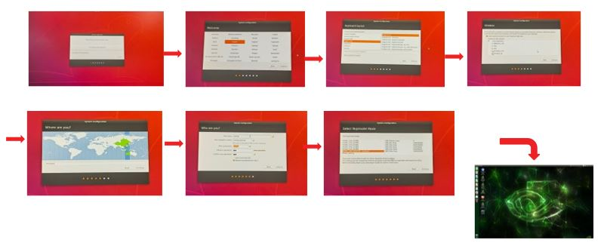

# Install Tensorflow

1. Install the needed package:



2. Install python independencies:



3. Install Tensorflow (online installation often fails, you can refer to step 4 for offline installation).



4. Finally, it is recommended to install offline, first log in to NVIDIA's official website to download [the TensorFlow installation package](https://developer.nvidia.com/embedded/downloads) (take "jetpack4.6 TensorFlow2.5.0 nv21.08" as an example, it is recommended to use Firefox browser to download).

5. After the installation is complete, check whether the installation is successful, enter into the terminal:

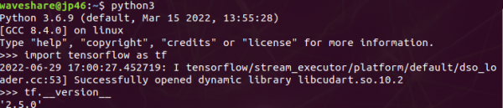

# Install other libraries



# Dowload source code

To download the source code of the D-ESCA project, run the following command:

# Check the operation of some programs

##### **Check plotting_graph.py**

To fix the issue with the matplotlib library, please modify the function update_from_first_child(tgt, src) in the path /usr/lib/python3/dist-packages/matplotlib/legend_handler.py as shown below.

Run the following command to test the graph plotting function.



If the graph appears as shown below, the graph plotting function is working properly.

##### **Check Resource_monitoring.py**

Please run the following command to check the operation of the resource monitoring library:



If the result displayed is as shown below, it means that the installation of the resource monitoring library was successful. Otherwise, it is necessary to reinstall the jtop library.

After confirming the successful installation of the resource monitoring library, run the following command to check the resource monitoring program.

