E-ESCA Project

Setup environment on Jetson Nano

SPARC Laboratory

Technical Report

|  |  |
| --- | --- |
| **Created by** | **Ho Trong Thanh** |
| **Date of Report:** | **30-April-2023** |
| **Reporting Period:** |  |
| **Version** | **1.0** |

Foreword

This document shows how to setup environment to training on Jetson Nano.

# Flash Jetpack OS for Jetson nano

**Equipment Preparation**

* Jetson Nano board
* Ubuntu virtual machine on VMware Workstation (or host computer)
* 5V/4A power adapter
* Jumper caps (or Dupont wire)
* USB data cable (Micro USB port, can transfer data)

**Hardware configuration (enter recovery mode)**

* Use jumper caps or Dupont wires to short-circuit the FC REC and GND pins, as shown in the figure below, at the bottom of the core board.
* Connect the DC power supply to the circular power port and wait a moment.
* Connect the Micro USB port of the Jetson Nano to the Ubuntu host with a USB cable (note that it is a data cable).

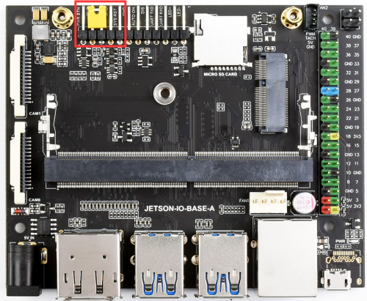

We have two methods to flash OS for Jetson Nano Develop Kit:

* Method 1: Adopt SDK Manager Tool (requires the Ubuntu 18.04 host or virtual machine on VMware Workstation)
* Method 2: Directly Download Jetpack (If you have an Ubuntu virtual machine on VMware Workstation or host but not 18.04 and can accept formatted SD cards or USB flash drivers )

**Note:** Furthermore, if you wish to flash OS for Jetson Nano Develop Kit (version without EMMC). You can follow the instructions in this link : [*https://developer.nvidia.com/embedded/learn/get-started-jetson-nano-devkit#intro.*](https://developer.nvidia.com/embedded/learn/get-started-jetson-nano-devkit#intro)

## Method One: Adopt SDK Manager Tool

1. Download SDK Manager: open the browser and enter the URL, click to download SDK Manager, and install it.

*Link :* [*https://developer.nvidia.com/zh-cn/embedded/jetpack*](https://developer.nvidia.com/zh-cn/embedded/jetpack)

1. Click LOGIN, log in to the NVIDIA account, and a link will pop up in the browser, enter the previous registered email and password to log in.

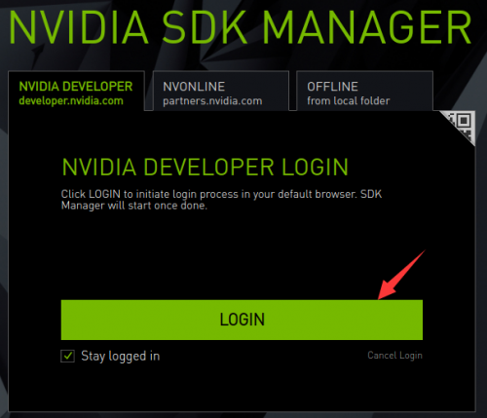

1. Log in to your account, if the Jetson Nano is recognized normally, SDK Manager will detect and prompt options

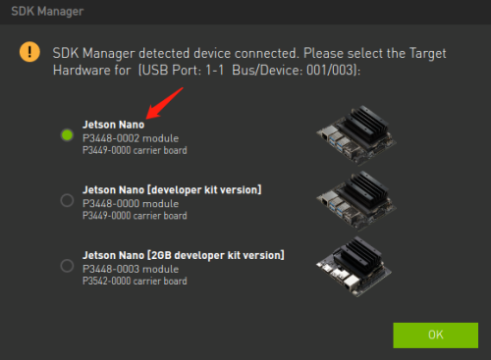

1. In the JetPack option, take the JetPack4.6 system as an example, uncheck Host Machine and click CONTINUE.

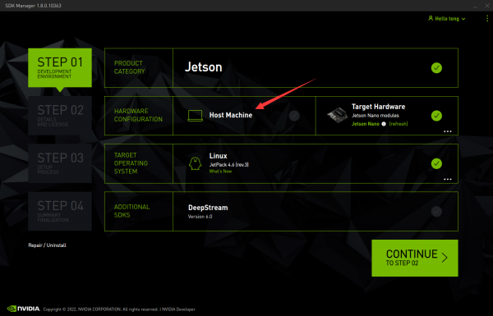

1. Select Jetson OS, and 'remove the option of Jetson SDK Components. Check the protocol and click CONTINUE.

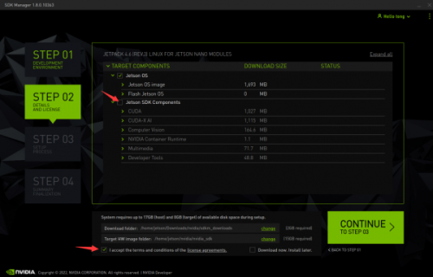

Note: Checking both will cause the download to fail.

1. The path is saved by HW Imager by default. Select Create and the path will be created automatically.

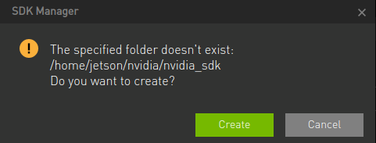

1. The path is saved by HW Imager by default. Select Create and the path will be created automatically.

Note:The Pre-config option in 7. OME Configuration is to set the username and password in advance, and the Runtime is to set the username and password during the boot configuration of the Jetson Nano.

1. Enter the password of the virtual machine, wait for the download, and the programming is finished.

1. After the programming is finished, remove the jump cap of the bottom panel, connect to the monitor, power on it again, and follow the prompts to configure the boot (if it is a pre-config set, enter the system directly after powering on).

## Method Two: Directly Download Jetpack

The following Jetpack download is based on Jetpack 4.6.2 as an example, for other Jetpack version resource pack download methods, please refer to the Jetpack download method in the FAQ.

1. Open the terminal on the ubuntu virtual machine or host and create a new folder



2. Download path

<https://developer.nvidia.com/embedded/l4t/r32_release_v7.2/t210/jetson-210_linux_r32.7.2_aarch64.tbz2>

<https://developer.nvidia.com/embedded/l4t/r32_release_v7.2/t210/tegra_linux_sample-root-filesystem_r32.7.2_aarch64.tbz2>

Move the Jetpack to a folder and extract it (in practice, try to use the tab button to automatically complete the instructions).



3. Unzip resource



4. Programming system, Jetson Nano needs to enter recovery mode and connect to the Ubuntu computer.

If Jetson Nano has a part number of P3448-0002 ( For production use )



If Jetson Nano has a part number of P3448-0000 ( For development; not for production use. Has a microSD card slot instead of eMMC for storage )



5. After the programming is finished, remove the jumping cap of the bottom panel, connect to the monitor, power on it again, and follow the prompts to configure the boot (if it is a pre-config set, enter the system directly after powering on).

# Install CUDA and Tensorflow

## Install CUDA

1. Open the SDK Manager on the Ubuntu 18.04 computer, skip to step 2, and download CUDA; after the download is complete, find the CUDA installation package.



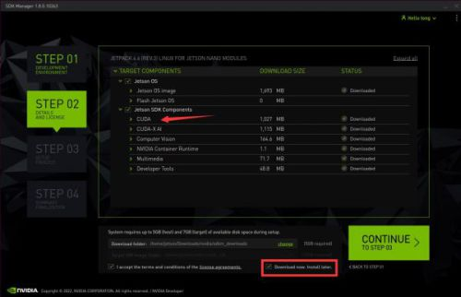

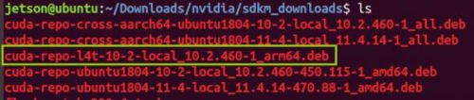

Transfer the installation package to Jetson Nano and add the downloaded key to the local trusted database:



Install CUDA Toolkit and CUDA:



## Tensorflow GPU Environment Construction

1. Install the needed package:



2. Install python independencies:



3. Install Tensorflow (online installation often fails, you can refer to step 4 for offline installation).



4. Finally, it is recommended to install offline, first log in to NVIDIA's official website to download [the TensorFlow installation package](https://developer.nvidia.com/embedded/downloads) (take "jetpack4.6 TensorFlow2.5.0 nv21.08" as an example, it is recommended to use Firefox browser to download).

5. After the installation is complete, check whether the installation is successful, enter into the terminal:

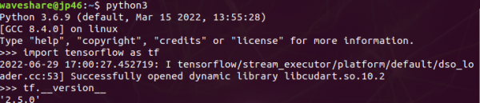

# Install other libraries

