**D****-ESCA 2 Project**

**Setup environment on ThinkEdge SE70-12A7S00E Guide**

SPARC Laboratory

*Technical Report*

|  |  |
| --- | --- |
| **Created by** | **Ho Trong Thanh** |
| **Date of Report:** | **16 Jan-2023** |
| **Reporting Period:** |  |

Foreword

This document shows how to setup environment to training on ThinkEdge SE70-12A7S00E.

I. Flash OS for ThinkEdge SE70-12A7S00E

**(Reference :** <https://smartsupport.lenovo.com/us/en/products/smart/smart-edge/thinkedge-se70/12a7/12a7s00e/solutions/ht513731>)

To flash OS for ThinkEdge SE70-12A7S00E, follow the steps listed below.

##### **Dowload OS Image**

1. Go to the website : [Lenovo Technical Support (support.lenovo.com)](https://support.lenovo.com/us/en/solutions/ht513706-thinkedge-se70-service-and-support-overview)
2. Select **Drivers & Software**, then select Select **Order Recovery Media.**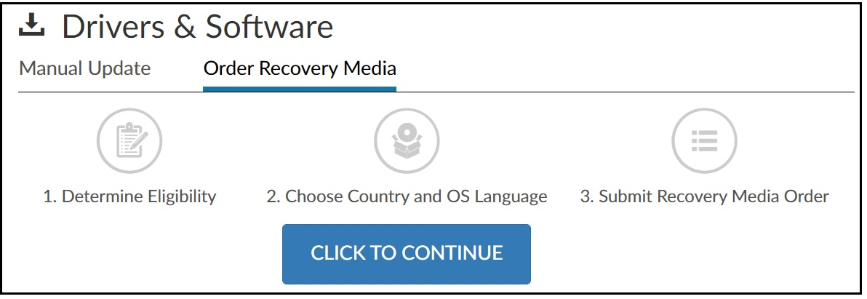
3. Select “Click to continue” and enter the ThinkEdge SE70 Serial Number (printed on the case) to dowload OS image

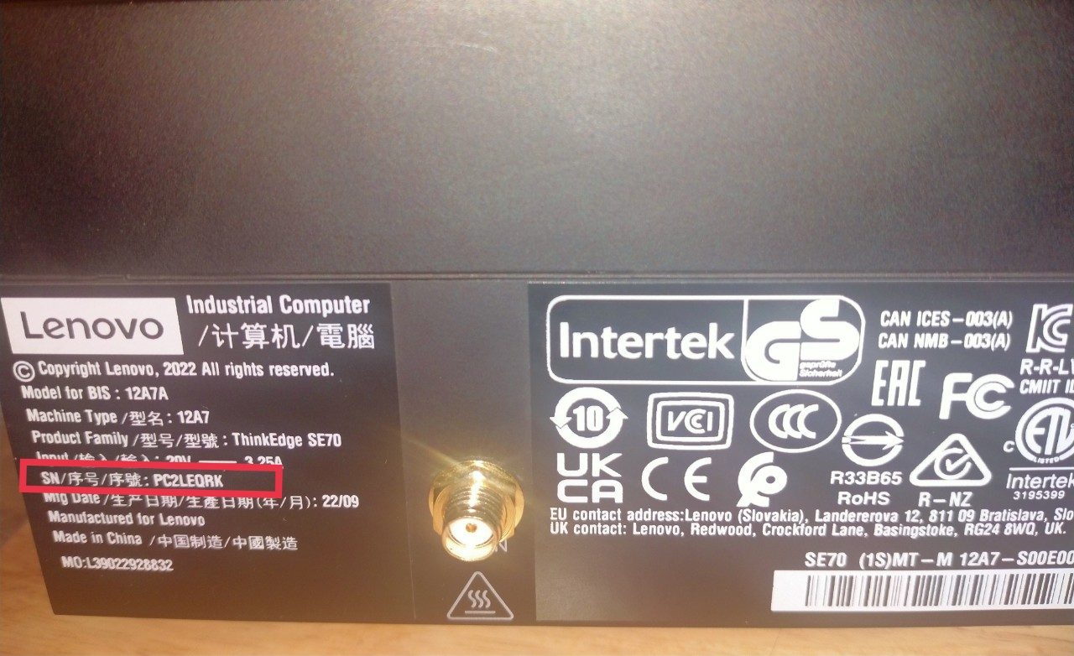

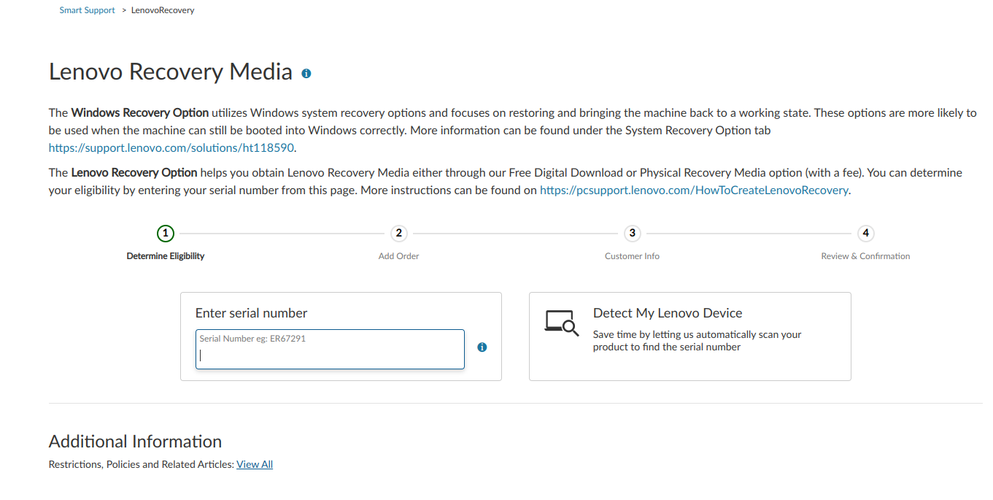

The download image should be name as: **se70_generic_preload_tarball.tgz**

##### **Flash the system using the image download**

1. Put the SE70 into **Force Recovery Mode** by following these steps:
   1. Ensure that SE70 is powered off, and the power adapter is connected.
   2. Press and hold **RECOVERY** button usinge a pointed object, such as pen tip, needle or toothpick.
   3. Press **POWER** button to power on.  
      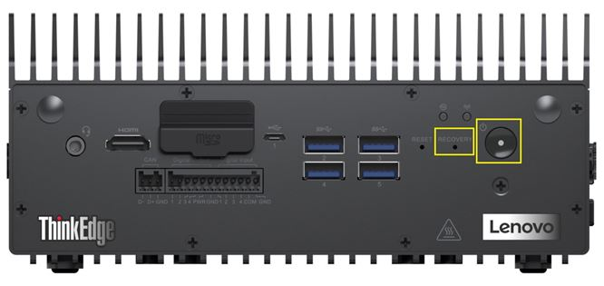
   4. Then release the **RECOVERY** and **POWER** buttons.
   5. After Recovery Mode has been entered, the LED light, under the Wi-Fi icon turns red.  
      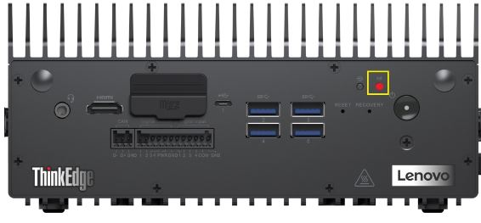
2. Connect the SE70 with an Ubuntu host system:
   1. Prepare, and login to a Ubuntu host system
   2. Connect the SE70 to the Ubuntu host system using a Micro-USB port.  
      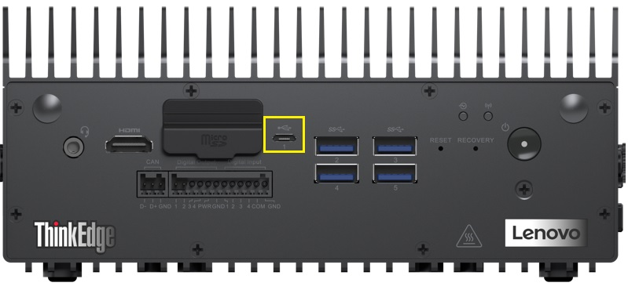
   3. Enter lsusb command to confirm if the SE70 is deteced by the Unbuntu host system. If the SE70 is detected, "NVIDIA Corp" appears in the listing results.  
      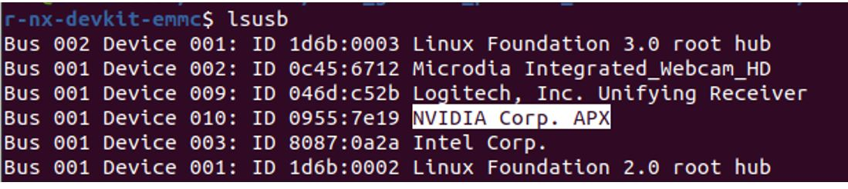
3. Flash the system using download image.
   1. Login to the Unbuntu host system, **Copy** and **Paste** the recovery image file to a directory.  
      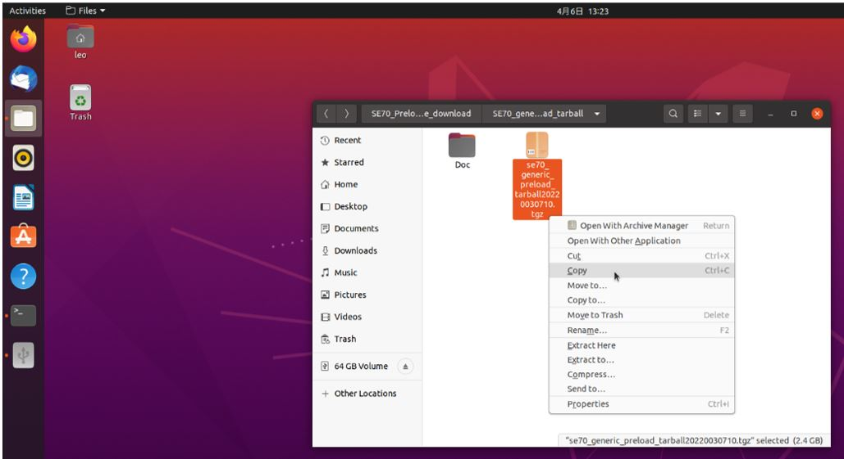
   2. Entering into the directory where you put the image file (*.tgz), Extract the tar ball by right-click and choose ”Extract Here”.  
      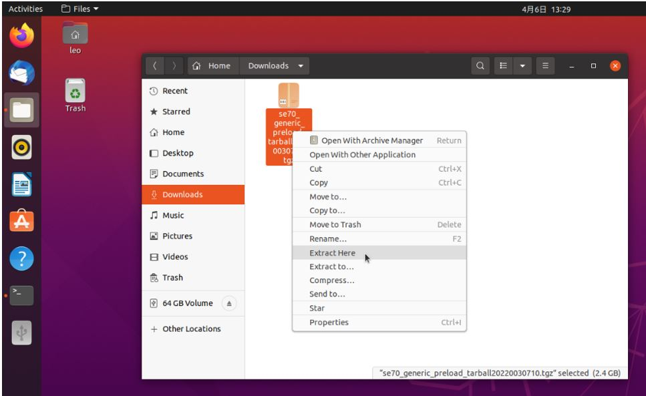
   3. Inside the extracted folder, entering into the subfolder se70_generic_preload_tarball2022030710/se70_preload_tarball/, right-click on the mfi_jetson-xavier-nx-devkit-emmc.tbz2 and choose to “Extract Here”.  
      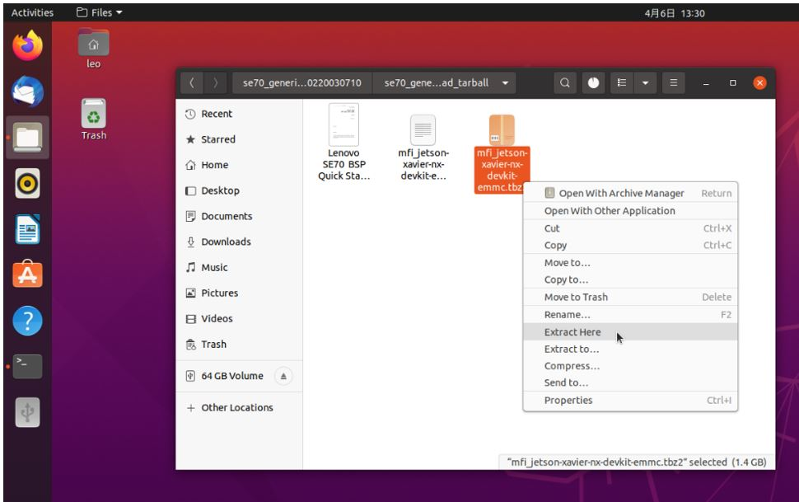
   4. Open the the terminal, type command in sequence and press Enter: cd /home/Downloads/se70_generic_preload_tarball20220030710/ cd se70_generic_preload_tarball/ cd mif_jetson-xavier-nx-devkit-emmc/
   5. Execute Burning script with sudo superuser privileges sudo ./nvmflash.sh  
      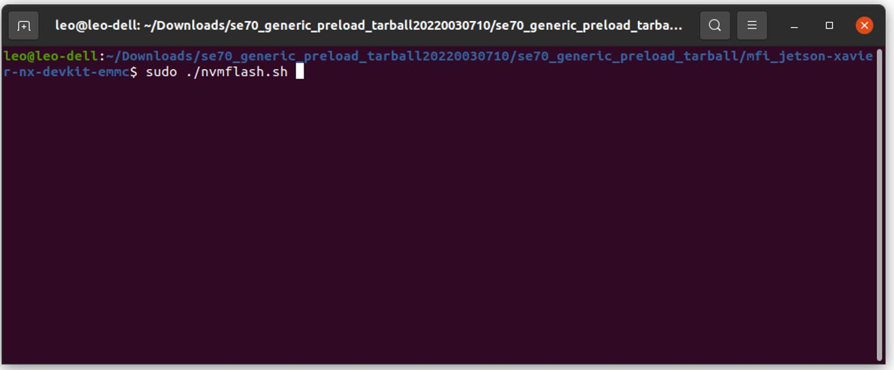  
      When prompted for the password, type the super user (root) password and press enter. Note there will be no input character displaying when entering password in. Important Notes: please make sure to use SuperUser privilege (root) to launch and execute the scripts.
   6. Flashing will be started with “Starting flashing device:…”  
      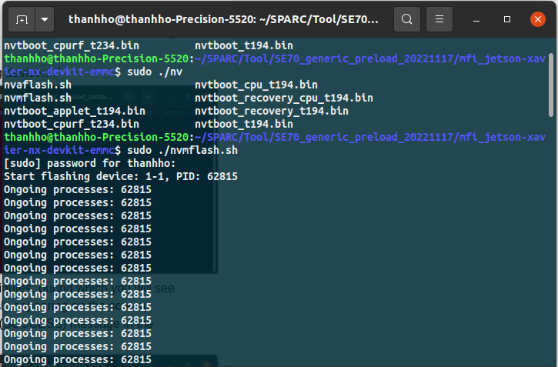
   7. The whole flashing process will take a few minutes, during which you will see “Ongoing processes: “information continuously appearing on the screen.
   8. Flash should complete with “Flash complete (SUCCESS) message in the end of the line . on SE70, system will reboot.  
      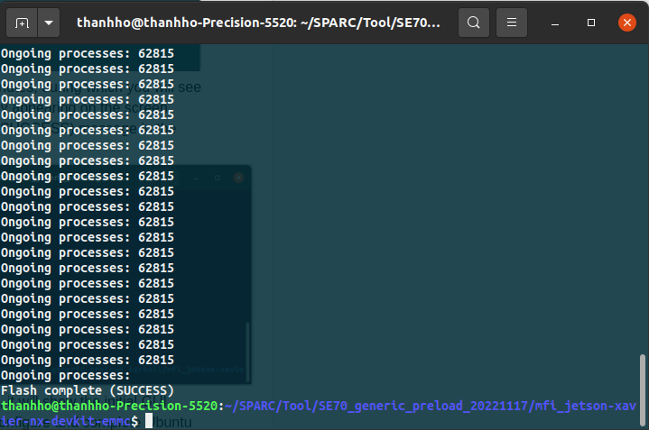
   9. On SE70 after reboot with Monitor connected, it will show the initial GUI desktop setup, follow the onscreen steps to configure and complete Ubuntu initial setup.

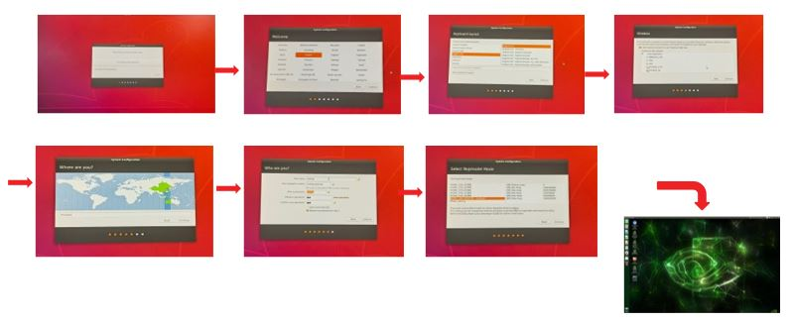

II. Install CUDA and Tensorflow

**Install CUDA**

1. Open the SDK Manager, select version of Jetpack and skip to step 2, and download CUDA; after the download is complete, find the CUDA installation package in directory /Downloads/nvidia/sdkm_downloads

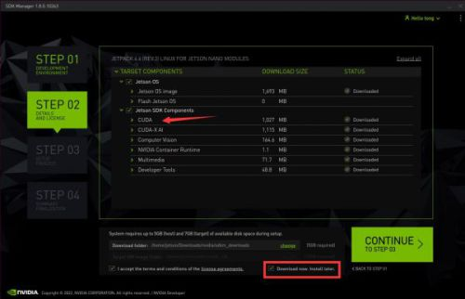

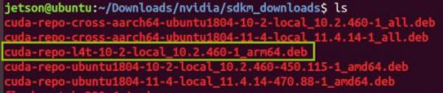

Transfer the installation package to ThinkEdge SE70 using scp and install using the following commands:

sudo dpkg -i cuda-repo-l4t-11-4-local_11.4.14-1_arm64.deb

sudo cp /var/cuda-repo-l4t-11-4-local/cuda-82DB0B48-keyring.gpg /usr/share/keyrings/

sudo apt-get -y update

sudo apt-get -y install cuda-toolkit-11-4 libgomp1 libfreeimage-dev libopenmpi-dev

openmpi-bin

**Install cuDNN library:**

sudo apt install libcudnn8

sudo apt install libcudnn8-dev

**Install Tensorflow**

1. Install system packets required by Tensorflow:

sudo apt-get update

sudo apt-get install libhdf5-serial-dev hdf5-tools libhdf5-dev zlib1g-dev zip libjpeg8-dev liblapack-dev libblas-dev gfortran

sudo pip3 install -U pip testresources setuptools==65.5.0

2. Install python independencies:

sudo pip3 install -U numpy==1.21.1 future==0.18.2 mock==3.0.5 keras_preprocessing==1.1.2 keras_applications==1.0.8 gast==0.4.0 protobuf pybind11 cython pkgconfig packaging h5py==3.6.0

3. Install the latest version of Tensorflow:

sudo pip3 install --extra-index-url https://developer.download.nvidia.com/compute/redist/jp/v502 tensorflow==2.10.0+nv22.11

(compatible with JetPack 5.0.2)

**Install other library**

pip install librosa

pip install git+https://github.com/detly/gammatone.git

sudo apt install python3-pyaudio

pip install pydub

pip install tqdm

pip install yacs

pip install psutil

pip install sounddevice

sudo pip install -U jetson-stats

III. Dowload source code

Run command:

***git clone https://github.com/SPARC-HUST/IoT-AnomallySoundDetection.git***

IV. Check the operation of some programs

**Check Resource_monitoring.py**

python3 ./helper/Resource_monitoring.py -p 1 -log ~/Desktop/ -ri 0 -cfg ./config/params.yaml

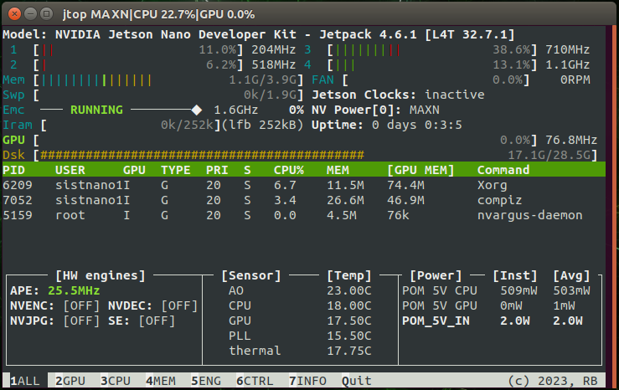

**Check plotting_graph.py**

* Fix matplotlib library

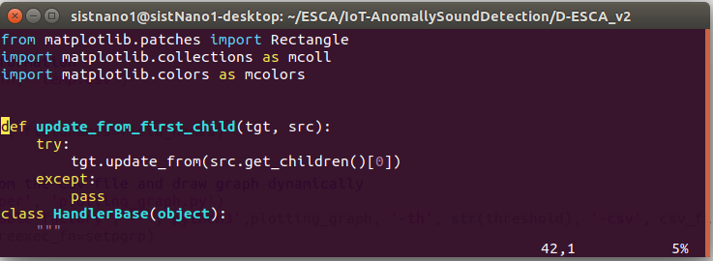

* Run command:

python3 ./helper/plotting_graph.py -th 0.5 -csv ./Results/rt_test_results/temp.csv

