MIDDLEWARES



What are middlewares used for?

1.Authentication

2.Input validation

Middleware functions can perform the following tasks:

* Execute any code.
* Make changes to the request and the response objects.
* End the request-response cycle.
* Call the next middleware function in the stack.

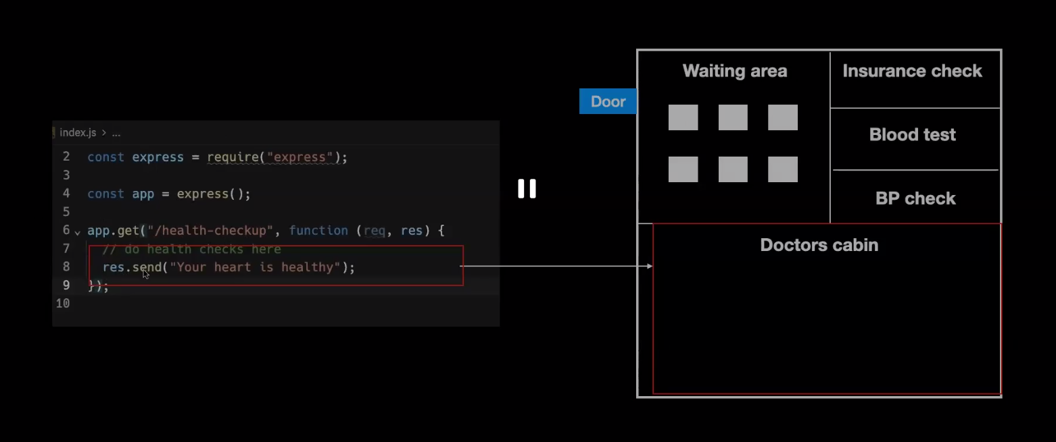

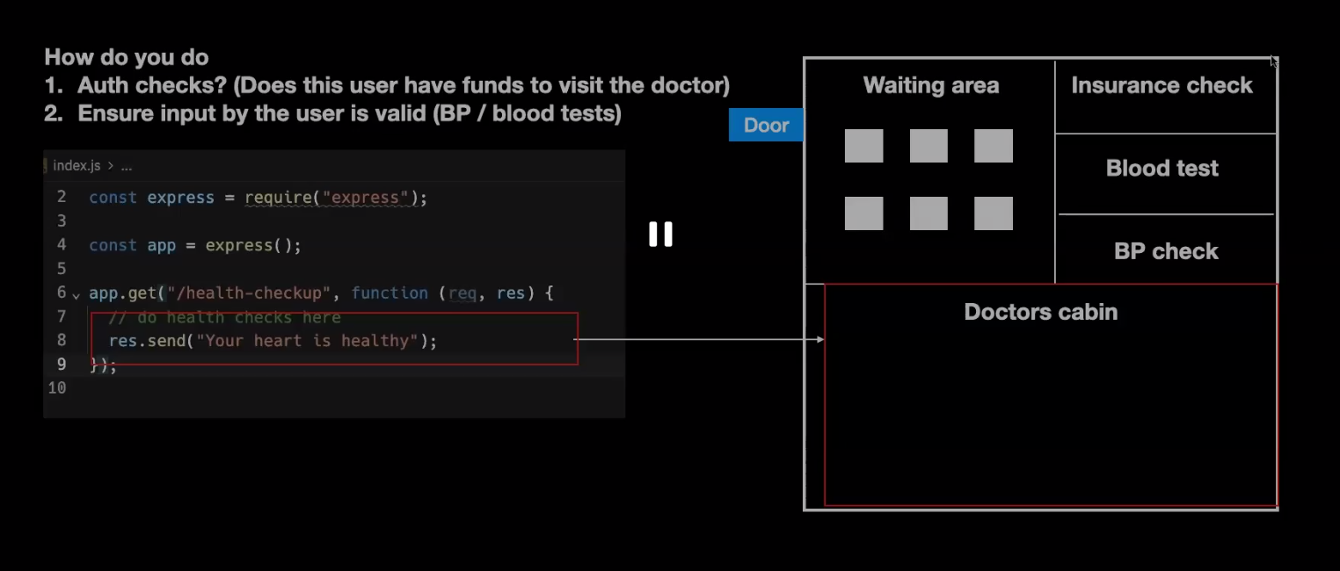

<http://localhost:3000/health-checkup?kidneyId=1>

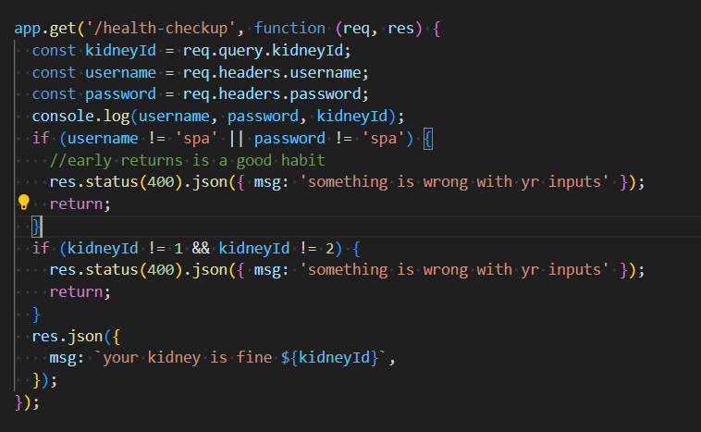

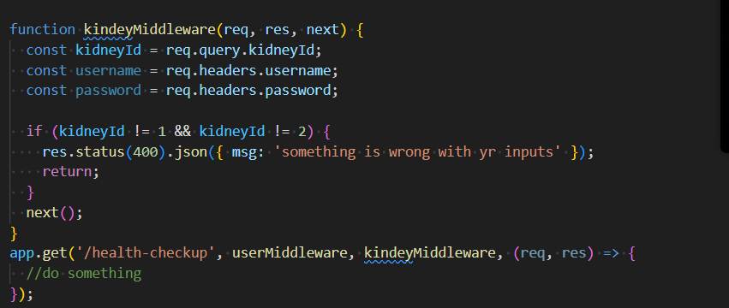



Any thing that comes after it any reqsuests will have this middleware

App.use(express.json()) => to use req.body (which should be in json)

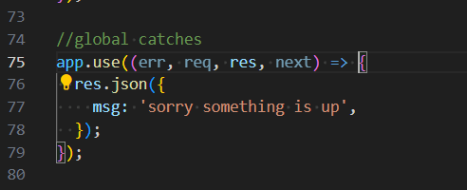

Error middlewares

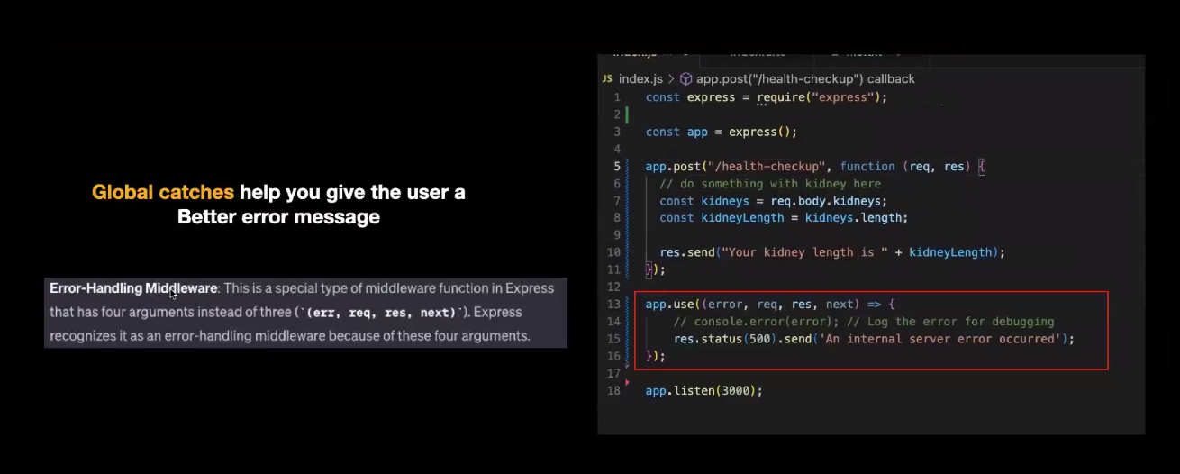

HOW TO DO BETTER INPUT VALIDATIONS -ZOD