**WEB-3**

Blockchains - currency will bloat in future (inflation)

- why we cant prnt a lot of money - inflation , money will lose its value

- govt have complete control over it

- BAILOUTSSS 2008 (mortgage backed securities)

- Fractional reserve banking -they lend money

- SVB collapsed silicon valley bank YC suggested this bank

How to create your new currency

-u can inflate money (there will be a centralised entity)

- decentralised currency

Hashing

-given a string -> function -> fixed size string , by which u cant get the original string

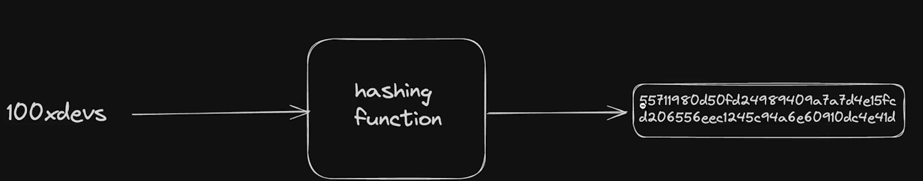

-properties :

-deterministic - same input -same output

-fast computation

-pre image resistance - infeasible to reverse the hash function - brute force the inputs -cant reverse engineer

- small change in input very high large change

- collision resistance

Encryption Is 2 way we can predict the pre computation image

SHA-256 -> 256 bits => ouptuts => 2 power 256