1. LOGIC BASED PROGRAM ON STRING/LIST/TUPLE/DICTIONARY

**Code:**

x = input("Enter a string: ")

s=''

for i in range(len(x)-1,-1,-1):

s+=x[i]

print(f"{s} is the reverse of {x}")

**Output:**

Enter a string: Hello everyone

enoyreve olleH is the reverse of Hello everyone

2. FLOOR DIVISION

**Code:**

x = float(input("Enter a number: "))

y = int(input("Enter the number for division: "))

print("Enter your choice")

print("1.Floor division")

print("2.Regular division")

choice = input("Enter choice: ")

if choice == "1":

print(x//y)

elif choice == "2":

print(x/y)

else:

print("Enter a valid choice")

**Output:**

Enter a number: 78

Enter the number for division: -4

Enter your choice

1.Floor division

2.Regular division

Enter choice: 1

-20.0

3. OPERATORS IN PYTHON

**Code**

x = int(input("Enter a number: "))

y = int(input("Enter another number: "))

print("Choose the option")

print("1.Arithmetic operator")

print("2.Logical operator")

print("3.Comparison operator")

choice = input("Your choice: ")

if choice == "1":

print(f"{x+y} if their sum")

print(f"{x-y} if their diff")

print(f"{x*y} if their prod")

print(f"{x/y} if their quotient")

elif choice == "2":

if x+y == 10 or x-y==5:

print("the sum is 10 or the diff is 5")

else:

print("neither the sum is 10 nor the diff is 5")

elif choice == "3":

if x>y:

print(f"{x} if greater than {y}")

elif y>x:

print(f"{y} if greater than {x}")

else:

print("Both are equal")

else:

print("Enter a valid option")

Output:

Enter a number: 3

Enter another number: 7

Choose the option

1.Arithmetic operator

2.Logical operator

3.Comparison operator

Your choice: 1

10 if their sum

-4 if their diff

21 if their prod

0.42857142857142855 if their quotient

4. NUMBER SYSTEM

**CODE**

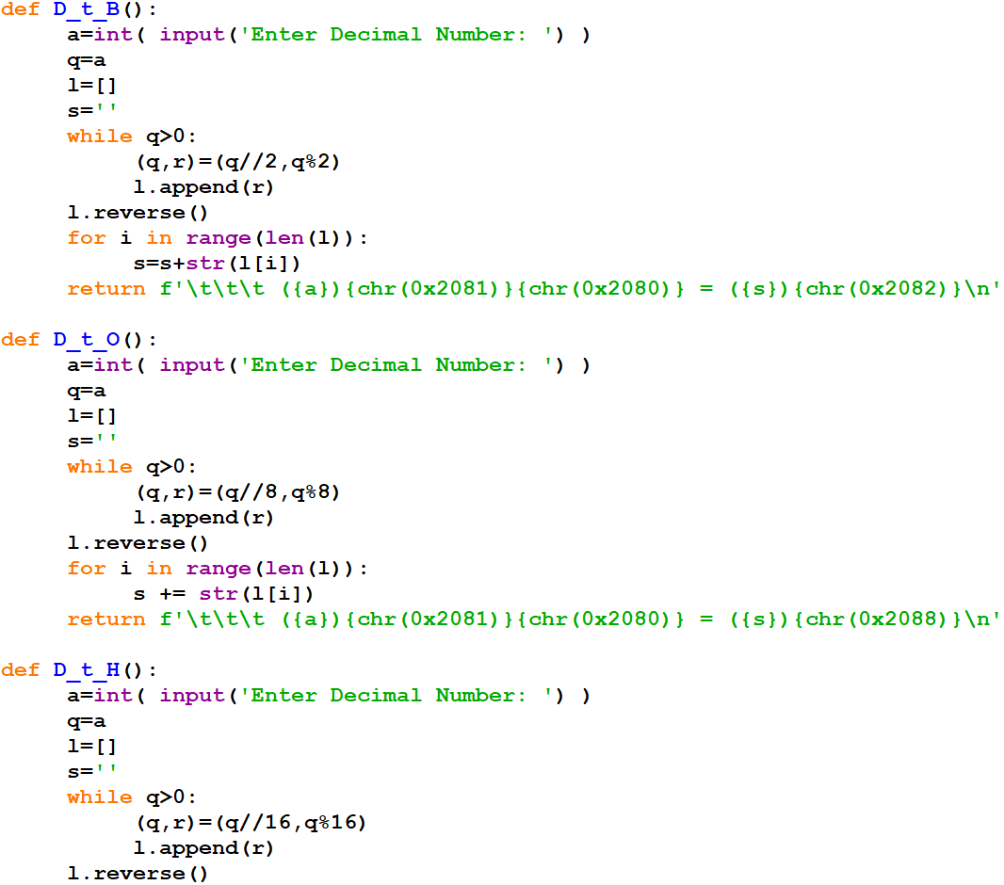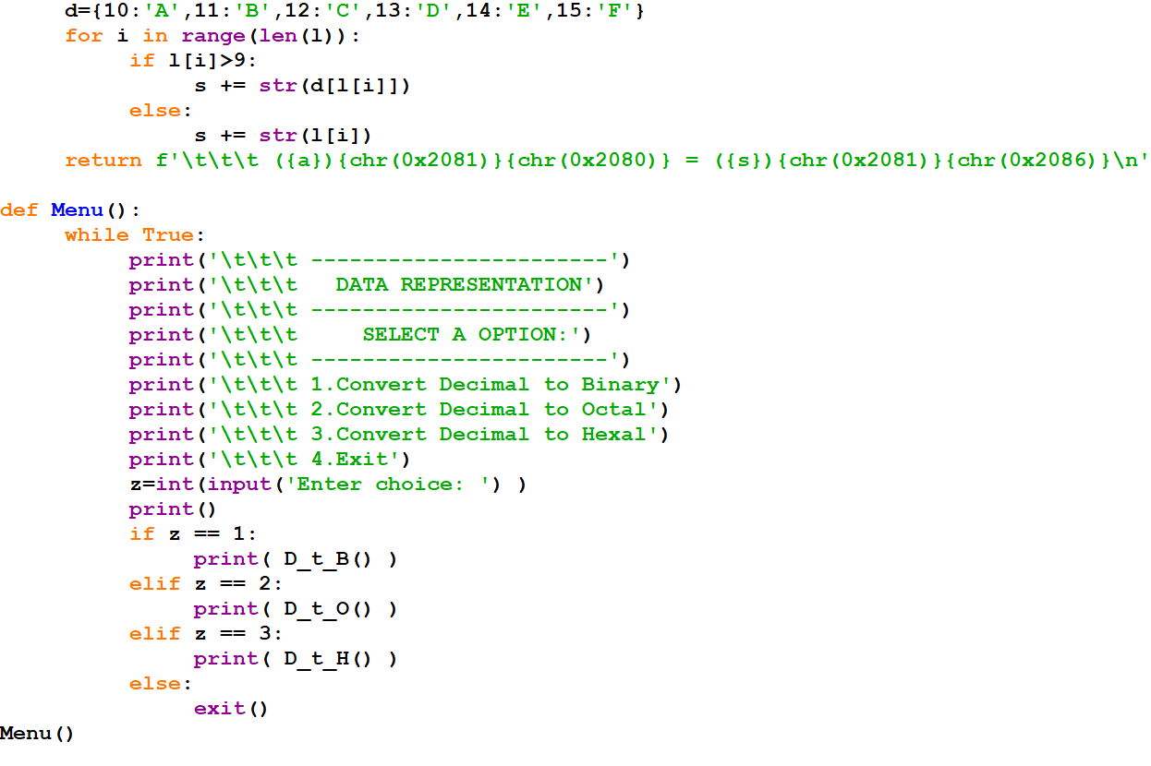

**OUTPUT**

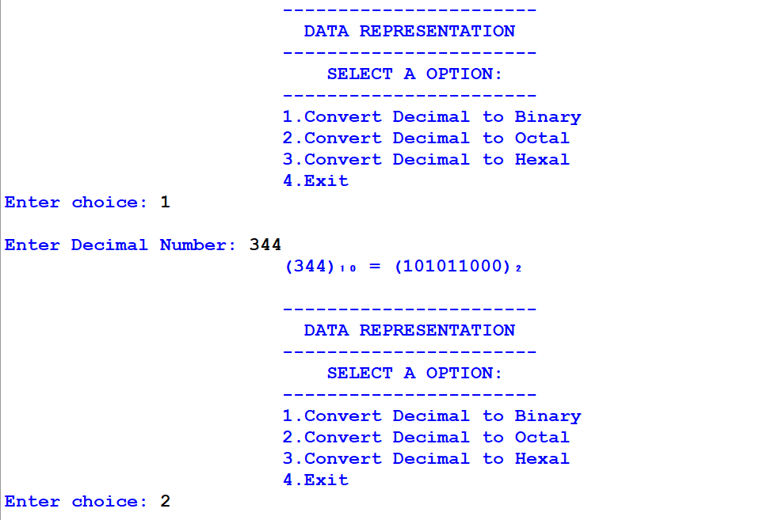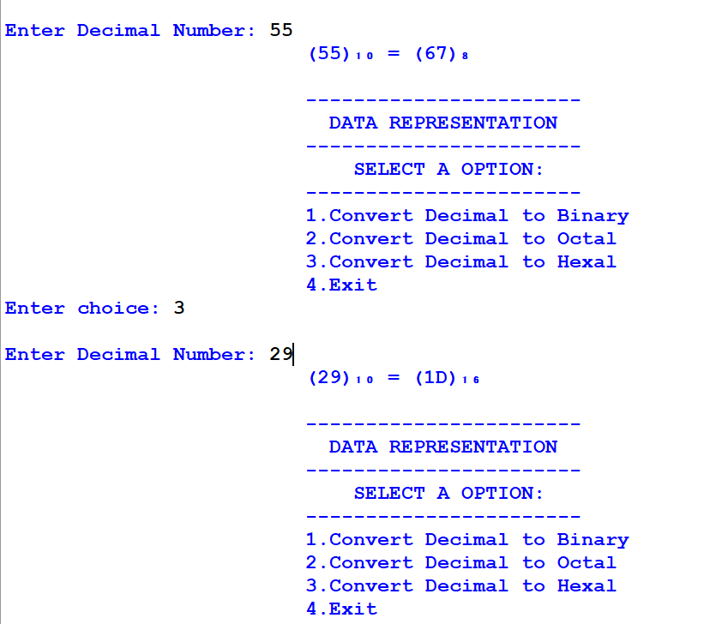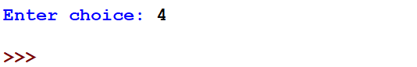

5. SEARCHING

**CODE**

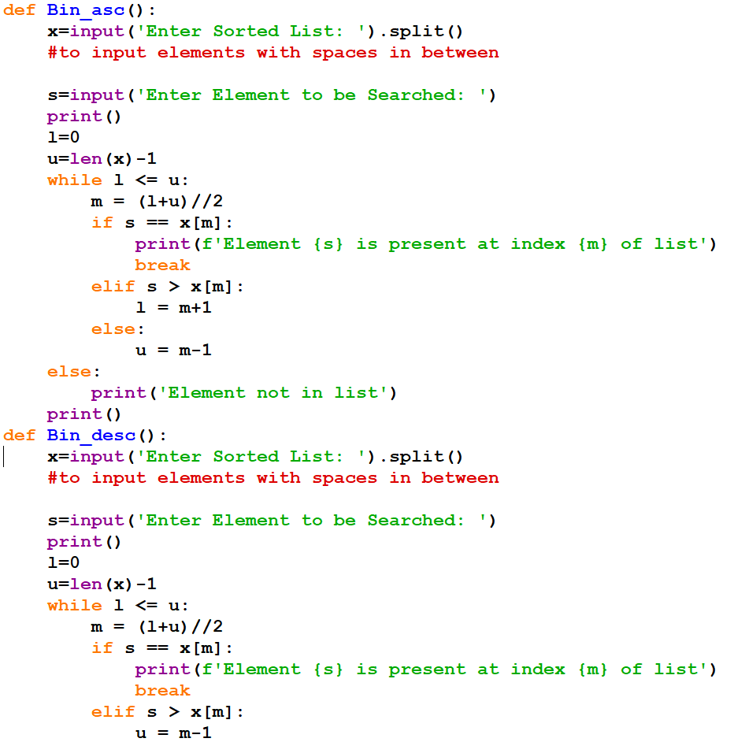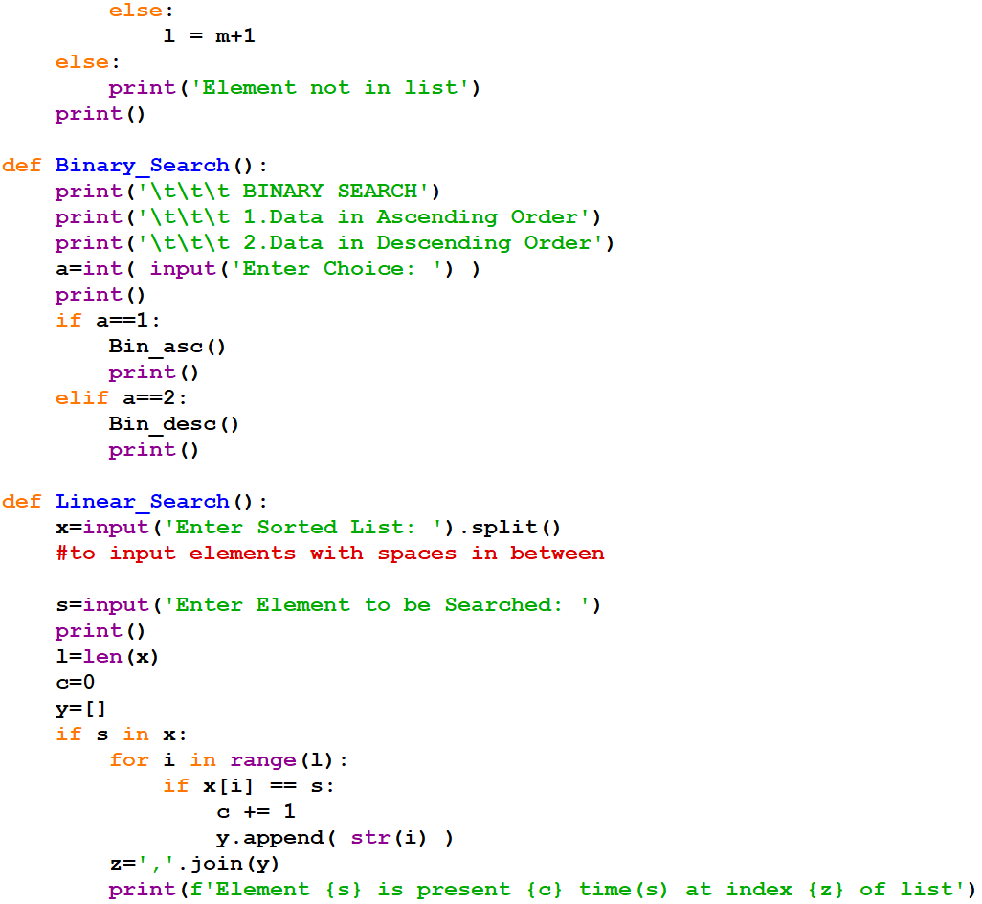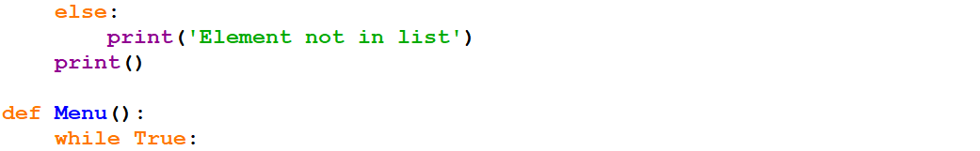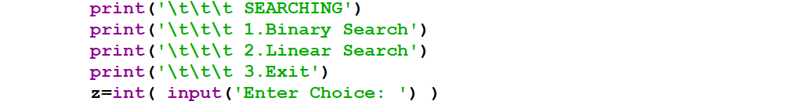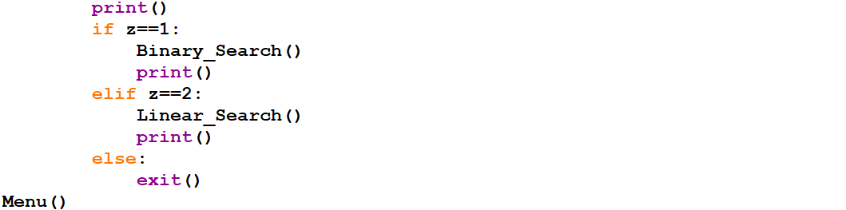

**OUTPUT**

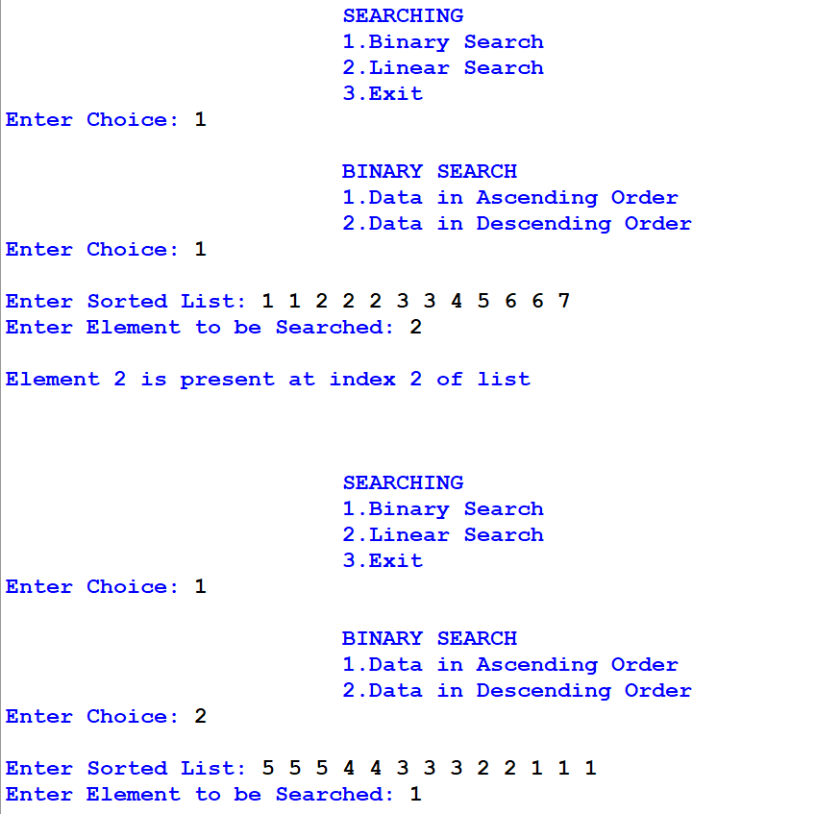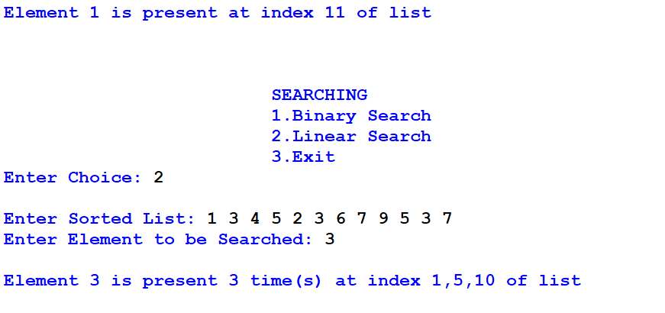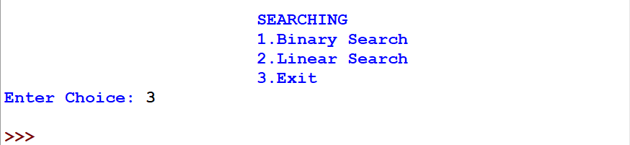

6. SORTING

**CODE**

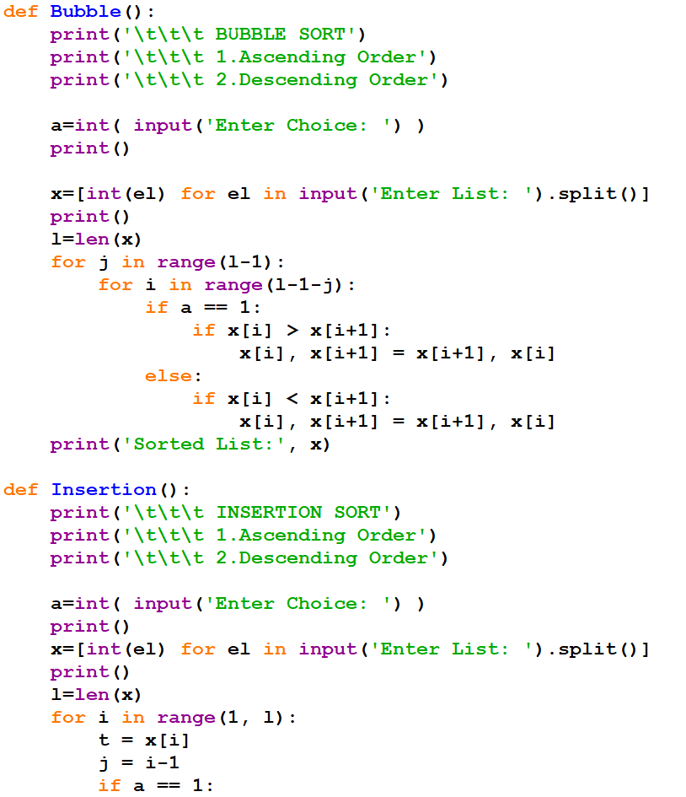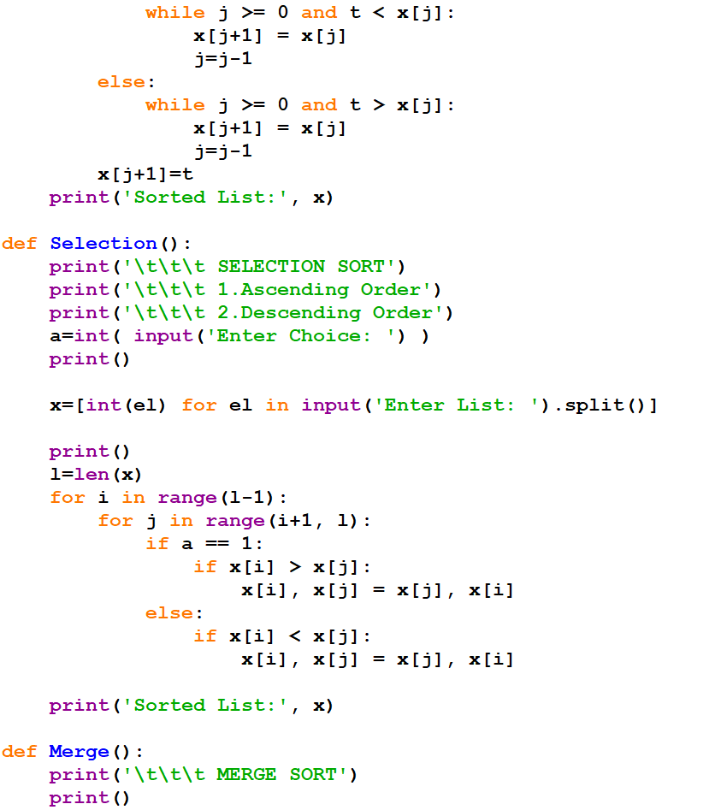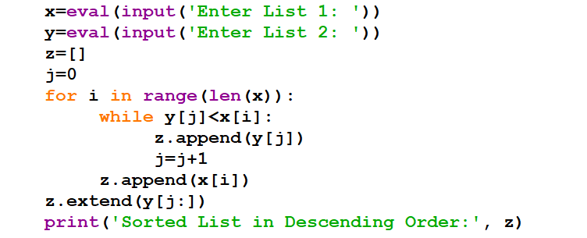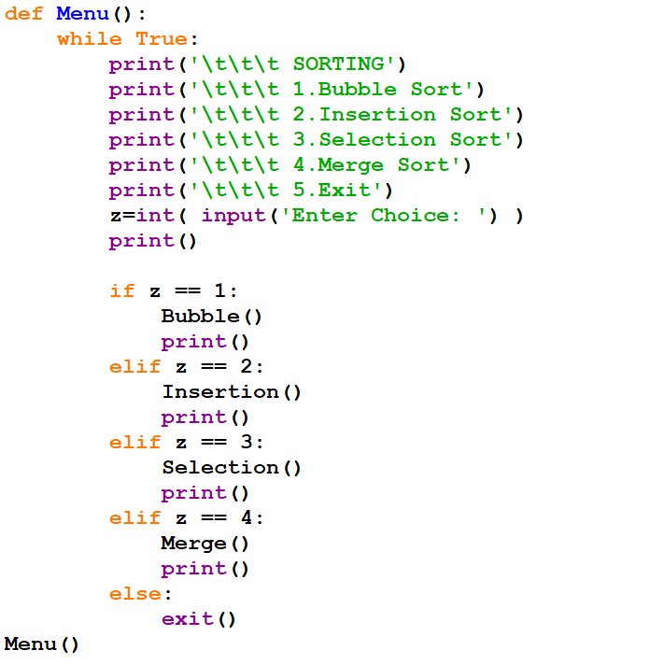

**OUTPUT**

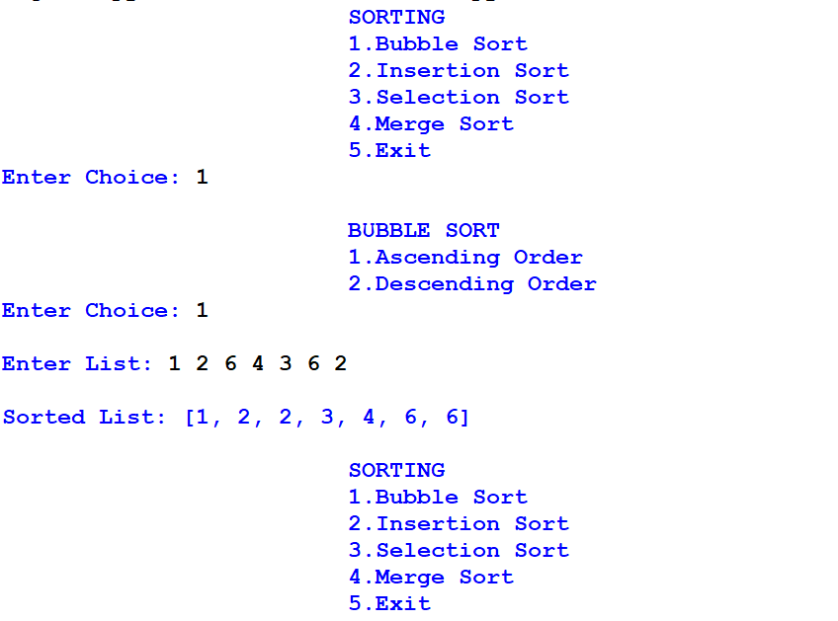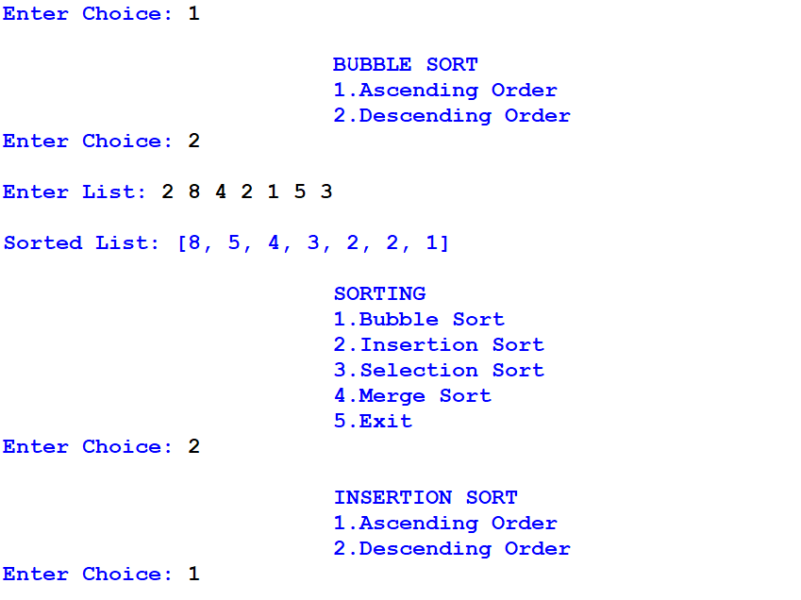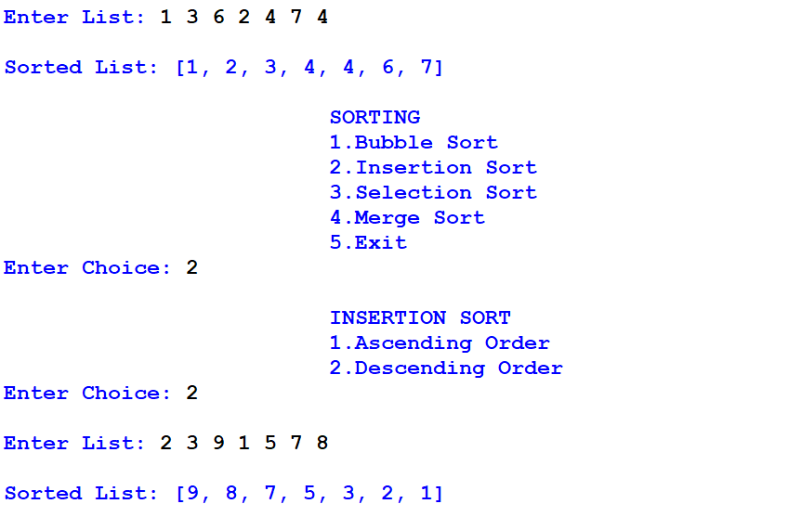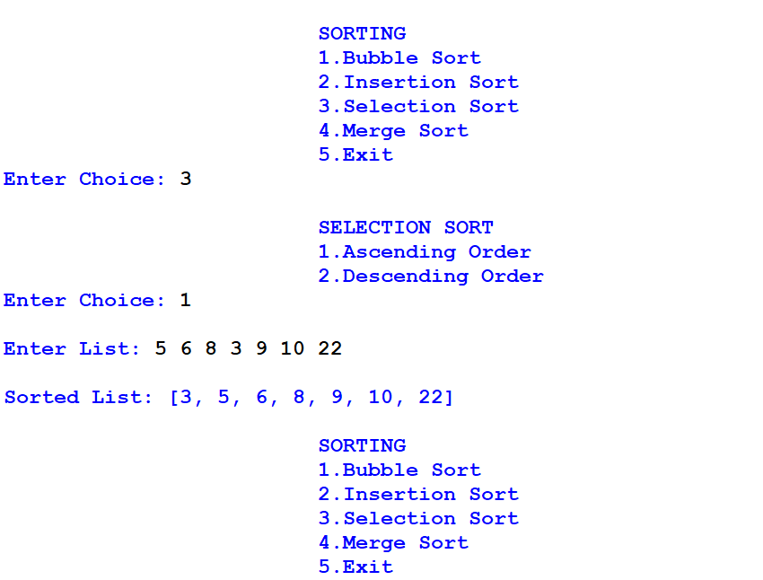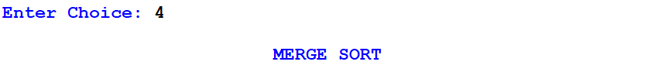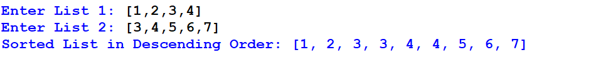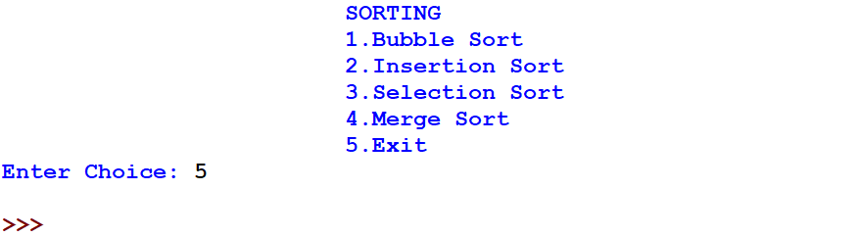

7. STRING HANDLING

**CODE**

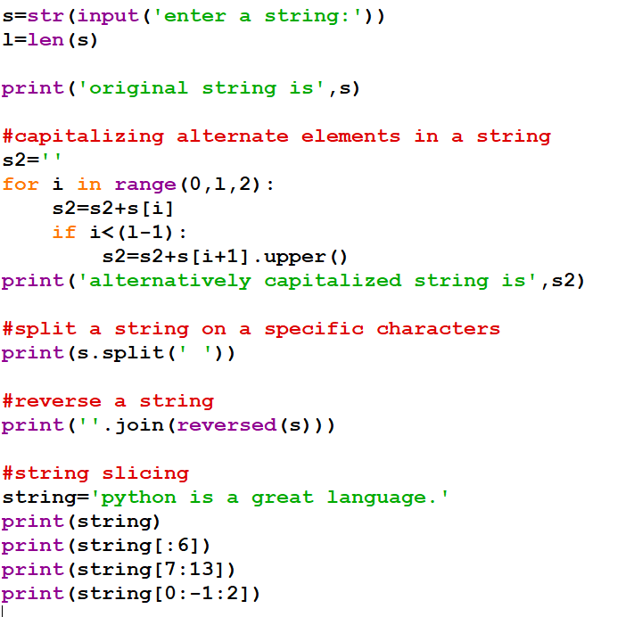

**OUTPUT**

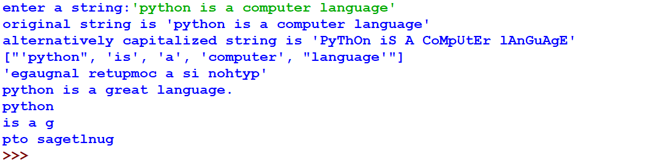

8. LIST HANDLING

**CODE**

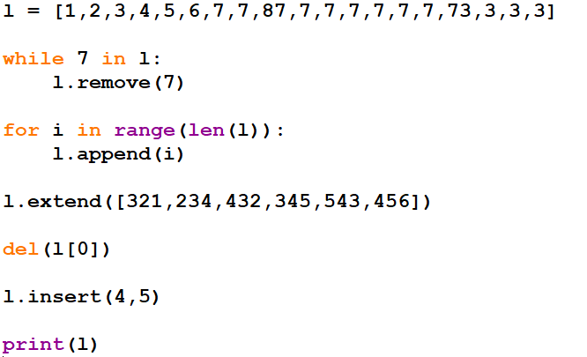

**OUTPUT**



9. TUPLE HANDLING

**CODE**

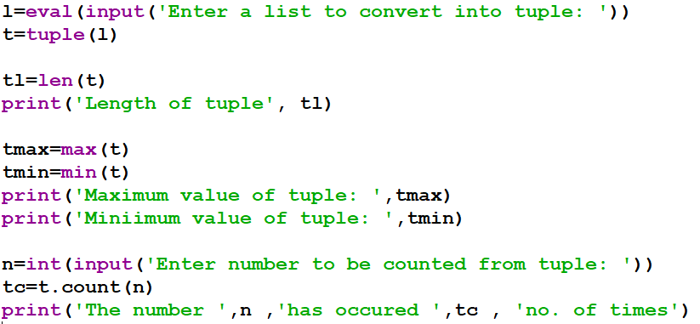

**OUTPUT**

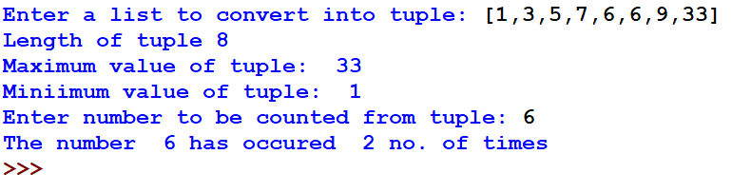

10. DICTIONARY HANDLING

**CODE**

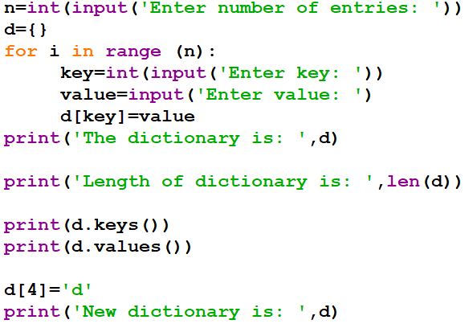

**OUTPUT**

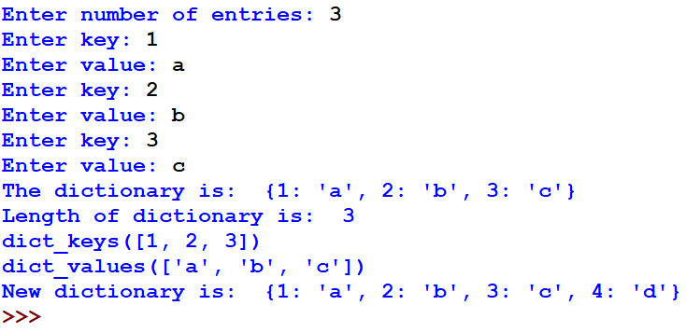

11. RANDOM

**CODE**

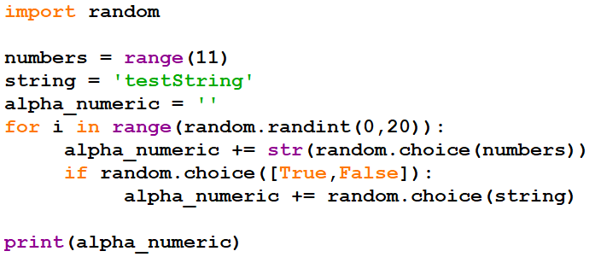

**OUTPUT**



12. FILE HANDLING (TEXT MODE)

**--> removing all empty lines**

**CODE**

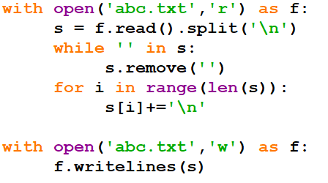

**OUTPUT**

Initially:

file

handling

text

Finally:

file

handling

text

13. FILE HANDLING (BINARY MODE)

**CODE**

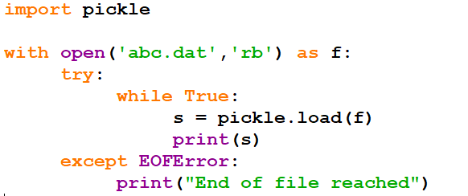

**OUTPUT**

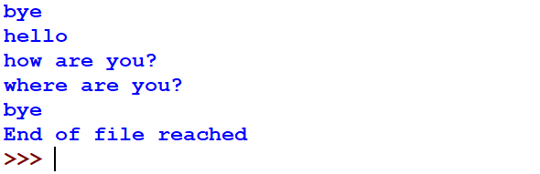

14. FILE HANDLING (CSV)

**CODE**

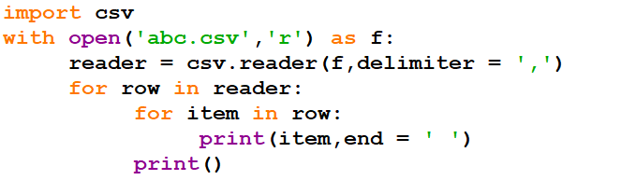

**OUTPUT**

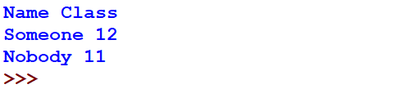

15. USER DEFINED FUNCTION

code:

def avg_number(numList):

    x=0

    for i in numList:

        x+=i

    mean=x/len(numList)

    print("The average is ",mean)

numListStr = input("Enter numbers separated by space:").split()

numList = [int(i) for i in numListStr]

avg_number(numList)

output:

Enter numbers separated by space:90 80 75 94 21 47 82 56

The average is 68.125

16. MYSQL QUERIES

**1*:*** *Creating a table with suitable fields*

*Code:*

**CREATE TABLE jobs (**

**JOB_ID integer NOT NULL UNIQUE PRIMARY KEY,**

**JOB_TITLE varchar(35) NOT NULL DEFAULT ' ',**

**MIN_SALARY decimal(6,0) DEFAULT 8000,**

**MAX_SALARY decimal(6,0) DEFAULT NULL**

**);**

*Output:*

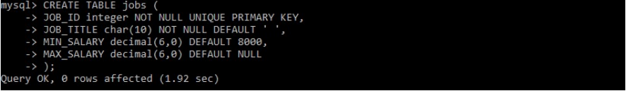

**2:** *Entering 3 records at once*

*Code:*

**insert into jobs values(281,'Engineer',24435,291198),(991,'Engineer',246645 ,291198),(721,'Engineer',287645,291348);**

*Output:*

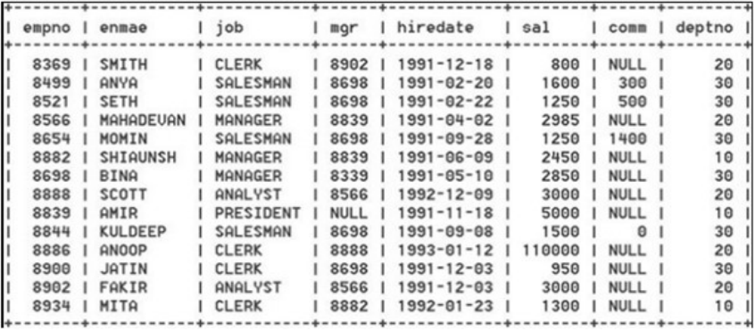

*1. Details of those employees whose annual salary is between*

*25000 and 40000.*

**SELECT * FROM empl where sal BETWEEN 2500 AND 4000;**

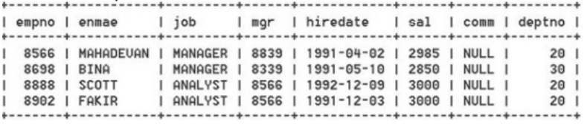

*2. Names of employees whose name contains ‘A’ as the 4th alphabet.*

**SELECT ename FROM empl WHERE ename like ‘___a%’;**

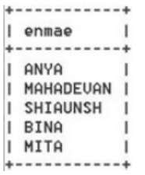

*3. Name, Job and Salary of employees who do not have a manager.*

**SELECT ename, job, sal FROM empl WHERE mgr IS NULL;**

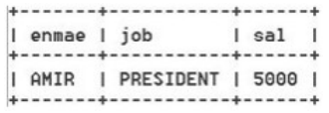

*4. Name, Salary and salary added with commision.*

**SELECT ename, sal, sal+comm FROM empl;**

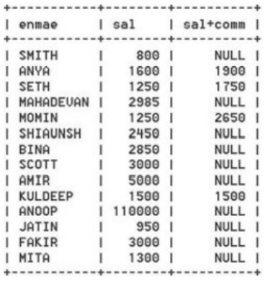

*5. Details of employees who earn more commission than their salaries.*

**SELECT * FROM empl WHERE comm>sal;**

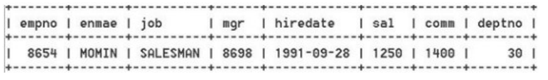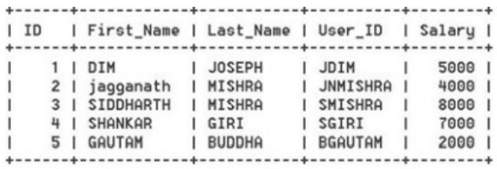

*1. For record with ID=4 update record with last Name, User ID and Salary.*

**UPDATE employe SET Last_Name=’SAHUKAR’,User_ID=’skar’,Salary=9000**

**WHERE ID=4;**

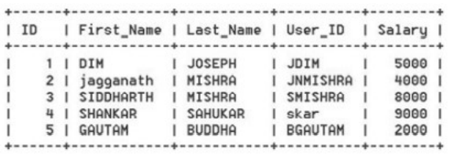

*2. Modify the last name of employees to Gautam where salary<5000.*

**UPDATE employe SET Last_Name=’Gautam’ WHERE Salary;**

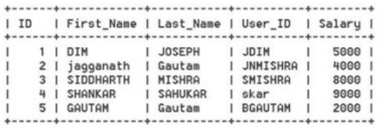

*3. Add column Email of data type VARCHAR to the table.*

**ALTER TABLE employe ADD(Email VARCHAR(30));**

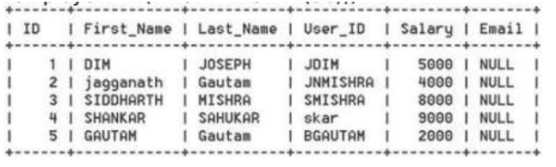

*4. Delete the employee record having first name as SIDDHARTH.*

**DELETE FROM employe WHERE First_Name=’SIDDHARTH’;**

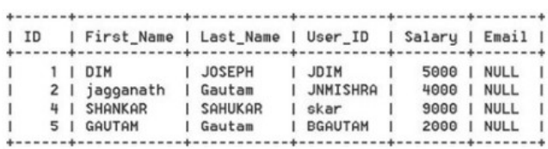

*5. Modify the salary and increases it by 1000, for all who get salary less than 5000.*

**UPDATE employe SET Salary =Salary+1000 WHERE Salary<5000;**

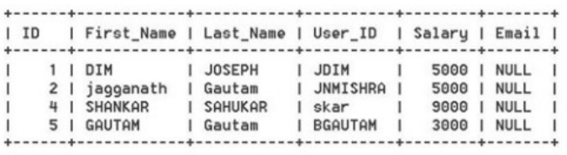

17. RECURSION

Code:

def pow(a,n):

if n==0:

return 1

else:

return a*pow(a,n-1)

def factorial(n):

if n==1:

return 1

else:

return n*factorial(n-1)

def Menu():

print(“Choose your option: “)

print(“1.Power”)

print(“2.Factorial”)

choice = int(input (“Enter choice: “))

if choice == 1:

base = int(input (“Enter base: “))

exponent = int(input (“Enter exponent: “))

print(pow(base,exponent))

elif choice == 2:

n = int(input (“Enter number: “))

print(factorial(n))

else:

print(“Enter valid input ”)

return Menu()

if __name__ == “__main__”:

Menu()

**Output:**

Choose your option:

1.Power

2.Factorial

Enter choice: 2

Enter number: 5

120

Choose your option:

1.Power

2.Factorial

Enter choice: 1

Enter base: 2

Enter exponent: 10

1024

18. STACKS

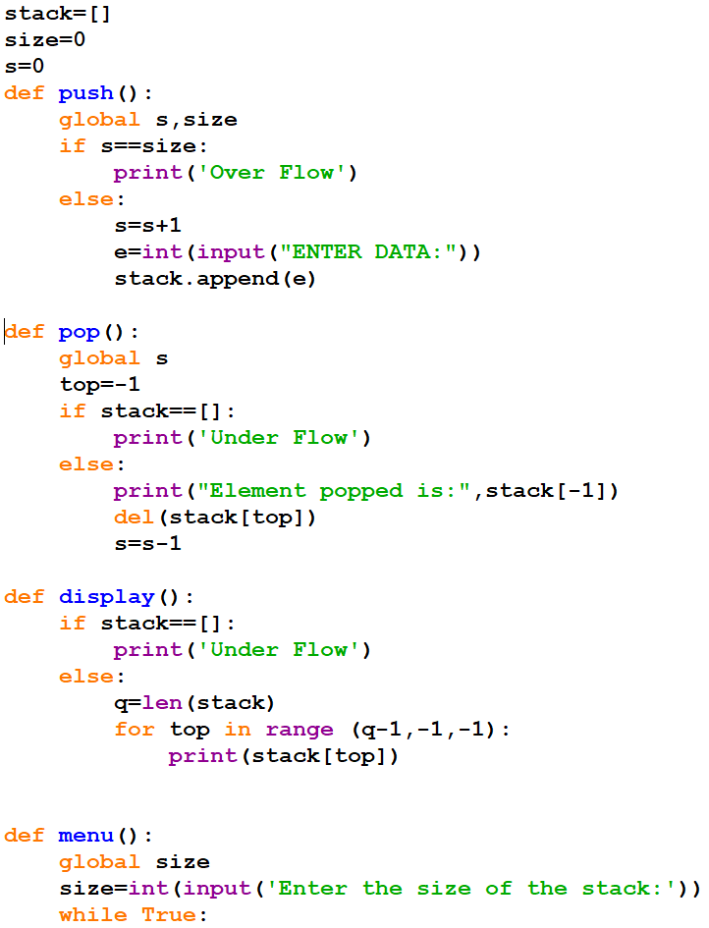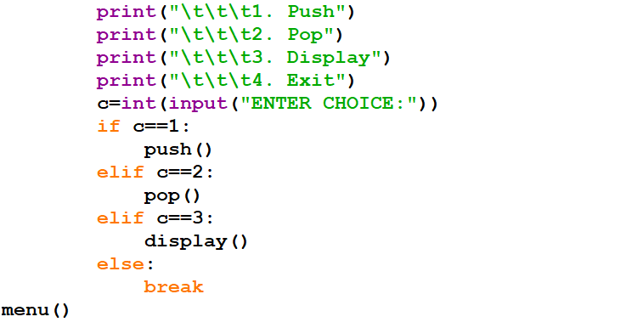

**OUTPUT**

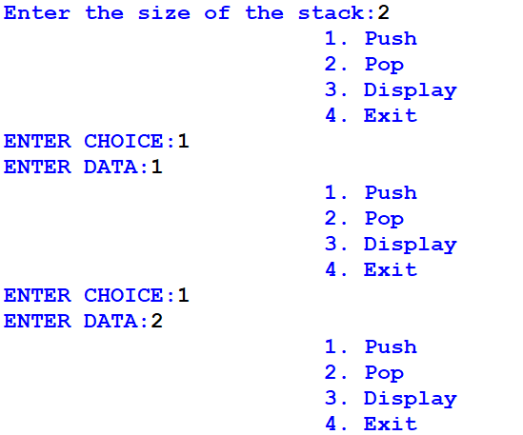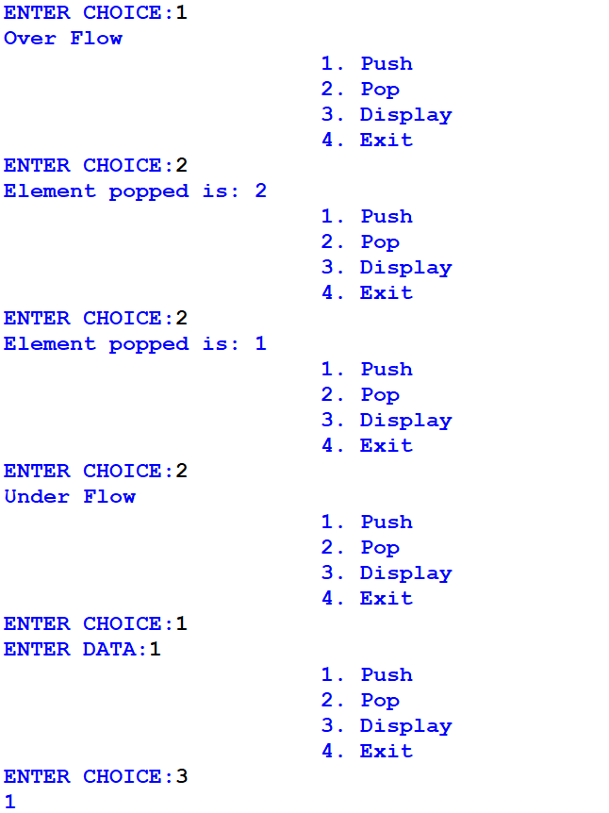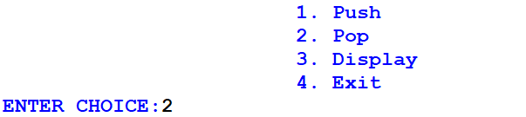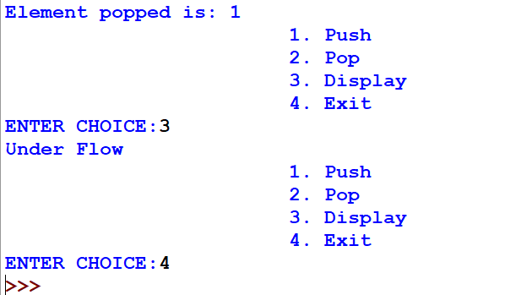

19. QUEUES

**CODE**

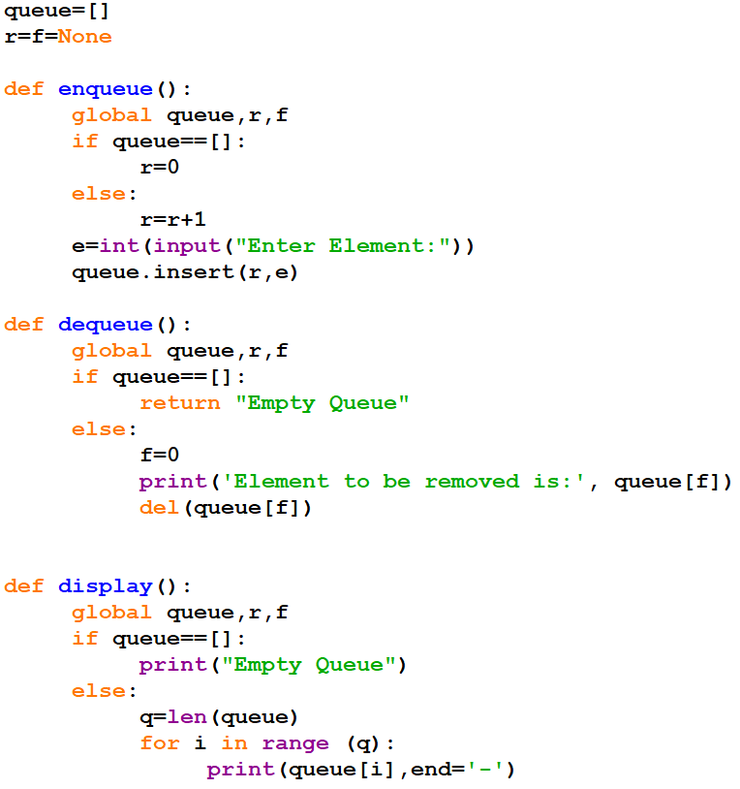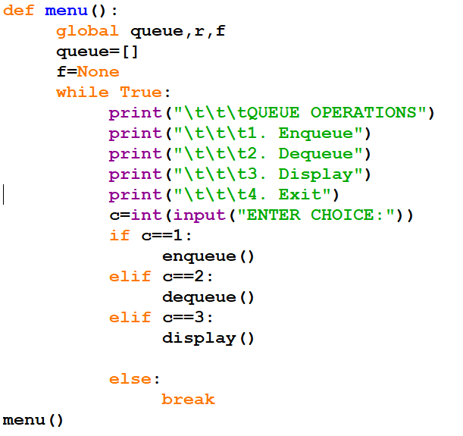

**OUTPUT**

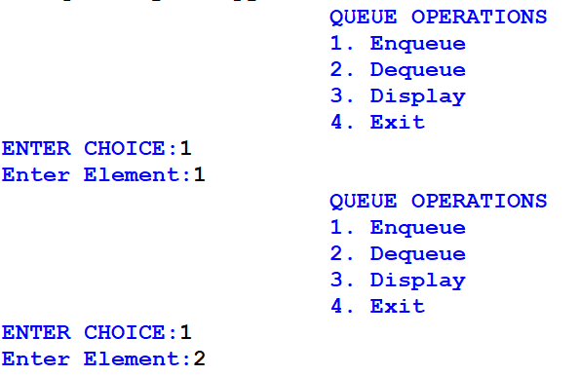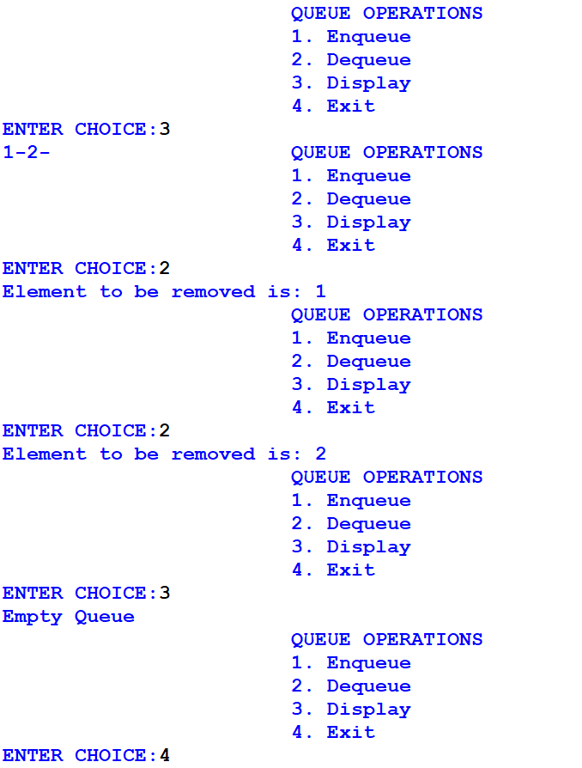

20. ART INTEGRATION PROJECT

**CODE**

import pymysql

import matplotlib.pyplot as plt

from tkinter import *

def create_table():

    db=pymysql.connect(host="localhost",user="root",passwd=rootpwd,db=database)

    cur=db.cursor()

    cur.execute("create table stu(Roll int,Name char(20),Class char(5),English int, Physics int, Chemistry int, Maths int, Computers int, Percentage char(6),Grade char(2), Remark char(4));")

    db.commit()

    cur.close()

    db.close()

def add_record_screen():

    global mainframe

    mainframe.destroy()

    mainframe = Frame(root,width=1100,height=600,bg="#111")

    mainframe.grid_propagate(0)

    mainframe.pack()

    def add_record():

        roll=int(rolle.get())

        name=namee.get()

        clas=clase.get()

        eng=int(enge.get())

        mat=int(mate.get())

        cs=int(cse.get())

        chem=int(cheme.get())

        phy=int(phye.get())

        total = eng+mat+phy+chem+cs

        perc = round(total/500 * 100,2)

        if perc > 33 : rem = 'PASS'

        else: rem = 'FAIL'

        if perc > 90: grade = 'A1'

        elif perc > 80: grade = 'A2'

        elif perc > 70: grade = 'B1'

        elif perc > 60: grade = 'B2'

        elif perc > 50: grade = 'C1'

        elif perc > 40: grade = 'C2'

        elif perc > 33: grade = 'D'

        else: grade = 'F'

        perc = str(perc)+"%"

        db=pymysql.connect(host="localhost",user="root",passwd=rootpwd,db=database)

        cur=db.cursor()

        cur.execute(f"insert into stu values({roll},\"{name}\",\"{clas}\",{eng},{phy},{chem},{mat},{cs},\"{perc}\",\"{grade}\",\"{rem}\");")

        db.commit()

        cur.close()

        db.close()

        rolle.delete(0,'end')

        namee.delete(0,'end')

        clase.delete(0,'end')

        enge.delete(0,'end')

        phye.delete(0,'end')

        cheme.delete(0,'end')

        mate.delete(0,'end')

        cse.delete(0,'end')

    Label(mainframe,bg="#111",fg="#fff",text='Roll No.').grid(row=1,column=1)

    Label(mainframe,bg="#111",fg="#fff",text='Name').grid(row=2,column=1)

    Label(mainframe,bg="#111",fg="#fff",text='Class').grid(row=3,column=1)

    Label(mainframe,bg="#111",fg="#fff",text='English').grid(row=4,column=1)

    Label(mainframe,bg="#111",fg="#fff",text='Physics').grid(row=5,column=1)

    Label(mainframe,bg="#111",fg="#fff",text='Chemistry').grid(row=6,column=1)

    Label(mainframe,bg="#111",fg="#fff",text='Mathematics').grid(row=7,column=1)

    Label(mainframe,bg="#111",fg="#fff",text='Comuper Science').grid(row=8,column=1)

    rolle = Entry(mainframe)

    rolle.grid(row=1,column=2)

    namee = Entry(mainframe)

    namee.grid(row=2,column=2)

    clase = Entry(mainframe)

    clase.grid(row=3,column=2)

    enge = Entry(mainframe)

    enge.grid(row=4,column=2)

    phye = Entry(mainframe)

    phye.grid(row=5,column=2)

    cheme = Entry(mainframe)

    cheme.grid(row=6,column=2)

    mate = Entry(mainframe)

    mate.grid(row=7,column=2)

    cse = Entry(mainframe)

    cse.grid(row=8,column=2)

    Button(mainframe,text="Back",command=Menu).grid(row=9,column=1)

    Button(mainframe,text="Submit",command=add_record).grid(row=9,column=2)

def display():

    global box

    db=pymysql.connect(host="localhost",user="root",passwd=rootpwd,db=database)

    cur=db.cursor()

    rows=cur.execute("select * from stu;")

    rec=cur.fetchall()

    records = """

+----------+-------------------------+----------+----------+----------+----------+----------+----------+----------+----------+----------+

|Roll No.  |Name                     |Class     |English   |Physics   |Chemistry |Maths     |CS        |Percentage|Grade     |Remarks   |

+----------+-------------------------+----------+----------+----------+----------+----------+----------+----------+----------+----------+

"""

    for i in rec:

        for j in range(len(i)):

            if j==0: records+="|"

            if j==1: records += "{0:<25}|".format(i[j])

            else:  records += "{0:<10}|".format(i[j])

        records+="\n+----------+-------------------------+----------+----------+----------+----------+----------+----------+----------+----------+----------+\n"

    cur.close()

    db.close()

    box.configure(state='normal')

    box.insert('end', records)

    box.configure(state='disabled')

def display_graph():

    db=pymysql.connect(host="localhost",user="root",passwd=rootpwd,db=database)

    cur=db.cursor()

    rows=cur.execute("select * from stu;")

    all_records=cur.fetchall()

    avg_eng=avg_phy=avg_chem=avg_maths=avg_cs=0

    for i in all_records:

        avg_eng+=i[3]

        avg_phy+=i[4]

        avg_chem+=i[5]

        avg_maths+=i[6]

        avg_cs+=i[7]

    avg_eng/=rows

    avg_phy/=rows

    avg_chem/=rows

    avg_maths/=rows

    avg_cs/=rows

    bg2=[avg_eng,avg_phy,avg_chem,avg_maths,avg_cs]

    try: rr=int(roll_no.get())

    except:

        print('Please enter roll no.')

        return

    aa=f"select * from stu where roll='{rr}';"

    rows=cur.execute(aa)

    rec=cur.fetchall()

    bg1=[]

    x=["English","Physics","Chemistry","Mathematics","Computer Science"]

    barWidth = 0.1

    for i in rec:

        bg1.append(i[3])

        bg1.append(i[4])

        bg1.append(i[5])

        bg1.append(i[6])

        bg1.append(i[7])

    r1 = [0,1,2,3,4]

    r2 = [i + barWidth for i in r1]

    plt.bar(r1,bg2,width=0.1,label="Class Average")

    plt.bar(r2,bg1,width=0.1,label="Student")

    plt.xlabel('group', fontweight='bold')

    plt.xticks([r + barWidth for r in range(len(bg1))], ['English', 'Physics', 'Chemistry', 'Maths', 'CS'])

    plt.legend()

    plt.show()

    cur.close()

    db.close()

def Menu():

    global mainframe,box,roll_no

    mainframe.destroy()

    mainframe = Frame(root,width=1100,height=600,bg="#111")

    mainframe.grid_propagate(0)

    mainframe.pack()

    Label(mainframe,text="Menu",bg="#111",fg="#fff",font=('serif',25)).grid(row=1,column=1)

    Button(mainframe,text="Create Table",command=create_table).grid(row=2,column=1)

    Button(mainframe,text="Add Record",command=add_record_screen).grid(row=3,column=1)

    Button(mainframe,text="Display All Records",command=display).grid(row=4,column=1)

    Button(mainframe,text="Display Bar Graph Student Wise",command=display_graph).grid(row=5,column=1)

    Button(mainframe,text="Exit",command=quit).grid(row=6,column=1)

    roll_no = Entry(mainframe)

    roll_no.grid(row=7,column=1)

    box=Text(mainframe,width=137,height=25,bg='#333',fg='#fff',state='disabled')

    box.grid(row=8,column=1)

def connect(a1,a2):

    global database,rootpwd

    rootpwd = a1

    database = a2

    Menu()

def connect_screen():

    e1 = Entry(mainframe,show="*")

    e2 = Entry(mainframe)

    Label(mainframe,text="Enter root@localhost Password",bg="#111",fg="#fff").grid(row=1,column=1)

    e1.grid(row=1,column=2)

    Label(mainframe,text="Enter name of database to be used",bg="#111",fg="#fff").grid(row=2,column=1)

    e2.grid(row=2,column=2)

    Button(mainframe,text="Submit",command=lambda: connect(e1.get(),e2.get()) ).grid(row=3,column=1,columnspan=2)

root = Tk()

root.geometry('1100x600')

mainframe = Frame(root,width=1100,height=600,bg="#111")

mainframe.grid_propagate(0)

mainframe.pack()

connect_screen()

root.mainloop()

**OUTPUT:**

