Joint inversion of proxy system models to reconstruct paleoenvironmental time series from heterogeneous data

Gabriel J. Bowen, Brenden Fisher-Femal, Gert-Jan Reinhart, Appy Sluijs, Caroline Lear

# Abstract

Paleoclimatic and paleoenvironmental reconstructions are fundamentally uncertain because no known proxy is a direct record of a single environmental variable of interest; all proxies are sensitive to multiple forcing factors. One productive approach to reducing proxy uncertainty is the integration of information from multiple proxy systems with complimentary, overlapping sensitivity to environmental one or more target variables. Most such analyses are conducted in an ad-hoc fashion, either through qualitative comparison to assess the similarity of single-proxy reconstructions or through step-wise quantitative interpretations where one proxy is used to constrain a variable relevant to the interpretation of a second proxy. Here we propose a formal framework for the integration of multiple proxies via the joint inversion of proxy system models. The “Joint Proxy Inversion” (JPI) method provides a statistically robust approach to producing self-consistent interpretations of multiproxy datasets, allowing full and simultaneous assessment of all proxy and model uncertainties to obtain quantitative estimates of past environmental conditions. Other benefits of the method include the ability to use independent information on climate and environmental systems to inform the interpretation of proxy data, to fully leverage information from unevenly- and differently-sampled proxy records, and to obtain refined estimates of proxy model parameters that are conditioned on paleo-archive data. Application of JPI to the marine Mg/Ca and δ18O proxy systems at two distinct timescales demonstrates many of the key properties, benefits, and sensitivities of the method, and produces new, statistically-grounded reconstructions of Neogene ocean temperature and chemistry from previously published proxy data. We suggest that JPI is a universally applicable method that can be implemented using proxy models of wide-ranging complexity to generate more robust, quantitative understanding of past climatic and environmental change.

# Introduction

Paleoenvironmental reconstructions, including reconstructions of past climate, provide a powerful tool to document the sensitivity of Earth systems to forcing, characterize the range of natural responses associated with different modes of global change, and identify key mechanisms governing these responses. Throughout the vast majority of the planet’s history, however, estimates of environmental conditions can only be obtained through proxy reconstructions. Proxy data are, as their name implies, indirect recorders of the environmental conditions we hope to estimate, and the estimates they provide are plagued by substantial, often poorly characterized, uncertainty.

The simplest proxy reconstructions typically focus on a single environmental variable of interest, inverting experimental or natural calibration datasets to obtain quantitative estimates of that variable and treating residual variance in the calibration as ‘noise’. In reality, however, no proxy system exists that is sensitive only to a single paleoenvironmentally-relevant variable, the majority of this noise reflects the uncharacterized influence of other environmental variables on the proxy system. Fossil leaf assemblages exhibit characteristic variability that can be associated with mean annual air temperature, but also appears to be influenced by annual temperature range and diverges among floras separated by long periods of independent evolution (REF). The saturation state of alkenones produced by marine phytoplankton is a sensitive recorder of water temperature, but is also strongly controlled by cell growth rate and size (REF). Even recently emerging clumped isotope techniques, which are in theory a direct recorder of the temperature of carbonate mineral formation, can be affected by factors such as kinetic growth-rate effects and poorly constrained, potentially variable offsets between the environment of carbonate formation and more commonly targeted atmospheric temperature conditions (Passey et al. 2010). Failure to recognize and consider the sensitivity of proxies to multiple environmental factors leads to two important problems in traditional proxy interpretations. First, considering only a single environmental variable in our interpretations maximizes the uncertainty in our reconstructions, which could be reduced if the influence of other variables is described and constrained. Second, unacknowledged sensitivity to multiple variables creates potential for biased proxy interpretations if variation in these variables is non-random over the period being reconstructed.

One productive approach to resolving the second issue is the development and use of proxy system models in the interpretation of proxy data (REFS). These models represent an attempt to mathematically describe the complex of environmental, physical, and biological factors that control how environmental signals are sampled, recorded, and preserved in proxy measurements. Several recent reviews and perspectives are available discussing the concepts underlying proxy system models and different ways that they have been applied to proxy interpretation, ranging from substitution for empirical calibrations in inverse estimation of environmental signals to formal integration within climate model data assimilation schemes (Evans et al. 2013). A growing number of proxy system models and modeling systems are being developed (e.g., Tolwinski-Ward et al. 2011, Stoll et al. 2012, Dee et al. 2015), and useful models span a range of complexity from empirically-constrained regressions to fully mechanistic, theory-based formulations. Key to any such model is accurate representation of uncertainty in each model component, which allows even relatively simple, potentially incomplete models to be used to obtain reconstructions with quantifiable uncertainty bounds.

Reducing the uncertainty of quantitative paleoenvironmental reconstructions requires adding constraints to proxy interpretations, as exemplified by the increasingly common development of multi-proxy reconstructions. In situations where two or more proxies share sensitivity to common or complimentary environmental variables, it stands to reason that the information provided by each can be used to refine interpretation of the multi-proxy suite. In practice, a variety of approaches have been used. Commonly, multi-proxy integration has been qualitative and focused on confirmation: trends reconstructed using one proxy system are cross-checked against a second, providing increased confidence in the reconstruction where the patterns match and further investigation where they don’t (e.g., Keating-Bitonti et al. 2011, Grauel et al. 2013). In other cases, proxies have been combined quantitatively, but usually in a stepwise fashion: one proxy system is used to estimate an environmental variable to which it is sensitive, and those reconstructed values are then used to constrain the interpretation of a second proxy formed at the same time (e.g., Fricke et al. 1998, Lear et al. 2000). Although it provides a simple strategy to combining complimentary proxy information, this approach does not fully leverage overlapping information that may be contained in multiple systems that respond to common forcing, is not conducive to robust quantification of uncertainty, and requires that both proxies sample coeval paleoenvironmental conditions.

Here we propose a general approach to proxy interpretation that leverages the benefits of proxy models and provides a formal statistical framework for proxy integration. The method, which we call Joint Proxy Inversion (JPI), cast in a Bayesian inferential framework, uses Markov Chain Monte Carlo methods to invert a hierarchy of proxy-system and environmental time series models. These models are simultaneously conditioned on proxy data and calibration datasets to obtain posterior estimates of the target paleoclimate time series with quantifiable uncertainty that accounts for all model components. We first describe the framework as applied to joint inversion of the marine Mg/Ca and δ18O proxy systems. We choose this system not because it is particularly challenging, but because it represents a well-established and widely-used multi-proxy system where diverse examples of proxy integration are available. We then present applications of JPI to two such datasets recording paleoceanographic conditions at two different timescales. These applications provide a platform allowing us to illustrate and discuss merits and limitations of JPI relevant to its broader application.

# Methods

Bayesian inversion of proxy system models has been demonstrated previously, for example to estimate site-specific model parameters (Tolwinski-Ward et al. 2013). JPI extends this approach to the simultaneous inversion of multiple proxy system and environmental time series models, conditioned on multiproxy data, to generate estimates of the posterior distribution of model parameters including the target paleoenvironmental time series.

## Data

Five datasets were compiled from published work for this analysis (Fig. 1). Estimates from fluid inclusions, calcite veins, and echinoderm fossils (Lowenstein et al. 2001, Dickson 2002, Coggon et al. 2010) were combined with information on modern seawater Mg/Ca (de Villiers & Nelson 1999) to represent variation in seawater Mg/Ca since 110 Ma. For simplicity, and because of the relatively low sensitivity of the other paleoenvironmental variables to seawater Mg/Ca estimates, we use interpreted seawater Mg/Ca estimates given by these authors instead of developing formal models for each Mg/Ca proxy system. Because uncertainty exists in the form of the partitioning function between seawater and echinoderm carbonate, our dataset includes both the original estimates from Dickson (2002) and the reinterpreted estimates of Hasiuk and Lohmann (2010). The uncertainty associated with each estimate was approximated from the primary publication, and ranged from 0.03 mmol/mol for modern seawater to ~0.5 mmol/mol for some of the proxy estimates (1 σ, see data and code available at <https://github.com/SPATIAL-Lab/JPI_marine>).

Foram Mg/Ca and δ18O data were compiled from Ocean Drilling Program (ODP) site 806, Ontong Java Plateau. Mg/Ca measurements were made on the benthic infaunal foraminifer *Oridorsalis umbonatus* (Lear et al. 2003, Lear et al. 2015). δ18O data (Bickert et al. 1993, Lear et al. 2003, Lear et al. 2015) represent a mix of benthic species, predominantly *Cibicidoides* spp, adopting the inter-species offset corrections applied by Lear et al. (2003) to correct data from other species to *Cibicidoides*-equivalent values. Variance in the foram data, e.g., due to analytical effects and sample heterogeneity, was not estimated directly but rather modeled as a function of the proxy system model calibration datasets (below), which are based on field-collected samples and should incorporate these sources of uncertainty.

Two calibration datasets were compiled to constrain the Mg/Ca and δ18O proxy system models. The Mg/Ca calibration data is based on the compilation of Lear et al. (2015), and includes data for *O. umbonatus* both from modern coretop samples and from Paleocene and Eocene sediments of ODP site 690B. Data from site 690B include an adjustment for differences in cleaning procedures used for those samples (Lear et al. 2015). Each Mg/Ca datum is accompanied by a bottom water temperature (BWT) estimate based on syntheses of observational data (modern) or δ18O thermometry (paleo), the latter assuming ice-free conditions. We adopt both sets of estimates directly, applying a normally distributed uncertainty to the BWT values with a standard deviation of 0.2 and 1 °C for the modern and paleo data, respectively, to approximate the different strength of these estimates. For δ18O we used the compilation of Marchitto et al. (2014) including new and published coretop data for the genera *Cibicidoides* (Keigwin 1998). BWT estimates from the original authors were adopted with an estimated uncertainty of 0.2 °C (1 σ).

The age of each pre-modern datum was taken from the primary source. Age uncertainties, where known, can easily be incorporated in the JPI analysis framework by treating ages as random variables rather than as fixed values. In this case, we do not include such a treatment for any of the datasets due to a lack of robust estimates of uncertainty associated with individual age estimates and the likely limited significance of age errors for the long-term reconstructions considered here.

## Proxy models

The proxy system models used here are comprised of simple, empirically constrained transfer functions relating proxy data to contemporaneous environmental variables. Given the coarse time-resolution of the environmental time series reconstructions (> tens of thousands of years) relative to the integration time of the proxy systems (i.e. the temporal variation in environmental conditions is integrated by the proxy measurement due to factors such as growth rate, sampling resolution, and bioturbation; likely no more than thousands of years) we do not explicitly consider integration processes; however, we do account for known changes in shorter-term environmental variance (e.g., during the transition to late Pleistocene “100-kyr” glacial world) via their impact on the dispersion of proxy data values (below).

As mentioned, we do not explicitly model the seawater Mg/Ca data proxy systems, but use the interpreted data directly, giving:

. (1)

Here *MgCaswp*(*i*) is the *i*th proxy estimate, *N* represents the normal distribution, *MgCasw* is the paleo-seawater Mg/Ca value, and *tswp* and *σswp* are the age estimate and uncertainty associated with a proxy estimate.

We model foram Mg/Ca (*MgCaf*, including both calibration and proxy data) as a function of seawater chemistry and bottom water temperature:

, (2)

where *α1-3* and *τMgCaf* are the parameters and precision (1/σ2) associated with the transfer function, respectively, and other parameters are analogous to equation 1. In the absence of theoretical constraints, we assign normally distributed priors to the *α* parameters based on Bayesian regression of the expression for the mean in equation 2 against the calibration dataset, assuming paleo-seawater Mg/Ca of 1.5 mmol/mol in the Paleocene and Eocene (*α1* ~ N[1.5, σ = 0.1], *α2* ~ N[0.1, σ = 0.01], *α3* ~ N[-0.02, σ = 0.03]). The prior estimate on the precision of foram Mg/Ca, *τMgCaf*, is the gamma distribution Γ[shape = 3, rate = 1/30], which approximates the precision of the independent regression.

Foram calibration and proxy δ18O values (*δ18Of*) are modeled similarly, with:

. (3)

Here *δ18Osw* is the modeled seawater isotope composition and *β1-3* are the transfer function coefficients. In this analysis we treat the scale conversion factor between the SMOW and PDB reference scales (Shackleton 1974) as implicit in the transfer function intercept term (*β1*), which is relevant only in comparing our posterior parameter estimates to other work. Prior estimates of the model parameters were obtained and specified as for Mg/Ca; these are *β1* ~ N[3.32, σ = 0.02], *β2* ~ N[-0.237, σ = 0.01], *β3* ~ N[0.001, σ = 0.0005]. Because the amplitude of high-frequency (i.e. below the resolution of our model) *δ18Osw*variance increased substantially with the onset of modern, 100 kyr glacial cycles, we modeled *τδ18Of*(*i*) separately for proxy data younger than 800 ka (*τδ18Of* ~ Γ[6, 1]) and for all other proxy and calibration data (*τδ18Of* ~ Γ[3, 1/30]). The former estimate is based on the observed proxy variance since 800 ka, whereas the former approximates the precision of the calibration relationship.

## Environmental models

The paleoenvironmental variables underlying the observed proxy signals are represented as time series using a correlated random walk model. This parameterization is desirable in that it is minimally prescriptive (i.e. no preferred state or pattern of change is prescribed) but allows incorporation of constraints on (and extraction of inference about) two basic characteristics of the underlying environmental systems – namely their rates and directedness of change. The correlated random walk for variable *Y* is expressed as:

, (4)

where:

. (5)

In short, the variable follows a random walk in which the next value in the time series is a function only of the current value and a normally distributed error term *ϵY*, which has a temporal autocorrelation of *φY* and precision *τy*. This gives three independent parameters, *φY*, *τy*, and an initial value of *Y* at the beginning of the time series.

For seawater Mg/Ca, which is thought to evolve gradually in response to long-term tectonic and biogeochemical forcing (Wilkinson & Algeo 1989), we simulate the time series at 1 Myr steps from 110 Ma to present. Although the foram proxy data used here span only the interval from ~18 Ma to present, extending the seawater model over this longer temporal domain was necessary in order to generate a stable time series, conditioned on sparse seawater Mg/Ca proxy data, that spanned both the target post-Oligocene interval and the Paleogene-aged Mg/Ca proxy calibration data. Given that the modeled quantity is a ratio, we treat the error term in this time series model as a proportion, such that the change in *MgCasw* between two time steps is *MgCasw*(*t-1*) * *ϵMgCasw*. We adopt priors that imply relatively slow change and strong temporal trends (*φMgCasw* is given by a uniform distribution, U[0.9, 1]; *τMgCasw* ~ Γ[1,000, 0.01]). We use a weakly informative prior on the initial state of *MgCasw* at 110 Ma, U[1, 2], consistent with independent interpretations of Cretaceous proxy data (Coggon et al. 2010).

The average sampling resolution for the Mg/Ca and δ18O proxy data is approximately 1 sample per 240 and 180 kyr, respectively, prior to the 800 ka transition. As such, the data are best suited to characterizing secular trends at timescales above 105 years, and are inadequate to resolve finer-scale (e.g., orbital) variation. We thus model bottom water temperature and δ18O for site 806 at 50 kyr time steps from 18 Ma to present. Prior estimates of the error term parameters were chosen to allow sampling across a range of weak to moderate autocorrelation states and error variances that were consistent with first-order interpretations of the proxy data (*φ* ~ U[0, 0.4] for both proxies; *τBWT* ~ Γ[20, 2]; *τδ18Osw* ~ Γ[10, 0.2]). We use weakly informative uniform priors for initial values at 18 Ma (*BWT*(-18) ~ U[3, 8], *δ18Osw*(-18) ~ U[-1, 1]).

## Model inversion

The equations above were coded in the BUGS language (Lunn et al. 2012) and Markov Chain Mote Carlo was used to generate samples from the posterior distribution of all model parameters conditioned on the proxy and calibration datasets. The analysis was implemented in R version 3.4.4 (R Core Team 2018) using the rjags (Plummer 2018) and R2jags (Su & Yajima 2015) packages. Three chains were run in parallel to a length of 1e6 samples each, with a burn-in period of 10e5 samples and thinning to retain one of 100 posterior samples. Convergence was assessed visually via trace plots and with reference to the Gelman and Rubin convergence factor (Rhat; REF) and effective sample sizes reported by rjags. All parameters showed strong convergence (Rhat < 1.05, effective sample size > 3,500) with the exception of some parts of the seawater Mg/Ca time series and the initialization period of the *BWT* and *δ18Osw* time series (i.e. prior to the first proxy observation). The long run and burn-in periods were driven entirely by the *MgCasw*, which exhibited very strong autocorrelation as a result of low temporal variance and weak data constraints. Qualitative assessments of covariance between seawater MgCa and other parameters showed no perceptible covariance in the posterior draws; as a result, we do not believe the weaker sampling from the *MgCasw* posterior has a significant impact on our results or interpretations. The entire analysis took approximately 15 hours running on three cores of a Windows desktop computer.

# Results and Discussion

Bickert T, Berger W, Burke S, Schmidt H, Wefer G. 1993. Late Quaternary stable isotope record of benthic foraminifers: Sites 805 and 806, Ontong Java Plateau 1. Proceedings of the Ocean Drilling Program, Scientific Results 130: 411-20

Coggon RM, Teagle DAH, Smith-Duque CE, Alt JC, Cooper MJ. 2010. Reconstructing past seawater Mg/Ca and Sr/Ca from mid-ocean ridge flank calcium carbonate veins. Science 327: 1114-7

de Villiers S, Nelson BK. 1999. Detection of Low-Temperature Hydrothermal Fluxes by Seawater Mg and Ca Anomalies. Science 285: 721

Dee S, Emile-Geay J, Evans MN, Allam A, Steig EJ, Thompson DM. 2015. PRYSM: An open-source framework for PRoxY System Modeling, with applications to oxygen-isotope systems. Journal of Advances in Modeling Earth Systems 7: 1220-47

Dickson JAD. 2002. Fossil Echinoderms As Monitor of the Mg/Ca Ratio of Phanerozoic Oceans. Science 298: 1222

Evans MN, Tolwinski-Ward SE, Thompson DM, Anchukaitis KJ. 2013. Applications of proxy system modeling in high resolution paleoclimatology. Quaternary Science Reviews 76: 16-28

Fricke HC, Clyde WC, O'Neil JR, Gingerich PD. 1998. Evidence for rapid climate change in North America during the latest Paleocene thermal maximum; oxygen isotope compositions of biogenic phosphate from the Bighorn Basin (Wyoming). Earth and Planetary Science Letters 160: 193-208

Grauel A-L, Leider A, Goudeau M-LS, Müller IA, Bernasconi SM, et al. 2013. What do SST proxies really tell us? A high-resolution multiproxy (UK′37, TEXH86 and foraminifera δ18O) study in the Gulf of Taranto, central Mediterranean Sea. Quaternary Science Reviews 73: 115-31

Hasiuk FJ, Lohmann KC. 2010. Application of calcite Mg partitioning functions to the reconstruction of paleocean Mg/Ca. Geochimica et Cosmochimica Acta 74: 6751-63

Keating-Bitonti CR, Ivany LC, Affek HP, Douglas P, Samson SD. 2011. Warm, not super-hot, temperatures in the early Eocene subtropics. Geology 39: 771-4

Keigwin LD. 1998. Glacial-age hydrography of the far northwest Pacific Ocean. Paleoceanography 13: 323-39

Lear CH, Coxall HK, Foster GL, Lunt DJ, Mawbey EM, et al. 2015. Neogene ice volume and ocean temperatures: Insights from infaunal foraminiferal Mg/Ca paleothermometry. Paleoceanography 30: 1437-54

Lear CH, Elderfield H, Wilson PA. 2000. Cenozoic deep-sea temperatures and global ice volumes from Mg/Ca in benthic foraminiferal calcite. Science 287: 269-87

Lear CH, Rosenthal Y, Wright JD. 2003. The closing of a seaway: ocean water masses and global climate change. Earth and Planetary Science Letters 210: 425-36

Lowenstein TK, Timofeeff MN, Brennan ST, Hardie LA, Demicco RV. 2001. Oscillations in Phanerozoic seawater chemistry: Evidence from fluid inclusions. Science 294: 1086-8

Lunn D, Jackson C, Best N, Thomas A, Spiegelhalter D. 2012. The BUGS Book: A Practical Introduction to Bayesian Analysis: CRC Press / Chapman and Hall

Marchitto TM, Curry WB, Lynch-Stieglitz J, Bryan SP, Cobb KM, Lund DC. 2014. Improved oxygen isotope temperature calibrations for cosmopolitan benthic foraminifera. Geochimica et Cosmochimica Acta 130: 1-11

Passey BH, Levin NE, Cerling TE, Brown FH, Eiler JM. 2010. High-temperature environments of human evolution in East Africa based on bond ordering in paleosol carbonates. PNAS 107: 11245-9

Plummer M. 2018. rjags: Bayesian graphical models using MCMC. R package version 4-8. <https://CRAN.R-project.org/package=rjags>.

R Core Team. 2018. R: A language and environment for statistical computing. R Foundation for Statistical Computing, Vienna, Austria. <https://www.R-project.org/>

Shackleton NJ. 1974. Attainment of isotopic equilibrium between ocean water and the benthonic foraminifera genus Uvigerina: isotopic changes in the ocean during the last glacial. Colloques Internationaux du C.N.R.S 219: 203-9

Stoll HM, Müller W, Prieto M. 2012. I-STAL, a model for interpretation of Mg/Ca, Sr/Ca and Ba/Ca variations in speleothems and its forward and inverse application on seasonal to millennial scales. Geochemistry, Geophysics, Geosystems 13

Su Y-S, Yajima M. 2015. R2jags: Using R to Run 'JAGS'. R package version 0.5-7. <https://CRAN.R-project.org/package=R2jags>.

Tolwinski-Ward SE, Anchukaitis KJ, Evans MN. 2013. Bayesian parameter estimation and interpretation for an intermediate model of tree-ring width. Climate of the Past 9: 1481-93

Tolwinski-Ward SE, Evans MN, Hughes MK, Anchukaitis KJ. 2011. An efficient forward model of the climate controls on interannual variation in tree-ring width. Climate Dynamics 36: 2419-39

Wilkinson BH, Algeo TJ. 1989. Sedimentary carbonate record of calcium-magnesium cycling. American Journal of Science 289: 1158-94

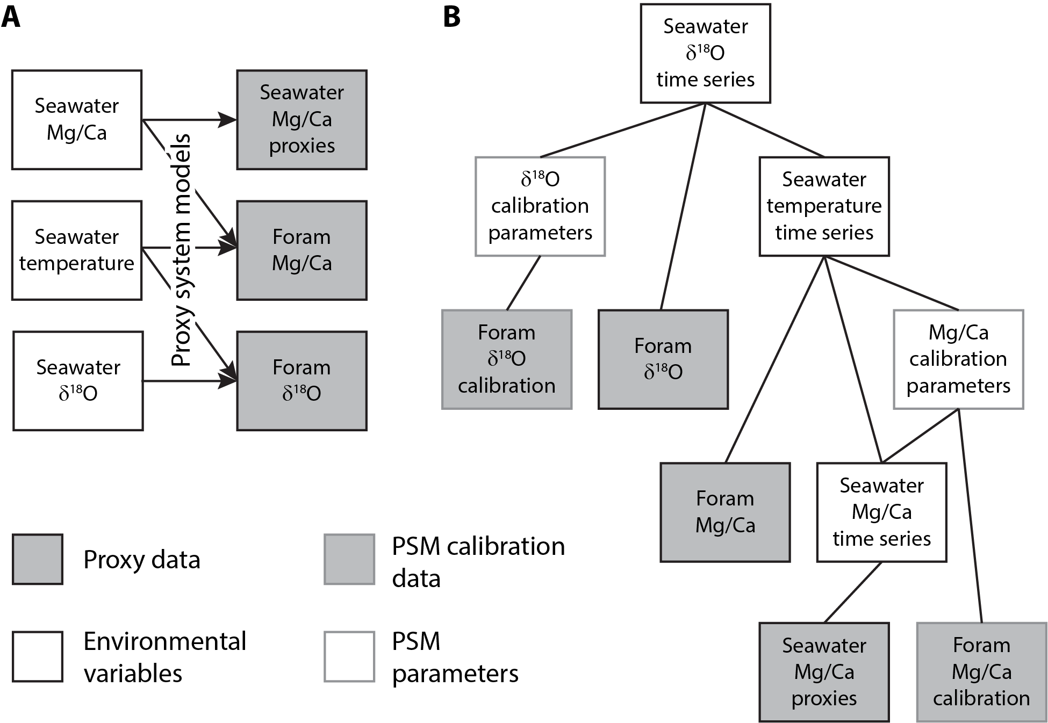

Figure 1: Schematic representations of the coupled Mg/Ca and δ18O proxy systems. A) Forward-modeling framework for the coupled proxy systems, showing each proxy’s dependence on environmental variables. B) Hierarchical structure of the JPI analysis for these proxy systems. Each level of the hierarchy is directly dependent on the connected underlying nodes.

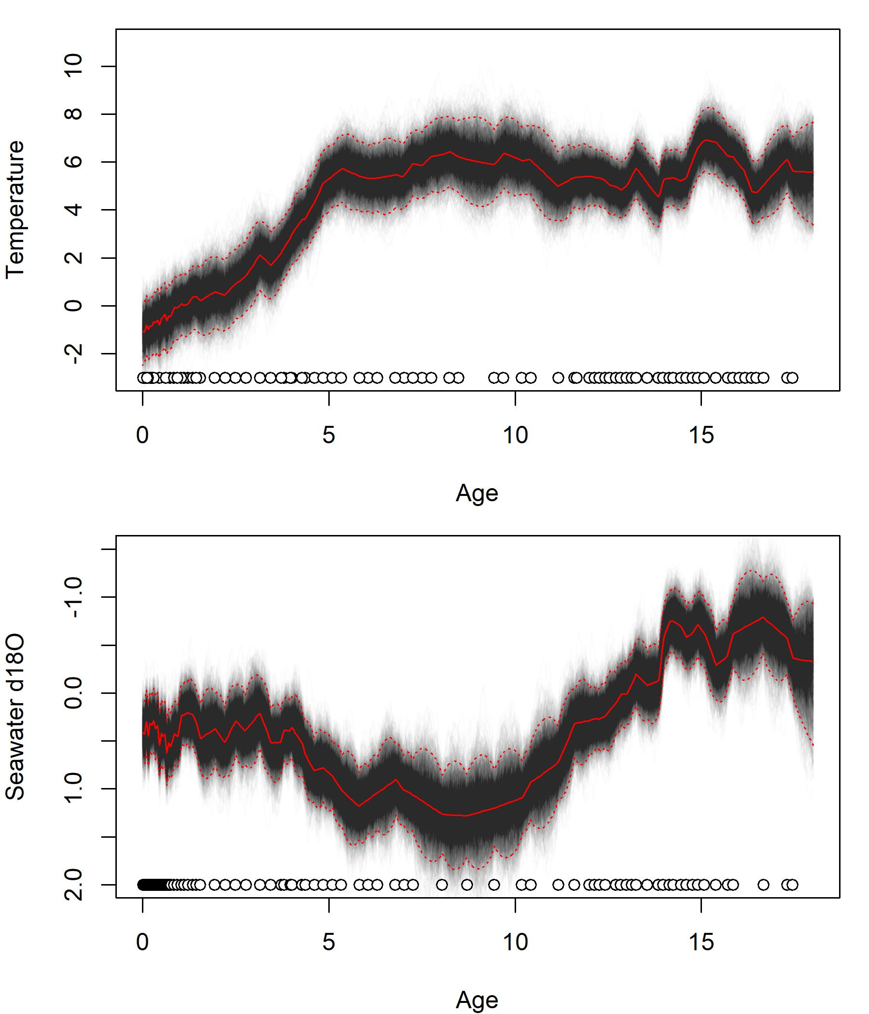

Figure 2:

Figure 3: