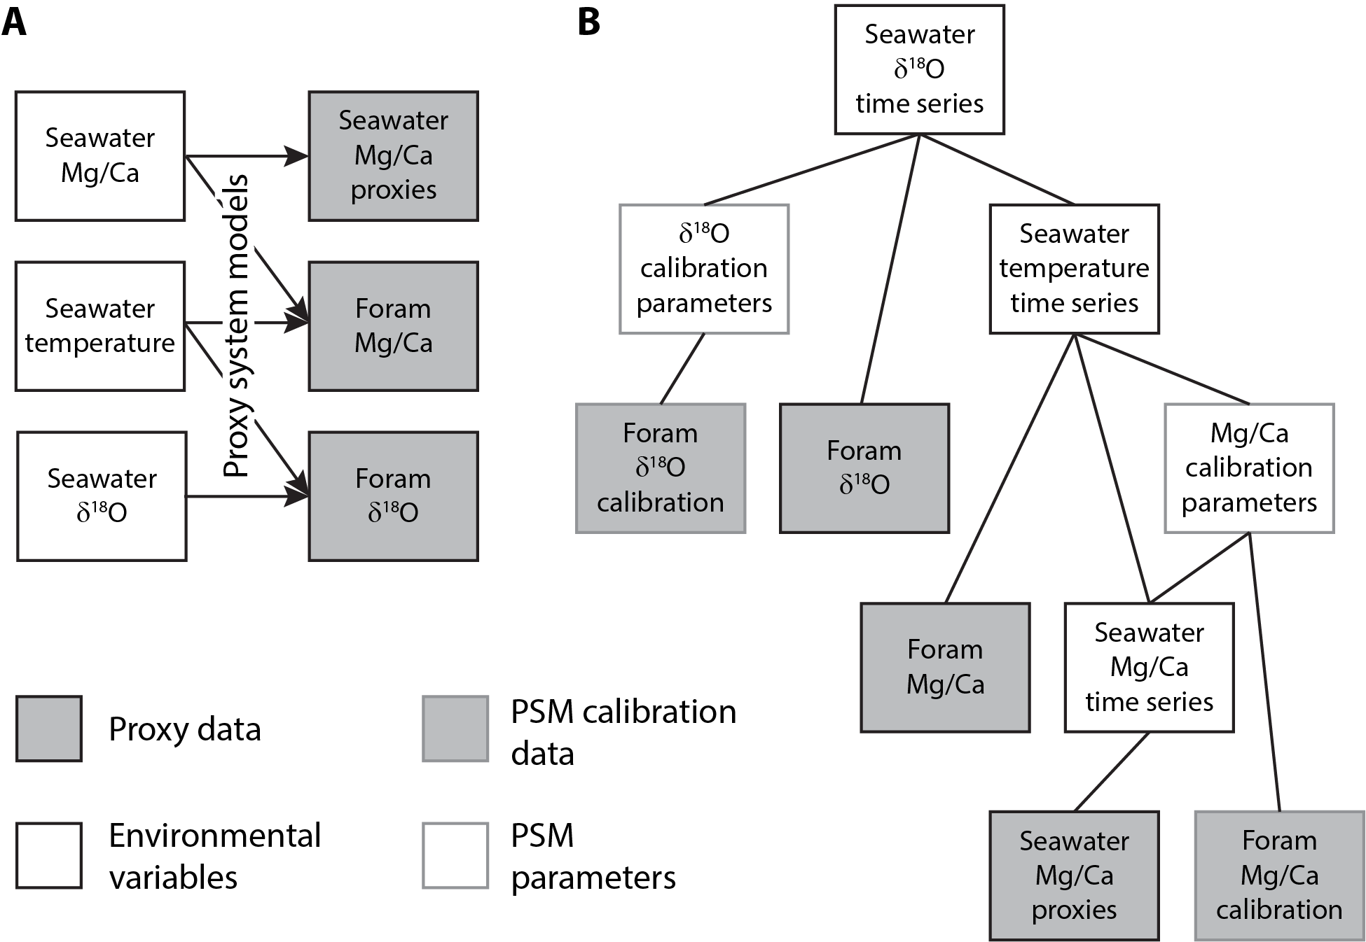

Figure 1: Schematic representations of the coupled Mg/Ca and δ18O proxy systems. A) Forward-modeling framework for the coupled proxy systems, showing each proxy’s dependence on environmental variables. B) Hierarchical structure of the JPI analysis for these proxy systems. Each level of the hierarchy is directly dependent on the connected underlying nodes.

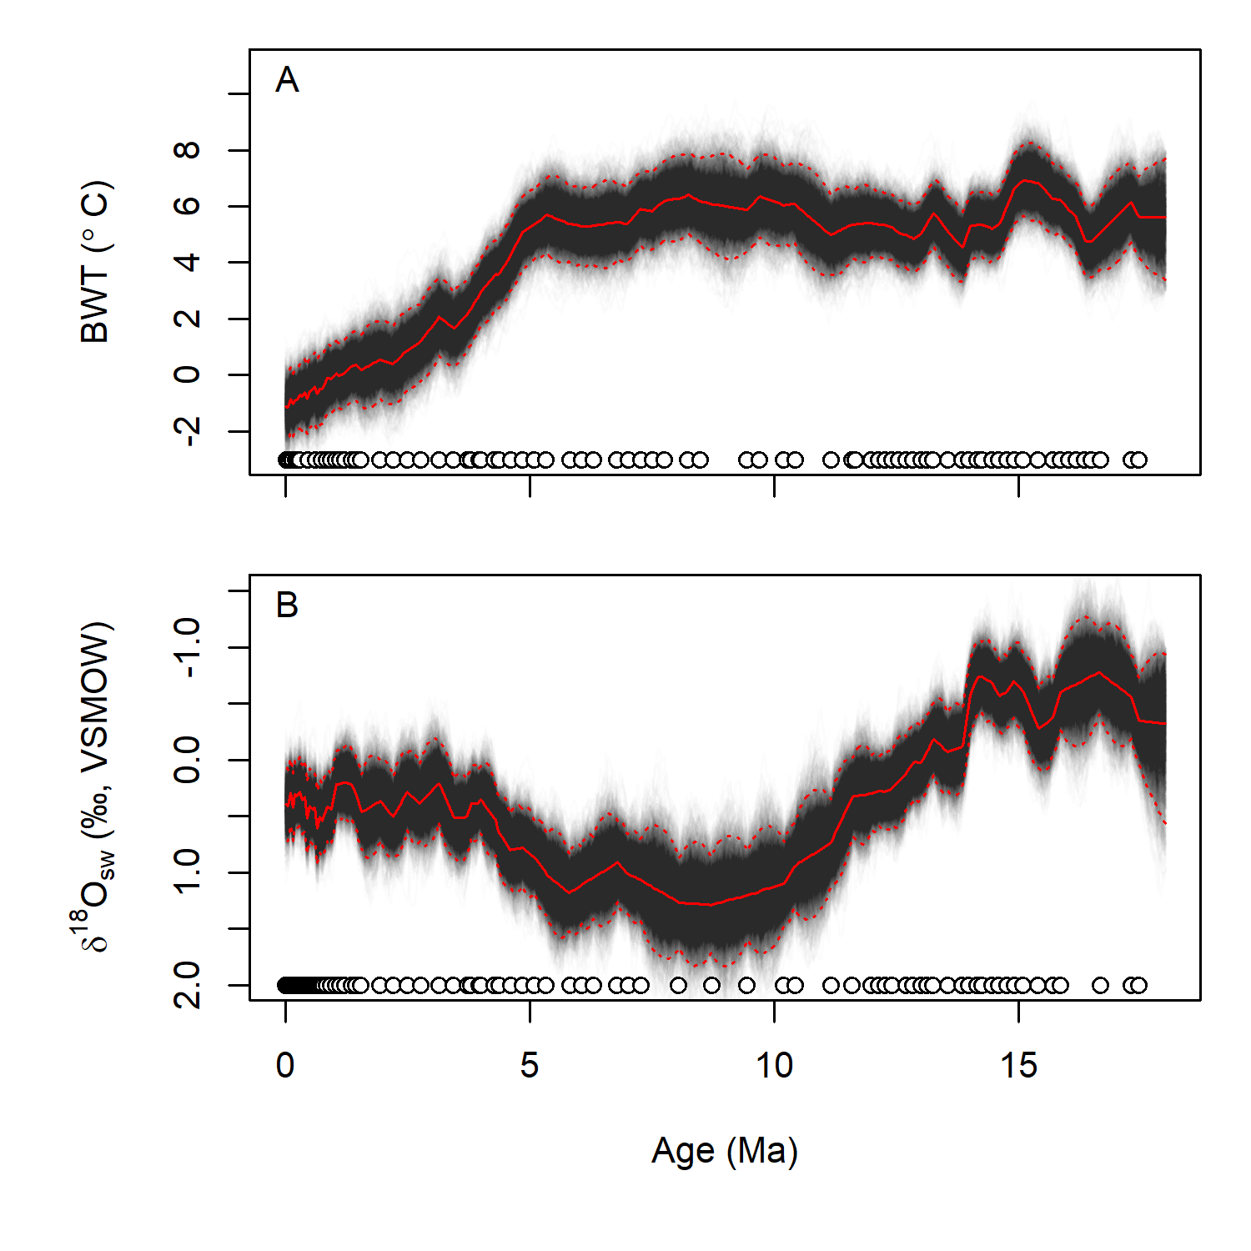

Figure 2: Reconstructed bottom water temperature (A) and seawater δ18O values since 18 Ma (B). Black lines show individual draws from the posterior distribution for each time series; red lines show the median (solid) and 95% credible intervals (dotted). Circles show the distribution of foram Mg/Ca (A) and δ18O (B) data in time.

***Broadly similar to Lear et al. Fig. 7, but a few cool things to note here… 1) Uncertainty includes all model components simultaneously and quantitatively (seawater Mg/Ca, calibrations, proxy data). Q - I have only used the linear Mg/Ca equation form here but found that they converged on the same solution space when I ran it w/ the exponential form. I could include both in the same analysis – is there a first-principles reason that the exponential form has been used? It seems like an odd/unexpected form for this relationship to me. Also, I notice that the calibrated temperatures are a ~2 C lower than in the Lear15 figure. I’ve cross-checked everything and these values are ‘right’ given the inputs used…I’m a little perplexed by the higher values in the Lear15 paper, for example the end Pleistocene foram values in the dataset are ~1.2 mmol/mol, which comparing w/ Lear15 Fig 4D would equate to a below-zero BWT. 2) All data are used, i.e. no need to have paired Mg/Ca and δ18O measurements. 3) Uncertainty is explicitly modeled at all points in the time series, so for example you see the increase in uncertainty between data points and during periods where data are more sparse (e.g., 10 to 7.5 Ma).***

***I’m not sure I see anything here that would fundamentally change our paleoclimate interpretations relative to Lear15, but thoughts/comments from those who think more about Neogene climate would be welcomed. My next step is to do some analysis of BWT/18O correlation over different timescales and time periods, as I think there may be some interesting information embedded in that.***

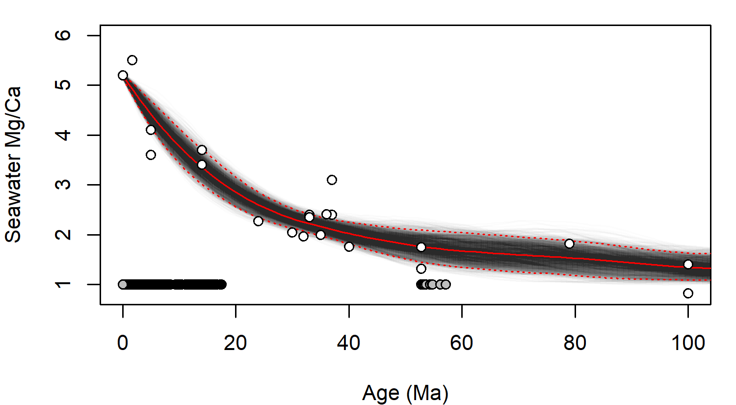

Figure 3: Reconstructed seawater Mg/Ca from 110 Ma to present. Lines as in Fig. 2. White-filled circles show individual proxy estimates, black and grey symbols at the bottom of the panel show the distribution of the foram Mg/Ca proxy data and Paleogene proxy calibration data, respectively, in time.

***Pretty self-explanatory. I’ve worked a lot on this component of the model…the challenge here is the data density and quality. Without proscribing a pretty stiff time series model (strong error autocorrelation, low error variance) you end up with extremely limited constraints and models that give wildly chaotic behavior during some periods. Fortunately, I think stiff behavior is well-justified for this system. I tried to approximate the uncertainty estimates associated with the different proxy data based on the original pubs, but in some cases these may still be a bit optimistic and a revision to them could produce a bit broader distribution of posterior models.***

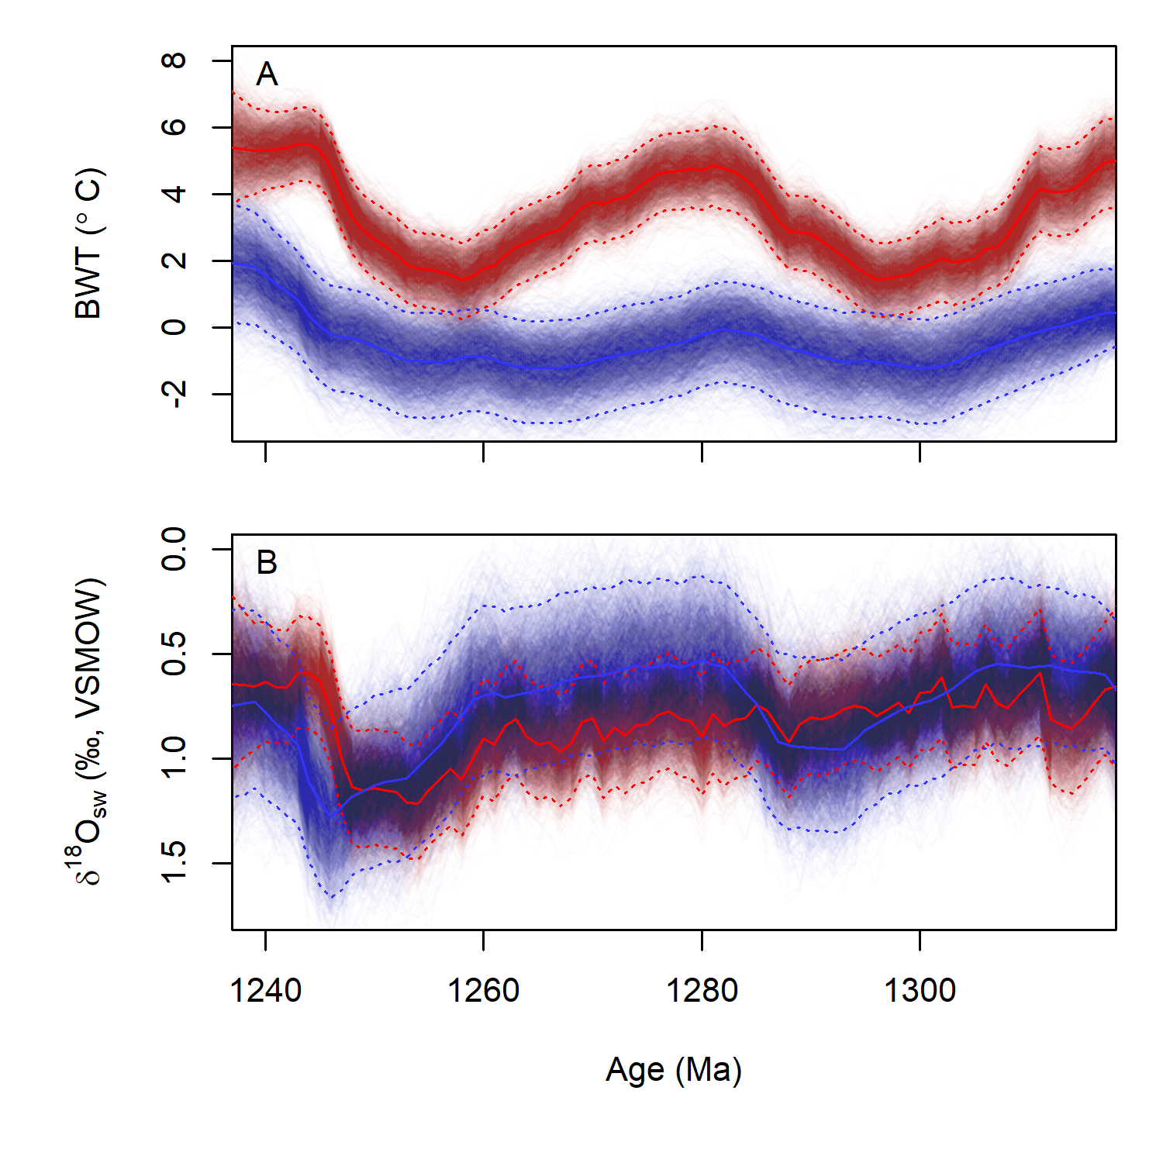

Figure 4:

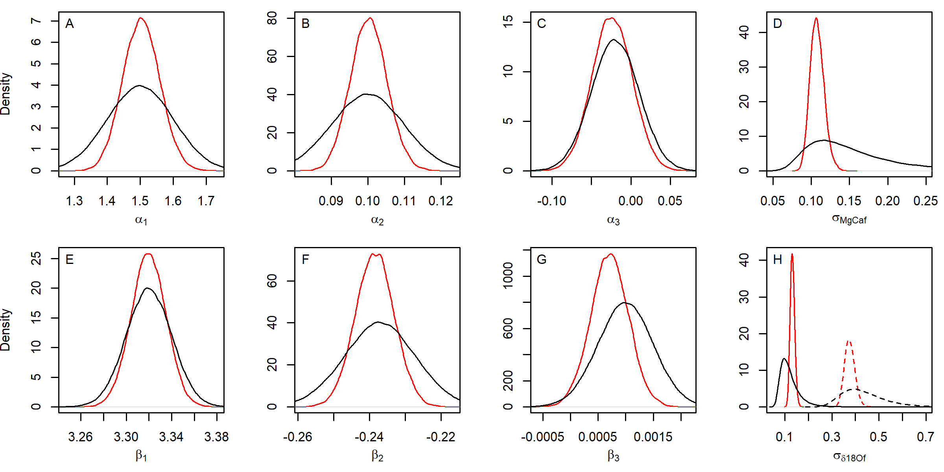

Figure 5: Prior (black) and posterior (red) distributions for foram Mg/Ca (A-D) and δ18O (E-H) proxy model parameters (ref. equations 2 and 3, respectively). Solid and dashed lines in panel H show standard deviations of the calibration relationship prior to and following the 800 ka transition, respectively.

***These panels suggest that the full inversion improves the precision of our estimates of these parameters (difference in ‘tightness’ of prior and posterior) but has a limited impact on the mean values (mostly overlapping prior and posterior).***

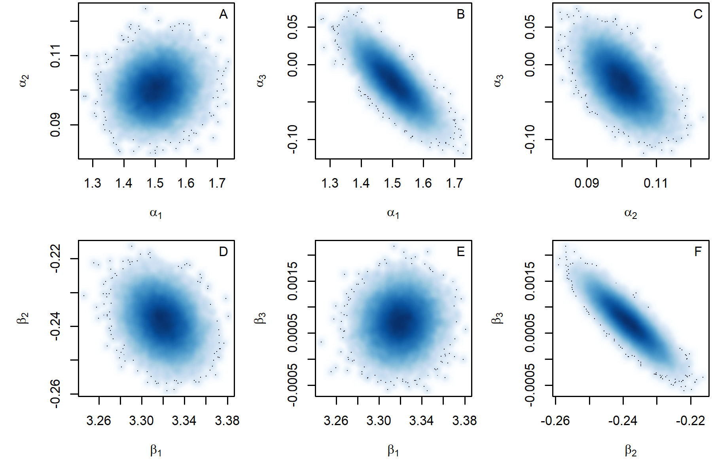

Figure 6: Bivariate density plots of the posterior distributions for Mg/Ca (A-C) and δ18O (D-F) proxy model parameters.

***A general point here is the strong covariance among parameters in both models, which means that any uncertainty estimate that uses individual model parameter uncertainties w/ accounting for the covariance will give biased estimates of uncertainty.***

***For Mg/Ca, this shows that both the constant and slope of the calibration are strongly correlated with the exponent on seawater Mg/Ca (here α3). I believe this stems from an unique juxtaposition of the equation form and the calibration dataset: 1) the Mg/Ca term in the equation is multiplicative with the temperature term and constant, and 2) the ‘hottest’ calibration data also correspond to low seawater Mg/Ca; thus if α3 is larger and thus the model more sensitive to seawater Mg/Ca change, sensitivity to BWT must be lower.***

***For δ18O the covariance is on the linear and second order temperature terms…this is just a mathematical trade off (higher second-order sensitivity must be balanced by lower first-order sensitivity).***

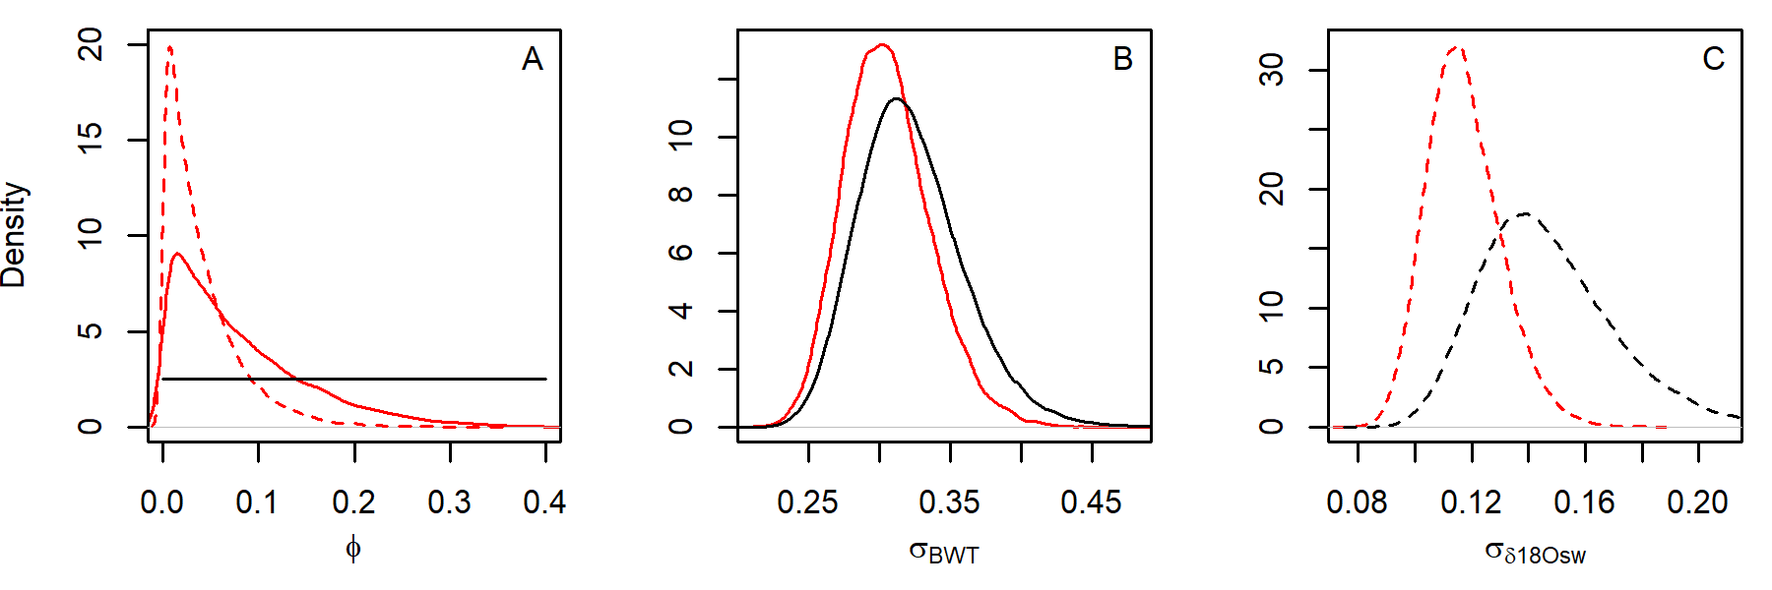

Figure 7: Do this for all 3 timeseries? Prior (black) and posterior (red) parameter distributions for bottom water temperature (*BWT*, solid) and seawater δ18O (*δ18Osw*, dashed) time series models. (A) Error autocorrelation (models for both variable used the same prior show here in solid black), (B) standard deviation of *BWT* error term, and (C) standard deviation of δ18Osw error term. ***The first plot indicates limited ‘directionality’ of change in these two parameters at the time step modeled, in other words the change in BWT over one 50kyr period is only loosely correlated with the change in the previous period. Directionality is stronger for BWT than oxygen isotopes. Panels B and C characterize the average variance of each variable at the modeled time step (i.e. standard deviation of 50kyr means), and show that the data provide a reasonably strong constraint on variance of δ18O, less so for BWT***

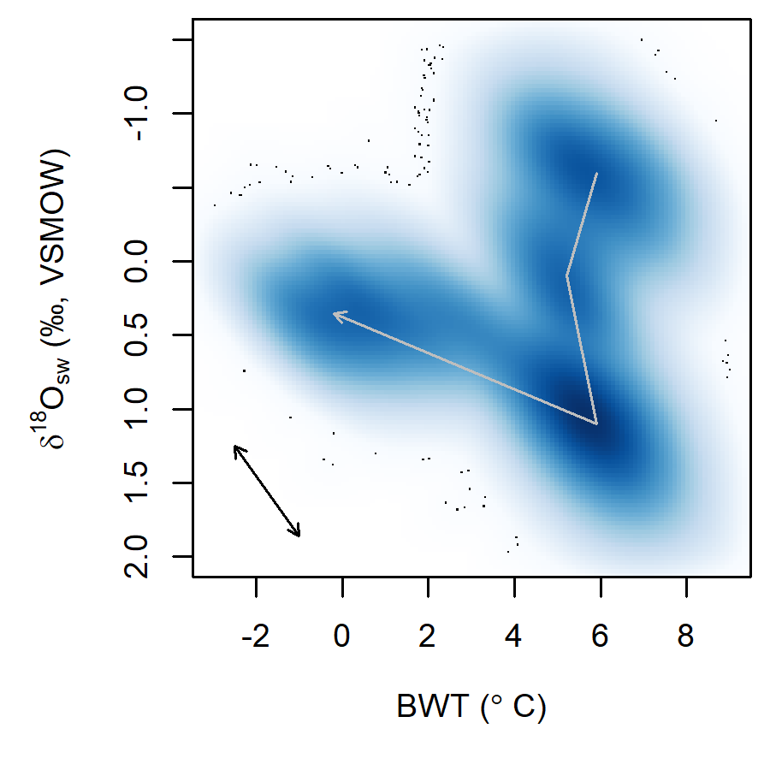

Figure 8: Bivariate density plot of posterior values from the environmental time series models. Grey arrow shows idealized trajectory of values from 18 Ma to present. Black arrow shows mean direction of correlation between BWT and δ18Osw across samples within the posterior distribution for individual time steps.

***This is just an initial exploratory look at the distributions in the time series. Definitely emphasizes that the system is jumping between 3-4 semi-stable states.***

Figure 9: Difference figure