Outline

Intro

The timing and season of pedogenic carbonate precipitation has been debated in recent years, with significant consequences to paleoclimatic inference (a few citations). Clumped isotope temperatures of modern pedogenic carbonates have found a variety of formation temperatures, relative to MAT, in different environments (Mintz, Peters, Quade, Gallagher). Usually, these temperatures are at or above MAT, indicating the well-cited warm-season bias in most environments. The main drivers of pedogenic carbonate formation are increasing temperatures, decreasing *p*CO2, root-water uptake, and evaporation; however, the relative importance of these drivers is debated (Quade, Gallagher, Meyer). Some studies invoke soil drying, lowering soil *p*CO2, while other studies suggest transpiration could play a larger role in concentration Ca ions the growing season (Gallagher, Meyer). Modelling suggests that pedogenic carbonate precipitates and dissolves in both short and long time periods, but the last precipitation event of the year is usually best preserved (Meyer). Overall, the main season and timing of pedogenic carbonate formation remains unresolved and likely varies with C3 vs. C4 vegetation and different precipitation patterns. Here, we create a model that predicts oxygen and carbonate isotope values of pedogenic carbonate in C3 ecosystems with arid to sub humid climates. We then compare predicted model results with modern studies of pedogenic carbonate that include clumped isotope temperatures to gain insight into the season and mechanisms of carbonate precipitation.

Methods

We assume pedogenic carbonate formation takes place over a 3-month season (DJF, MAM, JJA, SON), hereby referred to as the pedogenic carbonate quarter (PCQ). Here we explore a complimentary, model-based approach to evaluating the conditions of soil carbonate formation. We create a mechanistic model connecting carbon and oxygen isotope values of pedogenic carbonate to both seasonal and annual climatic drivers. We explore the effectiveness of the model with different model assumptions and its implications for the timing and mechanisms of pedogenic carbonate formation. The result is a set of hypotheses, which are discussed in depth in the next section.

Results/Discussion

Warm vs. Dry

- Compare HQ and DQ temps to clumped T estimates

- Use HQ and DQ values to model isotopes

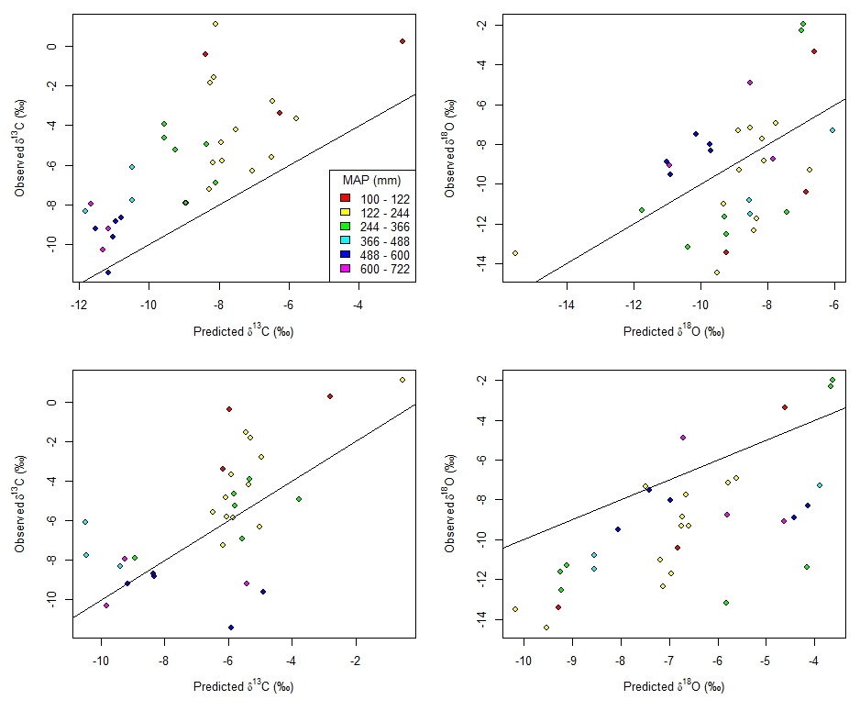

- Carbon – HQ gives tighter relationship for MAP > 100 but a systematically biased, DQ greater scatter but around the 1:1 line

- Oxygen – HQ gives an approximate normal distribution around the mean, while DQ shows a systematic bias toward more positive values, compared to measured values.

- Use clumped T estimates to inform quarter of formation

- Did this, and oxygen isotopes are ok. Using either dqp or hqt, carbon isotope values are usually too low predicted vs. measured. Used a different calibration than original you had in here – Brietenbach et. al. 2018.

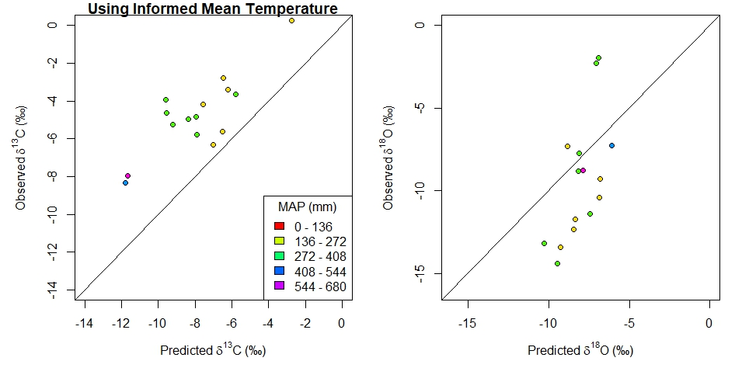

Clumped temperatures all predict warm season precipitation (under the Kelson 2017 calibration curve; this changes with other curves). Underestimates d13C and overestimates d18O, overall.

We could also work up doing clumped temperatures as the mean air temps, but that would include one very high air temp value (55C).

Discussion points/implications:

Evaporative and Seasonal Effects on Oxygen Isotope Values

- Compare measured and predicted isotope values of carbonate running model with a range of parameter values for evaporation and seasonal precipitation controls (fraction of evaporated waters and fraction of seasonal precipitation).

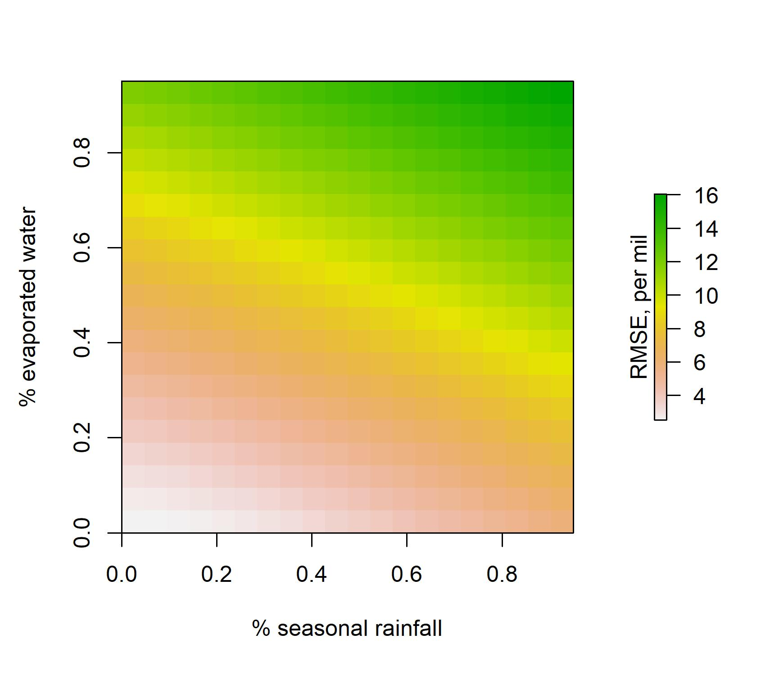

-The lowest RMSE is observed in the simulation which both are 0 (no evaporated or seasonally biased waters)

Discussion points/implications:

-Transpiration leading to upward water movement may be more important than evaporation? (e.g. Meyer). Or at 50cm or below, as we have selected samples, evaporation is not prevalent.

- Both of these processes enrich oxygen isotopes of pedogenic carbonate. If we look at the HQ and DQ plots comparing measured vs. predicted oxygen isotope values, HQ is normally distributed, but the DQ is biased toward higher values, not lower values. Therefore, neither of these processes would correct for this bias.

CO2 degassing as a mechanism of pedogenic carbonate formation

* Soil pCO2 likely too high in the model
  + Optimize the respiration equation in the model to test if consistently lower respiration rates could explain the difference between modelled and observed carbon isotope values of pedogenic carbonate given certain climatic conditions. 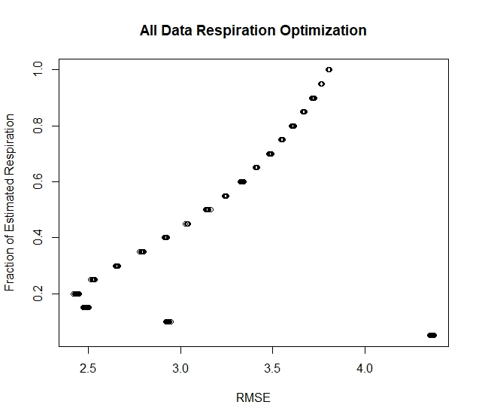

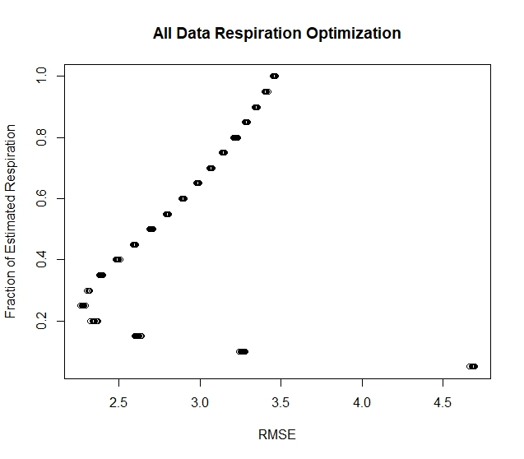

* Respiration ratio (fraction of respiration from equation) vs. RMSE
  + This seems to indicate that actual respiration rate at the time of precipitation is about 20 – 25 % (depending on clumped vs. all data) of estimated respiration rate in the warm quarter of the year.
* Could the model equation for respiration be biased for these conditions?
  + Extracted sites from the large annual respiration database where MAP < 760, then re-fit the regression using rjags. The resulting equation constants were K = 4.87 Q = 0.55 Ro = 1.24. When the HQ model is run using this regression, the RMSE for data-model comparison reduced very slightly by ~ 0.1.
* Discussion points/implications:

One interesting thing that I have been thinking, which may be out of the scope of this particular paper:

Most of these modern sites are still very low MAP (even when culling for >100mm)

Seasonal precipitation patterns likely drive carbonate formation in most envrs

For paleo-applications, at least in our PETM sites, MAP is predicted to be much higher. So, how are we creating a good model for paleo-application by testing the model with these arid to hyper-arid sites? Seasonal patterns of precipitation and carbonate formation are likely different in these sites vs. higher MAP sites.

What if we attempt to use data only from MAP > 400 mm that still have carbonate in the modern envr? There may not be many of them, but maybe would be a better analog, even if they don’t have clumped isotope temps. There could be a significant difference or “tipping point” of when sites precipitate carbonate in the summer vs. fall/spring controlled by MAP/soil water balance (which is temp, soil texture dependent as well).

Could be a target of future work: find some sites that are higher MAP, C3 dominant, and also have pedogenic carbonate with the target paleoapplication being paleosols that indicate higher MAP and are older than mid Cenozoic (C3 plants only).