Title

Authors

1 Introduction

Isotope values of pedogenic carbonates are important terrestrial climate proxies and are frequently used to infer paleotemperatures, paleoelevation, *p*CO2, and past carbon cycle perturbations (Bowen et al., 2015; Ekart et al., 1999; Garzione et al., 2000; Snell et al., 2013). However, changes in pedogenic carbonate carbon and oxygen isotope values can be difficult to interpret because their isotope values are derived from a suite of local seasonal and annual climate variables as well as global signals such as *p*CO2 and δ13CpCO2. Most paleoclimatic studies keep many of the possible environmental and climatic controls on isotope values constant to infer their target variable. Cerling (1984) described a model to predict pedogenic carbonate carbon isotope values and a version of this model has been used to calculate *p*CO2, keeping respiration rates, soil textures, and plant carbon isotope values as constants. More recently researchers have described a variety of techniques to take organic matter carbon isotope values and MAP estimates to estimate respiration rates and respired CO2 carbon isotope values; however, the need for an integrated model to include these variables is apparent, as temperatures also affect respiration rates and plant fractionation varies with precipitation and *p*CO2 (Diefendorf et al., 2010; Lloyd & Taylor, 1994; Schubert & Jahren, 2012). Oxygen isotope values of pedogenic carbonate have been used to infer terrestrial temperatures and elevations (citations). However, this estimation is probably oversimplified as soil water evaporation and seasonal variations in precipitation oxygen isotope values are often ignored in these estimates. Some of the environmental controls on oxygen isotope values of pedogenic carbonate, such as temperature, precipitation and soil texture, are shared with carbon isotope values.

The timing and season of pedogenic carbonate precipitation has also been debated in recent years, with significant consequences to paleoclimatic inference (Breecker et al., 2009; Passey et al., 2010; Peters et al., 2013; Quade et al., 2013). Modeling suggests that pedogenic carbonate precipitates and dissolves in both short and long time periods, but the last precipitation event of the year is usually best preserved (Meyer et al., 2014). Clumped isotope temperatures of modern pedogenic carbonates have found a variety of formation temperatures, relative to MAT, in different environments (Gallagher & Sheldon, 2016; Mintz et al., 2011; Peters et al., 2013; Quade et al., 2013). These temperatures are usually at or above MAT, indicating a warm-season bias in most environments, but can vary significantly with the calibration curve used to calculate the temperatures. Thus, clumped isotope measurements cannot fully be relied on to infer the timing or season of carbonate formation. The main drivers of pedogenic carbonate formation are increasing temperatures, decreasing *p*CO2, root-water uptake, and evaporation; however, the relative importance of these drivers is currently unknown (Gallagher & Sheldon, 2016; Meyer et al., 2014; Quade et al., 2013).

With many parameters that affect carbon and oxygen isotope values of pedogenic carbonate, a competent evaluation of what models the modern data best is needed to fully interpret the significance of these important paleoclimatic proxies. In order to conduct this evaluation, we create a model that predicts spatial variation in oxygen and carbonate isotope values of pedogenic carbonate in C3-dominant ecosystems with MAP > 100 mm to best emulate non-hyper arid paleoclimatic environments before the rise of C4 plants. After initially evaluating the effectiveness of the base model, the model is further optimized for modern C3 environments by minimizing errors with respect to respiration rates, evaporation, and seasonal precipitation.

2.1 Methods

We assume pedogenic carbonate formation takes place over a 3-month season (DJF, MAM, JJA, SON), hereby referred to as the pedogenic carbonate quarter (PCQ). This paper explores a complimentary, model-based approach to evaluating the conditions of soil carbonate formation, creating a mechanistic model connecting δ13Ccarbonate and δ18Ocarbonate to both seasonal and annual climatic drivers.

All isotope ratios are reported as δ values in units of permil (‰), normalized to a standard value with the following equation:

\* 1000 (1)

where Ri is the isotope ratio of the substance of interest, and Rs is the isotope ratio of the standard.

2.2 Mechanistic Model

2.2.1 Carbon

2.2.1.1 Photosynthesis

Soil carbonate carbon originates from a combination of atmospheric CO2 and respired CO2 (Fig. 3). Respired CO2 reflects plant carbon isotope values (δ13Cplant), which are a function of atmospheric CO2 isotope ratios and photosynthetic fractionation (Δ13Cplant):

. (2)

Photosynthetic fractionation has been observed to vary with both precipitation and *p*CO2 (Diefendorf et al., 2010; Schubert & Jahren, 2012). C3 plants were the dominant plant type before ~ 5 – 10 Ma (Sage, 2004), and thus we use empirical data for C3 plants to express the sensitivity of plant isotope discrimination to atmospheric *p*CO2 and mean annual precipitation:

, (3)

where

. (4)

Equation 3 is based on experimental data of Schubert and Jahren (2012), and equation 4 provides a correction for water limitation based on a synthesis of observational data (Diefendorf et al., 2010). A normally distributed uncertainty with 1σ = 1.1 ‰ is applied to Δ13Cplant, calculated from the average residuals of the correlation by Shubert and Jahren (2012), and a normally distributed uncertainty with 1σ = 1.5 ‰ is applied to ΔΔ13Cwater limitation, based on the reported average residual of the relationship by Diefendorf et. al. (2012).

2.2.1.2 Respiration

Organic matter respired in soils and plant roots contributes to the soil CO2 pool. We calculate respiration rate (R, gC m-2 d-1) as a function of precipitation and temperature, based on data from modern soils summarized by Raich et al. (2002):

(5)

where R0 represents the basal soil respiration rate at 0 °C with no moisture limitation (1.25 gC m-2 d-1), Q and K are constants (0.05452 °C-1 and 127.77 mm, respectively). The compilation of respiration rate studies that were used to create this regression span a variety of environments and is more sensitive to precipitation compared to other studies, usually underestimating respiration rates in hyper-arid environments with zero rainfall estimating zero respiration (Reichstein et al., 2003; Raich et al., 2002). A beta distributed uncertainty with 1σ = 1.05 gC m-2 d-1 is applied to R, calculated from the average residuals of respiration and climate data from sites that were excluded from the original regression (Raich et. al. 2002). If a decrease in soil *p*CO2 is a main mechanism to carbonate precipitation, the mean respiration rate could be significantly higher than the respiration rate during carbonate precipitation events. To optimize the model to this potential mechanism, we add a respiration fraction (Rf) between 0 and 1 to represent the fraction of estimated respiration, calculated in Equation 5, that best fit the carbon isotope values of the pedogenic carbonates.

2.2.1.3 Diffusion

Gas-phase diffusion through the soil profile affects both concentrations and isotope ratios of soil CO2. The diffusion coefficient for CO2 in soil (*DC*) is given by:

, (6)

where

Dair = 0.1369 \* (TmPCQ / 273.15)1.921 (7)

and ϵ is free air porosity, *p* is soil tortuosity, and *Dair* is the diffusion coefficient for carbon dioxide in air, based on TmPCQ, in K (Massman, 1998; Cerling, 1984). A normally distributed error with 1σ = 8.1 \* 10-4 cm2 s-1 is applied to Dair, based on the reported standard deviation of the relationship (Massman, 1998). The diffusion coefficient for 13CO2 (D13C) is 0.995577 times that of bulk CO2 (Cerling, 1984; Craig, 1953).

We adopt a simple approximation of free air porosity (ϵ) as a function of soil porosity (ɸ) and the ratio of actual evapotranspiration (AET, mm quarter-1) to precipitation during the PCQ:

, (8)

where porosity (ɸ) is normally distributed with mean 0.46 and 1σ = 0.1 and tortuosity (p) is normally distributed with mean 0.7 and 1σ = 0.1.

We estimate AET from potential evapotranspiration (PET, mm d-1), where PET is given by a well-established function of thermal and solar radiation energy terms (Turc, 1961):

, (9)

where:

, (10)

Rs is solar radiation in MJ m-2 d-1, and RH is mean relative humidity in %. A normally distributed uncertainty with 1σ = 23.4 mm quarter-1 is applied to PET, based on the root means squared error in Kashyap & Panda (2001), and consistent with the variability of the relationship as validated in a range of modern settings (Alexandris et al., 2008; Fisher & Pringle III, 2013; Kashyap & Panda, 2001; Kisi, 2007; Lu et al., 2005).

Average surface-level relative humidity (*h*) during the carbonate precipitation quarter is estimated from an empirical spatial relationship for the modern climate (Derbyshire et al., 2004):

, (11)

where minimum and maximum *h* values specified by the coefficients are based on world-wide data on average JJA relative humidity (Dai, 2006). A beta distributed uncertainty with 1σ = 0.05 is applied to *h*, based on the observed standard deviation of JJA humidity measurements about this relationship (Dai, 2006).

To estimate Rs for equation 9, we use the Hargreaves and Samani (1982) equation,

, (12)

with the constant KT set at 0.16 and TD (daily temperature range) assumed constant at 12 °C, to calculate average solar radiation reaching Earth’s surface (Rs, MJ m-2 d-1) in the pedogenic carbonate precipitation quarter (Samani, 2000). Equation 11 is used to obtain an estimate of Rs for the latitudes of the sites based on modern total radiation at the top of the atmosphere (Ra) at the site latitudes in JJA (Hartmann, 2015). Error in Rs is considered when applying error to PET.

We calculate actual evapotranspiration (AET, mm quarter-1) from PET (mm quarter-1) and precipitation rate using a Budyko Curve framework, as described by Pike (1964):

. (13)

A normally distributed uncertainty with 1σ = 25 mm quarter-1 is applied to AET, based on the estimated +/- 10 % variability of the relationship (Gentine et al., 2012).

2.2.1.4 Soil CO2

Soil CO2 isotope ratios are calculated as a function of soil depth (*z*, cm) according to Cerling (1984):

, (14)

where:

(15)

and L is a constant set at 100 cm, the soil depth below which there is no change in the *p*CO2 of soil air with progressive soil depth.

2.2.1.5 Mineral Precipitation

The depth (zt, cm) from the soil surface to carbonate formation is necessary to calculate both C and O isotope values of pedogenic carbonate. We adopt an empirical relationship for depth to the top of the pedogenic carbonate formation horizon (Retallack, 2005):

(16)

Then, the average depth of carbonate formation is found, using PPCQ as a proxy for seasonality of precipitation (Retallack, 2005):

z = zt + abs[(PPCQ – Pa / 4) \* 0.74 + 17.4] / 2

We restrict *z* to > 100 cm, based on the assumption that isotope values of pedogenic carbonates precipitated at a depth of 100 cm (L) are similar to those precipitated deeper in the soil column. A beta distribution with 1σ = 20 cm is applied to *z*, calculated from the average residuals of the data from Retallack (2005).

The δ13Ccarbonate value is calculated assuming isotopic equilibrium with soil CO2:

, (17)

where αCO2-carbonate is the fractionation factor from CO2 to carbonate, TmPCQ is in °C, and we assume soil temperature to be approximately equal to air temperatures (Romanek et al., 1992).

2.2.2 Oxygen

2.2.2.1 Precipitation

Oxygen isotope compositions of meteoric precipitation, sometimes modified by evaporation (quantified by the model in equation 26), directly influence soil water and carbonate δ18O values. We test the assumption that soil water from which carbonate forms is originally sourced from precipitation with a composition equal to annual average precipitation with equation 19, adding a term in for seasonal rainfall based on seasonal temperatures. We use precipitation isotope data from the GNIP database to obtain a spatial relationship between temperature and precipitation to calculate the site-specific δ18Op values (GNIP database, accessed 2018):

. (18)

. (19)

Many other factors can influence δ18Op including changes in precipitation sources, distance from the coast, the amount effect, changes in seasonal precipitation (discussed in section #.#.#), and recycling. A large normally distributed uncertainty with 1σ = 1.7 ‰ is applied to δ18Op, based on the standard deviation of the regression.

2.2.2.2 Evaporation

Evaporation can alter the oxygen isotope ratio of soil waters, thus affecting the oxygen isotope values of pedogenic carbonate. In order to test the potential effects of evaporation on oxygen isotope values of pedogenic carbonate, we first estimate soil evaporation rate (E, mm quarter-1) from AET and the ratio of soil evaporation to transpiration (ETR),

, (20)

where we use a value of ETR = 0.06 based on an estimate for global modern ecosystem water fluxes (Good et al., 2015; Jasechko et al., 2013). A beta distributed error with 1σ = 0.04 is applied to ETR, based on the standard deviation of modern ecosystems worldwide calculated by Good et. al. (2015).

2.2.2.3 Diffusion

How fast water diffuses from the surface of the soil into lower depths affects the shape of the water oxygen isotope value curve with soil depth. The effective diffusivity of water molecules in the soil column (DO, m2 s-1) is calculated using an equation from (Barnes & Allison, 1983)

(21)

where,

Dw = 1.635 \* 10-8 \* (TmPCQ / 215.05 – 1)2.063. (22)

and Dw is the effective diffusivity of water in porous media, which is dependent on TmPCQ, in K (Holz et al., 2000). The difference in diffusion between H218O and H216O during evaporation, referred to as the diffusion ratio factor (DRF), is calculated as:

(23)

where n is a diffusion factor associated with the amount of turbulence over the saturated soil column (0.8), and Dratio is the constant difference of diffusivities between H218O and H216O (1.028; Merlivat 1978; Barnes and Allison 1983).

2.2.2.4 Soil Water

The isotope value of surface soil water (18O/16Osurface water), the point of maximum 18O-enrichment in the soil water profile, is calculated as:

(24)

(Barnes & Allison, 1983). The isotope ratio of atmospheric vapor (δ18Oatm) is assumed to be in temperature-dependent equilibrium with mean annual precipitation according to the fractionation factor:

, (25)

where TmPCQ here is in K (Horita & Wesolowski, 1994).

The soil water isotope ratio (18O/16Osoil water) varies as a function of soil depth (here in meters) according to:

, (26)

where

(27)

(Barnes & Allison, 1983). E is converted to m s-1, *zi* is the mean penetration depth of evaporation (m), below which the soil water will be unaffected by evaporation and z is carbonate precipitation depth calculated above (equation 16). An added equation is given in an optimization test in both warm and dry quarters to estimate the fraction of evaporated waters in the pedogenic carbonates:

18O/16Osoil water = fevap \* 18O/16Osoil water evap + (1 - fevap) \* 18O/16Op (28)

2.2.2.5 Mineral Precipitation

The isotope value of pedogenic carbonate is assumed to be in isotopic equilibrium with soil water at depth *z*, according to:

, (28)

where TmPCQ is in K (Kim & O’Neil, 1997).

We explore the effectiveness and possible optimization of this model with different model assumptions and its implications for the timing and mechanisms of pedogenic carbonate formation. Gridded climate data are obtained for each site from the WorldClim global climate model (citation). The result is a set of hypotheses, which are discussed in depth in section.

Results/Discussion

Carbonate saturation is reached when pCO2 decreases, temperature increases and/or there is rapid evaporation. Therefore, hot and/or dry conditions have been suggested to facilitate pedogenic carbonate precipitation, with the relative importance of these conditions debated. Examining model results when it is run in hot quarter and dry quarter conditions reveals that carbon isotope values more closely match the one to one line in the dry quarter, while oxygen isotope values more closely match the one to one line in the hot quarter. No clear support for one season over the other. Even in the hot quarter, the model is overestimating the oxygen isotope values of pedogenic carbonate, indicating that we may have to include seasonal biasing in precipitation (toward winter) or evaporation may not be very influential in these carbonates. More revisions need to be developed in the model to fully match either hot or dry season.

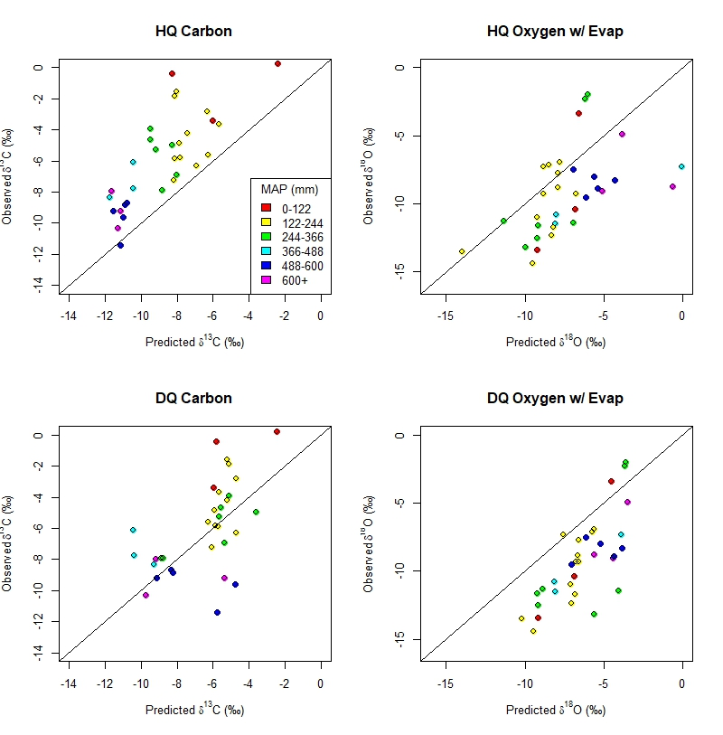

\*Side Note\*

Given that the model does not fully resolve season of formation, clumped temperatures might be useful to help inform the season of carbonate formation. Comparing gridded climate temperatures of hot and dry seasons to clumped temperatures reveals that, while there is significant variation and calibration curves affect the clumped temperatures, overall hot season temperatures are preferred in clumped temperature calculations. However, this is far from definitive because of the aforementioned issues with clumped temperature calculations.

clumped: 17.71 +/- 12.34 °C (Kelson 2017 calibration)

dry: -0.22 +/- 5.72 °C

hot: 7.02 +/- 1.61 °C

If a decrease in respiration rate is a significant mechanism of carbonate precipitation, this would greatly affect the interpreted climatic signals, given that the mean respiration rate would not be equal to the respiration rate at the time of carbonate formation. When the hot quarter is assumed to be the season of carbonate precipitation, the optimal respiration rate is actually only ~20% of the estimated respiration rate calculated in the model equation. This could indicate: 1) dry season is the season of formation, which is optimized ~ 50% to 100%, 2) the model equation overestimates the influence of temperature on respiration rate or, 3) pedogenic carbonate precipitates during short periods of low respiration rate, not reflecting mean respiration rate during the hot quarter. The third option would indicate that respiration rate could play a dominant role in facilitating pedogenic carbonate precipitation.

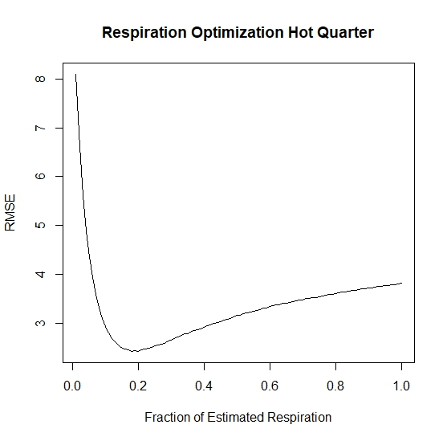

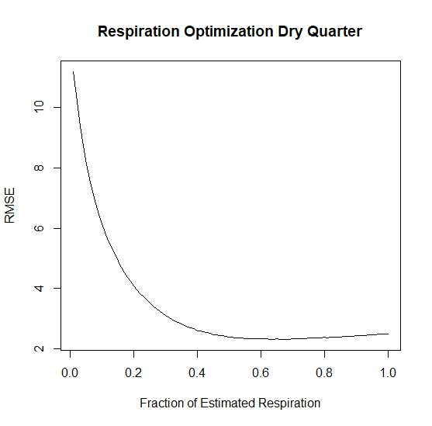

Lower MAP could affect the relationship between soil respiration and climate (temperature and precipitation).

Q: Does filtering respiration sites for lower MAP affect the relationship between respiration rate and climate?

A: Run the JAGS model for the filtered sites (annual respiration, MAP < 760 mm)

R: This filtering affects it only slightly, with a small increase in the effect of precipitation and temperature and small decrease in basal respiration rate. K from 4.25 to 4.87 and Q from 0.054 to 0.055. R0 from 1.25 to 1.24.

I: The very small change in these parameters does not appreciably affect any results so the relationship holds at low precipitation regimes.

Seasonal rainfall and evaporation have been proposed to significantly affect oxygen isotope values of pedogenic carbonate. The best fit of the model in the dry quarter indicates that there is no influence of these two processes. The effects of evaporation and seasonal rainfall on d18O values of pedogenic carbonate have been proposed to complicate the relationship between d18O of mean annual precipitation and d18O of pedogenic carbonate.

Q: Do evaporation and/or seasonal rainfall significantly affect d18O values of pedogenic carbonate?

A: Run the model with successively increasing amounts of seasonal rainfall bias and evaporative effects.

R: RMSE of predicted vs. measured d18O is lowest with no seasonal rainfall bias and no evaporative effects.

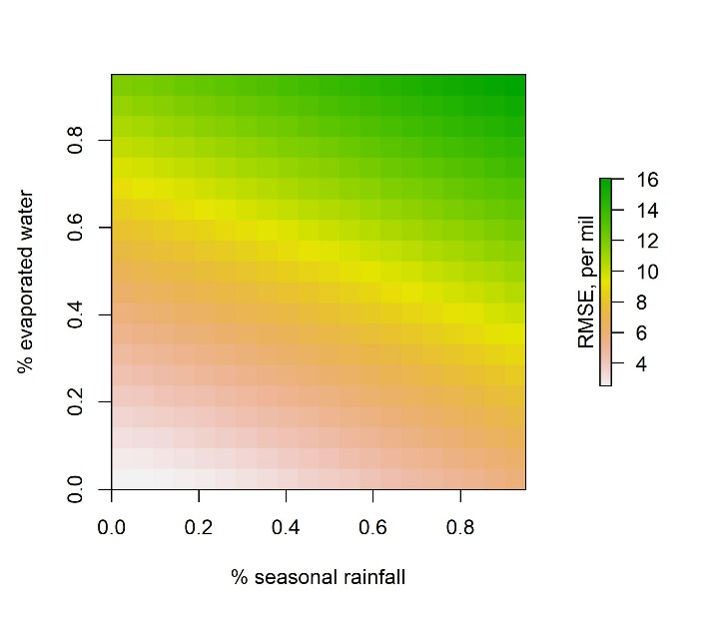

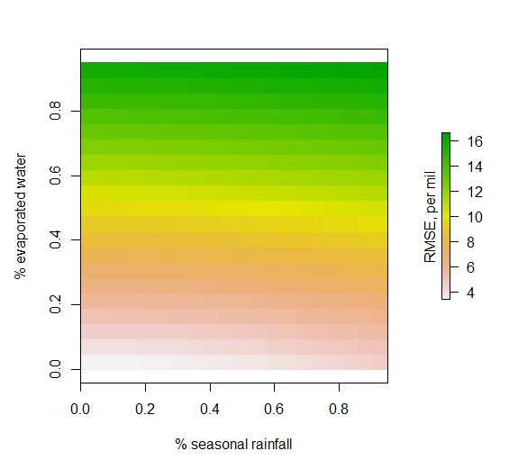

I: Therefore, d18O seems to be most influenced by MAT and temperature of formation, with minimal influence of evaporation or seasonal rainfall.

Comparison w/ no evap

Transpiration leading to upward water movement may be more important than evaporation? (e.g. Meyer).

One interesting thing that I have been thinking, which may be out of the scope of this particular paper:

Most of these modern sites are still very low MAP (even when culling for >100mm)

Seasonal precipitation patterns likely drive carbonate formation in most envrs

For paleo-applications, at least in our PETM sites, MAP is predicted to be much higher. So, how are we creating a good model for paleo-application by testing the model with these arid to hyper-arid sites? Seasonal patterns of precipitation and carbonate formation are likely different in these sites vs. higher MAP sites.

What if we attempt to use data only from MAP > 400 mm that still have carbonate in the modern envr? There may not be many of them, but maybe would be a better analog, even if they don’t have clumped isotope temps. There could be a significant difference or “tipping point” of when sites precipitate carbonate in the summer vs. fall/spring controlled by MAP/soil water balance (which is temp, soil texture dependent as well).

Could be a target of future work: find some sites that are higher MAP, C3 dominant, and also have pedogenic carbonate with the target paleoapplication being paleosols that indicate higher MAP and are older than mid Cenozoic (C3 plants only).