Dual Isotope Model of Pedogenic Carbonate

Brenden Fischer-Femal1 and Gabriel Bowen1

1University of Utah

1 Introduction

Isotope values of pedogenic carbonates are important terrestrial climate proxies and are frequently used to infer paleotemperatures, paleoelevation, *p*CO2, and past carbon cycle perturbations (Bowen et al., 2015; Ekart et al., 1999; Garzione et al., 2000; Snell et al., 2013). However, changes in pedogenic carbonate carbon and oxygen isotope values can be difficult to interpret because their isotope values are derived from a suite of local seasonal and annual climate variables as well as global signals such as *p*CO2 and the carbon isotope value of atmospheric CO2 (δ13C*p*CO2). Cerling (1984) described a model to predict pedogenic carbonate carbon isotope values and a version of this model has been used to calculate *p*CO2, keeping respiration rates, soil textures, and plant carbon isotope values as constants (Cerling 1991). Most paleoclimatic studies keep variables associated with environmental and climatic controls on isotope values constant to infer their target variable, typically *p*CO2 or paleoelevation (*e.g.* Ekart 1999). More recently, researchers have described a variety of techniques to take organic matter carbon isotope values and MAP estimates to estimate respiration rates and respired CO2 carbon isotope values; however, the need for an integrated model to include these variables is apparent, as temperatures also affect respiration rates and plant fractionation varies with precipitation and *p*CO2 (Diefendorf et al., 2010; Lloyd & Taylor, 1994; Schubert & Jahren, 2012). Oxygen isotope values of pedogenic carbonate have been used to infer terrestrial mean annual temperatures and paleoelevations (e.g. Dworkin et. al. 2005). However, this estimation could be oversimplified because soil water evaporation and seasonal variations in precipitation oxygen isotope values are often ignored in these estimates, which could affect oxygen isotope values of pedogenic carbonate (Breecker et al., 2009; Quade et al., 1989). Examining various controls on carbon and oxygen isotope values reveals there is a set of climatic and soil texture factors that can affect both carbon and oxygen isotope values of pedogenic carbonate. Therefore, these proxies should be interpreted together to improve overall climate reconstruction.

The timing and season of pedogenic carbonate precipitation has been debated in recent years, with significant consequences to paleoclimatic inference (Breecker et al., 2009; Passey et al., 2010; Peters et al., 2013; Quade et al., 2013). The main drivers of pedogenic carbonate formation are increasing temperatures, decreasing *p*CO2, root-water uptake, and evaporation; however, the relative importance of these drivers is currently unknown (Gallagher & Sheldon, 2016; Meyer et al., 2014; Quade et al., 2013). Modeling suggests that pedogenic carbonate precipitates and dissolves in both short and long time periods, but the last precipitation event of the year is usually best preserved (Meyer et al., 2014). Clumped isotope temperatures of modern pedogenic carbonates have found a variety of formation temperatures, relative to mean annual temperature, in different environments (Gallagher & Sheldon, 2016; Mintz et al., 2011; Peters et al., 2013; Quade et al., 2013). These temperatures are usually at or above mean annual temperature, indicating a warm-season bias in most environments, but can vary significantly with the calibration curve used to calculate the temperatures (Kelson et al., 2017). Thus, clumped isotope measurements cannot fully be relied on to infer the timing or season of carbonate formation.

Given that many climate and soil texture parameters affect carbon and oxygen isotope values of pedogenic carbonate, a competent evaluation of the relative magnitude of the main controls is needed to fully interpret the significance of these important paleoclimatic proxies. In order to conduct this evaluation, we create a model that predicts spatial variation in oxygen and carbonate isotope values of pedogenic carbonate in C3-dominant ecosystems with MAP > 100 mm to best emulate non-hyper arid paleoclimatic environments before the rise of C4 plants. We assume that pedogenic carbonates form in either the hot or dry season and results are calculated for both seasons. After initially evaluating the effectiveness of the base model, the model is further optimized for modern C3 environments by minimizing errors with respect to respiration rates, evaporation, and seasonal precipitation. The result is an optimized model that estimates both carbon and oxygen isotope values of pedogenic carbonate from climate data with comprehensive error propagation.

2.1 Methods

We assume pedogenic carbonate formation takes place over a 3-month season (DJF, MAM, JJA, SON), hereby referred to as the pedogenic carbonate quarter (PCQ). This paper explores a complimentary, model-based approach to evaluating the conditions of soil carbonate formation, creating a mechanistic model connecting δ13Ccarbonate and δ18Ocarbonate to both seasonal and annual climatic drivers.

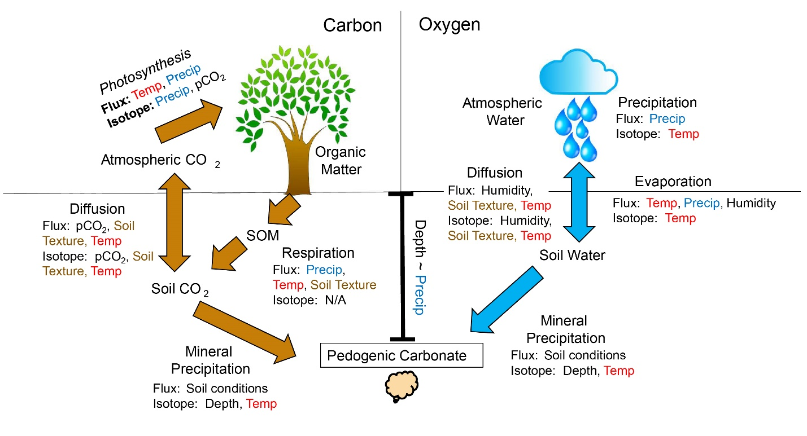

Figure 1. Conceptual framework of the coupled carbon and oxygen isotope system in pedogenic carbonate. Colors indicate shared climatic/soil texture drivers.

All isotope ratios are reported as δ values in units of permil (‰), normalized to a standard value with the following equation:

\* 1000 (1)

where Ri is the isotope ratio of the substance of interest, and Rs is the isotope ratio of the standard.

2.2 Mechanistic Model

2.2.1 Carbon

2.2.1.1 Photosynthesis

Soil carbonate carbon originates from a combination of atmospheric CO2 and respired CO2 (Fig. 3). Respired CO2 reflects plant carbon isotope values (δ13Cplant), which are a function of atmospheric CO2 isotope ratios and photosynthetic fractionation (Δ13Cplant):

. (2)

Photosynthetic fractionation has been observed to vary with both precipitation and *p*CO2 (Diefendorf et al., 2010; Schubert & Jahren, 2012). C3 plants were the dominant plant type before ~ 5 – 10 Ma (Sage, 2004), and thus we use empirical data for C3 plants to express the sensitivity of plant isotope discrimination to atmospheric *p*CO2 and mean annual precipitation:

, (3)

where

. (4)

Equation 3 is based on experimental data of Schubert and Jahren (2012), and equation 4 provides a correction for water limitation based on a synthesis of observational data (Diefendorf et al., 2010). A normally distributed uncertainty with 1σ = 1.1 ‰ is applied to Δ13Cplant, calculated from the average residuals of the correlation by Shubert and Jahren (2012), and a normally distributed uncertainty with 1σ = 1.5 ‰ is applied to ΔΔ13Cwater limitation, based on the reported average residual of the relationship by Diefendorf et. al. (2012).

2.2.1.2 Respiration

Organic matter respired in soils and plant roots contributes to the soil CO2 pool. We calculate respiration rate (R, gC m-2 d-1) as a function of precipitation and temperature, based on data from modern soils summarized by Raich et al. (2002):

(5)

where R0 represents the basal soil respiration rate at 0 °C with no moisture limitation (1.25 gC m-2 d-1), Q and K are constants (0.05452 °C-1 and 127.77 mm, respectively). The compilation of respiration rate studies that were used to create this regression span a variety of environments and is more sensitive to precipitation compared to other studies, usually underestimating respiration rates in hyper-arid environments with zero rainfall estimating zero respiration (Reichstein et al., 2003; Raich et al., 2002). A beta distributed uncertainty with 1σ = 1.05 gC m-2 d-1 is applied to R, calculated from the average residuals of respiration and climate data from sites that were excluded from the original regression (Raich et. al. 2002). If a decrease in soil *p*CO2 is a main mechanism to carbonate precipitation, the mean respiration rate could be significantly higher than the respiration rate during carbonate precipitation events. To optimize the model to this potential mechanism, we add a respiration fraction (Rf) between 0 and 1 to represent the fraction of estimated respiration, calculated in Equation 5, that best fit the carbon isotope values of the pedogenic carbonates.

Depth to Carbonate Formation

The depth (zt, cm) from the soil surface to carbonate formation is necessary to calculate both C and O isotope values of pedogenic carbonate. We adopt an empirical relationship for depth to the top of the pedogenic carbonate formation horizon (Retallack, 2005):

(16)

Then, the average depth of carbonate formation is found, using PPCQ as a proxy for seasonality of precipitation (Retallack, 2005):

z = zt + abs[(PPCQ – Pa / 4) \* 0.74 + 17.4] / 2.

We restrict *z* to ≤ 100 cm, based on the assumption that isotope values of pedogenic carbonates precipitated at a depth of 100 cm (L) are similar to those precipitated deeper in the soil column. A beta distribution with 1σ = 20 cm is applied to *z*, calculated from the average residuals of the data from Retallack (2005).

2.2.1.3 Soil Temperature

Soil temperatures affect the rate of diffusion of CO2 and water as well as the temperature-dependent fractionation factor in carbonate precipitation. We calculate the soil temperature (Tmsoil) based on air temperature (TmPCQ, C), the depth to carbonate formation (z), and a dampening term (d),

π

where,

d =

and k (soil conductivity) and are assumed to be respectively.

2.2.1.3 Diffusion

Gas-phase diffusion through the soil profile affects both concentrations and isotope ratios of soil CO2. The diffusion coefficient for CO2 in soil (*DC*) is given by:

, (6)

where

Dair = 0.1369 \* (TmPCQ / 273.15)1.921 (7)

and ϵ is free air porosity, *p* is soil tortuosity, and *Dair* is the diffusion coefficient for carbon dioxide in air, based on TmPCQ, in K (Massman, 1998; Cerling, 1984). A normally distributed error with 1σ = 8.1 \* 10-4 cm2 s-1 is applied to Dair, based on the reported standard deviation of the relationship (Massman, 1998). The diffusion coefficient for 13CO2 (D13C) is 0.995577 times that of bulk CO2 (Cerling, 1984; Craig, 1953).

We adopt a simple approximation of free air porosity (ϵ) as a function of soil porosity (ɸ) and the ratio of actual evapotranspiration (AET, mm quarter-1) to precipitation during the PCQ:

, (8)

where porosity (ɸ) is normally distributed with mean 0.4 and 1σ = 0.1 and tortuosity (p) is normally distributed with mean 0.7 and 1σ = 0.1.

We estimate AET from potential evapotranspiration (PET, mm d-1), where PET is given by a well-established function of thermal and solar radiation energy terms (Turc, 1961):

, (9)

where:

, (10)

Rs is solar radiation in MJ m-2 d-1, and RH is mean relative humidity in %. A normally distributed uncertainty with 1σ = 23.4 mm quarter-1 is applied to PET, based on the root means squared error in Kashyap & Panda (2001), and consistent with the variability of the relationship as validated in a range of modern settings (Alexandris et al., 2008; Fisher & Pringle III, 2013; Kashyap & Panda, 2001; Kisi, 2007; Lu et al., 2005).

Average surface-level relative humidity (*h*) during the carbonate precipitation quarter is estimated from an empirical spatial relationship for the modern climate (Derbyshire et al., 2004):

, (11)

where minimum and maximum *h* values specified by the coefficients are based on world-wide data on average JJA relative humidity (Dai, 2006). A beta distributed uncertainty with 1σ = 0.05 is applied to *h*, based on the observed standard deviation of JJA humidity measurements about this relationship (Dai, 2006).

To estimate Rs for equation 9, we use the Hargreaves and Samani (1982) equation,

, (12)

with the constant KT set at 0.16 and TD (daily temperature range) assumed constant at 12 °C, to calculate average solar radiation reaching Earth’s surface (Rs, MJ m-2 d-1) in the pedogenic carbonate precipitation quarter (Samani, 2000). Equation 11 is used to obtain an estimate of Rs for the latitudes of the sites based on modern total radiation at the top of the atmosphere (Ra) at the site latitudes in JJA (Hartmann, 2015). Error in Rs is considered when applying error to PET.

We calculate actual evapotranspiration (AET, mm quarter-1) from PET (mm quarter-1) and precipitation rate using a Budyko Curve framework, as described by Pike (1964):

. (13)

A normally distributed uncertainty with 1σ = 25 mm quarter-1 is applied to AET, based on the estimated +/- 10 % variability of the relationship (Gentine et al., 2012).

2.2.1.4 Soil CO2

Soil CO2 isotope ratios are calculated as a function of soil depth (*z*, cm) according to Cerling (1984):

, (14)

where:

(15)

and L is a constant set at 100 cm, the soil depth below which there is no change in the *p*CO2 of soil air with progressive soil depth.

2.2.1.5 Mineral Precipitation

The δ13Ccarbonate value is calculated assuming isotopic equilibrium with soil CO2:

, (17)

where αCO2-carbonate is the fractionation factor from CO2 to carbonate, TmPCQ is in °C, and we assume soil temperature to be approximately equal to air temperatures (Romanek et al., 1992).

2.2.2 Oxygen

2.2.2.1 Precipitation

Oxygen isotope compositions of meteoric precipitation, sometimes modified by evaporation (quantified by the model in equation 26), directly influence soil water and carbonate δ18O values. We test the assumption that soil water from which carbonate forms is originally sourced from precipitation with a composition equal to annual average precipitation with equation 19, adding a term in for seasonal rainfall based on seasonal temperatures. We use precipitation isotope data from the GNIP database to obtain a spatial relationship between temperature and precipitation to calculate the site-specific δ18Op values (GNIP database, accessed 2018):

. (18)

. (19)

Many other factors can influence δ18Op including changes in precipitation sources, distance from the coast, the amount effect, changes in seasonal precipitation (discussed in section #.#.#), and recycling. A large normally distributed uncertainty with 1σ = 1.7 ‰ is applied to δ18Op, based on the standard deviation of the regression.

2.2.2.2 Evaporation

Evaporation can alter the oxygen isotope ratio of soil waters, thus affecting the oxygen isotope values of pedogenic carbonate. In order to test the potential effects of evaporation on oxygen isotope values of pedogenic carbonate, we first estimate soil evaporation rate (E, mm quarter-1) from AET and the ratio of soil evaporation to transpiration (ETR),

, (20)

where we use a value of ETR = 0.06 based on an estimate for global modern ecosystem water fluxes (Good et al., 2015; Jasechko et al., 2013). A beta distributed error with 1σ = 0.04 is applied to ETR, based on the standard deviation of modern ecosystems worldwide calculated by Good et. al. (2015).

2.2.2.3 Diffusion

How fast water diffuses from the surface of the soil into lower depths affects the shape of the water oxygen isotope value curve with soil depth. The effective diffusivity of water molecules in the soil column (DO, m2 s-1) is calculated using an equation from (Barnes & Allison, 1983)

(21)

where,

Dw = 1.635 \* 10-8 \* (TmPCQ / 215.05 – 1)2.063. (22)

and Dw is the effective diffusivity of water in porous media, which is dependent on TmPCQ, in K (Holz et al., 2000). The difference in diffusion between H218O and H216O during evaporation, referred to as the diffusion ratio factor (DRF), is calculated as:

(23)

where n is a diffusion factor associated with the amount of turbulence over the saturated soil column (0.8), and Dratio is the constant difference of diffusivities between H218O and H216O (1.028; Merlivat 1978; Barnes and Allison 1983).

2.3.2.4 Soil Water

The isotope value of surface soil water (18O/16Osurface water), the point of maximum 18O-enrichment in the soil water profile, is calculated as:

(24)

(Barnes & Allison, 1983). The isotope ratio of atmospheric vapor (δ18Oatm) is assumed to be in temperature-dependent equilibrium with mean annual precipitation according to the fractionation factor:

, (19)

where TmPCQ here is in K.

The soil water isotope ratio (18O/16Osoil water) varies as a function of soil depth (here in meters) according to:

, (25)

where:

(26)

(Barnes & Allison, 1983). E is converted to m s-1, *zi* is the mean penetration depth of evaporation (m), below which the soil water will be unaffected by evaporation and z is carbonate precipitation depth calculated above (equation 15). An added equation is given in an optimization test in both warm and dry quarters to estimate the fraction of evaporated waters in the pedogenic carbonates:

18O/16Osoil water = fevap \* 18O/16Osoil water evap + (1 - fevap) \* 18O/16Op (28)

2.2.2.5 Mineral Precipitation

The isotope value of pedogenic carbonate is assumed to be in isotopic equilibrium with soil water at depth *z*, according to:

, (28)

where TmPCQ is in K (Kim & O’Neil, 1997).

We explore the effectiveness and possible optimization of this model with different model assumptions and its implications for the timing and mechanisms of pedogenic carbonate formation. Gridded climate data are obtained for each site from the WorldClim global climate model (citation). The result is a set of hypotheses, which are discussed in depth in section.

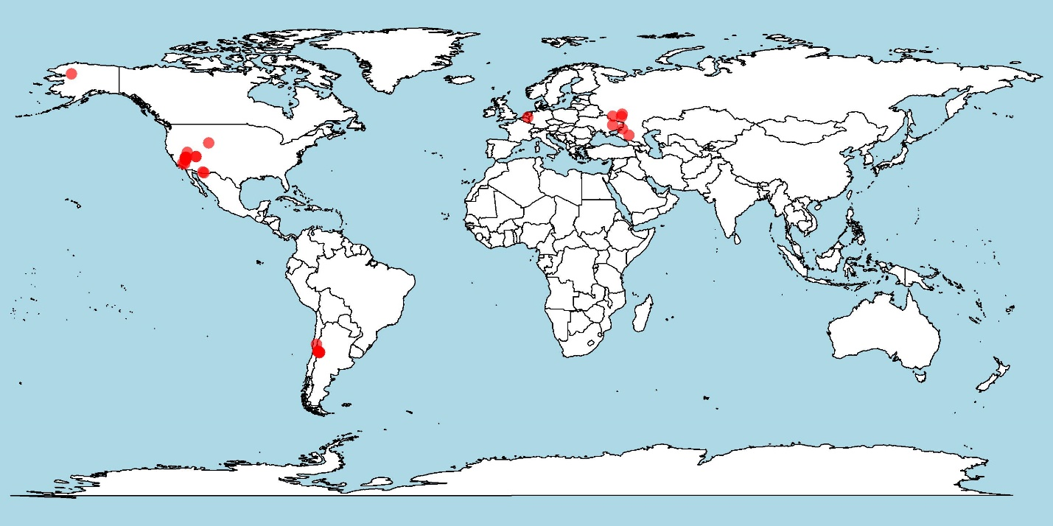

Figure 2. Map of sites, selected based on C3-dominant vegetation and Pa > 100 mm.

Results/Discussion:

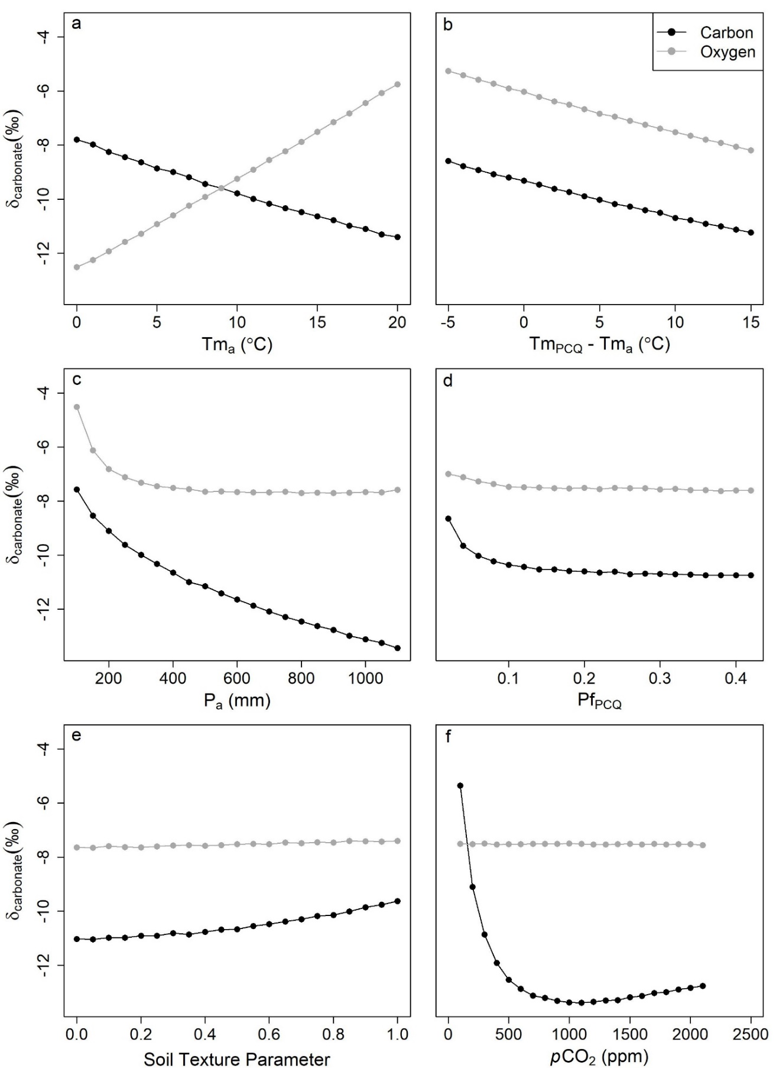

Figure 3. Sensitivity tests on the base model, varying each parameter while keeping the others constant. The constant values used in the sensitivity tests are as follows: Tma: 10°C, TmPCQ - Tma: 10°C, Pa: 400mm, PfPCQ: 0.25, Soil Texture Parameter: 0.5, *p*CO2: 280ppm.

Results/Discussion 1, sensitivity tests:

Sensitivity testing the theoretical model indicates that many variables can significantly affect both carbon and oxygen isotope values of pedogenic carbonate through a variety of processes. Mean annual temperatures have opposite effects on carbon and oxygen isotope values, reflecting increases in respiration and d18Op as temperatures increase. Seasonality of temperature does not affect d18Op, but does affect the temperature of carbonate formation and respiration rates, so carbon and oxygen isotope values have the same negative response. Seasonal and annual precipitation amounts have non-linear effects on both isotope systems, reflecting a variety of processes including depth to carbonate formation, evaporation rate, and plant fractionation. Soil texture does not significantly affect oxygen isotope values, while carbon isotope values are significantly affected by soil texture due to the effect of diffusion on the relative mix of atmospheric and respired CO2. Carbon isotope values have an interesting response to increases in pCO2, where between 200 and 1000 ppm it decreases, reflecting the increase in plant fractionation; however, after 1000 ppm, plant fractionation is saturated and increased diffusion into the soil column increases the carbon isotope value. This response could be slightly different than that proposed by Shubert and Jahren (2016), where they suggest that pedogenic carbonate CIEs are higher solely based on the plant fractionation, while not taking into account increased soil column diffusion.

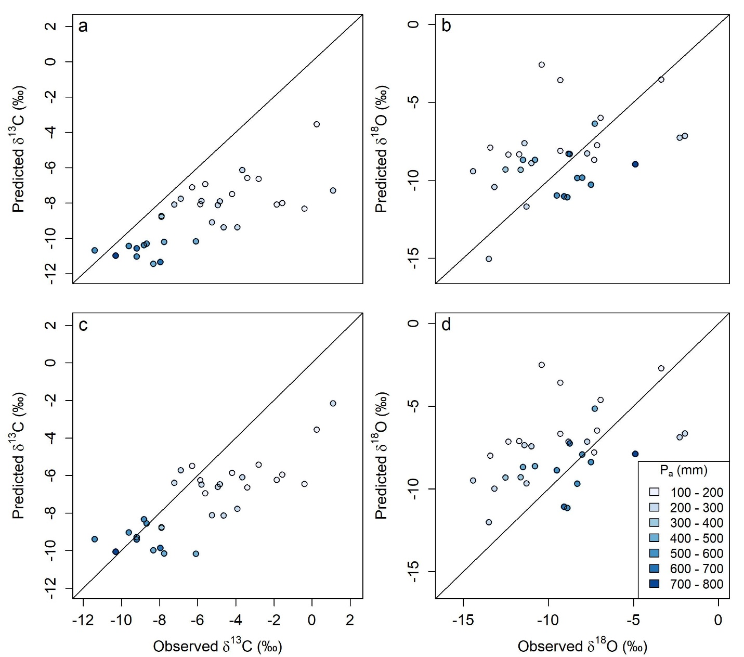

Figure 4. Predicted vs. observed carbon and oxygen isotope values (‰) of pedogenic carbonate for the 33 sites in this study. Panels a and b show predicted and observed carbon and oxygen isotope values assuming the hot season for carbonate precipitation. Panels c and d show predicted and observed isotope values assuming the dry season for carbonate precipitation. Values will be the same between hot and dry seasons if the hot season is the dry season at any particular site.

Results/Discussion 2, theoretical forward model

The theoretical forward model does capture some of the spatial trends in pedogenic carbonate oxygen and carbon isotope values (Figure 3). However, there is significant scatter in these predictions as well as some inherent biases towards either lower carbon isotope values (panel a and c) or higher oxygen isotope values (panel d). These biases are troubling because, while the spatial trend is being captured, the absolute values are significantly different. With some optimization of the theoretical model based on these data, we can improve the model for use in paleoclimatic studies with more confidence. Carbonate saturation can be reached when *p*CO2 decreases, temperature increases and/or there is rapid evaporation. Therefore, hot and/or dry conditions have been suggested to facilitate pedogenic carbonate precipitation, with the relative importance of these conditions debated (*e.g.* Peters et al., 2013). With respect to hot season vs. dry season as the season of carbonate precipitation, the model does not prefer one to the other, with RMSEs being similar in both seasons.

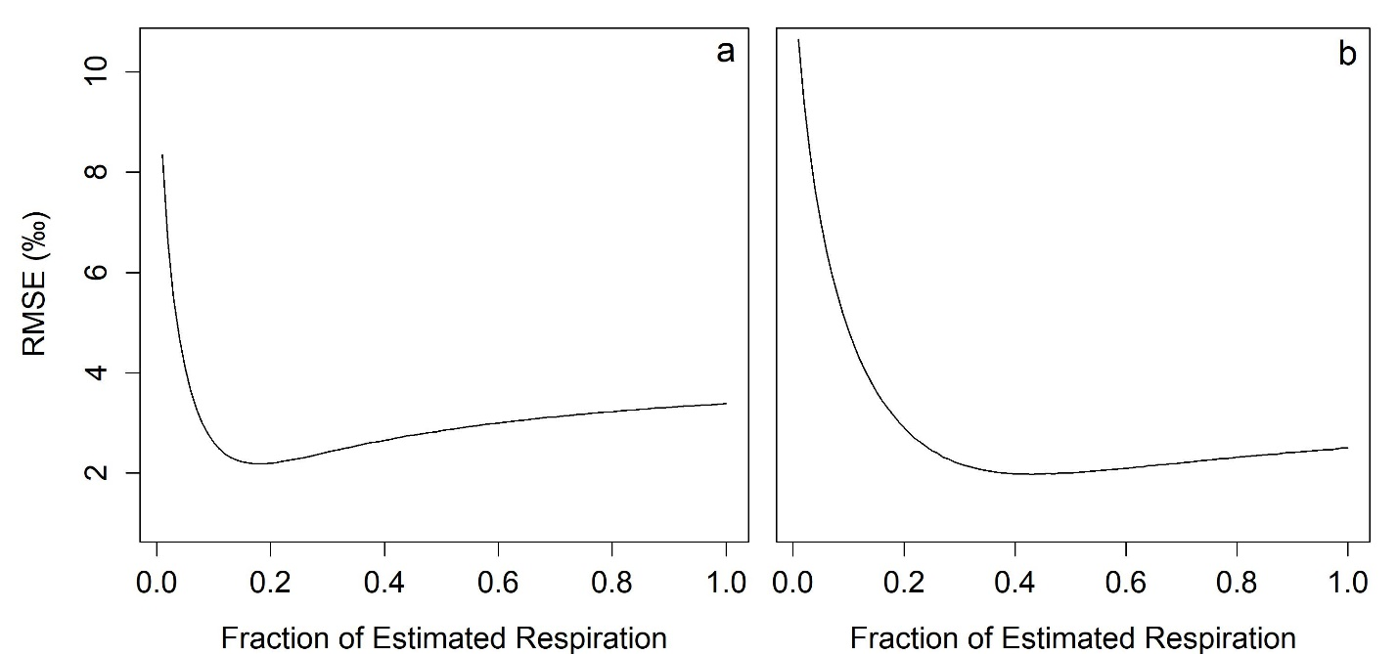

Figure 5. Root means squared error (RMSE, ‰) vs. the fraction of estimated respiration rate for optimizing the respiration rates where panels a and b are the hot quarter and dry quarter optimization, respectively. The fraction of the estimated respiration with the minimum RMSE is 0.17 and 0.34 for the hot quarter and dry quarter, respectively.

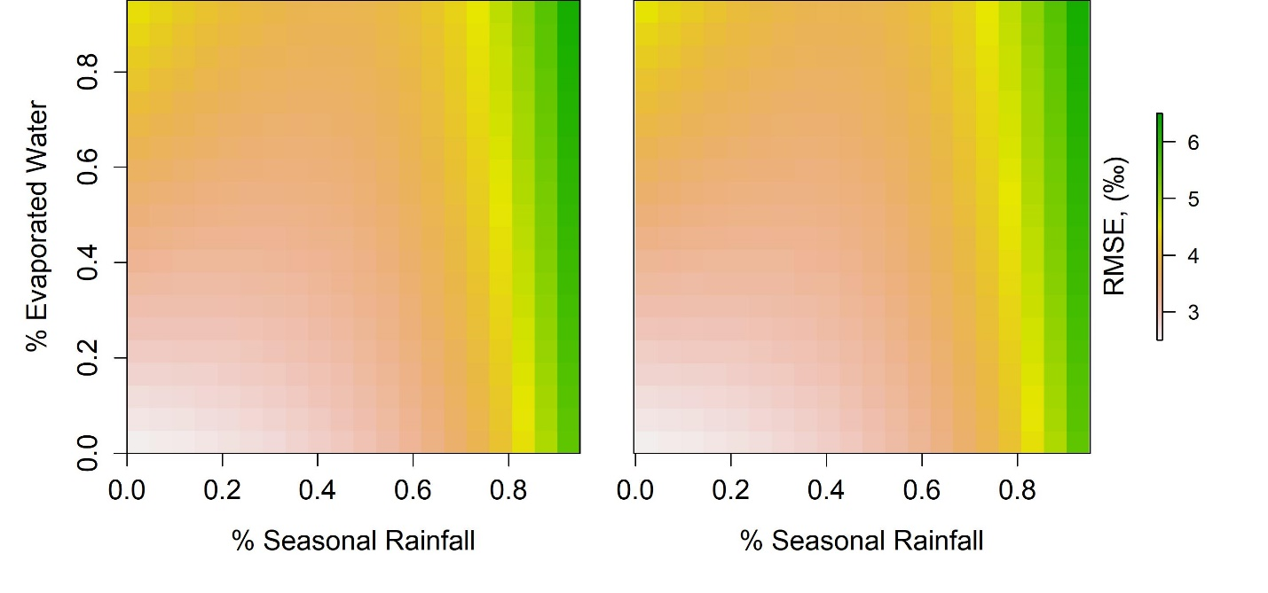

Figure 6. Optimization of the model for seasonal rainfall and evaporated waters (base model has 0 % seasonal rainfall and 100% evaporated waters. The minimum root means squared error in both the hot and dry quarters is 0% evaporated waters and 0% seasonal rainfall bias. Therefore, neither seasonal rainfall nor evaporation is considered in the optimized model.

Results/Discussion 3, optimization

The effects of evaporation and seasonal rainfall on δ18O values of pedogenic carbonate have been proposed to complicate the relationship between δ18O of mean annual precipitation and δ18O of pedogenic carbonate. The lowest RMSE in the model, compared to the measured data, indicates that there is no influence of either seasonal rainfall or evaporation in either the dry or hot quarter. This would indicate that the best explanatory variables for oxygen isotope values of pedogenic carbonate is simply the oxygen isotope value of precipitation and the temperature of carbonate formation. We suggest that this lack of evaporative effect could reflect a greater influence of non-fractionating transpiration by plants as a major driver of carbonate formation, as suggested by models of carbonate precipitation mechanisms (Meyer et. al. 2014).

Optimization of respiration rates indicates that carbon isotope values reflect lower than our calculated mean respiration rates, especially in the hot season. To test if this was due to the aridity of the sites, we recalculated the respiration rate equation for sites that had a lower than 500mm Pa. This analysis did not significantly change any constants in the equation, indicating no bias towards higher Pa and confirming that this equation accurately calculates average respiration even in arid environments. When the hot quarter is assumed to be the season of carbonate precipitation, the optimal respiration rate is only ~17% of the estimated respiration rate calculated in the model equation, with significantly more error at higher respiration rates. For the dry quarter, the lowest RMSE is at 34% estimated respiration rate, but the RMSE does not increase very much after that point (Figure 5, panel b). This could indicate either the dry quarter is the preferred time of carbonate precipitation or that carbonate precipitation in the hot quarter is facilitated by decreasing respiration rates. Respiration rates recorded in pedogenic carbonate carbon isotope values could be significantly lower than average respiration rates if CO2 degassing is a significant driver of carbonate precipitation, as suggested by previous researchers (citation). If this is the case, the interpreted climatic signals would be greatly affected because the mean respiration rate would not be equal to the respiration rate at the time of carbonate formation. This would lead to overestimation of pCO2, via the equation put forward in Cerling (1999).

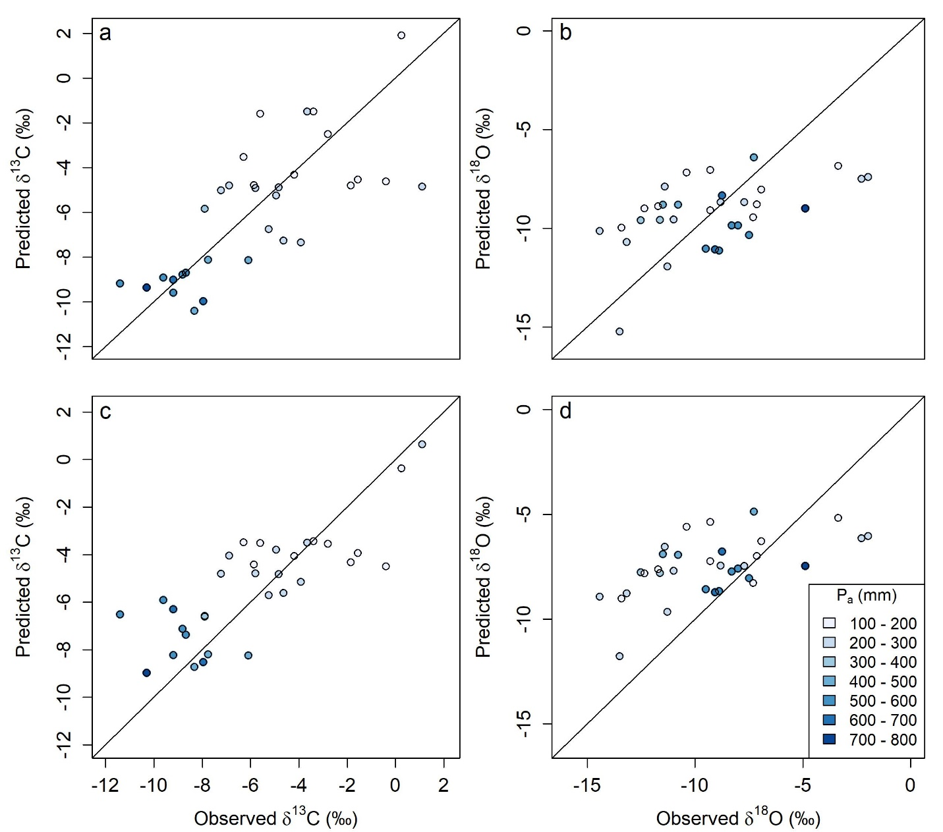

Figure 7. Model performance, post-optimization of evaporation, seasonal rainfall, and respiration rates. RMSEs of carbon and oxygen isotope values are similar between hot and dry quarters.

Results/Discussion 4, optimized model

The optimized model, with decreased respiration rates and no evaporation effect on oxygen isotope values, explains the modern data well. Spatial patterns in pedogenic carbonate isotope values have been observed in modern environments, but have rarely been applied to past climates. This model provides a framework to interpret pedogenic carbonate isotope values given specified climate regimes, atmospheric CO2 concentrations, and soil textures. Carbon and oxygen isotope values of pedogenic carbonate share some of these climatic drivers (seen in Figure 3), which indicates that it is beneficial to interpret these data together instead of separately. Clumped isotope calibration curves are still a challenge to researchers, with methods and standards debated (Kelson et. al. 2017). At the sites that we analyze here, the ones that have clumped isotope measurements are overwhelmingly high with an average of 17.71 C +/- 12.34 (recalculated from Kelson et. al. (2017) calibration curve), compared to hot season average temperatures of 7.02 +/- 1.61 and dry season average temperatures of -0.22 +/- 5.72. Given this extremely high result, we are cautious of putting too much weight on clumped isotope measurements for now. Our optimized model suggests similar RMSEs for both hot and dry season and it is likely particular sites have a preferential season of carbonate precipitation based on specific seasonal precipitation and temperature regimes as well as the amount of vegetation.

Lower MAP could affect the relationship between soil respiration and climate (temperature and precipitation).

Q: Does filtering respiration sites for lower MAP affect the relationship between respiration rate and climate?

A: Run the JAGS model for the filtered sites (annual respiration, MAP < 760 mm) (also did for MAP < 500)

R: This filtering affects it only slightly, with a small increase in the effect of precipitation and temperature and small decrease in basal respiration rate. K from 4.25 to 4.87 and Q from 0.054 to 0.055. R0 from 1.25 to 1.24.

I: The very small change in these parameters does not appreciably affect any results so the relationship holds at low precipitation regimes.

One interesting thing that I have been thinking, which may be out of the scope of this particular paper:

Most of these modern sites are still very low MAP (even when culling for >100mm)

Seasonal precipitation patterns likely drive carbonate formation in most envrs

For paleo-applications, at least in our PETM sites, MAP is predicted to be much higher. So, how are we creating a good model for paleo-application by testing the model with these arid to hyper-arid sites? Seasonal patterns of precipitation and carbonate formation are likely different in these sites vs. higher MAP sites.

What if we attempt to use data only from MAP > 400 mm that still have carbonate in the modern envr? There may not be many of them, but maybe would be a better analog, even if they don’t have clumped isotope temps. There could be a significant difference or “tipping point” of when sites precipitate carbonate in the summer vs. fall/spring controlled by MAP/soil water balance (which is temp, soil texture dependent as well).

Could be a target of future work: find some sites that are higher MAP, C3 dominant, and also have pedogenic carbonate with the target paleoapplication being paleosols that indicate higher MAP and are older than mid Cenozoic (C3 plants only).