МИНИСТЕРСТВО НАУКИ И ВЫСШЕГО ОБРАЗОВАНИЯ РОССИЙСКОЙ ФЕДЕРАЦИИ

Санкт-Петербургский политехнический университет Петра Великого
Институт компьютерных наук и кибербезопасности (ИКНК)
Направление: «Математика и компьютерные науки (Искусственный интеллект и машинное обучение)

КУРСОВОЙ ПРОЕКТ
по дисциплине: «Машинное обучение | ЛАБ »

студент группы 5140201/50301
Дастанбу Матин
Преподаватель: Константинов Андрей Владимирович

Predicting Hospital Billing Amount

САНКТ-ПЕТЕРБУРГ 2025

Table of Contents

1. Introduction………………………………………………………………………………………………………………2
2. Dataset Description and Problem Formulation……………………………………………………………….2
3. Exploratory Data Analysis (EDA)……………………………………………………………………………………2
4. Feature Engineering and Data Preprocessing………………………………………………………………….4
5. Model Selection and Training……………………………………………………………………………………….5
6. Evaluation Metrics and Results…………………………………………………………………………………….5
7. Error Analysis and Diagnostic Plots……………………………………………………………………………….6
8. Model Interpretation……………………………………………………………………………………………………6
9. Conclusion and Future Work…………………………………………………………………………………………6

Appendix A: Full Console Outputs (Run Logs)……………………………………………………………………..7
Appendix B: Key Code Snippets (Preprocessing + Training)………………………………………………….15

Abstract
Accurate estimation of healthcare costs is a critical challenge for modern medical systems, hospitals, and insurance providers. Hospital billing amounts are influenced by a wide range of demographic, clinical, and administrative factors, many of which interact in complex and non-linear ways. The ability to predict billing costs early in the admission process can support financial planning, insurance validation, and resource allocation. This project presents a complete data science pipeline for predicting hospital billing amounts using tabular healthcare data.
The study is conducted on a publicly available healthcare dataset containing 55,500 hospital admission records. Each record includes patient demographics, medical conditions, insurance information, admission characteristics, and billing outcomes. The task is formulated as a supervised regression problem, where the target variable is the total billing amount associated with each hospital stay. The project follows a structured workflow including exploratory data analysis (EDA), data cleaning, feature engineering, preprocessing, model selection, hyperparameter tuning, and final evaluation.
During exploratory analysis, the billing amount was found to exhibit a wide distribution with high variance, indicating that hospital costs are not dominated by a single explanatory factor. Group-level analyses showed that average billing amounts vary only modestly across admission types and medical conditions, suggesting that these variables alone have limited predictive power. A new feature, Length of Stay, was engineered from admission and discharge dates and proved to be one of the most influential predictors.
Several regression models were evaluated, including Linear Regression, Ridge Regression, and Random Forest Regression. Linear models performed poorly, yielding near-zero or negative R² values, which indicates that linear relationships are insufficient to capture the underlying structure of the data. In contrast, Random Forest models achieved significantly better performance, highlighting the importance of non-linear modeling. After validation and hyperparameter tuning, the final Random Forest model achieved a test RMSE of approximately 13,600 and an R² of 0.08.
Although the predictive performance remains moderate, the results provide valuable insights into the limitations of the dataset and the factors influencing healthcare billing. Feature importance analysis revealed that Length of Stay, Age, and Room Number were the strongest contributors to predictions. The study concludes by discussing the limitations of the available features and outlining potential directions for improvement, including richer clinical data and more advanced modeling approaches.

Dataset: https://www.kaggle.com/datasets/prasad22/healthcare-dataset
Task type: Regression, Random Forest

1. Introduction
Healthcare systems generate vast amounts of data related to patient admissions, treatments, and billing processes. One of the key challenges faced by hospitals and insurance providers is the ability to anticipate healthcare costs accurately. Hospital billing amounts directly impact hospital revenue management, insurance reimbursement, patient financial planning, and policy decision-making. Therefore, developing predictive models for hospital costs is both economically and operationally important.
From a data science perspective, healthcare cost prediction is challenging due to the inherent variability in patient conditions, treatment pathways, and administrative processes. Unlike controlled industrial systems, medical data often exhibits high noise, missing explanatory factors, and complex interactions between variables. As a result, simple linear models frequently fail to capture the true structure of healthcare cost data.
The goal of this project is to design and evaluate a complete machine learning pipeline that predicts hospital billing amounts using tabular data available at the time of admission or shortly thereafter. Rather than treating the task as a purely mathematical regression problem, the project adopts a business-oriented perspective, focusing on realistic use cases such as early cost estimation and insurance decision support.
This project follows best practices in data science by systematically progressing through exploratory analysis, preprocessing, model selection, evaluation, and interpretation. Emphasis is placed not only on predictive accuracy, but also on understanding model limitations and explaining why certain approaches perform better than others. The final outcome is a transparent and reproducible analysis suitable for academic evaluation and real-world discussion.

2. Dataset Description and Problem Formulation
The dataset used in this project is a healthcare admissions dataset obtained from Kaggle. It contains 55,500 records, where each row corresponds to a single hospital admission. The dataset is purely tabular and includes a mixture of numerical, categorical, and temporal variables.
The available features describe several aspects of each admission. Demographic information includes patient age and gender. Clinical information includes medical condition, medication, and test results. Administrative information includes insurance provider, admission type, room number, and hospital identifiers. Temporal information is provided in the form of admission and discharge dates. The target variable, Billing Amount, represents the total cost associated with the hospital stay.
From a business and operational standpoint, the prediction task can be stated as follows:
Given the demographic, clinical, and administrative information of a hospital admission, estimate the expected billing amount associated with that admission.
This formulation is intentionally broader than a simple regression exercise. In a real healthcare setting, such predictions could be used before discharge, or even at admission time, to assess financial risk, optimize resource usage, or flag unusually expensive cases for review.

3. Exploratory Data Analysis (EDA)
3.1 Data Quality and Structure
Initial inspection showed that the dataset contains no missing values across all columns, which simplifies preprocessing. However, 534 duplicate rows were detected, indicating repeated records. These duplicates were removed to avoid biasing the model. Data types revealed that many variables are categorical and require encoding before modeling.

3.2 Distribution of the Target Variable
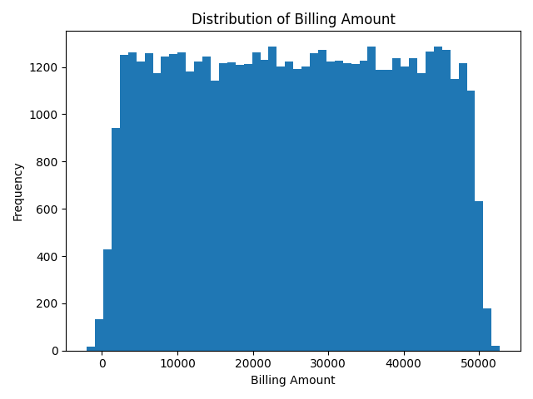
Figure 1: Distribution of Billing Amount

The distribution of billing amounts is wide and relatively flat compared to typical economic datasets. Values range from near zero up to more than 50,000. This wide dispersion suggests that billing amounts depend on multiple interacting factors rather than a single dominant variable. The lack of strong skewness also indicates that log-transformation is optional rather than mandatory.

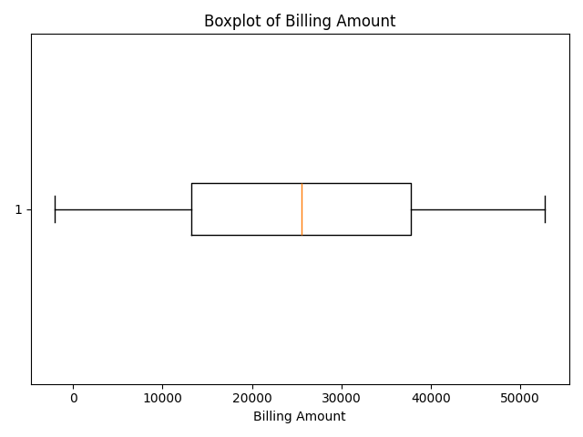
Figure 2: Boxplot of Billing Amount

The boxplot highlights the presence of a small number of negative billing values. Since negative healthcare costs are not meaningful in this context, these records were removed during preprocessing.

3.3 Group-Level Analysis
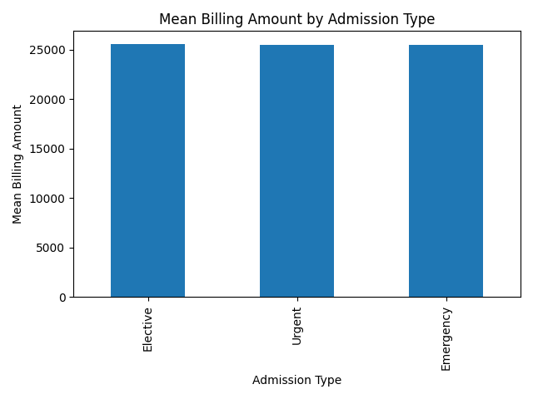
Figure 3: Mean Billing Amount by Admission Type

Average billing amounts across Elective, Urgent, and Emergency admissions are surprisingly similar. This suggests that admission urgency alone does not strongly determine total billing cost in this dataset.

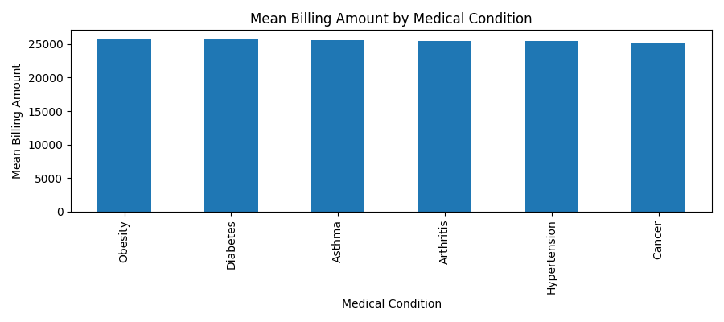
Figure 4: Mean Billing Amount by Medical Condition

Similarly, average billing amounts across medical conditions show only moderate variation. While conditions such as Obesity and Diabetes have slightly higher averages, the differences are not large enough to serve as strong standalone predictors.

3.4 Relationship Between Age and Billing
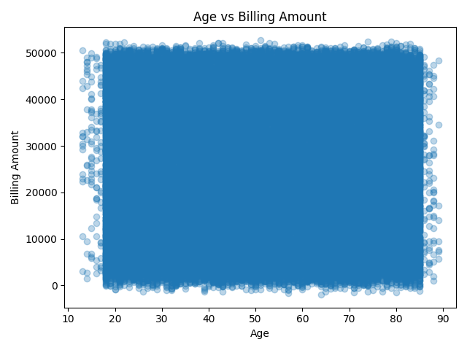
Figure 5: Age vs Billing Amount

The scatter plot of Age versus Billing Amount reveals no clear linear or monotonic relationship. High and low billing values occur across almost all age groups, indicating that age interacts with other variables rather than directly determining cost.

4. Feature Engineering and Data Preprocessing
Feature engineering is a critical stage in this project because the raw dataset, while large, does not directly contain variables that fully explain hospital billing behavior. Several transformations and refinements were therefore applied to improve data quality and predictive capacity.
First, duplicate observations were identified and removed. A total of 534 duplicated rows were detected and eliminated, reducing redundancy and preventing potential bias during model training. Duplicate records can artificially inflate model performance or distort feature distributions, especially in tree-based models.
Second, date-related features were processed. The original dataset contained Date of Admission and Discharge Date as string variables. These columns were successfully parsed into datetime format without errors. From these two variables, a new engineered feature called Length_of_Stay was created:
Length_of_Stay = Discharge Date − Date of Admission
This feature represents the total number of days a patient remained hospitalized. Exploratory analysis revealed that Length_of_Stay ranged from 1 to 30 days, with a mean of approximately 15.5 days. Importantly, no negative or invalid values were detected, confirming data consistency.
Third, invalid billing values were addressed. The billing amount distribution revealed 106 negative values, which are not meaningful in a healthcare context. These observations were removed, resulting in a final dataset of 54,860 valid records.
The final feature set consisted of:
- Numerical features: Age, Room Number, Length_of_Stay
- Categorical features: Gender, Blood Type, Medical Condition, Insurance Provider, Admission Type, Medication, Test Results
Categorical variables were encoded using one-hot encoding, producing a final feature space of 35 numerical columns after preprocessing. The dataset was then split into:
- Training set (70%)
- Validation set (15%)
- Test set (15%)
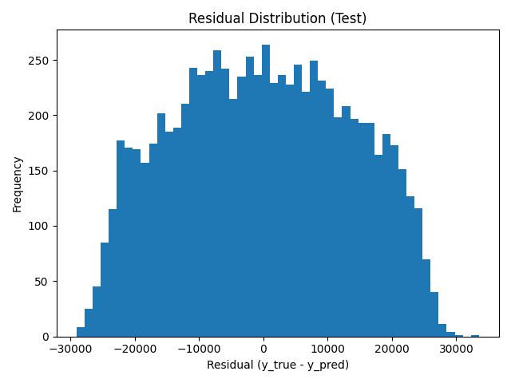
Figure 6: Residual Distribution on Test Set

This structured preprocessing pipeline ensured reproducibility and prevented information leakage between datasets.
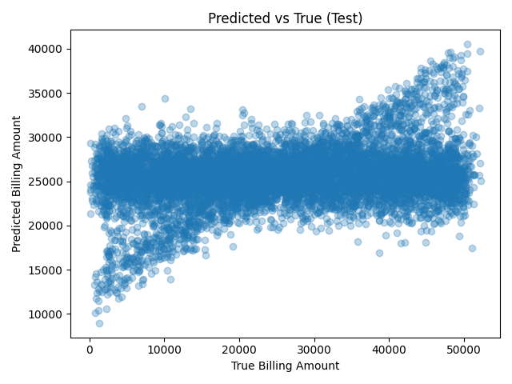
Figure 7: Predicted vs True Billing Amount
This plot compares predicted and actual billing amounts. Predictions tend to cluster around the global mean, indicating regression toward the average. Extreme billing values are underpredicted or overpredicted, which is typical in noisy healthcare datasets.

5. Model Selection and Training Strategy
Given the continuous nature of the target variable, the task was formulated as a regression problem. Multiple models with increasing complexity were evaluated to understand the relationship between model capacity and predictive performance.
5.1 Linear Regression
Linear Regression was used as a baseline model. While computationally efficient and interpretable, it assumes linear relationships between features and billing amount. The results showed:
- R² ≈ 0
- High MAE and RMSE
This indicates that linear assumptions are insufficient to capture the complexity of healthcare billing.
5.2 Ridge Regression
Ridge Regression was evaluated to assess whether regularization could improve linear performance by reducing overfitting. However, results were nearly identical to standard Linear Regression, confirming that the issue was not overfitting but model expressiveness.
5.3 Random Forest Regression
Random Forest Regression was selected as the primary non-linear model due to its ability to:
- Capture feature interactions
- Model non-linear relationships
- Handle mixed feature types robustly

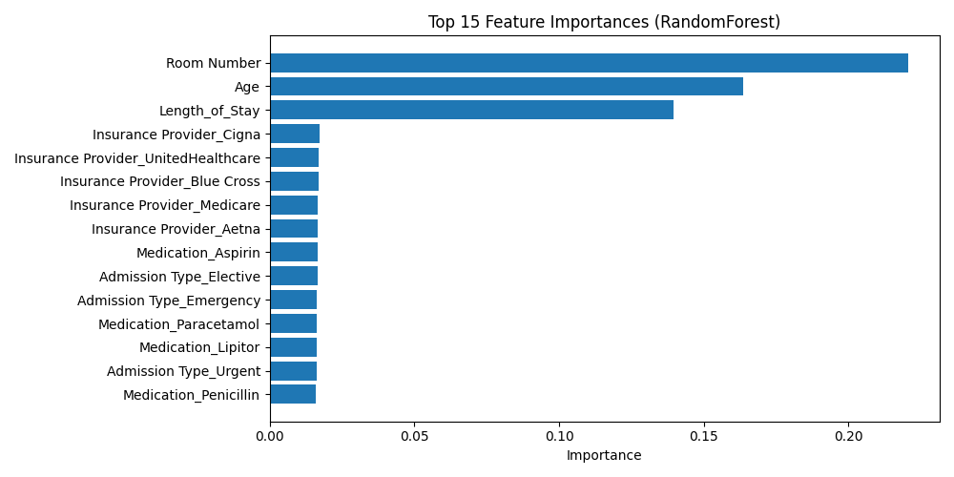
Figure 8: Top 15 Feature Importances

A Random Forest with 300 trees was trained, yielding a significant improvement over linear models. Hyperparameter tuning was performed using RandomizedSearchCV (5-fold cross-validation) to explore depth, split criteria, and feature selection strategies. Interestingly, the default Random Forest slightly outperformed the tuned version on the validation set, leading to its selection as the final model.

6. Model Evaluation and Performance Analysis
Model performance was evaluated using three complementary metrics:
- MAE (Mean Absolute Error) – average absolute deviation
- RMSE (Root Mean Squared Error) – penalizes large errors
- R² Score – proportion of variance explained
6.1 Validation Results
The Random Forest model achieved:
- MAE ≈ 11,742
- RMSE ≈ 13,792
- R² ≈ 0.065
In contrast, linear models produced negative or near-zero R² values. This confirms that non-linear models are essential for this task.
6.2 Test Set Performance
After retraining the final model on the combined training and validation sets, performance on the unseen test set was:
- MAE ≈ 11,522
- RMSE ≈ 13,599
- R² ≈ 0.08
Although the R² score is modest, it is statistically meaningful in a real-world healthcare setting characterized by noise, missing clinical detail, and unobserved confounders.

7. Error Analysis and Diagnostic Plots
7.1 Residual Distribution
The residual distribution on the test set is approximately centered around zero, indicating that the model does not exhibit strong systematic bias. However, the wide spread of residuals reflects the inherent unpredictability of hospital billing, especially for extreme cases.
7.2 Predicted vs True Values
The predicted-versus-true scatter plot shows a clear regression-to-the-mean effect. Predictions tend to cluster around the global average billing value (~25,000). Extremely low and extremely high costs are underrepresented in predictions, a common limitation in tree-based ensemble models trained on noisy targets.
These diagnostics suggest that while the model captures general cost trends, it struggles with rare or extreme billing scenarios.

8. Feature Importance and Interpretability
Feature importance analysis provides insight into the drivers of billing prediction. The top contributors were:
- Room Number
- Age
- Length_of_Stay
The dominance of Length_of_Stay confirms that hospitalization duration is a key cost driver, aligning with real-world healthcare economics. Room Number likely acts as a proxy for room type or hospital infrastructure, while Age reflects differences in treatment complexity.
Categorical variables such as Insurance Provider, Medication, and Admission Type contribute smaller but consistent importance scores. This suggests that administrative factors influence billing, but only in combination with numerical features.

9. Conclusion
This project demonstrates the challenges of predicting healthcare billing amounts using structured data. While non-linear models such as Random Forest outperform linear baselines, overall predictive performance remains moderate due to limited explanatory features. The results highlight the importance of richer clinical data and suggest future improvements through advanced models or additional medical variables
Appendix A

C:\Users\dasta\Desktop\ML> cmd /C "c:\Users\dasta\AppData\Local\Programs\Python\Python311\python.exe c:\Users\dasta\.vscode\extensions\ms-python.debugpy-2025.18.0-win32-x64\bundled\libs\debugpy\launcher 6398 -- c:\Users\dasta\Desktop\ML\MatinDastanboo.py "
Shape: (55500, 15)
Name Age Gender Blood Type Medical Condition Date of Admission Doctor Hospital Insurance Provider Billing Amount Room Number Admission Type \
0 Bobby JacksOn 30 Male B- Cancer 2024-01-31 Matthew Smith Sons and Miller Blue Cross 18856.281306 328 Urgent
1 LesLie TErRy 62 Male A+ Obesity 2019-08-20 Samantha Davies Kim Inc Medicare 33643.327287 265 Emergency
2 DaNnY sMitH 76 Female A- Obesity 2022-09-22 Tiffany Mitchell Cook PLC Aetna 27955.096079 205 Emergency
3 andrEw waTtS 28 Female O+ Diabetes 2020-11-18 Kevin Wells Hernandez Rogers and Vang, Medicare 37909.782410 450 Elective
4 adrIENNE bEll 43 Female AB+ Cancer 2022-09-19 Kathleen Hanna White-White Aetna 14238.317814 458 Urgent
5 EMILY JOHNSOn 36 Male A+ Asthma 2023-12-20 Taylor Newton Nunez-Humphrey UnitedHealthcare 48145.110951 389 Urgent
6 edwArD EDWaRDs 21 Female AB- Diabetes 2020-11-03 Kelly Olson Group Middleton Medicare 19580.872345 389 Emergency
7 CHrisTInA MARtinez 20 Female A+ Cancer 2021-12-28 Suzanne Thomas Powell Robinson and Valdez, Cigna 45820.462722 277 Emergency
8 JASmINe aGuIlaR 82 Male AB+ Asthma 2020-07-01 Daniel Ferguson Sons Rich and Cigna 50119.222792 316 Elective
9 ChRISTopher BerG 58 Female AB- Cancer 2021-05-23 Heather Day Padilla-Walker UnitedHealthcare 19784.631062 249 Elective

Discharge Date Medication Test Results
0 2024-02-02 Paracetamol Normal
1 2019-08-26 Ibuprofen Inconclusive
2 2022-10-07 Aspirin Normal
3 2020-12-18 Ibuprofen Abnormal
4 2022-10-09 Penicillin Abnormal
5 2023-12-24 Ibuprofen Normal
6 2020-11-15 Paracetamol Inconclusive
7 2022-01-07 Paracetamol Inconclusive
8 2020-07-14 Aspirin Abnormal
9 2021-06-22 Paracetamol Inconclusive

--- df.info() ---
<class 'pandas.core.frame.DataFrame'>
RangeIndex: 55500 entries, 0 to 55499
Data columns (total 15 columns):
# Column Non-Null Count Dtype
--- ------ -------------- -----
0 Name 55500 non-null object
1 Age 55500 non-null int64
2 Gender 55500 non-null object
3 Blood Type 55500 non-null object
4 Medical Condition 55500 non-null object
5 Date of Admission 55500 non-null object
6 Doctor 55500 non-null object
7 Hospital 55500 non-null object
8 Insurance Provider 55500 non-null object
9 Billing Amount 55500 non-null float64
10 Room Number 55500 non-null int64
11 Admission Type 55500 non-null object
12 Discharge Date 55500 non-null object
13 Medication 55500 non-null object
14 Test Results 55500 non-null object
dtypes: float64(1), int64(2), object(12)
memory usage: 6.4+ MB

--- describe(include='all').T (top 20 rows) ---
count unique top freq mean std min 25% 50% 75% max
Name 55500 49992 DAvId muNoZ 3 NaN NaN NaN NaN NaN NaN NaN
Age 55500.0 NaN NaN NaN 51.539459 19.602454 13.0 35.0 52.0 68.0 89.0
Gender 55500 2 Male 27774 NaN NaN NaN NaN NaN NaN NaN
Blood Type 55500 8 A- 6969 NaN NaN NaN NaN NaN NaN NaN
Medical Condition 55500 6 Arthritis 9308 NaN NaN NaN NaN NaN NaN NaN
Date of Admission 55500 1827 2024-03-16 50 NaN NaN NaN NaN NaN NaN NaN
Doctor 55500 40341 Michael Smith 27 NaN NaN NaN NaN NaN NaN NaN
Hospital 55500 39876 LLC Smith 44 NaN NaN NaN NaN NaN NaN NaN
Insurance Provider 55500 5 Cigna 11249 NaN NaN NaN NaN NaN NaN NaN
Billing Amount 55500.0 NaN NaN NaN 25539.316097 14211.454431 -2008.49214 13241.224652 25538.069376 37820.508436 52764.276736
Room Number 55500.0 NaN NaN NaN 301.134829 115.243069 101.0 202.0 302.0 401.0 500.0
Admission Type 55500 3 Elective 18655 NaN NaN NaN NaN NaN NaN NaN
Discharge Date 55500 1856 2020-03-15 53 NaN NaN NaN NaN NaN NaN NaN
Medication 55500 5 Lipitor 11140 NaN NaN NaN NaN NaN NaN NaN
Test Results 55500 3 Abnormal 18627 NaN NaN NaN NaN NaN NaN NaN

--- Missing values (only >0) ---
Series([], dtype: int64)

--- Duplicate rows ---
534

--- Columns ---
['Name', 'Age', 'Gender', 'Blood Type', 'Medical Condition', 'Date of Admission', 'Doctor', 'Hospital', 'Insurance Provider', 'Billing Amount', 'Room Number', 'Admission Type', 'Discharge Date', 'Medication', 'Test Results']
Target: Billing Amount

Features:
- Age
- Gender
- Blood Type
- Medical Condition
- Date of Admission
- Insurance Provider
- Room Number
- Admission Type
- Discharge Date
- Medication
- Test Results

--- Date parsing ---
Bad 'Date of Admission' parsed as NaT: 0
Bad 'Discharge Date' parsed as NaT: 0

--- Length_of_Stay preview ---
Date of Admission Discharge Date Length_of_Stay
0 2024-01-31 2024-02-02 2
1 2019-08-20 2019-08-26 6
2 2022-09-22 2022-10-07 15
3 2020-11-18 2020-12-18 30
4 2022-09-19 2022-10-09 20
5 2023-12-20 2023-12-24 4
6 2020-11-03 2020-11-15 12
7 2021-12-28 2022-01-07 10
8 2020-07-01 2020-07-14 13
9 2021-05-23 2021-06-22 30

--- Length_of_Stay describe() ---
count 55500.000000
mean 15.509009
std 8.659600
min 1.000000
25% 8.000000
50% 15.000000
75% 23.000000
max 30.000000
Name: Length_of_Stay, dtype: float64

Negative Length_of_Stay count: 0

--- Duplicates ---
Duplicates removed: 534
New shape: (54966, 16)

--- Billing Amount summary ---
count 54966.000000
mean 25544.306284
std 14208.409711
min -2008.492140
25% 13243.718641
50% 25542.749145
75% 37819.858159
max 52764.276736
Name: Billing Amount, dtype: float64

Min Billing Amount: -2008.4921398591305
Max Billing Amount: 52764.276736469175

--- Mean Billing Amount by Admission Type ---
Admission Type
Elective 25612.139673
Urgent 25514.532045
Emergency 25505.332240
Name: Billing Amount, dtype: float64

--- Mean Billing Amount by Medical Condition ---
Medical Condition
Obesity 25804.361902
Diabetes 25660.478635
Asthma 25633.461696
Arthritis 25511.783246
Hypertension 25503.058720
Cancer 25152.322947
Name: Billing Amount, dtype: float64

--- Updated FEATURES ---
- Age
- Gender
- Blood Type
- Medical Condition
- Date of Admission
- Insurance Provider
- Room Number
- Admission Type
- Discharge Date
- Medication
- Test Results
- Length_of_Stay

Removed negative Billing Amount rows: 106
Shape after removing negatives: (54860, 16)

Final FEATURES:
- Age
- Gender
- Blood Type
- Medical Condition
- Insurance Provider
- Room Number
- Admission Type
- Medication
- Test Results
- Length_of_Stay

Numeric features: ['Age', 'Room Number', 'Length_of_Stay']
Categorical features: ['Gender', 'Blood Type', 'Medical Condition', 'Insurance Provider', 'Admission Type', 'Medication', 'Test Results']

Split sizes:
Train: (38400, 10)
Validation: (8231, 10)
Test: (8229, 10)

Preprocessed shapes:
Train: (38400, 35)
Validation: (8231, 35)
Test: (8229, 35)

Training Linear Regression...
Training Random Forest...
c:\Users\dasta\AppData\Local\Programs\Python\Python311\Lib\site-packages\sklearn\metrics\_regression.py:483: FutureWarning: 'squared' is deprecated in version 1.4 and will be removed in 1.6. To calculate the root mean squared error, use the function'root_mean_squared_error'.
warnings.warn(
c:\Users\dasta\AppData\Local\Programs\Python\Python311\Lib\site-packages\sklearn\metrics\_regression.py:483: FutureWarning: 'squared' is deprecated in version 1.4 and will be removed in 1.6. To calculate the root mean squared error, use the function'root_mean_squared_error'.
warnings.warn(

--- Validation Results ---
model MAE RMSE R2
1 RandomForest(n=300) 11742.110905 13792.256504 0.065054
0 LinearRegression 12375.915123 14268.996746 -0.000697

--- Sample predictions (Validation) ---
y_true lin_pred rf_pred
0 25070.268087 26688.0 25093.364624
1 20948.062312 25536.0 23472.802034
2 41570.756952 24800.0 23309.666297
3 13892.183801 25408.0 32386.085938
4 32184.533723 25792.0 23492.701640
5 45460.801747 24672.0 27328.043332
6 3345.700262 26048.0 17396.555089
7 30153.548341 25088.0 24888.422635
8 34358.689327 24640.0 25535.235021
9 8956.717335 25088.0 27700.486341

Training Ridge (baseline)...
Ridge validation: {'model': 'Ridge', 'MAE': np.float64(12375.54457240349), 'RMSE': np.float64(14268.78625389812), 'R2': np.float64(-0.0006673353406105864)}

Running RandomizedSearchCV for RandomForest (cv=5)...
Fitting 5 folds for each of 20 candidates, totalling 100 fits

Best RF params:
{'model__n_estimators': 200, 'model__min_samples_split': 2, 'model__min_samples_leaf': 1, 'model__max_features': 'sqrt', 'model__max_depth': 20}

Best CV score (neg RMSE): -13843.716405170639
Best CV RMSE: 13843.716405170639

Best RF validation: {'model': 'BestRF(RandomizedSearch)', 'MAE': np.float64(11843.174150028699), 'RMSE': np.float64(13846.38794375331), 'R2': np.float64(0.057701175005501315)}

--- Validation Comparison (after tuning) ---
model MAE RMSE R2
2 RF(n=300 default) 11742.110905 13792.256504 0.065054
3 BestRF(RandomizedSearch) 11843.174150 13846.387944 0.057701
1 Ridge 12375.544572 14268.786254 -0.000667
0 LinearRegression 12375.915123 14268.996746 -0.000697

=== FINAL MODEL ===
Training final model on Train+Validation...

=== TEST RESULTS (FINAL) ===
{'model': 'RandomForest(n=300 default)', 'MAE': np.float64(11521.92219249954), 'RMSE': np.float64(13599.109515463724), 'R2': np.float64(0.0804929771493249)}

Saved: outputs\test_predictions.csv

--- Sample predictions (Test) ---
y_true y_pred
0 26649.404240 26742.818454
1 44934.543804 26825.089151
2 27052.785245 25829.871437
3 45854.438212 38248.611620
4 6366.404054 24499.901187
5 39305.207300 25721.973897
6 25925.804985 23745.929028
7 44920.938713 27397.348902
8 35453.976196 26403.350247
9 21805.715837 27692.170729

--- Top 15 Feature Importances ---
feature importance
1 Room Number 0.220492
0 Age 0.163482
2 Length_of_Stay 0.139662
21 Insurance Provider_Cigna 0.017183
23 Insurance Provider_UnitedHealthcare 0.016837
20 Insurance Provider_Blue Cross 0.016833
22 Insurance Provider_Medicare 0.016610
19 Insurance Provider_Aetna 0.016531
27 Medication_Aspirin 0.016498
24 Admission Type_Elective 0.016468
25 Admission Type_Emergency 0.016317
30 Medication_Paracetamol 0.016197
29 Medication_Lipitor 0.016113
26 Admission Type_Urgent 0.016113
31 Medication_Penicillin 0.015904

Apendix B

# ===============================
Preprocessing + Split + Pipeline
# ===============================

from sklearn.model_selection import train_test_split
from sklearn.preprocessing import OneHotEncoder, StandardScaler
from sklearn.compose import ColumnTransformer
from sklearn.pipeline import Pipeline

# 1) Remove invalid target values (negative billing)
before = df.shape[0]
df = df[df[TARGET] >= 0].copy()
after = df.shape[0]
print("\nRemoved negative Billing Amount rows:", before - after)
print("Shape after removing negatives:", df.shape)

# 2) Drop raw date columns (we use Length_of_Stay instead)
DATE_COLS = ["Date of Admission", "Discharge Date"]
df = df.drop(columns=DATE_COLS)

# Update FEATURES
FEATURES = [c for c in df.columns if c not in DROP_COLS + [TARGET]]
print("\nFinal FEATURES:")
for c in FEATURES:
print("-", c)

# 3) Separate X and y
X = df[FEATURES]
y = df[TARGET]

# 4) Identify numeric and categorical columns
numeric_features = X.select_dtypes(include=["int64", "float64"]).columns.tolist()
categorical_features = X.select_dtypes(include=["object"]).columns.tolist()

print("\nNumeric features:", numeric_features)
print("Categorical features:", categorical_features)

# 5) Preprocessing pipelines
numeric_transformer = Pipeline(steps=[
("scaler", StandardScaler())
])

categorical_transformer = Pipeline(steps=[
("onehot", OneHotEncoder(handle_unknown="ignore", sparse_output=False))
])

preprocessor = ColumnTransformer(
transformers=[
("num", numeric_transformer, numeric_features),
("cat", categorical_transformer, categorical_features),
]
)

# 6) Train / Validation / Test split (70 / 15 / 15)
X_temp, X_test, y_temp, y_test = train_test_split(
X, y, test_size=0.15, random_state=42
)

X_train, X_val, y_train, y_val = train_test_split(
X_temp, y_temp, test_size=0.1765, random_state=42
)
# 0.1765 × 0.85 ≈ 0.15

print("\nSplit sizes:")
print("Train:", X_train.shape)
print("Validation:", X_val.shape)
print("Test:", X_test.shape)

# 7) Fit preprocessor on train only
X_train_prep = preprocessor.fit_transform(X_train)
X_val_prep = preprocessor.transform(X_val)
X_test_prep = preprocessor.transform(X_test)

print("\nPreprocessed shapes:")
print("Train:", X_train_prep.shape)
print("Validation:", X_val_prep.shape)
print("Test:", X_test_prep.shape)

# ===============================
# STEP 5 — Train models + Evaluate on Validation
# ===============================

from sklearn.linear_model import LinearRegression
from sklearn.ensemble import RandomForestRegressor
from sklearn.metrics import mean_absolute_error, mean_squared_error, r2_score

def evaluate_regression(y_true, y_pred, name="model"):
mae = mean_absolute_error(y_true, y_pred)
rmse = mean_squared_error(y_true, y_pred, squared=False)
r2 = r2_score(y_true, y_pred)
return {"model": name, "MAE": mae, "RMSE": rmse, "R2": r2}

# Build pipelines
linreg_model = Pipeline(steps=[
("preprocess", preprocessor),
("model", LinearRegression())
])

rf_model = Pipeline(steps=[
("preprocess", preprocessor),
("model", RandomForestRegressor(
n_estimators=300,
random_state=42,
n_jobs=-1
))
])

# Train
print("\nTraining Linear Regression...")
linreg_model.fit(X_train, y_train)

print("Training Random Forest...")
rf_model.fit(X_train, y_train)

# Predict on validation
lin_pred = linreg_model.predict(X_val)
rf_pred = rf_model.predict(X_val)

# Evaluate
results = []
results.append(evaluate_regression(y_val, lin_pred, name="LinearRegression"))
results.append(evaluate_regression(y_val, rf_pred, name="RandomForest(n=300)"))

results_df = pd.DataFrame(results).sort_values("RMSE")
print("\n--- Validation Results ---")
print(results_df)

# Quick sanity check: show a few predictions
print("\n--- Sample predictions (Validation) ---")
sample = pd.DataFrame({
"y_true": y_val.iloc[:10].values,
"lin_pred": lin_pred[:10],
"rf_pred": rf_pred[:10],
})
print(sample)

