SPECCHIO

SPECCHIO Virtualbox

Version: 3.3.0.03.3.0.0

Date: 08.03.202208.03.2022

Status: ApprovedApproved

Authors: A. Hueni (UZH)A. Hueni (UZH)

File: SPECCHIO\_VM.docx

Pages: 30

Classification:

Distribution: SPECCHIO UsersSPECCHIO Users

::::RSL_logo_new.pdf

# Contents

1 Contents 2

2 Introduction 3

2.1 Document scope 3

2.2 Intended audience 3

2.3 SPECCHIO ownership and access 3

2.4 Copyright and licensing 3

2.5 For Further Information 3

3 Installation, Configuration and Usage 4

3.1 Prerequisites 4

3.2 Installing the SPECCHIO Virtual Machine 4

3.3 Logging into the Virtual Machine 4

3.4 Virtual Machine Configuration 4

3.5 Accessing SPECCHIO via the Web Interface 5

3.6 Launching the SPECCHIO Application 6

3.7 Creating a User Account 7

3.8 Networking Access to the SPECCHIO Server 8

3.9 Accessing SPECCHIO from the Host Machine 10

3.10 Accessing SPECCHIO from Outside the Virtual Machine 12

3.11 Accessing SPECCHIO VM in the Field without any existing Network 12

3.12 Mounting a host folder into the VM 13

3.13 Handling larger database requirements 14

4 Database access from the Host Machine 15

5 Upgrading the SPECCHIO System 16

5.1 Upgrade Scenarios 16

5.2 Upgrade from an old SPECCHIO VM 16

5.2.1 Creating and Exporting a dump in the old SPECCHIO VM 16

5.2.2 Transferring and Importing an old dump in the new SPECCHIO VM 17

5.3 Server and Client Software Upgrades 17

5.3.1 Automatic Upgrade (In-place Upgrade) 17

5.3.2 Manual Upgrade 18

5.4 Virtual Machine Image Upgrade 19

5.4.1 Database Export 19

5.4.2 Transferring the dump 21

5.4.3 Importing the dump 22

5.5 SPECCHIO Database Upgrades 25

Appendix A: Change History 27

Appendix B: Bridged Networking under MacOS – Ethernet and WiFi 29

# Introduction

This document introduces the SPECCHIO Virtualbox. It is a complete SPECCHIO server and client installed under a virtual CentOS 7.6 installation using Virtualbox.

## Document scope

This Guide details operation of the Virtualbox installation of SPECCHIO only.

## Intended audience

SPECCHIO users who want to run the full system locally, either on their personal machines or on a server at their own institution and who do not want to go through the hassle of a full system installation themselves.

## SPECCHIO ownership and access

SPECCHIO was originally built by the Remote Sensing Laboratories at the University of Zurich, and extended by Intersect for the School of Earth and Environmental Sciences at the University of Wollongong.

## Copyright and licensing

SPECCHIO is licensed under the Creative Commons Attribution-ShareAlike 3.0 Unported Licence. Therefore its source is readily available for inspection and development. It can be found in LICENCE.html and at http://creativecommons.org/licenses/by-sa/3.0/.

## For Further Information

Please refer to the following documents for more information about SPECCHIO. Unless otherwise stated, they can be found in the SPECCHIO Installation kit.

**SPECCHIO\_ReleaseNotes.pdf** can be found in each Installation Kit and provides installation instructions for the SPECCHIO Client.

**SPECCHIO\_Tutorial.pdf** provides instruction in the operation of key areas of the SPECCHIO Client.

**SPECCHIO\_ServerInstallation.pdf** provides system administrators with information to assist in managing and maintaining a SPECCHIO Server System.

**SPECCHIO Web Site (**[www.specchio.ch](http://www.specchio.ch)) General information about SPECCHIO. Some of this information may be related to other non-UOW versions of SPECCHIO.

**SPECCHIO UoW (**https://specchio.uow.edu.au)Installation kits for University of Wollongong version of the SPECCHIO Client and documentation for that version.

**SPECCHIO GitHub (**<https://github.com/SPECCHIODB/SPECCHIO>) Source code for the community version of SPECCHIO, currently developed under the lead of RSL (University of Zurich).

# Installation, Configuration and Usage

## Prerequisites

Download the SPECCHIO virtual machine image (~4.2 GB) from <https://specchio.ch/downloads/> (or use any other SPECCHIO image that you have received).

Install the Virtualbox on your computer (<https://www.virtualbox.org>).

Install the Virtualbox Extension Pack (<https://www.virtualbox.org>): this will, among other things, give you access to USB ports, better mouse support.

## Installing the SPECCHIO Virtual Machine

Double-click the specchio-centos-7.6-vbox-x86\_64.ova file and it should show up as virtual machine in the Virtualbox Manager.

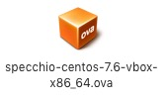

## Logging into the Virtual Machine

Login as user ‘specchio’ using the password ‘specchio’.

## Virtual Machine Configuration

Depending on your host machine, you may have to configure the keyboard to be used by the VM. To do this, select ‘System Tools’-‘Settings-‘Keyboard’ from the menu

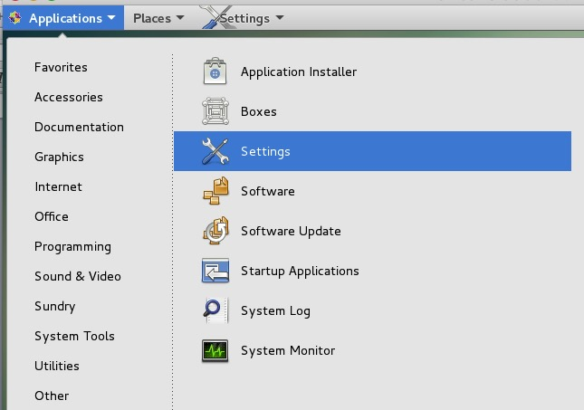

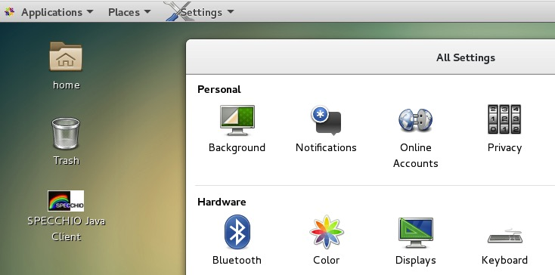

## Accessing SPECCHIO via the Web Interface

**This function is currently out of order as it needs upgrading to Glassfish4.**

SPECCHIO features a new interface via a web browser, starting with version 3.2.1.6.

The SPECCHIO VM comes pre-installed with the web interface. To start it open a browser in the VM and enter localhost:8080 as address:

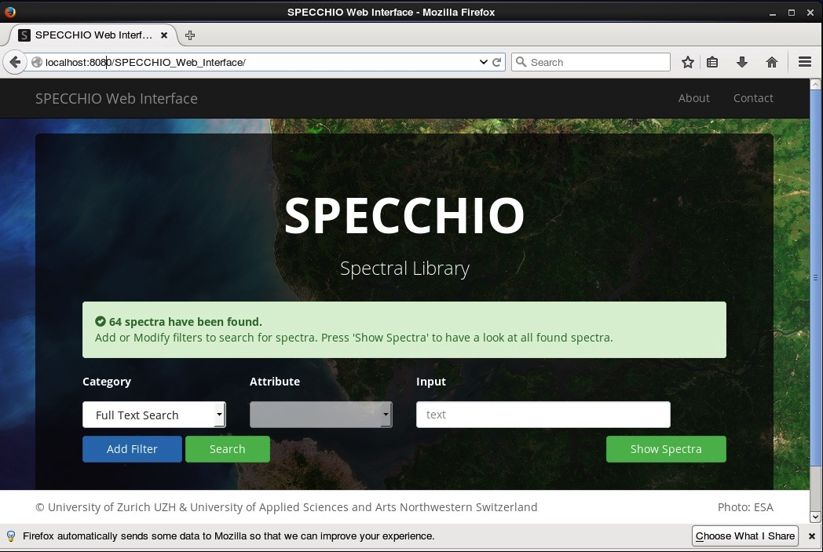

To access the web interface from host system, no further configurations are required, as port 8080 is by default forwarded to the SPECCHIO VM. Hence, in your host system type localhost:8080 into the address field:

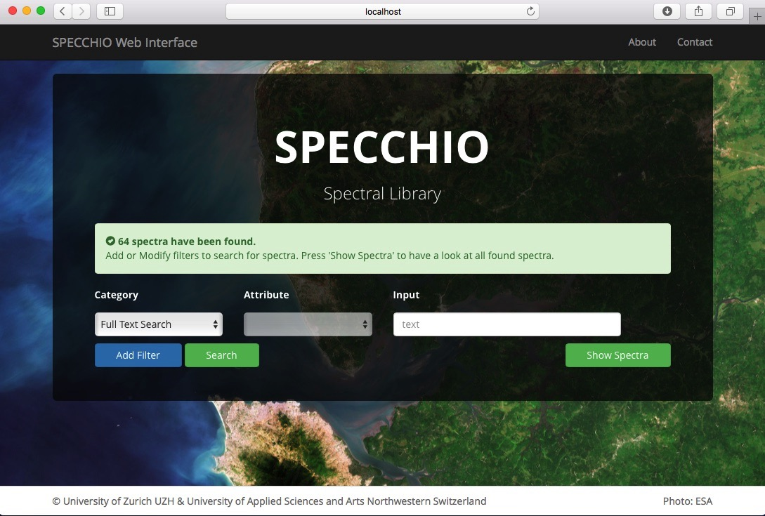

## Launching the SPECCHIO Application

Double-click the SPECCHIO Client App icon on the desktop and a few seconds later the SPECCHIO application is launched.[[1]](#footnote-1)



Figure 1: SPECCHIO client launching icon on the desktop

Use the existing connection using port 8181 to connect to the database as SPECCHIO database administrator (sdb\_admin).

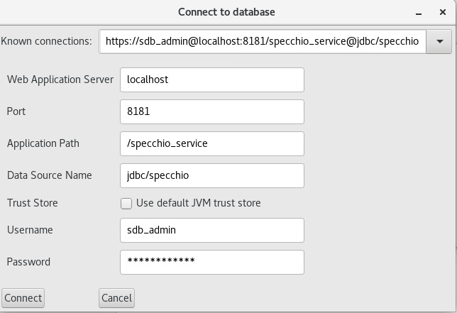

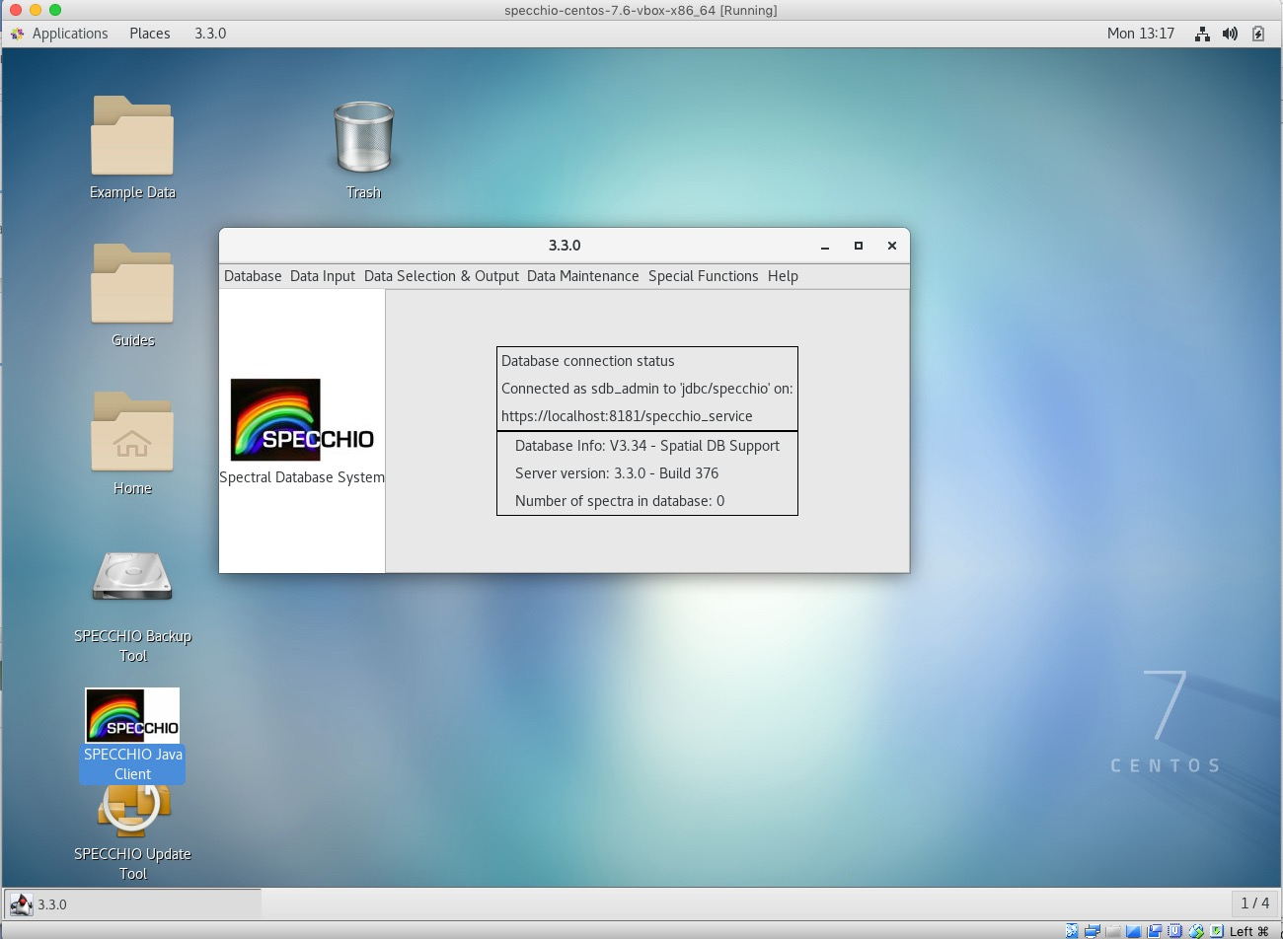

## Creating a User Account

**Note:** this SPECCHIO server is preconfigured for use with the sdb\_admin user. Adding a new user is not strictly required.

User Accounts can be created by connecting to the https port 8181.

This works without any further configuration from within the SPECCHIO VM as well as by using a SPECCHIO client running on the host system.

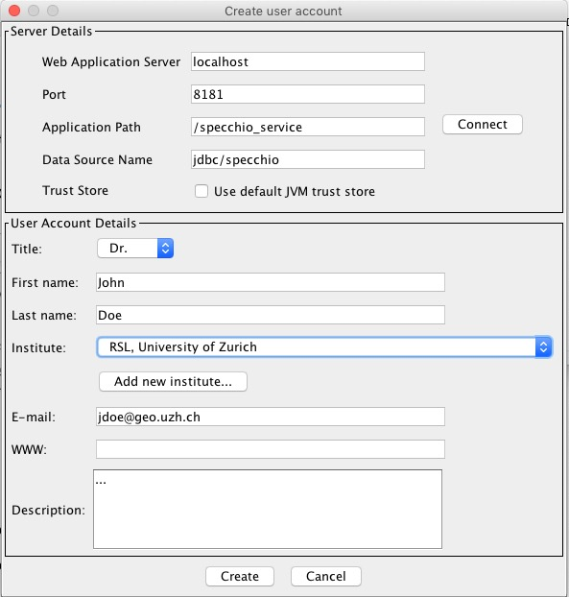

## Networking Access to the SPECCHIO Server

The SPECCHIO server running inside the VM can be accessed from the network. The following options exist:

* Connect to SPECCHIO server from the host machine, i.e. the machine running the VM (see 3.9)
* Connect to SPECCHIO server from a machine different from the host machine (see 3.10)

The SPECCHIO VM comes preconfigured in the NAT networking mode. Connections to the VM are established via port forwarding rules.

By default the localhost, i.e. the host machine is preconfigured for the port forwarding. To open the port forwarding option dialogue, open the ‘Settings’ dialogue of your VM, then select the ‘Network’ tab and display the ‘Advanced’ settings, then click on the ‘Port Forwarding’ button.

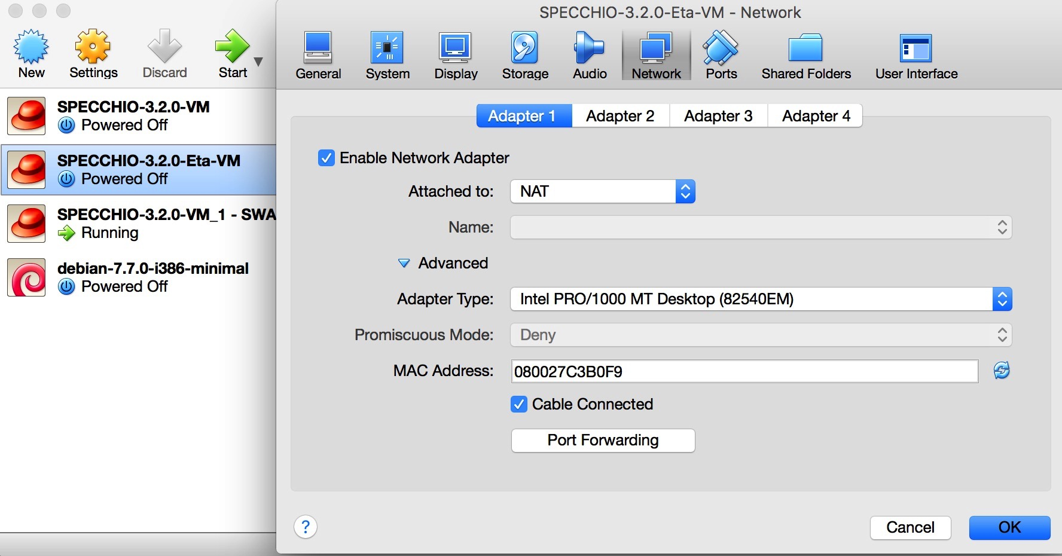

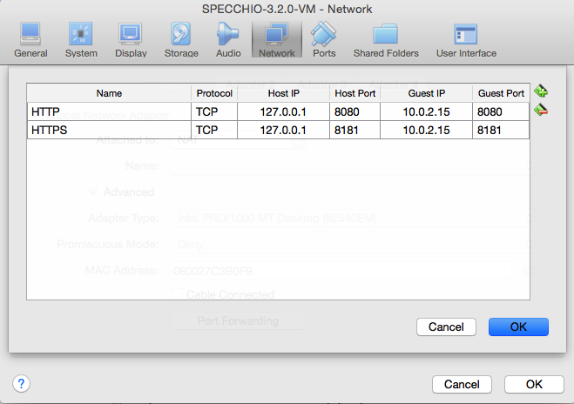

If access to the SPECCHIO VM is required from other machines in the network, then the forwarding rule must be defined with the IP of the host machine. The port forwarding defines which packets reaching a port on the host shall be forwarded to a certain port in the VM. The example below defines two forwarding rules (a) all connections on the host via port 8080 or 8181 are forwarded to the VM, and (b) all connections from external to the host (which in this example got the dynamic IP 130.60.16.221) on port 8080 or 8181 are forwarded to the VM.

Note that the guest IP remains the same once the networking is configured as NAT. The only problem that presents itself is the changing IP of the host machine. Ideally the host has a static IP, otherwise, once the IP is assigned via DHCP, the port forwarding table must be updated.

If the IP is defined by DHCP then the rules must be adapted each time the IP changes, usually a re-lease is triggered by disconnecting the machine from the network and not reconnecting for a certain time. Thus, the easiest solution is to keep the host machine running the SPECCHIO VM connected to the network as long as it must be accessible via the network. Optionally, a fix IP would solve this issue once and for all, but this may only be feasible for servers.

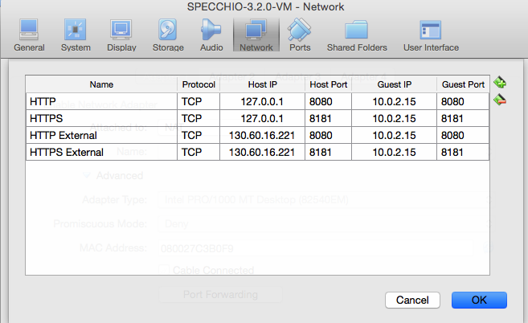

## Accessing SPECCHIO from the Host Machine

You can connect to the virtual SPECCHIO server from the hosting machine using the SPECCHIO Client.

**Prerequisite**: install the SPECCHIO client on the host machine.

The next step involves copying the database access information from the SPECCHIO client in the VM machine (SPECCCHIO\_client\_VM) to the SPECCHIO client on the host machine (SPECCCHIO\_client\_HOST).

Enable the editing of the SPECCHIO db\_config.txt file by ticking the option in the SPECCHIO Preferences for both clients (SPECCCHIO\_client\_VM and SPECCCHIO\_client\_HOST).

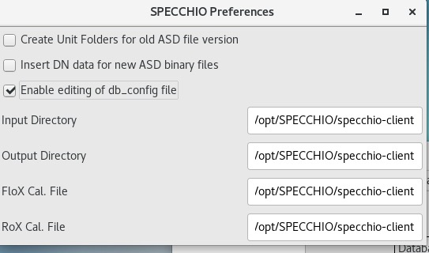

Open the SPECCHIO db\_config.txt file in the Virtual Machine (SPECCCHIO\_client\_VM) and on the host SPECCCHIO\_client\_HOST by selecting ‘Edit db\_config file’ from the SPECCHIO menu. Copy the https connection string from the Virtual Machine to the db\_config file on the host machine.

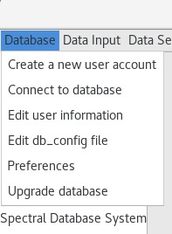

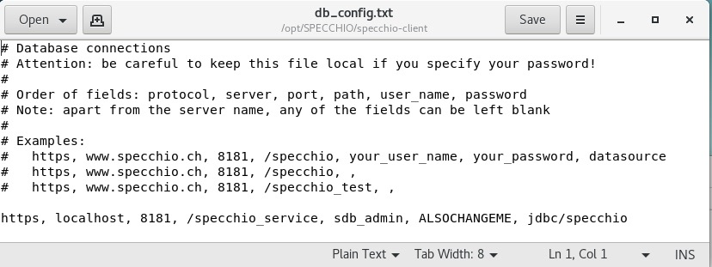

Restart the SPECCCHIO on the host system to make it re-read the db\_config file.

Connect to the SPECCHIO server running in the Virtual Machine:

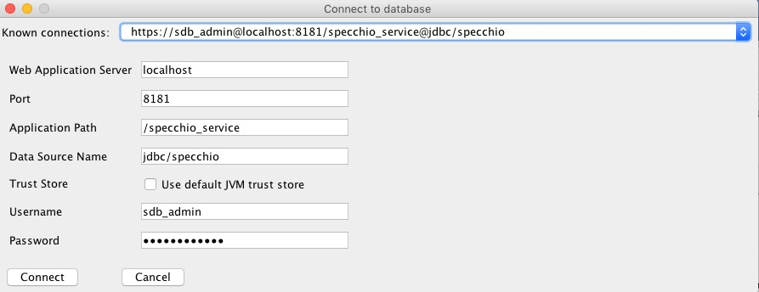

## Accessing SPECCHIO from Outside the Virtual Machine

Connecting from outside[[2]](#footnote-2) of the VM with a SPECCHIO Client requires a connection via the IP of the host machine, the connection is then automatically forwarded to the VM (Ensure that the forwarding rules for this IP are defined in the VM, see 3.8).

Copy the connection details as described in section 3.9. In the db\_config file on the external machine replace the server name ‘localhost’ with the IP of the host, e.g. for 130.60.16.221:

http, 130.60.16.221, 8080, /specchio\_service, sdb\_admin, 5p3cch10\_SDB\_VM, jdbc/specchio

Connect to the SPECCHIO server running in the Virtual Machine:

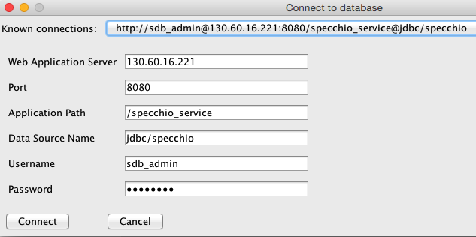

## Accessing SPECCHIO VM in the Field without any existing Network

**In Work … This section is not yet finished. More information will be added when practical tests have been conducted.**

This assumes that the SPECCHIO VM is used in a setting where no Ethernet of WiFi connection is existing per se.

Using the SPECCHIO VM on a single machine is no problem as no network is required.

Using the SPECCHIO VM running on one machine and connection from other machines to it requires the setup of an ad-hoc wireless.

This will be machine dependent and only the case of MacOS is used to illustrate this.

On the host machine running the SPECCHIO VM create a WiFi network:

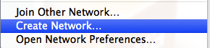

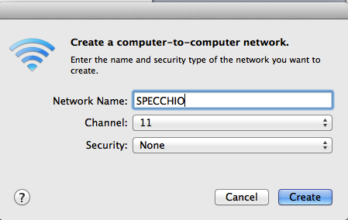

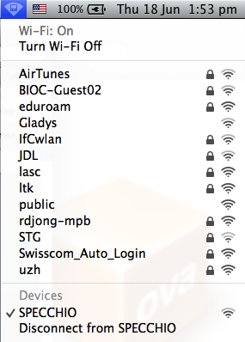

If the SPECCHIO VM is configured to have a static IP, the VM should be accessible to all machines connecting to the new wireless network.

## Mounting a host folder into the VM

This is not specific to the SPECCHIO VM, but useful to know anyway:

Add the folder of the host machine to be shared with the VM in the Shared Folders list and give it a name, in the case below ‘Documents’:

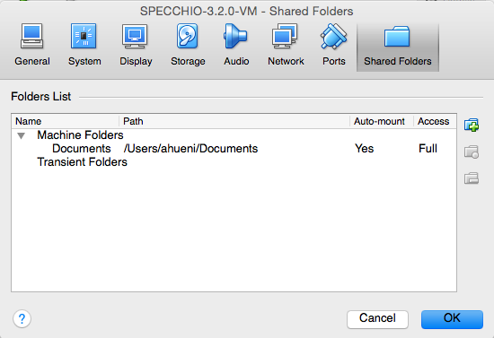

Assume you want to share your Documents folder and mount it in /mnt in the VM.

In the VM, mount the shared folder by opening a terminal window and type:

mount –t vboxsf Documents /mnt

Note: Auto-mount should work, but will need a restart of the virtual machine.

## Handling larger database requirements

The size of the VM is limited by means of configuration. For larger databases it is suggested that the database physical files are not held within the database but put onto a different server that will then be visible to the SPECCHIO VM. This could for example be achieved by putting the database file on the host machine and linking the directory into the VM.

While theoretically possible, this option has not yet been implemented, thus, no details can be presented here.

# Database access from the Host Machine

This step is required if the MySQL database bust be accessible from the host machine. Reasons for this are: (a) use the MySQL Workbench on the host machine to work on the SPECCHIO database running within the VM, or (b) as SPECCHIO developer to run the SPECCHIO web service in and IDE (e.g. Eclipse) on the host machine and use the SPECCHIO database in the VM.

Step 1: add another port forwarding for the SPECCHIO VM in the Oracle VM VirtualBox Manager. The host port may be chosen freely; here 4406 is used is it should not clash with local MySQL installations.

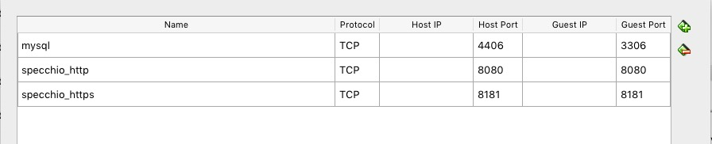

Step 2: Start the MySQL workbench inside the VM, login as database root and create a new entry for the sdb\_admin user. This will enable the user to connect to the database from hosts other than localhost.

CREATE USER 'sdb\_admin'@'%' IDENTIFIED BY 'ALSOCHANGEME';

GRANT SELECT, DELETE, INSERT, UPDATE, ALTER, DROP, CREATE, CREATE VIEW, GRANT OPTION, TRIGGER, REFERENCES, LOCK TABLES, SHOW VIEW ON `specchio`.\* TO 'sdb\_admin'@'%';

GRANT SELECT, DELETE, INSERT, UPDATE, DROP, CREATE TEMPORARY TABLES, GRANT OPTION, LOCK TABLES, SHOW VIEW ON `specchio\_temp`.\* TO 'sdb\_admin'@'%';

GRANT SUPER, CREATE USER ON \*.\* TO 'sdb\_admin'@'%';

GRANT INSERT ON `mysql`.`user` TO 'sdb\_admin'@'%';

UPDATE `mysql`.`user`

SET `Reload\_priv`='Y', `Process\_priv`='Y', `Update\_priv`='Y', `Delete\_priv`='Y', `Select\_priv`='Y'

WHERE `user`='sdb\_admin' AND `host`='%';

FLUSH PRIVILEGES;

# Upgrading the SPECCHIO System

SPECCHIO remains under active development and both the client application and the web service binary as well as the SPECCHIO database require occasional updates.

## Upgrade Scenarios

There are three possible scenarios when upgrading SPECCHIO.

1. Upgrading from a SPECCHIO VM dates earlier than March 2019, which does not yet support the new SPECCHIO database backup tool shipped with the later versions
2. Updating the SPECCHIO client and server inside the virtual machine.
3. Replacing the virtual machine image with a newer version of it.

## Upgrade from an old SPECCHIO VM

This section applies only when upgrading from an older SPECCHIO VM (per March 2019), which was shipped without the SPECCHIO database backup tool.

### Creating and Exporting a dump in the old SPECCHIO VM

Use MySQL Workbench to dump the SPECCHIO tables into a SQL file. Make sure to tick ‘Include Create Schema’.

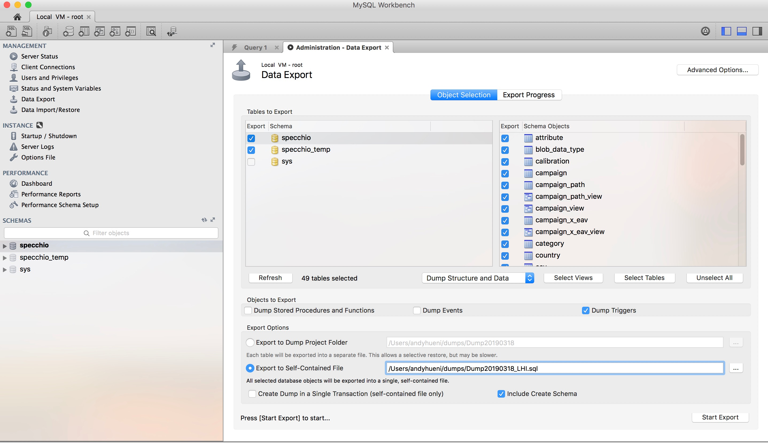

Export your dump to your host system by following the section on ‘Transferring the dump’ in this guide.

### Transferring and Importing an old dump in the new SPECCHIO VM

Transfer the dump into the new SPECCHIO VM by following the steps on ‘Transferring the dump’ in this guide.  
Import the dump into your new VM by using the command line. Open a Terminal and type:

sudo mysql

This opens the prompt of MySQL (MariaDB).

Remove the existing SPECCHIO schema by typing:

drop schema specchio

Load your dump by typing:

source <path to your dump>

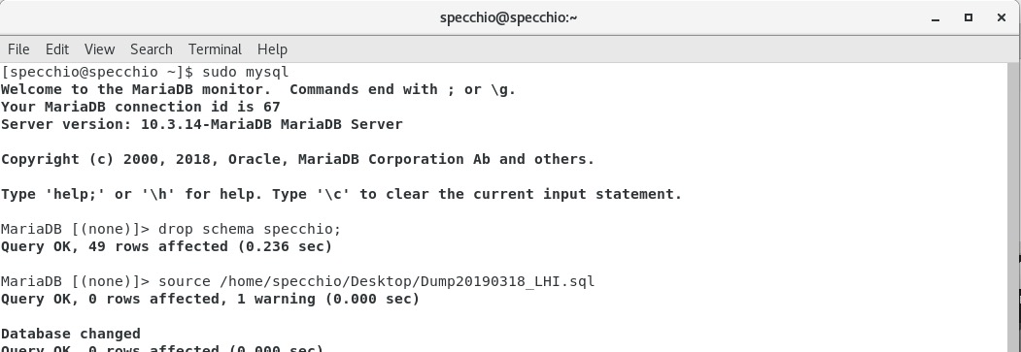

Update the admin password in the imported database to match the default password of sdb\_admin user in the new SPECCHIO VM:

ALTER USER 'sdb\_admin'@'localhost' IDENTIFIED BY 'ALSOCHANGEME';

Update specchio.specchio\_user set password = MD5('ALSOCHANGEME') where user = 'sdb\_admin';

flush privileges;

To complete the upgrade, carry out the schema upgrades via the SPECCHIO client as described in this guide: Apply Schema Changes.

## Server and Client Software Upgrades

### Automatic Upgrade (In-place Upgrade)

Most of the times you simply want to get your hands on a new SPECCHIO release. For this, you need to start the “SPECCHIO Update Tool” and confirm the dialog. The script will then download the most recent SPECCHIO client and webapp release.

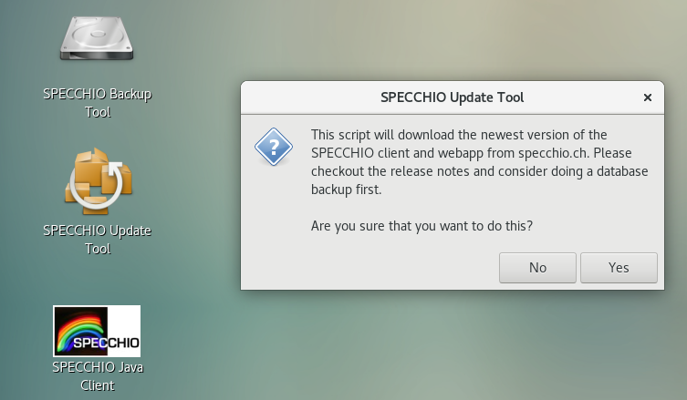

You can now skip to the chapter “Post-upgrade tasks” for tasks you might have to do after an upgrade.

### Manual Upgrade

Follow these instructions if:

* You have no network access in the VM but have the binaries on some disk.
* The automatic upgrade fails for some reason.
* The binaries you want to install are not the ones on GitHub (e.g. if you get a test version)

#### Manual Web Service Update

Download the new binary specchio-webapp.zip from the SPECCHIO Jenkins page [[3]](#footnote-3):

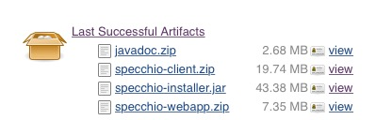

Figure 2: Jenkins SPECCHIO artifacts page

* Copy the new binary into /opt/SPECCHIO/

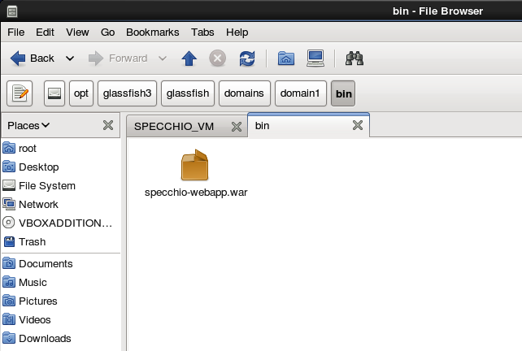

Figure 3: Location of the web service binary

* Deploy the new binary by the following commands in the shell:

cd /opt/glassfish4/glassfish/bin

./asadmin deploy --force /opt/SPECCHIO/webapp-3.3.0.war

./asadmin stop-domain

./asadmin start-domain domain1

#### Manual SPECCHIO Client Update

Login as centos user or root.

Download the latest cross-platform client installation package from <https://specchio.ch/downloads/> and run the installation package. The SPECCHIO client is installed in /opt/SPECCHIO/specchio-client/.

## Virtual Machine Image Upgrade

To upgrade the virtual machine image you want to download the newest version from the website. Then start the new virtual machine as well as the old one side by side.

By default, the only persistent thing inside the virtual machine is the database. The database can be exported through the built-in SPECCHIO backup tool. This export (also called database-dump) can then be transferred to the new virtual machine and imported using the same tool.

You might also consider creating a snapshot of your current virtual machine (just in case). Check out the [Vi](https://www.virtualbox.org/manual/ch01.html#snapshots)rtualBox manual on how to do this.

### Database Export

Simply click on the desktop link called “SPECCHIO Backup Tool”. You will then be asked whether you would like to do a backup or restore an existing database-dump. Select “Backup”:

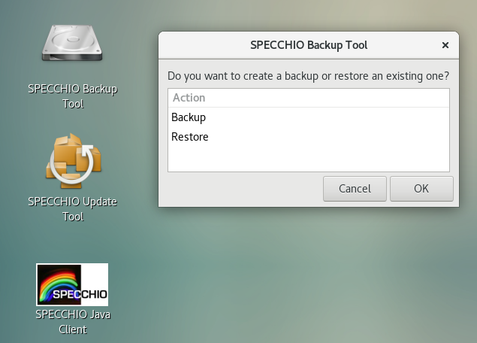

Confirm once more that you want to create a backup. Also, ensure that your virtual machine has enough space to store the database export:

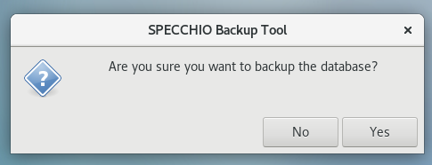

Depending on the size of your database you will see a progress bar. After the export has finished you should see a confirmation that the backup was successful:

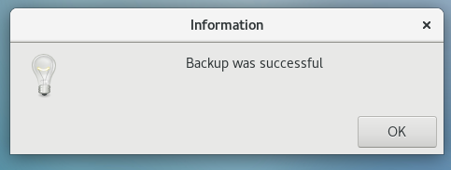

### Transferring the dump

To transfer your backup to the new virtual machine image we recommend that you create a shared folder and copy the database dump to your host system. Then create a second shared folder inside the new virtual machine and restore the dump from there.

Open the shared folders menu (“Devices” → “Shared Folders” → “Shared Folders Settings...”). Then click on the folder with the green plus symbol on it:

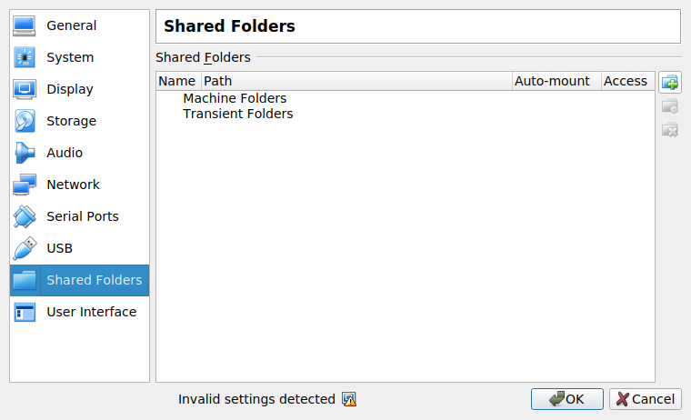

Create a new directory on your system and select it as “Folder Path”. Name the shared folder “specchio\_update” and ensure the “Auto-mount” feature is selected.

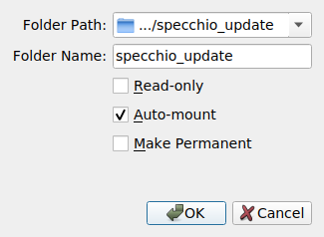

You then want to restart the virtual machine. Once you’re logged in again you should see a new symbol on your desktop called “sf\_specchio\_update”. Open up a terminal and copy your backup with rsync to the shared folder. (*sudo rsync -P Desktop/SPECCHIO\_\*.sql.gz /media/sf\_specchio\_update)*

* + 1. **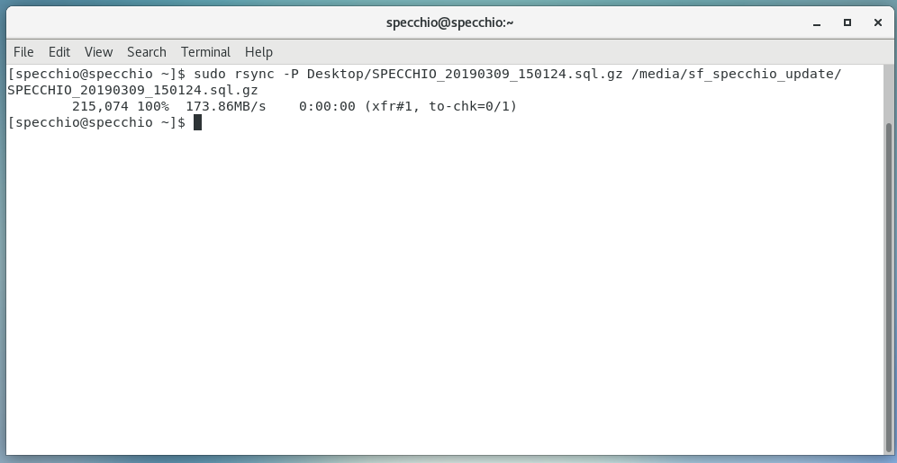**

Create the shared folder on the new virtual machine, reboot and run rsync again. This time with the arguments reversed. (*sudo rsync -P /media/sf\_specchio\_update/SPECCHIO\_\*.sql.gz ~/Desktop/).*

### Importing the dump

To import the database backup you want open the SPECCHIO backup tool but this time choose the “Restore” action.

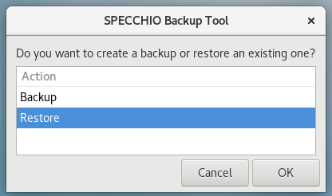

You will then be asked to specify the dump from which you want to restore:

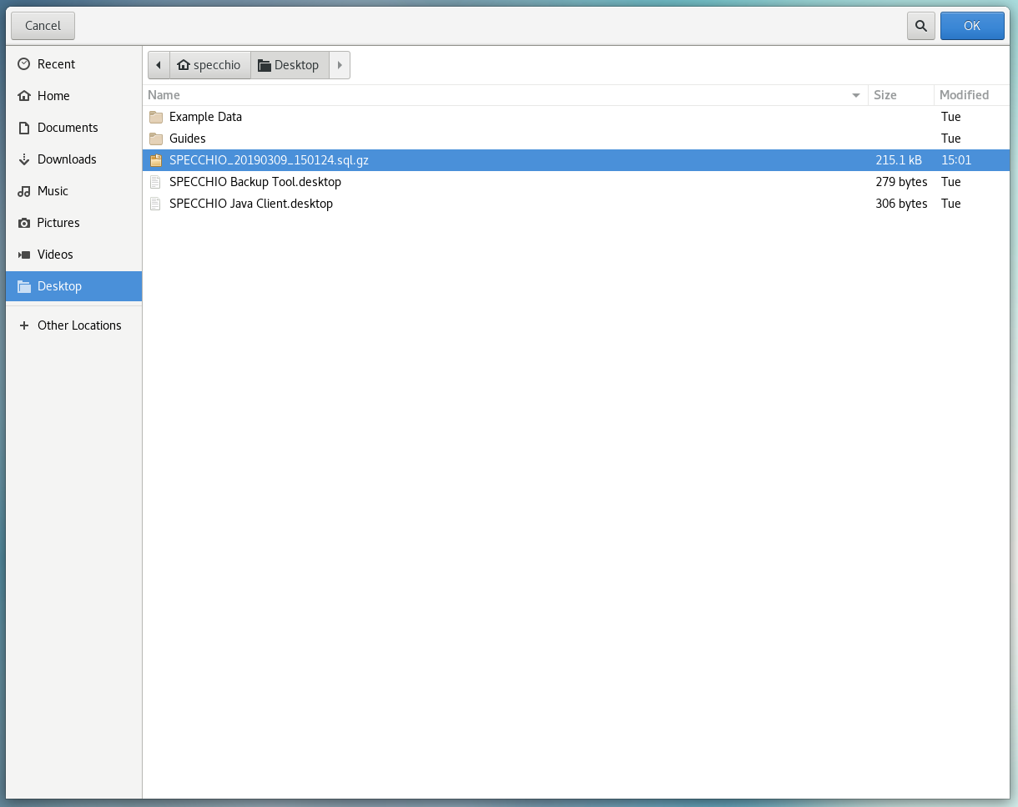

***Restoring a database will delete the current database and will also reset all users and passwords to the version of the dump. If you are ok with this, confirm the warning dialog:***

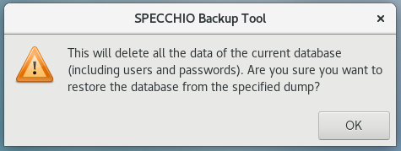

Once again dependent on the size of the dump you will see a progress bar or not. Once the import finished you should see the following infobox:

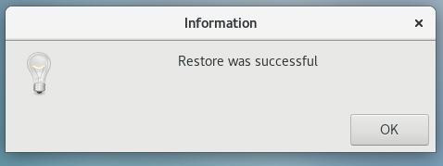

Congratulations; you’ve successfully transferred all your data to the new virtual machine.

## SPECCHIO Database Upgrades

**NOTE: Always dump the current version of the SPECCHIO database to a file before carrying out a database upgrade!**

A database dump is easiest created using the SPECCHIO Backup Tool (see 5.4.1).

A database dump can also be created from the command line:

mysqldump --user=root --max\_allowed\_packet=512M --host=127.0.0.1 --default-character-set=utf8 "specchio" --result-file=specchio\_dump.sql

The default password of the MySQL root user is empty.

To restore a dump in case something went wrong during an upgrade use:

sudo mysql -u root

mysql> use specchio

mysql> source specchio\_dump.sql

**Note: SPECCHIO V3.3 and higher requires MYSQL 5.5 or higher due to the spatial extension.** Old versions of the VM (pre 3.3.) cannot be upgraded by this routine. The easiest solution is to dump the database, install the SPECCHIO VM 3.3.0.0 or higher and import the dump. Then carry out the database upgrade as described below.

Starting with server and client version 3.3.0.0 an automatic upgrading process is part of SPECCHIO. This is relevant, as some upgrades, e.g. the spatial upgrade in V3.3.0.0, require more complex operations that are encoded on the server side within the SPECCHIO web application Java code.

1. Install the new war file (V3.3.0.0 or higher)
2. Install the new client application (V3.3.0.0 or higher)
3. Start client application, login as admin user
4. Select ‘Upgrade database’ from the Database menu  
     
   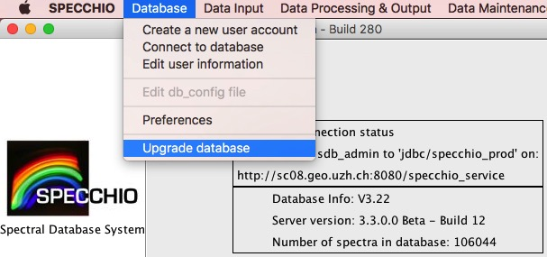
5. The current version and the available upgrades are displayed. Click OK to install all required upgrades in sequential order.  
     
   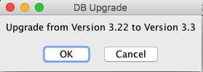

**Note**: Upgrades between 3.3.0 and 3.3.2 require a manual update of the rights of the sdb\_admin user. You will be prompted to do so by the upgrade process:

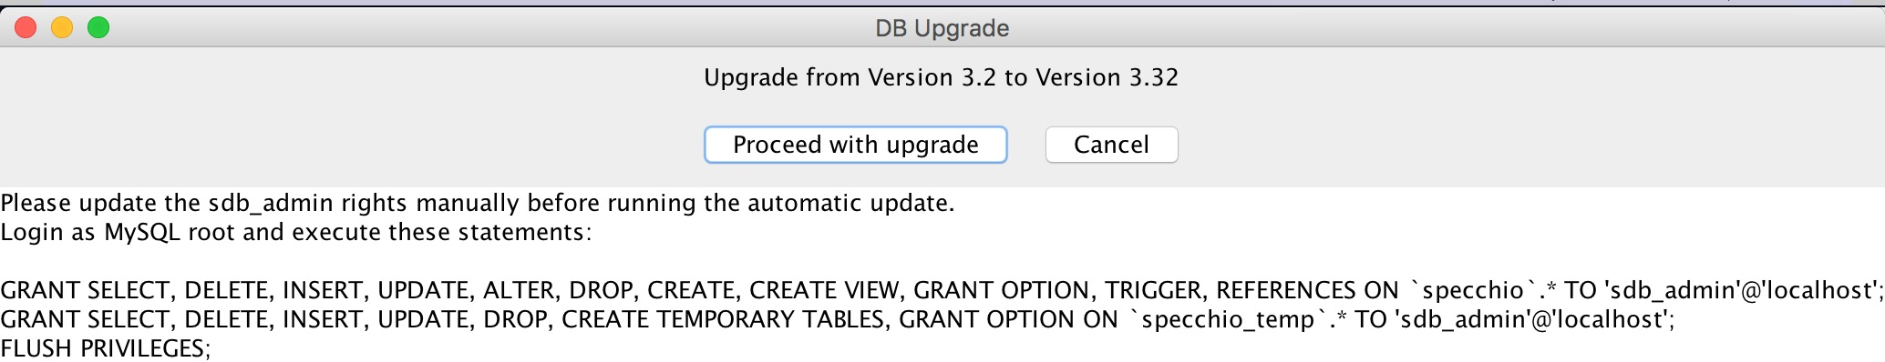

1. Change History

|  |  |  |
| --- | --- | --- |
| Date | Version | Changes |
| 18.06.2015 | 3.2.0.1 | Added networking details and fixes for MacOS.  Updated VM Machine Name  Fixed the authentication issue: user accounts can be created in the VM. |
| 01.07.2015 | 3.2.0.2 | More info on static IPs in connection with the NAT networking and port forwarding.  Added info on how to mount a host folder in the VM. |
| 07.10.2015 | 3.2.0.3 | Added info on how to upgrade the system to new SPECCHIO binaries.  Updates on the networking configuration. |
| 26.2.2016 | 3.2.1.0 | Added automatic installation info.  Updates to reflect new client launch icons. |
| 20.9.2016 | 3.2.1.3 | Update to add info on the keyboard configuration and version number update. |
| 25.1.2017 |  | Update on how to set up the host file on Windows to use the VM name. |
| 04.04.2017 | 3.2.1.6 | DB and java binaries update. Installation of new SPECCHIO WWW interface. Update of update shell script to properly restart the glassfish service. |
| 17.09.2017 | 3.3.0.0 | Updated the to CentOS 7 and MySQL 5.7 to allow the MySQL and SPECCHIO spatial extension to be installed. Updated the password of sdb\_admin.  Added upgrade instructions. |
| 23.9.2017 | 3.3.0.1 | Updated the specchio keystore to include certificate of new SPECCHIO VM. Updated the description on how to create a user account and connect to the VM. |
| 17.10.2017 | 3.3.0.1 | Included details on how to dump and restore the SPECCHIO MySQL database. |
| 19.01.2018 | 3.3.0.1 | Added details about manual update of sdb\_admin rights during DB upgrade. |
| 10.06.2019 | 3.3.0 | Update to new SPECCHIO VM, include Upgrade Guide Notes from SPECCHIO Packaging Project. |

1. Bridged Networking under MacOS – Ethernet and WiFi

The SPECCHIO VM is shipped with the networking set to NAT. The information hereafter is intended for user who want to user Bridged Networking under MacOS.

The SPECCHIO VM is then configured with the networking set to ‘Bridged Adapter’ and ‘en0: Ethernet’ selected [[4]](#footnote-4).

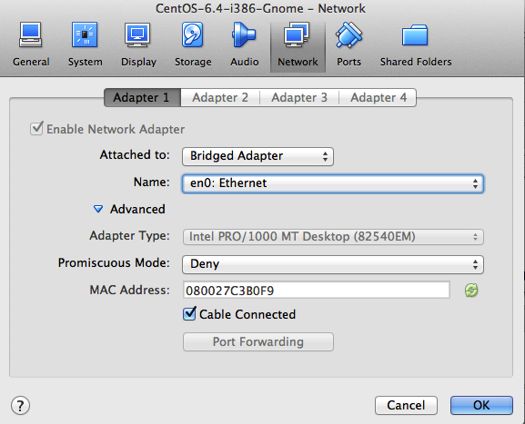

This allows the VM to access the Internet and to receive an IP from the DHCP. If using an Internet connection via WiFi, then this should be switched to Wi-Fi. [[5]](#footnote-5)

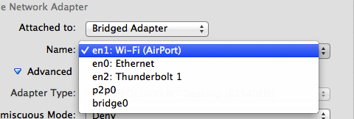

When using the MacOS host machine connected to the Ethernet, the DHCP will assign an IP to the virtual machine. If connected to WiFi then the bridging does not work at all, i.e. no connection to the Internet is possible from the VM. This is a persistent bug[[6]](#footnote-6).

There is however a workaround:

* On the Mac, open the ‘Sharing’ menu in the System Settings and select to share the Internet of the WiFi connection via Thunderbolt Bridge  
    
  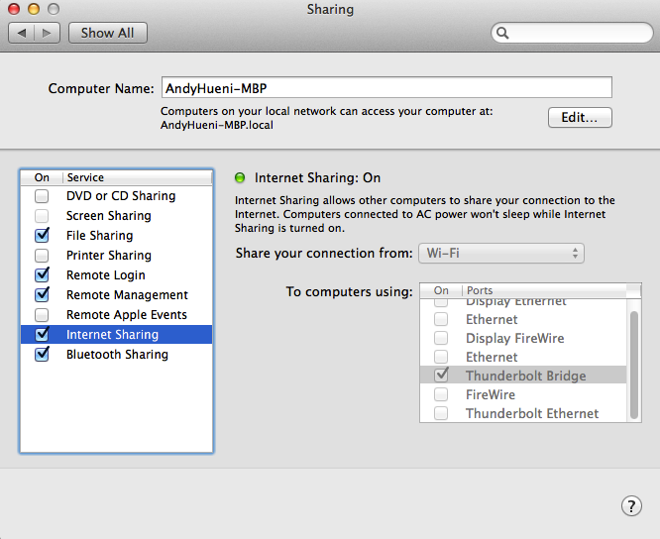
* In the VM, select ‘en2: Thunderbolt 1’  
    
  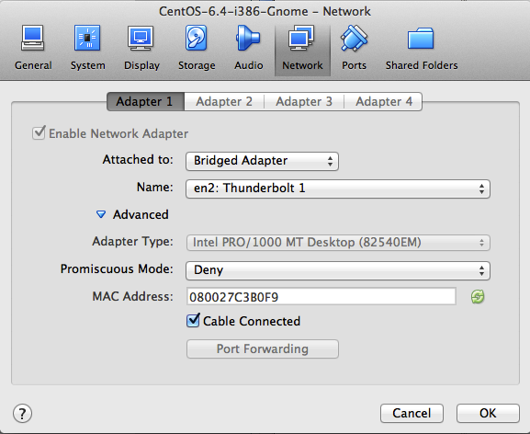
* The VM should now receive an IP from the DHCP and be able to access the Internet

1. The SPECCHIO application is installed in /opt/SPECCHIO/specchio-client/ [↑](#footnote-ref-1)
2. The host machine itself qualifies as well as ‘outside’ of the VM; i.e. the connection option described here works as well for the host machine, but using localhost as described in section 3.9 is the better option. [↑](#footnote-ref-2)
3. <https://jenkins.specchio.ch/job/SPECCHIO/> [↑](#footnote-ref-3)
4. This is presumably so, I actually do not know if these settings are part of the stored VM image. Should anyone know, give me notice of the fact. [↑](#footnote-ref-4)
5. I have not tested this yet, as on the Mac it does not work anyway. [↑](#footnote-ref-5)
6. https://www.virtualbox.org/ticket/10019 [↑](#footnote-ref-6)