Installation guide for Inter Repository Object Transfer Plugin.

To install Inter repository object transfer plugin, extract the given zip and put the folder InterRepoObjectTransfer to below path

Pentaho\pdi-ce-5.0.4-stable\data-integration\plugins\steps .
Now you can start spoon, Create new transformation. Now navigate to Big Data category and you can see latest added plugin.

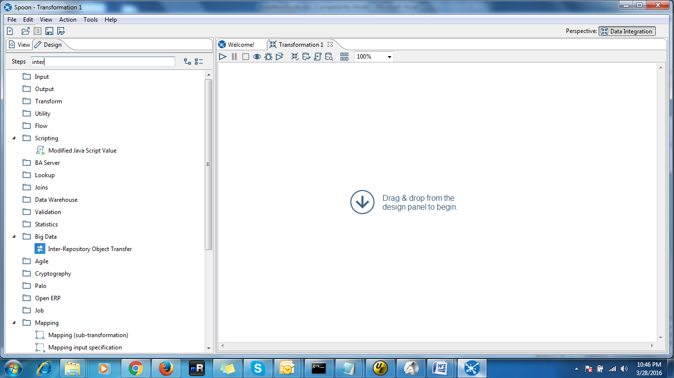

Handling for saving transformation to existing DB repositories issue.

After installation of new plugin, there would be error while saving transformation to existing DB repositories , so for resolution of this issue , we need to entry of new plugin in existing DB repositories, using following query:-

insert into r_step_type(ID_STEP_TYPE,CODE, DESCRIPTION, HELPTEXT)
select
(select (max(ID_STEP_TYPE)+1) as id from r_step_type) as ID_STEP_TYPE,
'InterRepoObjectTransfer' as CODE,
'Inter-Repository Object Transfer' as DESCRIPTION,
'Inter-Repository Object Transfer' as HELPTEXT

