Installation guide for Mongodb GridFS Output

To install Mongodb Gridfs output plugin we can put extracted file Mongogridfs_{x.x}.zip in Pentaho\pdi-ce-5.0.1-stable\data-integration\plugins\steps .
Now you can start spoon, Create new transformation. Now navigate to Big Data category and you can see latest added plugin.

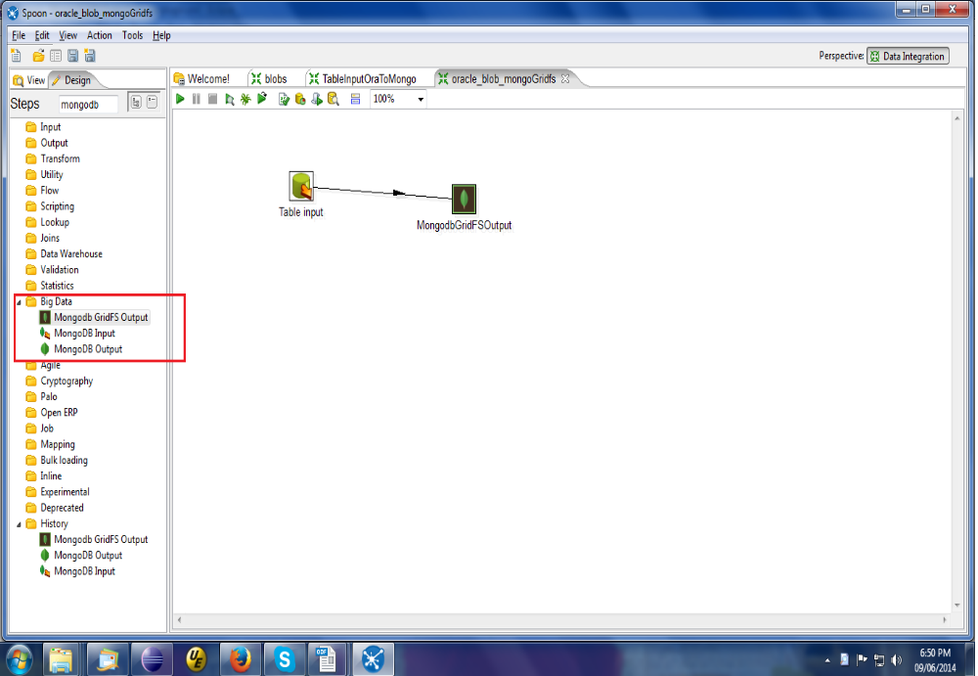

Demos by SPEC INDIA :
We prepare very simple and usefull demo.
1)File Path :
In first demo we use simple Data grid plugin in which we define various fields like filepath,metadatas and id.

Location : Pentaho\pdi-ce-5.0.1-stable\data-integration\plugins\steps\Mongogridfs{x.x}\DemoTransformation\FilePath.ktr
This transformation will perform get file from specify location and data insert into mongodb girdfs.
2)Blob Data :

We tested this plugin with Oracle (BLOB),Postgres(Bytea) and Mysql(BLOB). So here are all three example in following location.
We also put blob sample data dump on following location

Location : Pentaho\pdi-ce-5.0.1-stable\data-integration\plugins\steps\Mongogridfs{x.x}\DemoTransformation\Dump\

Location : Pentaho\pdi-ce-5.0.1-stable\data-integration\plugins\steps\Mongogridfs{x.x}\DemoTransformation\OracleToMongodGridfs.ktr
Location : Pentaho\pdi-ce-5.0.1-stable\data-integration\plugins\steps\Mongogridfs{x.x}\DemoTransformation\PostgresToMongodGridfs.ktr
Location : Pentaho\pdi-ce-5.0.1-stable\data-integration\plugins\steps\Mongogridfs{x.x}\DemoTransformation\MysqlToMongodGridfs.ktr

This transformation will perform get blob dataand data insert into mongodb girdfs.

Note : If already installed Mongodb GridFS Output plugin in your PDI and you want to install leatest version of it then first remove old plug in Pentaho\pdi-ce-5.0.1-stable\data-integration\plugins\steps and install new plugin in same folder.

Extra : Along with this plugin we also include one console base application called BLOB utility. Which is use to insert or retireve blob data in Oracle,Postgrest,MySql and Mongodb GridfS. Location : Pentaho\pdi-ce-5.0.1-stable\data-integration\plugins\steps\Mongogridfs{x.x}\BlobDataOperation\BlobUtility.jar. You can configure various database with its Property files.

