- User Interface

We have designed this system to remove complexity of report generation process and user no need to give more inputs that's makes LogAnalyzer user friendly.
LogAnalyzer supports 24 hours time format.
Valid input for Time should be 00:00:00 to 23:59:59

- LogAnalyzer Report
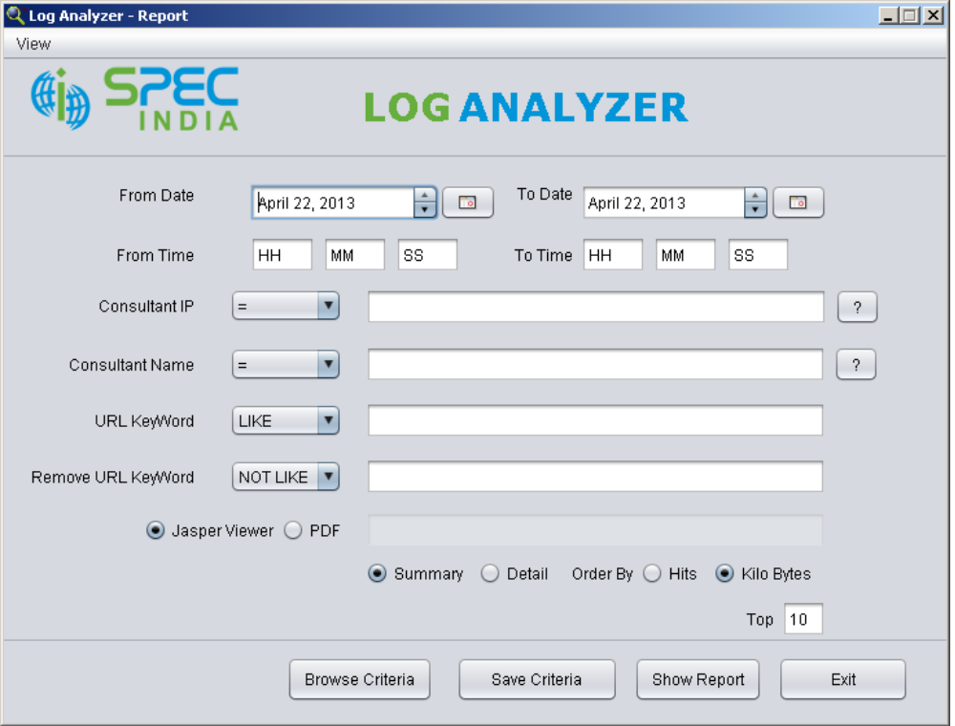
This is the primary interface for log analysis through which user can generate reports by giving inputs to different criteria
Log reports can be generated on various criteria such as Consultant IP, Consultant Name, URL keyword etc.
Primary input to generate report is the From Date and To Date , by giving this two inputs user can generate report between given dates.
LogAnalyzer provides two facilities to view reports either view report using jasper viewer or save report in PDF document.

(2) Available Operators

To better analysis LogAnalyzer provides various operators to generate reports
1. Consultant IP and Consultant Name have =, IN and NOT IN operators.
2. URL Keyword has LIKE operator.
    - Remove URL Keyword has NOT LIKE operator.

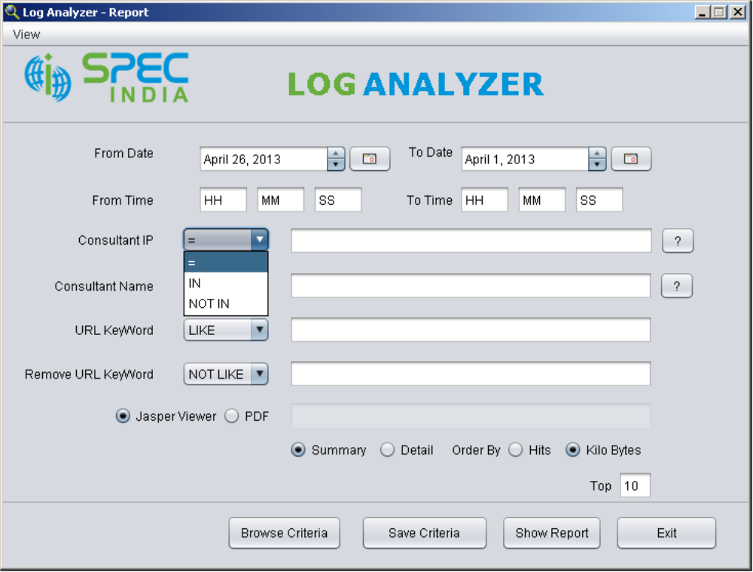

(3) Date Validation

If To Date is before From Date then LogAnalyzer warns user that “To date should not be before from date” and
prevents user to generate report.

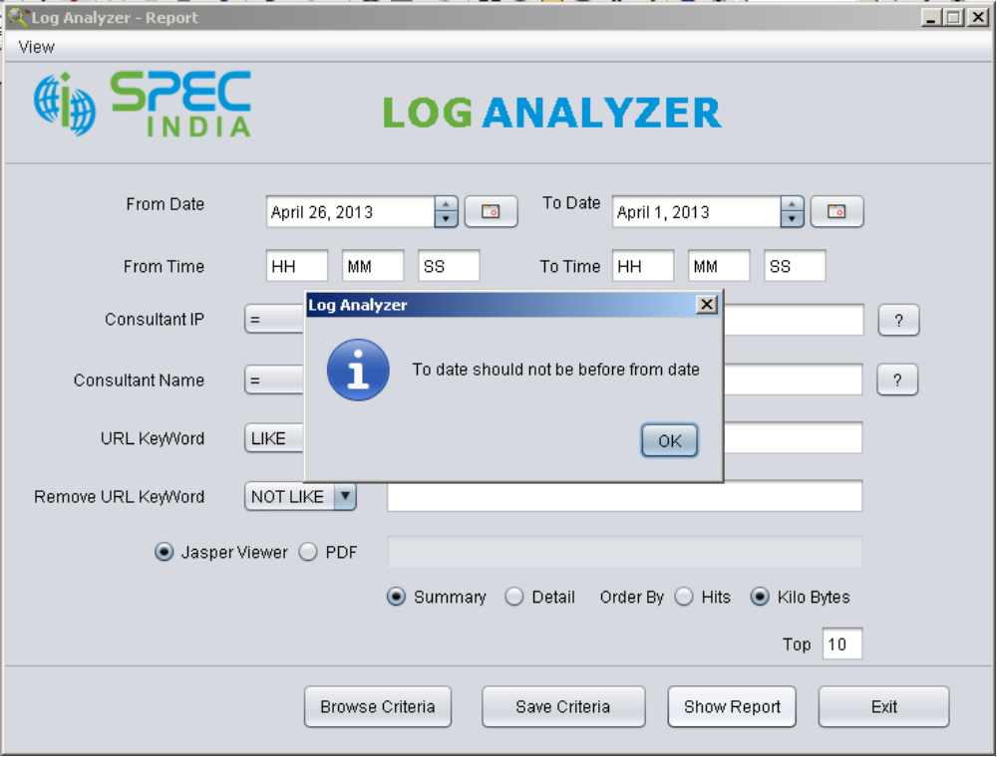

- Consultants Name and IP address

LogAnalyzer also has facility to show available consultants name and ip address which helps user to generate specific report if user do not know the consultant name and ip.

Click on the following button to see consultant name and ip address.

It will generate following report.

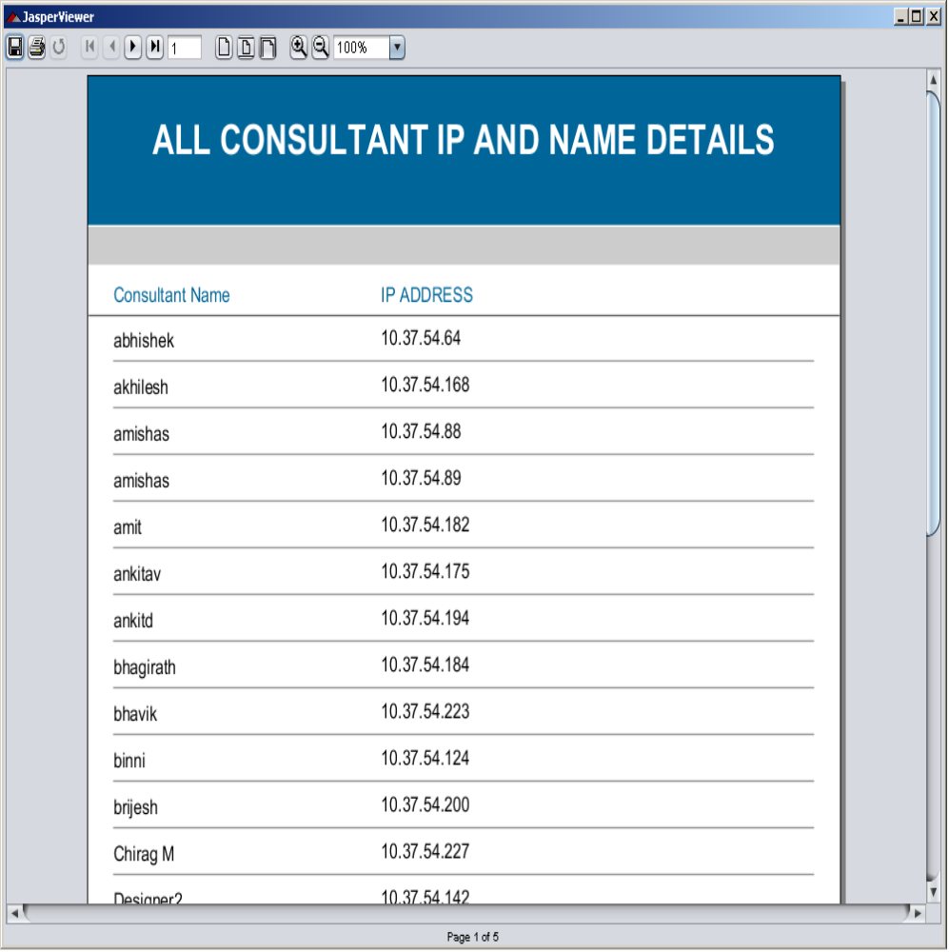

- Report Generation Process

Give input according to your requirement and then click on Show Report button.
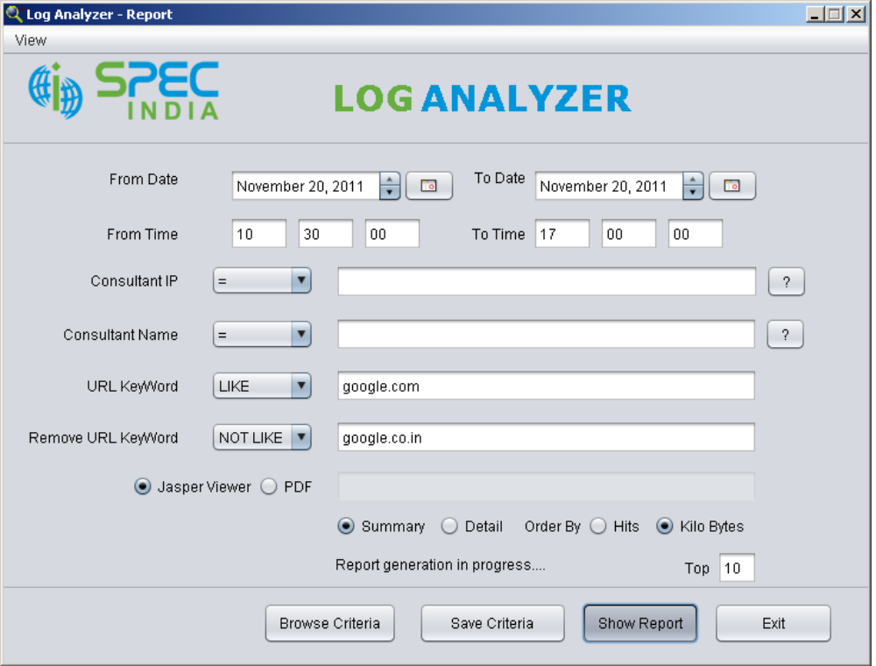

It has generated following report.

Horizontal Bar Chart
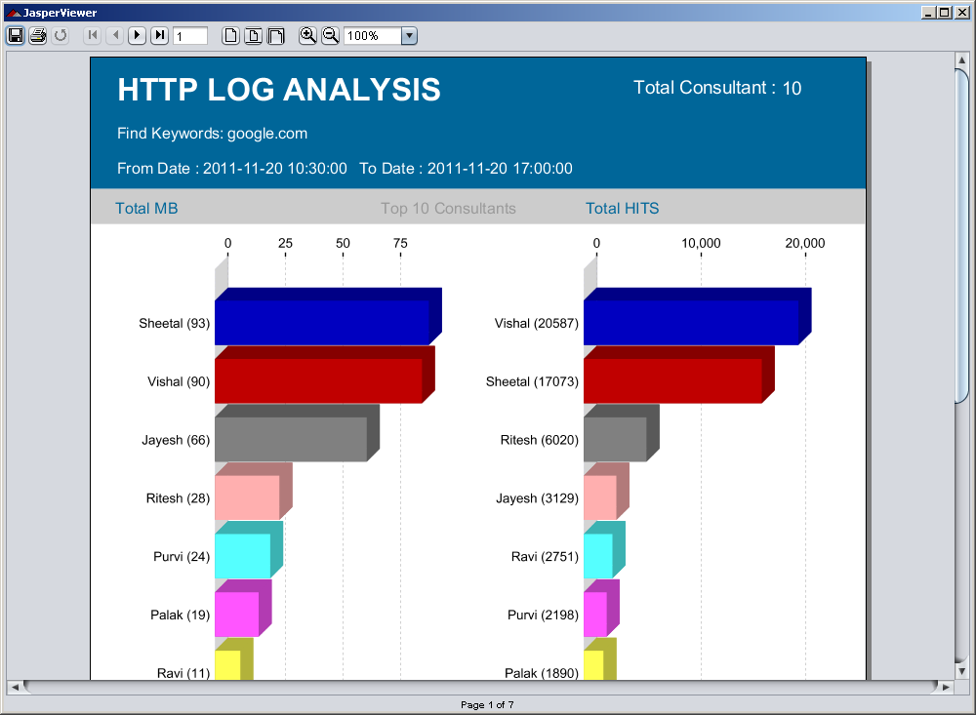

Summary Information

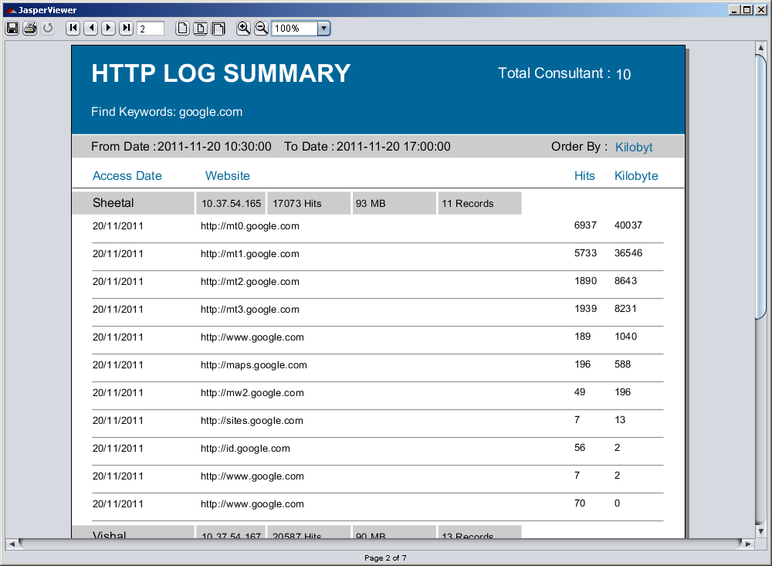
User can provide more filter to generate specific report according to requirement.

- Consultant Specific Report

If user wants report only for specific consultant then LogAnalyzer have facility to take multiple inputs.

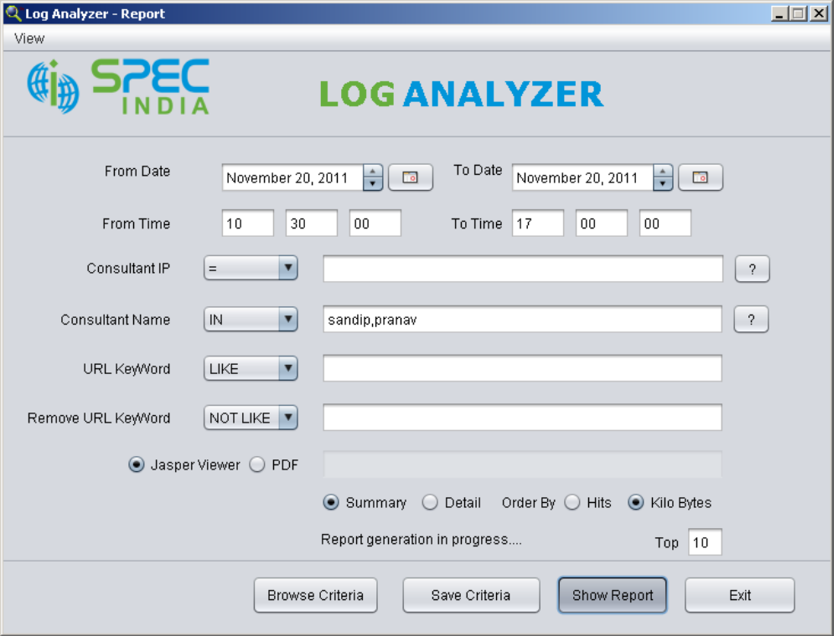
It generates following report.

Horizontal Bar Chart
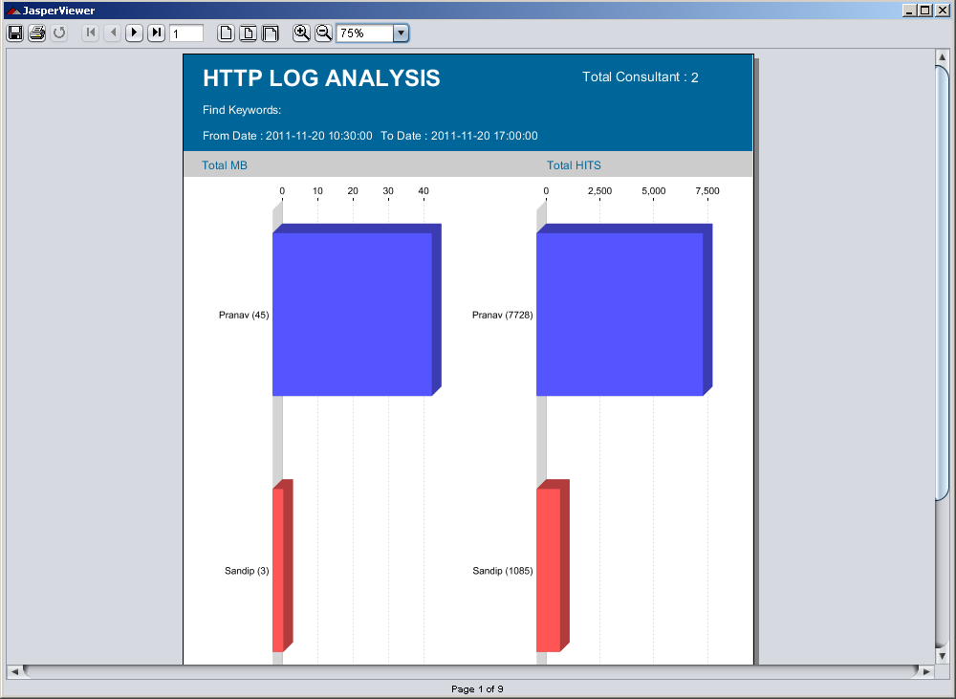

Summary Information of each consultant

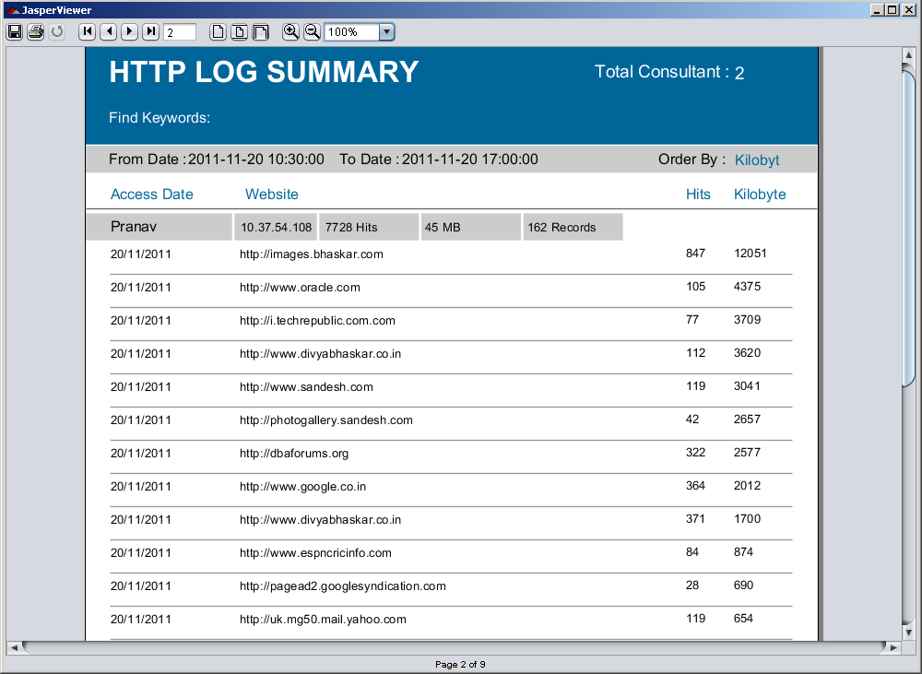

- Detail Report

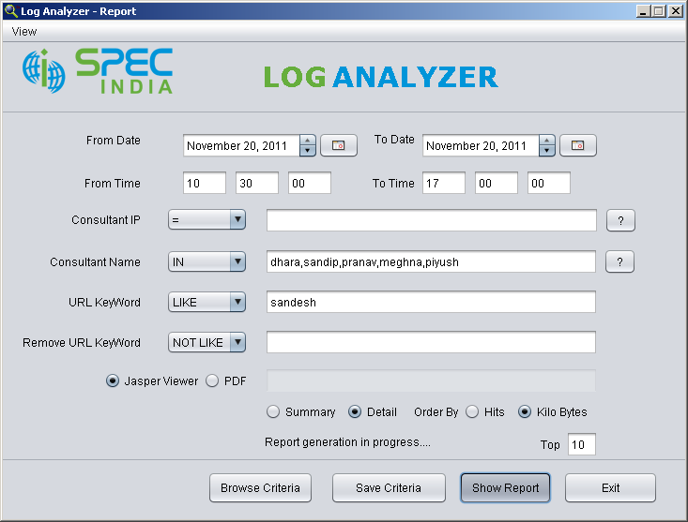

Horizontal Bar Chart

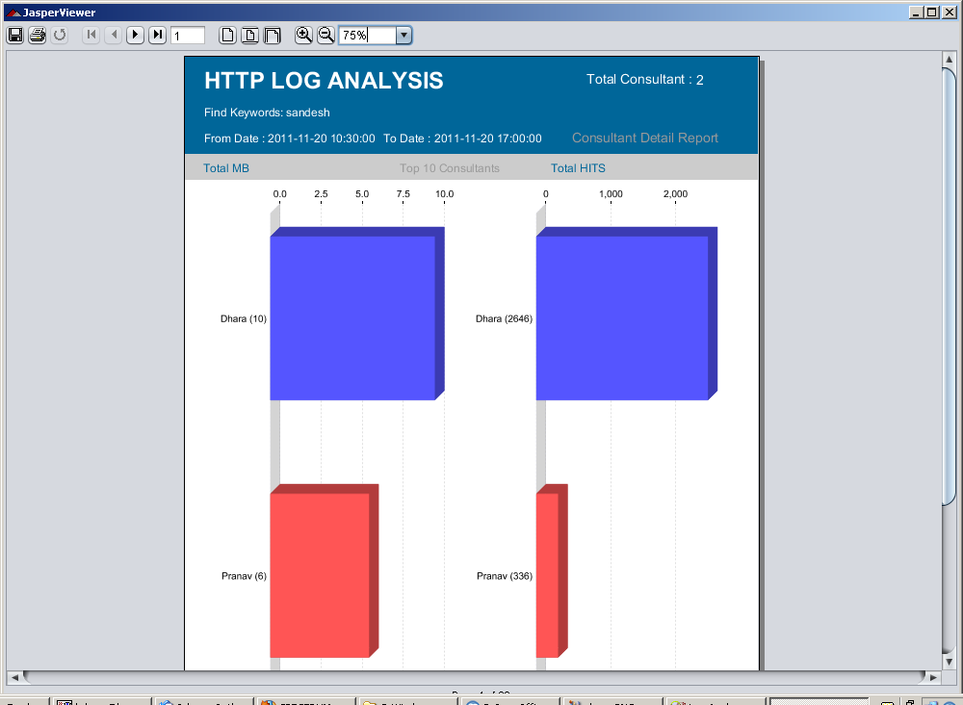

Detail information of each consultant

In this report whole url information with time is shown.

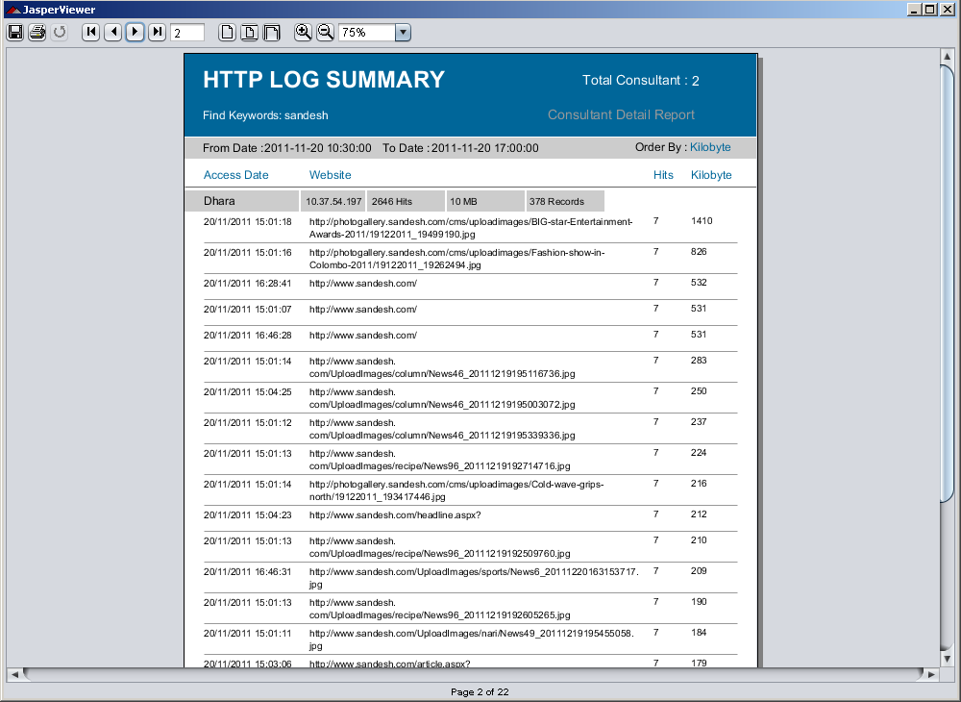

- Save Criteria

LogAnalyzer also has facility to save user input to file so that in future if user wants to generate same report
then user can directly browse saved file. It makes LogAnalyzer more user friendly.

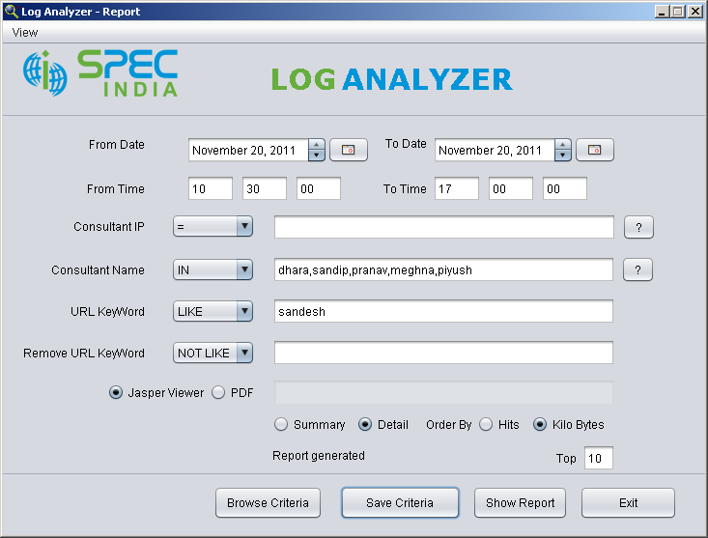

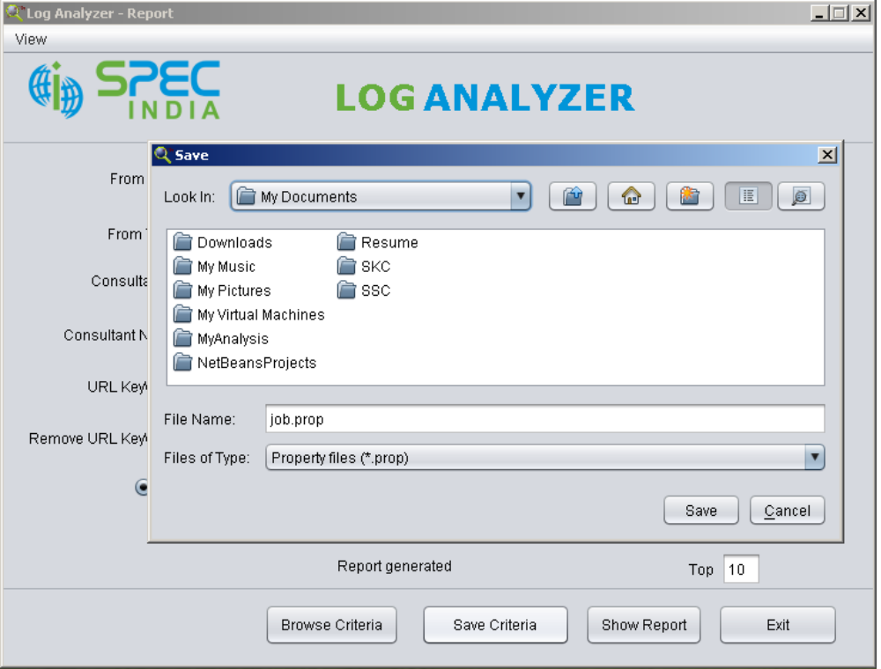
Click on Save Criteria button to save given input it will open save dialog box and default name of file is job.prop.

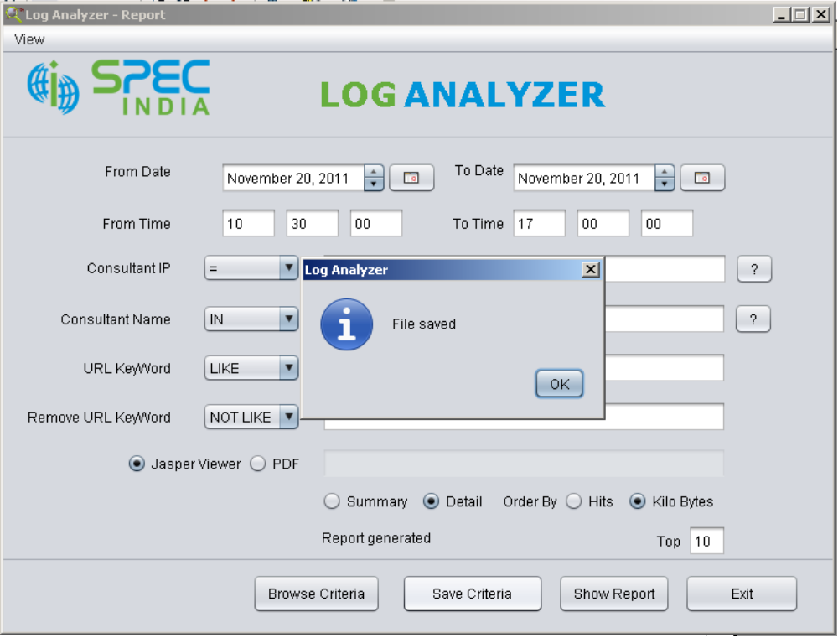

- Browse Criteria

User can browse saved file to generate previously generated report.
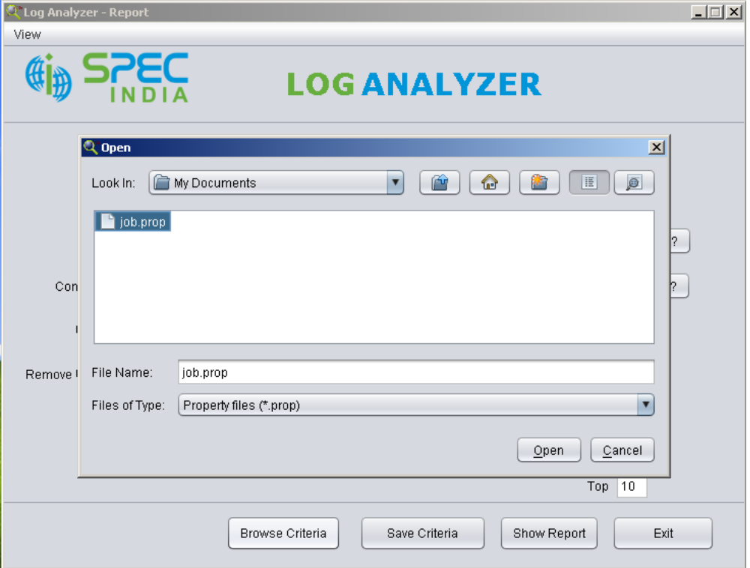

Values directly set to the particular field
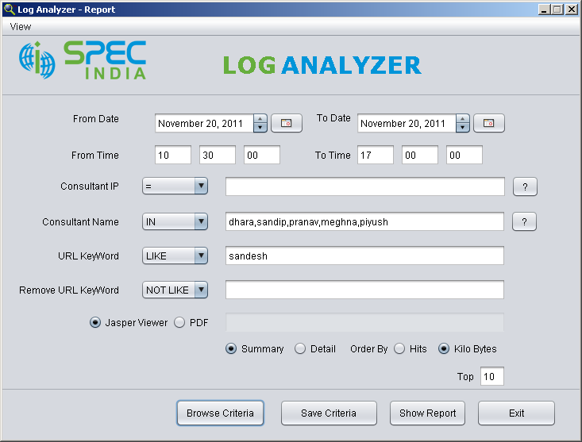

Now if user wants to process their own log files then LogAnalyzer also has facility to upload local files to hadoop cluster and then import data from that file and generate report this is know as on demand analysis.

- Connection with Hadoop Cluster

Initially LogAnalyzer is not configured with Hadoop Cluster if user has there own cluster then LogAnalyzer can
directy connect to the cluster and upload files.

To connect with Hadoop Cluster it requires following information
IP address and Port number of namenode of Hadoop Cluster

To import data from the uploaded file after processing it requires following information
IP address of master node
Username and Password of master node so that LogAnalyzer can execute job through SSH.

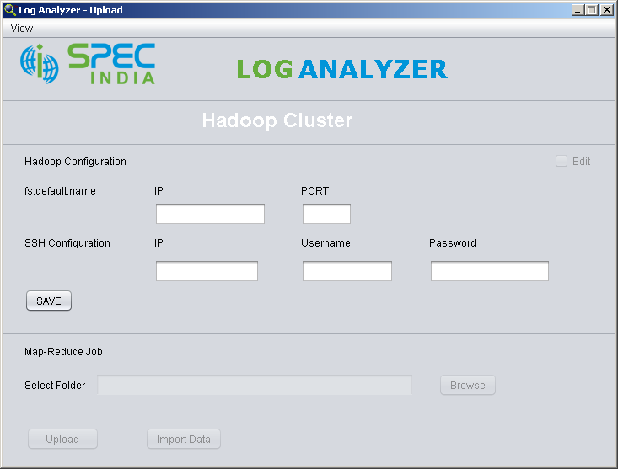

Once it is saved following screen is displayed

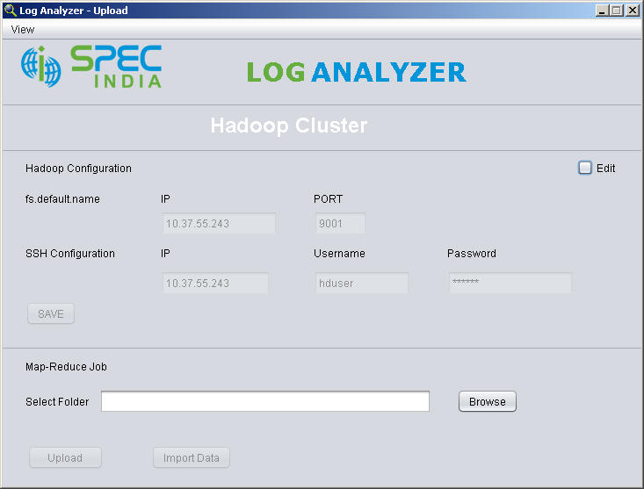

Now LogAnalyzer allow user to upload file to hadoop cluster by selecting folder which contains files.

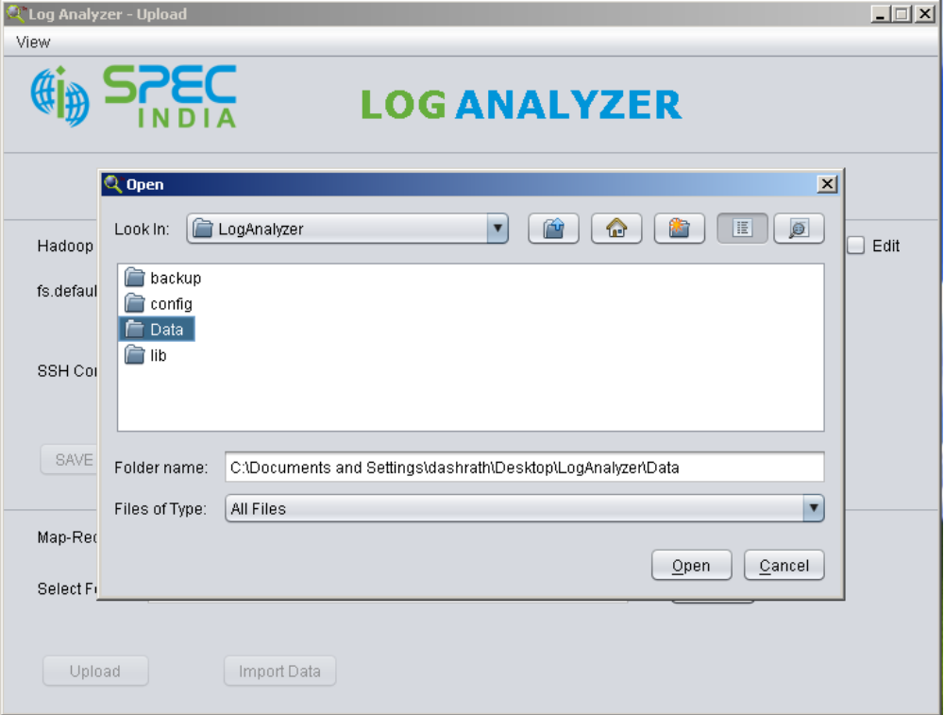

After folder selection upload button is enabled

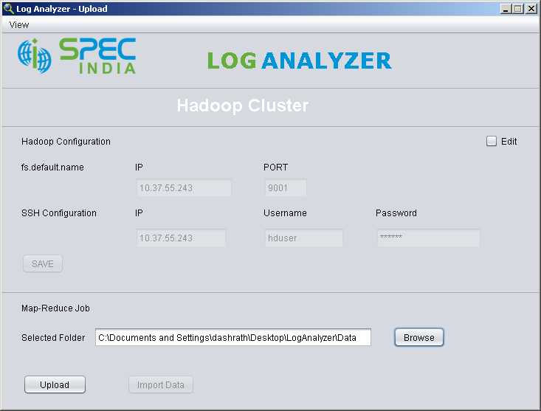

Click on upload button to start uploading file to cluster it asks for confirmation and total number of files user going
to upload

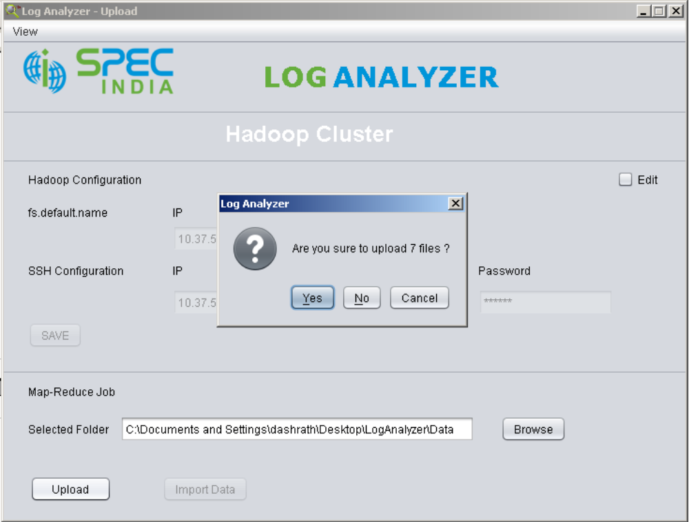

If user click on Yes button then LogAnalyzer starts file upload process and display following screen.

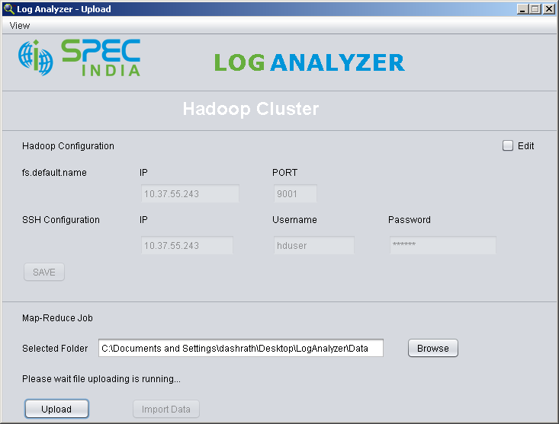

Once it completes upload process it displays following screen and Import Data button is enabled.

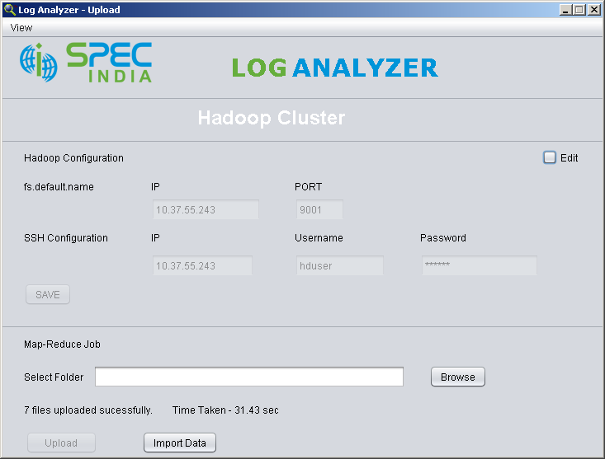

Now click on Import Data button to start import process it will first executes Map-Reduce job and then imports data to
MySQL.

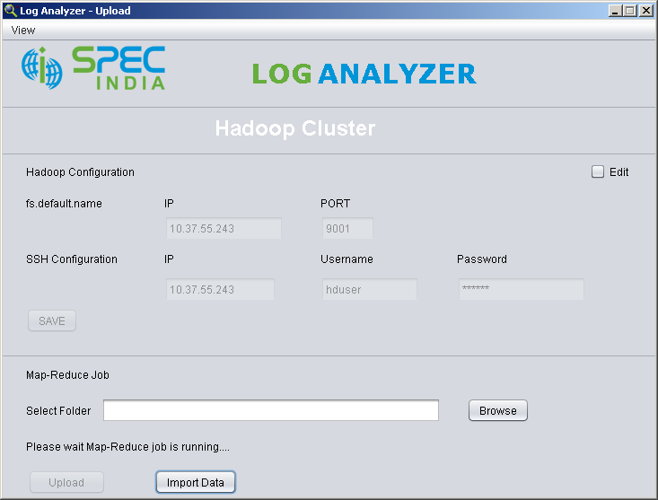

Once it completes execution it displays following screen

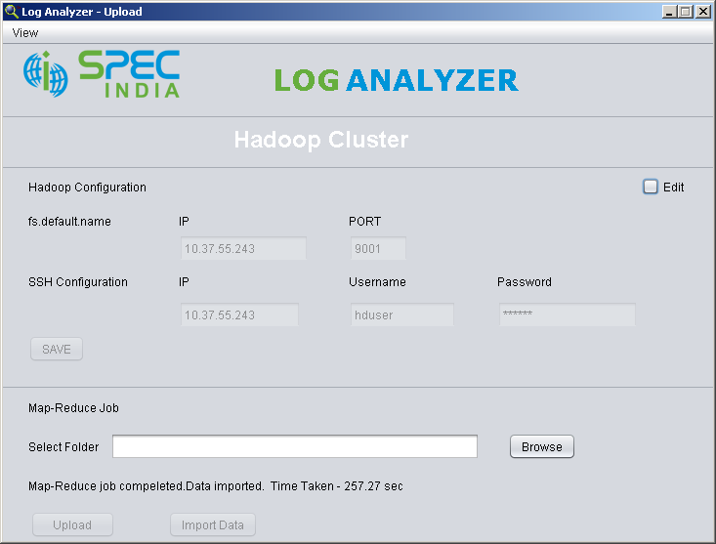
Now database is ready to do log analysis. Goto View->Report and generate reports.

