RangeSlider Component

Pentaho CDE is an advanced user tool for creating dashboards in the Pentaho BA server. CDE and the technology underneath (CDF, CDA and CCC) allows to develop and deploy dashboards in the Pentaho platform in a fast and effective way. It has many components which helps developers to create rich dashboards. To increase it's features we have developed a RangeSlider Component which is used to gives minimum and maximum value to other components as what we have in Jquery slider.

This component is very useful with charts because when we want to display value between some range then range slider is very helpful to provide range values instead of explicit input from the user.

How to use to Deploy ?

1. Download and extract RangeSlider.zip file
- Stop Pentaho BI Server if it is running.
- Copy RangeSlider folder to
<<pentaho-base-dir>>\pentaho-solutions\system\pentaho-cdf- dd\resources\custom\components
from component\ folder of extracted file.
- Copy RangeSlider's property file to
<<pentaho-base-dir>>\pentaho-solutions\system\pentaho-cdf- dd\resources\custom\properties
from properties\ folder of extracted file.
- Now restart Pentaho BI Server.
- Create New CDE Dashboard File ->New->CDE Dashboard
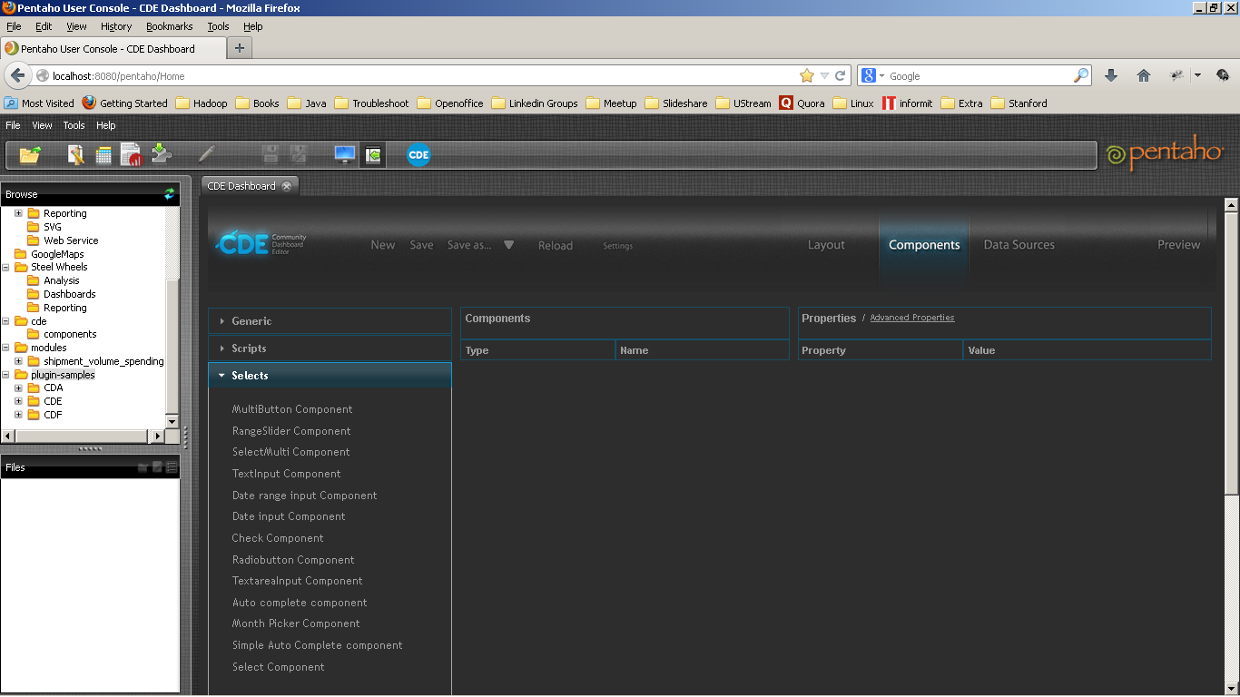
- Goto Components->Selects Category, You will find RangeSlider Component.

- Now lets check out it's properties.
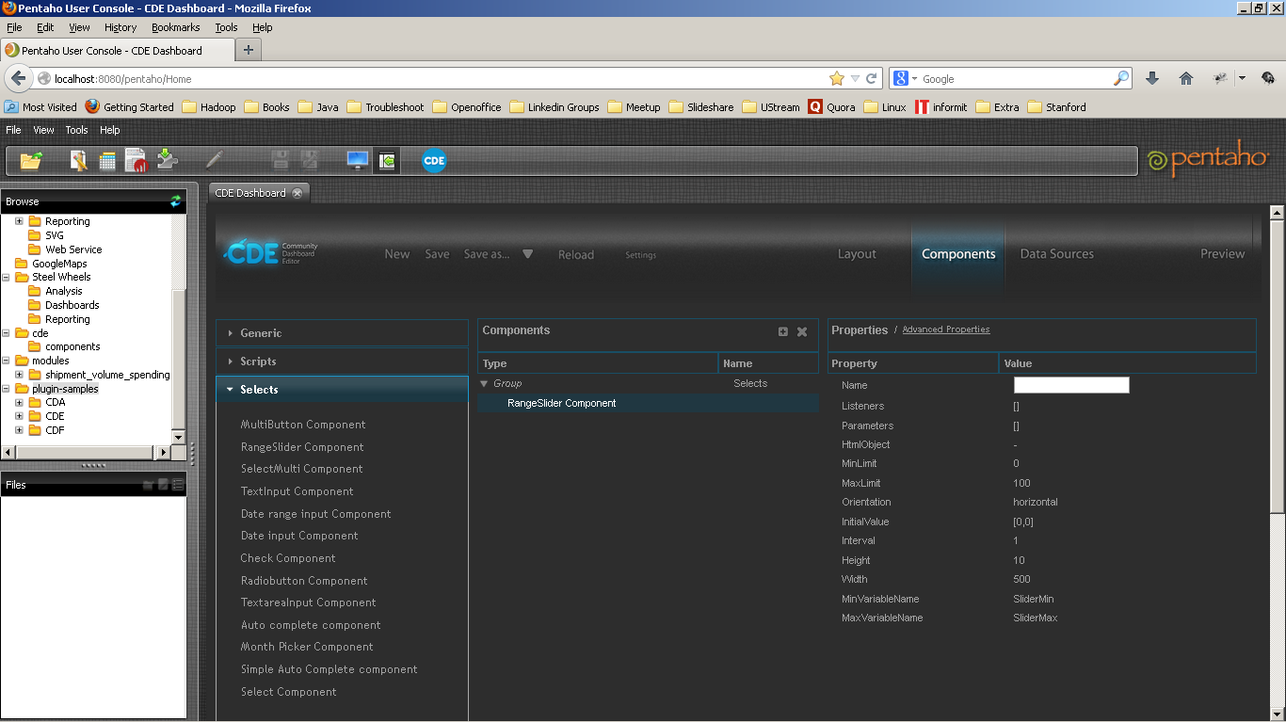

Property | Description | Default Value | Type
Name | Defines the name of component |  | String
Listeners | It contains variable name which triggers a refresh of the component when it changed. | [] | Array of String
Parameters | Parameters to execute the xaction. | [] | Arrayof String arrays
HtmlObject | The id of the html tag that display this component (usually a <div>) |  | String
MinLimit | Minimum value of slider range. | 0 | Integer
MaxLimit | Maximum value of slider range. | 100 | Integer
Orientation | Orientation of component either vertical or horizontal. | Horizontal
InitialValue | Current value of RangeSlider | [0,0] | Array of Integer
Interval | Step size of RangeSlider | 1 | Integer
Height | Height of component | 10 | Integer
Width | Width of component | 500 | Integer
MinVariableName | Variable name to access minimum value of slider at runtime. | Slidermin | String
MaxVariableName | Variable name to access maximum value of slider at runtime. | Slidermax | String

We have added MinVariableName and MaxVariableName properties which contains variable name which developer can use at runtime to get current value of slider-range and when slider- range is changed then this variable's value also get updated.

Bart Chart Example -

1. Dashboard Layout -

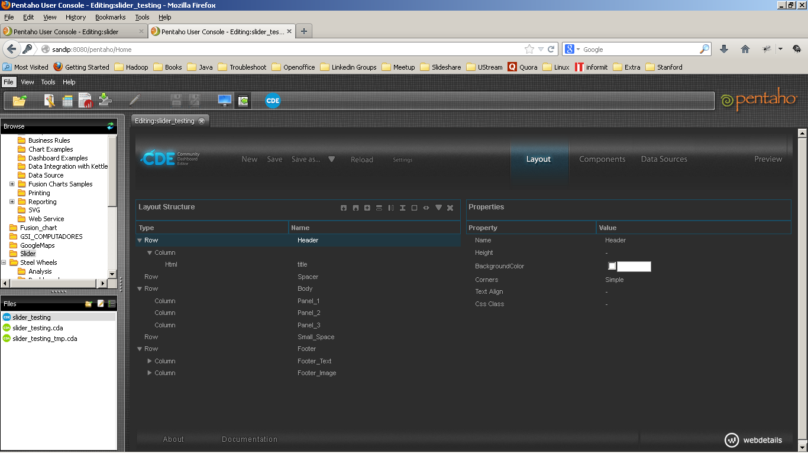

- We have taken three components CCC Bar Chart ,RangeSlider Component ,and Button Component so when user click on the button chart get refreshed according to the range value of RangeSlider Component.

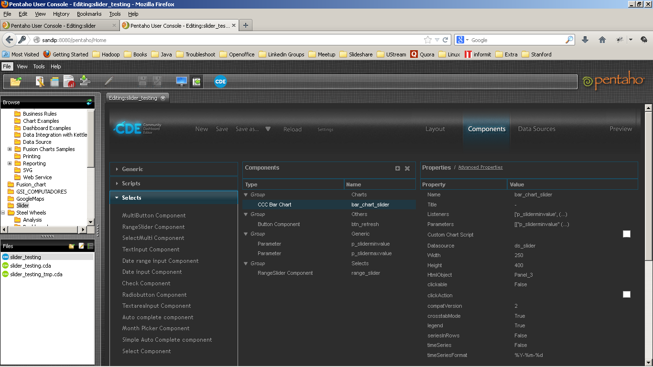

3. We have written javascript function in Expression property of Button Component which update the value of p_sliderminvalue and p_slidermaxvalue parameters and Barchart get refreshed.
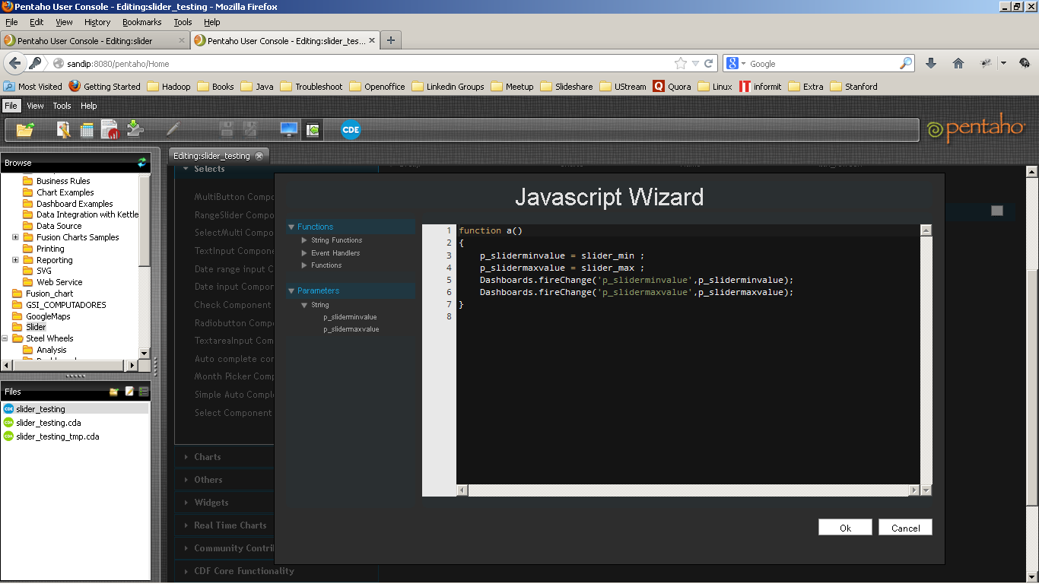
- Create datasource for the chart
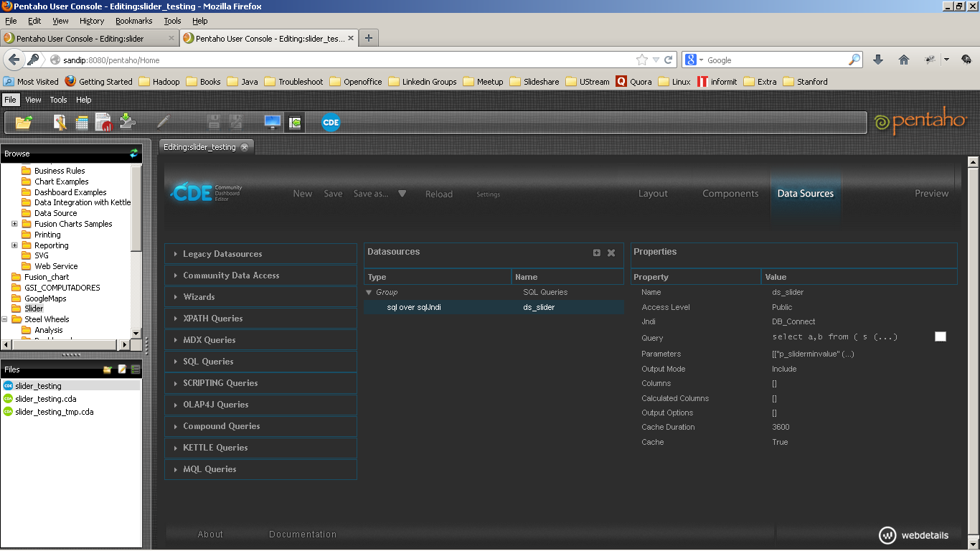

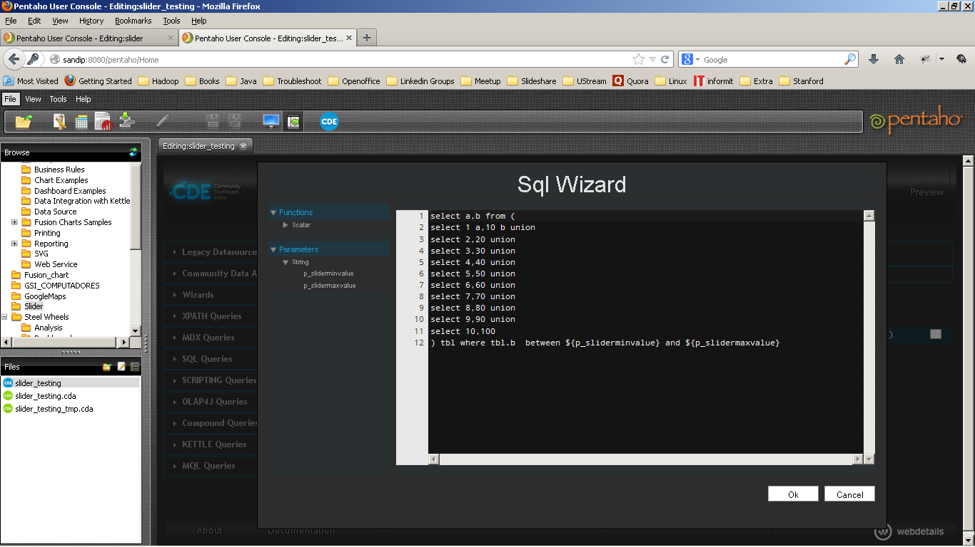

Output

