Practical 1a : Network Protocols

Objectives: Ping and default firewall settings
Use Wireshark
Analyse ICMP and HTTP packets
Use Netstat to view opened ports
Install and use a FTP Server

Exercise 1 Setting up your Windows image

- Create a folder D:\EHD-yourname, eg D:\EHD-johntan
- Go to My Computer. Go to C:\BaseImages (or D:\BaseImages). Copy the folder WinXP to D:\EHD-yourname” (eg after copying, you will have the folder D:\EHD-johntan\WinXP).
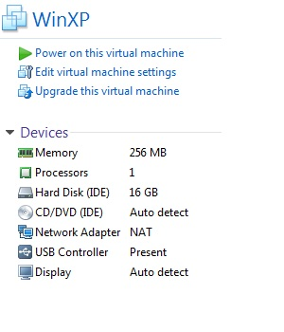
- Use VMware Workstation to open the WinXP image in your EHD folder. Do not start it yet.
USB Controller is Present
Network Adapter is “NAT”

- Check that you have a USB Controller listed under Devices for your WinXP image (see image above).
- If you do not have a USB Controller, do the following steps to add it :
- Under Commands, click on Edit virtual machine settings.
- Under Hardware, click the Add button at the bottom.
- Select USB Controller and click Next. Click Finish. Click OK.

Adding a USB controller means you can access USB devices in your image.

- Check that the Network Adapter is set to “NAT” or Network Address Translation (see image above).
- If the Network Adapter is not set to “NAT”, do the following steps to add it :
  - Under Commands, click on Edit virtual machine settings.
  - Under Hardware, select Network Adapter.
  - In the right-hand pane, select the radio button NAT. Click OK.

To learn more about the Networking Configurations “NAT” and “Bridged”, you can view the online VMware documentation at the following URL :
http://pubs.vmware.com/workstation-12/index.jsp#com.vmware.ws.using.doc/GUID-D9B0A52D-38A2-45D7-A9EB-987ACE77F93C.html
- Start up the WinXP image
- Select “I copied it” when asked.
- When the image has started up, you may want to install/update VMware Tools if it is not installed yet. Go to VM menu and choose Install VMware Tools or Update VMware Tools.

Exercise 2 Configure your Windows operating system

Screen Resolution and User Accounts
- To change the size of the VM screen, right-click on the background and choose Properties. Choose your desired Screen Resolution.
- Go to Start, Control Panel, User Accounts.
- Click on the user account. Click Create a password.
- Set a password for your user account. (You can set a simple password like “12345678” as this password may be ‘captured’ by your classmates later on). Click Create Password.
- When asked to make your files and folders private, click Yes, Make Private.
- Click on Back. Click on Create a new account.
- Type “student” as the name for the new account. Click Next.
- Select Limited radio button. Click Create Account.
- Click on the student account. Click Create a password.
- Set a password for your student account. (You can set a simple password like “12345678”). Click Create Password.
- Close the User Accounts window.

Turn off Automatic Updates
As we are just using our WinXP as a test image, we can turn off Automatic Updates. Note : turning off Automatic Updates is not recommended for production systems!
- Go to Start, Control Panel, Security Center.
- Under Manage security settings, click on Automatic Updates.
- Turn off Automatic Updates.
- Close the Automatic Updates window.

Do not hide extensions for known file types
- Go to Start, My Computer.
- Click on Tools, Folder Options. Click on View tab.
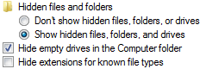

- Select the radio button “Show hidden files, folders and drives”.
- Uncheck the box “Hide extensions for known file types”.
- Click OK.

IP address and Computer Name
- Go on Start. In the textbox, type “cmd” and press Enter to start up a Command Prompt.
- In the Command Prompt, type “ipconfig”. Take note of your IP address (under Local Area Connection).
- If you want to change your computer name, do the following steps:
  - Go to Start, right-click on Computer and choose Properties.
  - Under Computer name, domain and workgroup settings, click Change Settings.
  - Click on the Change button.
  - Enter the new computer name. Click OK.
  - You will be asked to restart your computer. Restart your VM for the new computer name to take effect.

Exercise 3 Ping and default Firewall settings

Description:
The ping command uses the ICMP protocol. If you are able to ping another computer, it means that computer is up. However, most firewalls have been configured to block the ping packet so that attackers can not tell which computer is up.

From your Base PC
- In Command Prompt, are you able to ping your Windows VM?
You can not ping your Windows VM because the default Windows firewall is blocking ping requests.

In Windows VM
- Click on Start, Control Panel, Security Center. Click on Manage Security Settings for Windows Firewall.
- Click Off to turn off the firewall.
- From your Base PC, try to ping your Windows VM again. You should be successful now.

- Click On to turn on the firewall again. Click OK.
- Click on the Advanced tab. Under ICMP, click Settings.
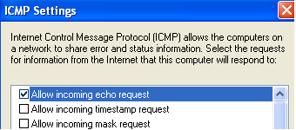

- Check the box “Allow incoming echo request”. Click OK. Click OK.
- From your Base PC, try to ping your Windows VM again. You should still be successful.

Exercise 4 Using a Network Traffic Analyzer - Wireshark

Description:
To get a better idea of what TCP/IP packet headers look like, using a network traffic analyzer to capture packets as they enter or leave your network can be helpful. In this activity, you download and use Wireshark to observe packets.

In Windows VM
- Go to www.wireshark.org. Download and install the Wireshark program. (A copy is also available on BlackBoard, or you can try to download from http://192.168.6.212/files) Accept the default values.
- Go to Start, All Programs, run Wireshark.
- From the Capture menu and select Interfaces.
- Change the Interface to “VMware AMD PCNET Adapter”. Click Start. Wireshark will start capturing packets.
- From your Base PC, ping your Windows VM.
- From the Capture menu, select Stop to stop capturing packets.
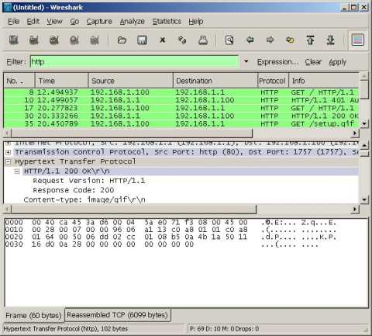
List of captured packets
The protocol details of a selected packet (using an expandable tree)
The data bytes of the selected packet (in hexadecimal and in ASCII)

- To view only the packets involved in the ping command, type “icmp” in the Filter textbox and press Enter. View the packets captured.

- From the Capture menu, choose Start to start capturing packets again. Choose Continue without Saving. This time, do a ping of a non-existent computer, eg “ping 1.2.3.4.”
- From the Capture menu, select Stop to stop capturing packets.
- To view only the packets involved in the ping command, type “icmp” in the Filter textbox and press Enter. View the packets captured.
- Start capturing packets. Access the Internet and download a file (for example, download Wireshark again). Stop the capture.
- From Statistics menu, choose IO Graphs. In the Y-Axis, change the Unit from Packets/Tick to Bytes/Tick. Can you identify the time when the file download is taking place? Click Close.

- To remove the filter, click on the Clear button.
- To view only packets that are sent from your Windows VM, type “ip.src==192.168.0.128” in the Filter box, changing the IP address to your Windows VM IP. Click Apply.
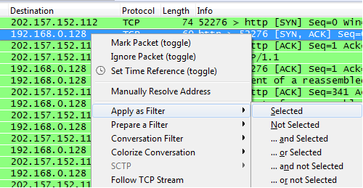

- You can also apply the filter by right-clicking on the IP address in the Destination column, and choose Apply as Filter, Selected.

- To view only packets that are received by your Windows VM, type “ip.dst==192.168.0.128” in the Filter box, changing the IP address to your Windows VM IP. Click Apply.
- To view only packets that are either sent or received by your Windows VM, type “ip.addr==192.168.0.128” in the Filter box, changing the IP address to your Windows VM IP. Click Apply.

- To view how Wireshark determines which packets are displayed using which colours, go to View, Coloring Rules.
You can also create your own Colour Rules to suit your needs.

Exercise 5 ICMP Protocol

In Windows VM
- In Wireshark, from the Capture menu, choose Start to start capturing packets again. Choose Continue without Saving.
- Ping another VM, or from your Base PC, ping your own Windows VM.
- Stop the packet capture and view the ICMP packets in Wireshark.

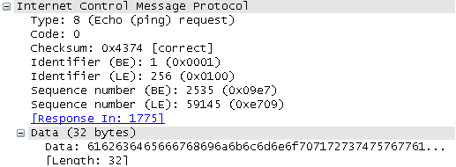

- Select one of the Echo (ping) request. In the middle section, click on the plus sign beside Internet Control Message Protocol to expand it.
- Look at the Sequence number (LE) (LE stands for Little Endian, BE stands for Big Endian – you will be learning about these in future)
- Select the next Echo (ping) reply. If the sequence number is the same, it is the reply to the earlier Echo (ping) request.

Exercise 6 Time-To-Live (TTL) field

Description:
The Time-To-Live (TTL) field in a packet indicates how many hops the packet is allowed to travel before it is discarded. Without the TTL, packets may circulate in the network forever.

The initial values of the TTL fields can sometimes give hints to the type of operating system.

Operating System | Default initial TTL value
Windows 98 | 32
Windows NT/XP/Vista/2003/ Windows 7 | 128
Most Linux distributions | 64

- Ping 192.168.6.211 and 192.168.6.212.
- By looking at the TTL values of the packets sent by the systems being pinged, can you make a guess of their operating systems?

Exercise 7 HTTP Protocol

In Windows VM
- Start a packet capture with Wireshark.
- Browse to http://192.168.6.212/word/index.jsp.
- Enter the word “rainbow” and click Submit.
- Stop the packet capture.
- Search for the three packets that make up the 3-way handshake.
You can use the following filters to help you in your search:
tcp.flags.syn==1
tcp.flags.syn==1 && tcp.flags.ack==1
tcp.flags.ack==1
- Search for the packet that contains your submitted form.
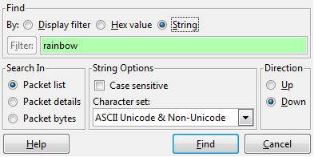
Choose “Packet details”

To help you in your search, you can go to the Edit menu, select Find Packet.
Under Find By, check String, type “rainbow” in the Filter textbox. Select Packet details and click Find.

HTTP is an unsecured protocol. Data submitted by users in web forms are transmitted in cleartext over the network.

- Exit Wireshark.

Challenge 1
Use Wireshark to open the packet capture file capture01.pcap from BlackBoard. This file contains the packets captured when another user submitted the form at http://192.168.6.53/word/index.jsp.

- When did the user submit the form?
April 12 2012, 11:06:48
- What is the IP address of the user?
192.168.10.88
- What is the MAC address of the user?
40:61:86:8b:59:e4
- What word did this user enter?
dinosaur
- Identify the three packets that make up the 3-way handshake. Record the packet numbers below:

 | Packet number
SYN packet | 9
SYN/ACK packet | 10
ACK packet | 11

Challenge 2
Use Wireshark to open the packet capture file capture02.pcap from BlackBoard. Analyse the contents and try to figure out what is the user doing.
The user is browsing through and buying things on amazon.com

Exercise 8 Identifying Open Ports - netstat

In Windows VM

- Close all Internet browser windows. In Command Prompt, run “netstat -a”.
- Start an Internet Explorer and browse to SP home page. Run “netstat -a” again. Is there any difference between this output and the earlier output?

- Run “netstat -an” to view the entries in IP addresses and port numbers (numeric form).
- Run “netstat /?” to display a list of all the available options.
- Open a web browser and browse to a webpage that has some dynamic content on it. (eg www.sp.edu.sg) Quickly run netstat -an a few times and take note of the outputs. You may be able to see connection states like SYN_SEND.

To find out which process is responsible for opening the port, you can use the -o or -b switches.
- Run “netstat -ano”. Find the Process ID (PID) of the process that is opening Port 445.
- Press Control-Alt-Insert to go to Task manager in the Windows VM.
- Click on the Processes tab.
- From the View menu, choose Select Columns.
- Check the box for PID (Process Identifier). Click OK.
- Using the PID, identify the process that is opening Port 445.

- Run “netstat -anb”. The executables that are opening the various ports are listed.

Exercise 9 Using FTP Server software
FTP Server
FTP Client
Base PC
Windows VM
You will install a FTP Server software on your Windows VM
Your Base PC will act as the FTP Client
TCP Port 21

Description:
Filezilla is a free FTP solution. We will be downloading the Filezilla server onto our Windows VM image.

In Windows VM
- Create a folder called “shared” on your Desktop.
- Double-click on “shared” folder.
- Use Notepad to create a text document called “myfile.txt”.
- Type “I love SP” as the file contents. Save the file and close it.

- Browse to filezilla-project.org. (A copy is also available on BlackBoard, or you can try to download from http://192.168.6.212/files)
- Click on “Download FileZilla Server” (for Windows).
- The default installation file may include bundled offers for other software (that you probably don’t need). To get the installation file for Filezilla Server only, you can click on More download options.
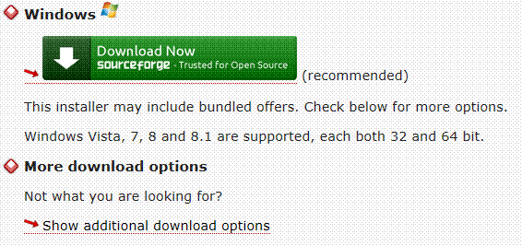
This installer comes with advertisements to ask you to install other software
Or you can download this installation file which doesn’t come bundled with other offers.

- Download the FileZilla executable file (for Windows) to your Desktop.
- Download and install Filezilla using default values.

Note : During the downloading of the installation program, there will be advertisements asking you to click Accept to install other software like add-ons. You do NOT need to install these, you can click Decline.

- Go to Start, All Programs, FileZilla Server, FileZilla Server Interface. Click OK.
- From the Edit menu, choose Users.
- On the right-hand side, under Users, click Add.
- Enter a name for the FTP user account you will be adding, eg “mary”.
- Leave “User should be member of the following group” to <none>. Click OK.
- Check the Password box and enter a password for your FTP user (Use a simple password like “12345678” as this password will be captured later).
- Under Shared folders, click Add.
- Select the “shared” folder on Desktop. Click OK.
- Click OK to close the FileZilla Users window.
- Run “netstat –an”. The port for FTP is 21 and the protocol is TCP. It should be listed as LISTENING.

From your Base PC (FTP Client)
- In a Command Prompt, connect to your FTP server by typing “ftp ip address” where ip address is the IP address of your image.

You are not able to connect to the FTP Server because of the firewall on the Windows VM. You can type “quit” or “bye” to exit the ftp prompt.

Exercise 10 FTP and Firewall settings

You will now adjust your Firewall so that clients can connect to your FTP Server.

In Windows VM
- Click on Start, Control Panel, Security Center. Click on Manage Security Settings for Windows Firewall.
- Click on Exceptions tab. Click Add Port button.
- For Name, enter “FTP Server”. For Port Number, type “21”. Check that the TCP radio button is selected. Click OK. Click OK.

Exercise 11 Connecting to the FTP Server

From your Base PC (FTP Client)
- In a Command Prompt, connect to your FTP server by typing “ftp ip address” where ip address is the IP address of your image.
- For User, enter the name of the FTP user that you created.
- For Password, enter the password. (you will not be able to see any characters appearing on screen as you type the password)
- Type “help” to see a list of available commands for FTP.
- Type “dir” to get a listing of the “shared” folder.

If the ftp client program on the Windows 8.1 Base PC is not able to get a listing of the “shared” folder, it is due to the firewall setting on the Windows 8.1 Base PC.

In this case you can try to connect to your classmates’ Filezilla Servers. In order to connect to your classmates’ images, you have to change the VMware Network Adapter of your WinXP image to “Bridged”. Then repeat the steps in this exercise on your WinXP to ftp to your classmate’s Windows VM.

- You should see myfile.txt listed.
- To download the myfile.txt file, type “get myfile.txt”.
- Type “bye” to end the FTP connection.
- Type “dir” to see the listing of the files in the current directory. You should see the myfile.txt.
- In My Computer, go to C drive, Documents and Settings. Double-click on your username. Double-click on myfile.txt to view its contents.

Exercise 12 Capturing packets in a FTP transaction

In Windows VM
- Run Wireshark and start capturing packets.
- Use FTP to download the myfile.txt file again. Type “bye” to end the FTP transaction.
- Stop the Wireshark capture.
- Find the packets that make up the 3-way handshake. There should be two sets of 3-way handshakes : one for the FTP control connection, and one for the FTP data connection.

- In Wireshark, from the Edit menu, choose Find Packet.
- Click on Find By : String.
- Under Search In, click Packet details.
- Enter myfile.txt in the textbox. Click Find. You should be able to find the packet containing the downloaded filename.
- In the Find Packet window, enter “I love SP”. Click Find. You should be able to find the packet containing the data “I love SP”.

Question :

Are you able to find the value of the FTP username and password in the captured packets? What string would you search for?

Note : FTP is an unsecured protocol. The username and password is transmitted across the network in plaintext.

- You can also type “ftp” in the Filter textbox. You will be able to see the username and password and the name of the downloaded file.
- Type “ftp-data” in the Filter textbox to see the packet that contains the data “I love SP”.
- Right-click on any FTP packet. Go to Analyse and Follow TCP Stream. The FTP transacation will be listed.

End of Practical

