PAPER REF: 18165

ON MODELLING BALLISTIC GELATINE BY SMOOTHED PARTICLE HYDRODYNAMICS

Luděk Hynčík^{1(*)}
¹New Technologies – Research Centre, University of West Bohemia, Pilsen, Czech Republic

^{(*)}Email: hyncik@ntc.zcu.cz

ABSTRACT
The study implements the smoothed particle hydrodynamics for numerical modelling of the ballistic gelatine. The study accommodates generic ballistic gelatine material properties into the numerical model describing the viscous fluid. Numerical simulations to verify the response of the ballistic gelatine material model reconstruct the quasi-static and dynamic experiments concerning the compression loading of a small cylinder sample. The simulation outputs are compared to the experimental data. The smoothed particle hydrodynamics shows a good performance in both quasi-static and dynamic compressions for modelling the ballistic gelatine.
Keywords: ballistic gelatine, modelling, smoothed particle hydrodynamics.

INTRODUCTION
The investigation of penetrating ballistic impact is a useful approach for estimating the consequences and severity of a gunshot wound. Because of the ethics, experimental tests on human tissue are not easy to realize, so the substituting matter in combination with numerical modelling plays an important role here.
Ballistic gelatine is a testing matter, which is correlated to have a similar response as human muscle tissue. It plays an important role as a substituting material to investigate the effects of bullet wounds. The study focuses on the numerical modelling of the ballistic gelatine for future use in virtual testing. Several studies using traditional mesh-based methods have already been conducted (Awoukeng-Goumtcha et al., 2014; Yoon et al., 2015; Chen et al., 2020).
The properties of ballistic gelatine are highly sensitive to strain rate and temperature and it behaves as a shear thickening fluid at high shear rates (Subhash, 2012), so the author chose the smoothed particle hydrodynamics for numerical modelling of the ballistic gelatine developing the previous work (Taddei et al., 2015; Frissane et al., 2019; Khalil et al., 2019).

METHOD
Since Gingold and Monaghan (1977) and Lucy (1977) introduced Smoothed particle hydrodynamics (SPH) originally for astrophysical problems in 1977, many authors have already used the method in many other areas. As SPH is a particle method, it is very useful for modelling highly deformable solids and fluids with a considerably moving matter and boundaries.
The basis of the smoothed particle methods is the interpolation theory. The conservation laws are transformed into integral equations using the kernel function $w\left(r,h\right)$ with the condition
$\lim_{h→0}{w\left(r,h\right)=δ\left(r\right)}$, (1)
where r is a position vector, h is the smoothing length and $δ$ is the Kronecker delta. The kernel refers to a weighting function and defines how much of each field variable contributes to the field variable at a given point in space. The kernel estimate of the physical field value $A\left(r\right)$ is defined by
$〈A\left(r\right)〉=\int_{V}{A\left(r'\right)}w\left(r-r',h\right)dr^{'}.$ (2)

Considering that values of the physical field $A\left(r\right)$ are known on a set of N discrete points given by position vectors $r_{j}$ and masses $m_{j}$, Equation (2) can be written as the summation
$〈A\left(r\right)〉=\sum_{j=1}^{N}{\frac{m_{j}}{ρ_{j}\left(r_{j}\right)}A\left(r_{j}\right)}w\left(r-r_{j},h\right)$. (3)
Analogically, the gradient of Equation (3) can be expressed in the summation form as
$〈∇_{r}A\left(r\right)〉=\sum_{j=1}^{N}{\frac{m_{j}}{ρ_{j}\left(r_{j}\right)}A\left(r_{j}\right)}∇_{r}w\left(r-r_{j},h\right).$ (4)
Using the kernel function in Equation (1) and Equation (4), the conservation laws are
$\frac{dv_{i}}{dt}=-\sum_{j=1}^{N}{m_{j}\left(\frac{p_{j}}{ρ_{j}^{2}}+\frac{p_{i}}{ρ_{i}^{2}}+Π_{ij}\right)}∇w_{ij}$, (5)
$\frac{dρ_{i}}{dt}=-\sum_{j=1}^{N}{m_{j}\left(v_{i}-v_{j}\right)}∇w_{ij}$, (6)
$\frac{du_{i}}{dt}=-\sum_{j=1}^{N}{m_{j}\frac{p_{j}}{ρ_{j}^{2}}\left(v_{i}-v_{j}\right)}∇w_{ij}$. (7)
Here $v_{i}, m_{i}, p_{i}, ρ_{i}, u_{i},$ denotes respectively the velocity, mass, pressure, density and internal energy of any particle $i$. So the background of SPH is in finding the nearest particles that contribute to the physical value of the particular particle. The equation of motion (5), the continuity equation (6) and the equation of conserving energy (7) drive the SPH method. The artificial viscosity term
$Π_{ij}=\frac{1}{ρ_{ij}}\left(-αμ_{ij}c_{ij}+β{μ_{ij}}^{2}\right)$, (8)
to improve stability is added to the equation of motion (Taddei et al., 2015). Here α and β are constants, usually taken as 1.2 and 1.5 respectively, and $μ$ is the dynamic viscosity, $c$ is the sound speed and the lower index $ij$ means the average value of particles $i$ and $j$.
The equation of state binding together pressure, volume and temperature completes the set of driving equations (5, 6, 7). A hydrodynamic material is considered to model the ballistic gelatine.
The time consumption of the method is quite high because the algorithm locates the neighbouring particles at any time step of the solution, therefore, special algorithms are used to optimise the nearest neighbour search for the particles (Domínguez et al., 2010).

VISCOUS AND INCOMPRESSIBLE MATTER
Modelling highly viscous and incompressible materials using SPH is challenging because of the second derivative in the equations of motion and state, respectively. One approach is to run the simulations in the quasi-incompressible limit (Ellero et al., 2007) by the equation of state in the form (Monaghan, 2006)
$p=K\left[{\left(\frac{ρ}{ρ_{0}}\right)}^{γ}-1\right]$, (9)
where
$K=\frac{{c_{s}}^{2}ρ_{0}}{γ}$. (10)
with coefficient γ usually taken equal to 7. Here $c_{s}$is the sound speed chosen so that the Mach number $M$ is small, $ρ_{0}$is the reference (initial) density, $ρ$is the actual density and $γ$ is the coefficient. The value of K takes into account density fluctuations under 1% for weakly compressible fluid (Becker and Teschner, 2007). If the maximum flow speed is $v$, then the magnitude of the density fluctuation $δρ$has the upper bound approximately
$\frac{δρ}{ρ_{0}}\sim \frac{v^{2}}{c^{2}}=M^{2}$. (11)
HIGH-SPEED LOADING
For the high-speed compressive loading, the Mie-Grüneisen equation of state can be found as the most appropriate (Taddei et al., 2015). The Mie-Grüneisen equation of state relates the pressure and volume of a solid at a given temperature (Robinson, 2019). It is used to determine the pressure in a shock-compressed solid. Several variations of the Mie-Grüneisen equation of state are in use. The author implements the polynomial interpretation form of the Mie-Grüneisen equation of state in the form
$p=\left\{ \begin{matrix}\sum_{k=0}^{3}{C_{k}η^{k}+\left(C_{4}+C_{5}η\right)}E_{n}, \\ C_{0}+C_{1}η,\end{matrix}\right. \begin{matrix}if η≥0 \\ if η<0\end{matrix}$, (12)
where $E_{n}$ is the energy per unit of initial volume and
$η=\frac{ρ}{ρ_{0}}-1$. (13)
with the parameters taken from Awoukeng-Goumtcha et al. (2014) and optimized to fit the experimental data for ballistic gelatine (Casem et al., 2014).

MODELLING BALLISTIC GELATINE IN LOADING
For modelling the ballistic gelatine as a highly viscous matter, a proper viscosity model is necessary. Yang and Wang (2008) found that the viscosity of the gelatine varied from 0.6 to 16 mPa s. Howe and Pitt (2009) also investigated the rheology of nano-emulsion and measured the viscosity of 10% gelatine as 18 mPa s at 42°C. Those viscosity ranges are for quasi-static loading at a significantly lower shear strain rate, the viscosity for the high-speed loading was based on studies by Subash et al. (2021) and Veysset et al. (2020).
The numerical simulations using the impact compression setups with the Kolsky impact bar (Kolsky, 1949) were carried out (Casem et al., 2014). Using the previously developed code (Hynčík, 2002; Hynčík, 2015), both quasi-static and dynamics compression experiments on a small cylinder sample (Casem et al., 2014) of the height and diameter equal to 6.35 mm were reconstructed. Due to the symmetry, only a quarter of the cylinder is considered (see Figure 1), so the particles lying on the front plane plate (plane xz at y = 0 in Figure 1) are fixed for the perpendicular motion to the front plane (motion along axis y) and the particles lying on the bottom plane (plane xy at z = 0 in Figure 1) are fixed for the perpendicular motion to the bottom plane (motion along axis z).
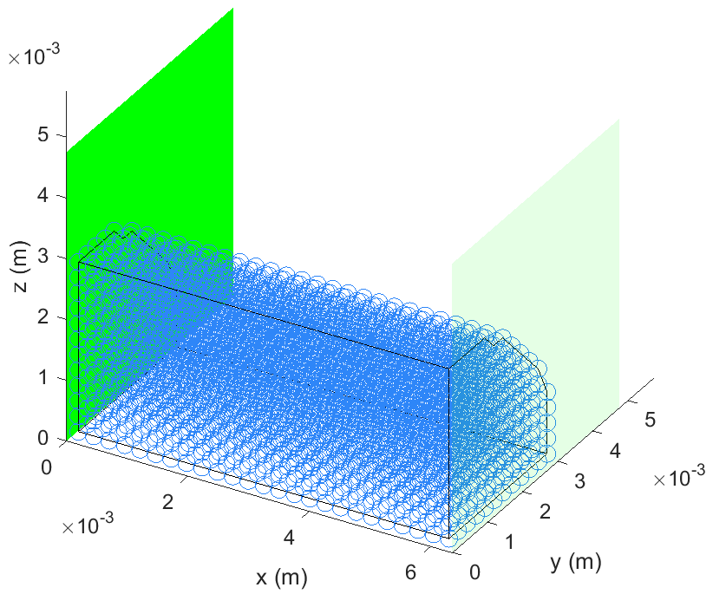
Fig. 1 – Compression test setup

The compression setup shown in Figure 1 is the same for both the quasi-static and the dynamic compression. The left plate (plane yz at x = 0, dark green in Figure 1) is fixed and the right plate (plane yz at x = 6.35 mm, bright green in Figure 1) is moving to the left (according to axis -x) by a constant velocity to hold the strain rate of 0.01 s⁻¹ for the quasi-static compression and the strain rate of 1000 s⁻¹ for the dynamic compression.
The particle spacing is uniform in all three special directions and it equals 0.254 mm leading to the total number of 3025 particles in the domain describing the quarter of the cylinder. The contact between the domain and the plates is done via the force acting on a particular particle when the particle penetrates the plate plane (Hynčík, 2002).
The time consumption of the method is quite high because the algorithm locates the neighbouring particles at any time step of the solution. As there is not a considerable mass flow in the problem, the author uses clusters to identify the nearest neighbours, in the beginning, to speed up the calculation.

RESULTS
The ballistic gelatine cylinder sample deforms reasonably according to the experimental data until the final strain ε = 0.5 for both quasi-static and dynamic loadings. Figure 2 shows the compression ε = 0.5 (50%) for both the quasi-static and the dynamic loadings. For better visibility, the borders of the deformed domain are highlighted in black.
As shown experimentally by Casem et al. (2014), non-uniform deformation is obvious throughout the entire loading. The maximum deformation of 50% corresponds well to the deformation observed by Casem et al. (2014) for both the quasi-static and dynamic compression tests.

(a) (b)
Fig. 2 – (a) Quasi-static compression by 50 %, and (b) dynamic compression by 50 %

CONCLUSIONS
The smoothed particle hydrodynamic was implemented for numerical modelling of the ballistic gelatine. Generic material properties of the ballistic gelatine were used. Numerical simulations verified the response of the implemented ballistic gelatine material model under the quasi-static and dynamic compressions loadings, where the simulation outputs are comparable to the experimental data. Therefore, smoothed particle hydrodynamics seems to be a promising method for modelling ballistic gelatine.

ACKNOWLEDGMENTS
This research was funded by the European Regional Development Fund-Project grant number CZ.02.1.01/0.0/0.0/17\048/0007280.

REFERENCES
[1]-Awoukeng-Goumtcha A, Taddei L, Tostain F, Roth S. Investigations of impact biomechanics for penetrating ballistic cases. Bio-Medical Materials and Engineering 24 (2014) 2331–2339.
[2]-Becker M., Teschner M. Weakly compressible SPH for free surface flows. Eurographics / ACM SIGGRAPH Symposium on Computer Animation, 2007, p.1-8.
[3]-Casem DT, Dwivedi AK, Mrozek RA, Lenhart JL. Compression response of a thermoplastic elastomer gel tissue surrogate over a range of strain-rates. International Journal of Solids and Structures, 2014, 51, p.2037-2046.
[4]-Chen F, Chen R, Jiang B. The adaptive finite element material point method for simulation of projectiles penetrating into ballistic gelatin at high velocities. Engineering Analysis with Boundary Elements, 2020, 117 p.143-156.
[5]-Domínguez JM, Crespo AJC, Gómez-Gesteira1 M, Marongiu JC. Neighbour lists in smoothed particle hydrodynamics. International Journal for Numerical Methods in Fluids, 2011, 67, p. 2026-2042.
[6]-Ellero M., Serrano M., Español P. Incompressible smoothed particle hydrodynamics. Journal of Computational Physics, 2007, 226, p.1731-1752.
[7]-Frissane H, Taddei L, Lebaal N, Roth S. SPH modeling of high velocity impact into ballistic gelatin. Development of an axis-symmetrical formulation. Mechanics of Advanced Materials and Structures, 2019, 26, p.1881-1888.
[8]-Gingold RA, Monaghan JJ. Smoothed particle hydrodynamics: theory and application to non-spherical stars. Monthly Notices of the Royal Astronomical Society, 1977, 181, p. 375-389.
[9]-Howe AM, Pitt AR. Rheology and stability of oil-in-water nanoemulsions stabilised by anionic surfactant and gelatin 1) addition of nonionic, cationic and ethoxylated-cationic co-surfactants. Advances in Colloid and Interface Science, 2008, 2, p.24-29.
[10]-Hynčík L. S Smoothed particle hydrodynamics: theory and practice. Engineering Mechanics, 2002, 9, p.1-15.
[11]-Hynčík L. SPHCOFEM: Solver for Coupling SPH and FE. IFMBE Proceedings, 2015, 52, p.162-165.
[12]-Khalil MA, Frissane H, Taddei L, Meng S, Lebaal N, Demoly F, Bir C, Roth S. SPH-based method to simulate penetrating impact mechanics into ballistic gelatin: Toward an understanding of the perforation of human tissue. Extreme Mechanics Letters, 2019, 29, p.1-8.
[13]-Kolsky H. An Investigation of the Mechanical Properties of Materials at Very High Rates of Loading. Proceedings of the Physical Society, Section B, 1949, 62, p.676-700.
[14]-Lucy LB. A numerical approach to the testing of the fission hypothesis. Astronomical Journal, 1977, 82, p.1013-1024.
[15]-Monaghan JJ. Smoothed particle hydrodynamic simulations of shear flow. Monthly Notices of the Royal Astronomical Society, 2006, 365, p.199-213.
[16]-Robinson AC. The Mie-Grüneisen Power Equation of State. Sandia National Laboratories Technical Report, 2019.
[17]-Subhash G, Kwon J, Mei R, Moore DF. Non-Newtonian Behavior of Ballistic Gelatin at High Shear Rates. Experimental Mechanics, 2012, 52, p.551-560.
[18]-Taddei L, Awoukeng Goumtcha AA, Roth S. Smoothed particle hydrodynamics formulation for penetrating impacts on ballistic gelatine. Mechanics Research Communications, 2015, 90, p.94-101.
[19]-Yang H, Wang Y. Effects of concentration on nanostructural images and physical properties of gelatin from channel catfish skins. Food Hydrocoll, 2009, 23, p.577-584.
[20]-Yoon GH, Mo JS, Kim KH, Yoon CH, Lim NH. Investigation of bullet penetration in ballistic gelatin via finite element simulation and experiment. Journal of Mechanical Science and Technology, 2015, 29(9), p.3747-3759.
[21]-Veysset D, Sun Y, Lem J, Kooi SE, Maznev AA, Cole ST, Mrozek RA, Lenhart JL, Nelson KA. High-Strain-Rate Behavior of a Viscoelastic Gel Under High-Velocity Microparticle Impact. Experimental Mechanics, 2020, 60, p.1179-1186.

