SPHCOFEM: Solver for coupling SPH and FE
L. Hynčík1
¹ New Technologies – Research Centre, University of West Bohemia, Plzeň, Czech Republic

Abstract— Numerical simulations in biomechanics and bioengineering consider highly deformable tissues in interaction with fluid flows. The solver SPHCOFEM for investigating fluid flow coupled problems with 1D, 2D or 3D calculations is presented. The fluid domain is represented by smoothed particle hydrodynamics and the boundary is modeled using finite elements. The interaction is done via a continuous contact model. Several material models useful for various hydrodynamics matters and simple finite elements for representing the boundary are implemented. Pre- and post-processors serve for task definition and result analyses.
Keywords— meshless, SPH, coupling, FE, solver.

INTRODUCTION
Modeling of fluid flow is important in many fields including not only energetics and automotive industry, but also biomechanics, bioengineering and clinical applications.
Laminar fluid flow is easy to describe with standard grid methods, but if any turbulence or complex flow, including multi-phase flows, appears, the grid methods are complicated to control. Additional contact problems with a highly deformable boundary, such as biological tissues, even increase the complexity of the problem.
Standard methods modeling fluid exploit the Eulerian approach using discretization of the domain by a grid. If a complex flow or highly deformable boundary appear, there is an option to implement the Lagrangean approach called smoothed particle hydrodynamics (SPH) [1]. SPH is a meshless method useful for flows, where the domain geometry changes considerably, because the fluid is discretized using the moving separated particles.
The boundary is modeled using the finite element method (FEM) [2]. There are several methods dealing with the interaction between SPH and FEM. The continuous contact model based on direct particle to wall coupling is an optimal choice [3] due to the moving particles.

Materials and methods
This work presents an in-house solver coupling SPH and FEM using the continuous contact model. The solver called SPHCOFEM (SPH COupled to Finite Element Method) investigates 1D, 2D and 3D problems. Since the solver is implemented using the C++ language, the pre- and post-processing is done via GUI (Graphical User Interface), developed in the MATLAB environment.

Modeling the fluid
The basis of SPH is interpolation theory. Fluid mechanics conservation laws are transformed into integral equations using an interpolation function, the kernel w(r,h), where r is a position vector and h is the smoothing length [4]. The kernel approximates the delta-function and refers to a weighting function that defines how much of each field variable contributes to the field variable at a given point in space.
Having the values of the physical field A(r) known on a set of N discrete points given by position vectors r_{i} and masses m_{i}, one can design the basic interpolation equation.
$〈A\left(r\right)〉=\sum_{j=1}^{N}{\frac{m_{j}}{ρ_{j}\left(r_{j}\right)}A\left(r_{j}\right)}w\left(r-r_{j}, h\right)$ (1)
Analogically the gradient can be expressed.
$〈∇_{r}A\left(r\right)〉=\sum_{j=1}^{N}{\frac{m_{j}}{ρ_{j}\left(r_{j}\right)}A\left(r_{j}\right)}∇_{r}w\left(r-r_{j}, h\right)$ (2)
The momentum equation, the continuity equation and the heat transfer equation are discretized using equation (2) to the final form.
$\frac{dv_{i}}{dt}=-\sum_{j=1}^{N}{m_{j}\left(\frac{p_{j}}{ρ_{j}^{2}}+\frac{p_{i}}{ρ_{i}^{2}}+Π_{ij}\right)}∇w_{ij}$ (3)
$\frac{dρ_{i}}{dt}=-\sum_{j=1}^{N}{m_{j}\left(v_{i}-v_{j}\right)}∇w_{ij}$ (4)
$\frac{du_{i}}{dt}=-\sum_{j=1}^{N}{m_{j}\frac{p_{j}}{ρ_{j}^{2}}\left(v_{i}-v_{j}\right)}∇w_{ij}$ (5)
The second derivative term describing the viscosity of the fluid flow cannot be easily designed using the equations (1) and (2) above. That is why here $Π_{ij}$ which refers to so called artificial viscosity term, with the numerical constants $α$ and $β$ to improve the stability, is added to the equations of motion (EOM) [5].
In contrast to the grid methods, where the interaction of the neighboring cells is processed via the direct connection, SPH is dependent on fast techniques for finding the neighboring particles that contribute to the summation (2). This is called the Nearest Neighbor Search (NNS) and it is the main issue related to the complexity and time consumption of the SPH calculation. The simplest NNS approach is to assess all pairs of particles, but it has a computational demand equal to N². SPHCOFEM benefits from pre-distributing the neighboring particles into independent sub-sets to be managed separately. This approach decreases the calculation time considerably; however, for complex turbulent flow, where the domain geometry changes too much, this approach is not always applicable.
There are several equations of state to be implemented for the fluid flow. The developed algorithm easily manages ideal gas due to the compressibility.
$p=ρ(κ-1)u$ (6)
Here p denotes pressure on any particle in equations (3) and (5), $κ$ is the ratio of the thermal capacities by constant pressure and constant volume, respectively, and u is the internal energy from equation (5). Incompressible flows are simulated within the quasi-incompressible limit [6].
$p=K\left[{\left(\frac{ρ}{ρ_{0}}\right)}^{γ}-1\right]$ (7)
Here K governs the relative density fluctuation and $γ$ is the constant usually set to 7. K refers to the liquid bulk modulus and is set in order to ensure the density variations under 1% for quasi-compressible fluid [6].

Modeling the boundary
The developed algorithm accommodates standard 1D, 2D and 3D finite elements (FE) to be in contact with the fluid domain. The Lagrange equations are used to develop the EOM for the boundary elements.
$\frac{d}{dt}\left(\frac{∂L}{∂{\dot{q}}_{i}}\right)-\frac{∂L}{∂q_{i}}=Q$ (8)
Here $L=E_{k}-E_{p}$ is the Lagrange function, q is the vector of generalized coordinates and Q is the vector of external forces including the contact forces caused by coupling the boundary FE with the fluid domain particles.
Introducing the kinetic energy E_{k} and the potential energy E_{p}, the EOM describing the boundary are developed.

Coupling
The interaction between the fluid domain and the boundary is designed via direct coupling using the penalty-based continuous contact model. The approach also utilizes the automatic force calculation. The contact thickness, which is an area with a defined thickness along each element, is defined. For each couple of particle and element, a particle entering that area is detected and the penalty force starts can be calculated taking into account the possibility to push the particle back within a time step [3].
$F_{n}=\frac{m_{p}m_{e}}{m_{p}{+m}_{e}}\frac{p}{∆t^{2}}$ (9)
Here F_{n} denotes the normal contact force, m_{p} and m_{e} are the penetrating particle and penetrated element masses, respectively, p is the penetration depth and $∆t$ is the current time step. The tangential friction force is easily added by defining the friction coefficient.

The algorithm and the software
EOM for SPH and FE are coupled to a single algorithm. Whilst the smoothed particle motion is integrated using the central acceleration method, the FE motion is driven by the conjugate gradient method [3].
The stable time step scheme, taking into account the Courant-Friedrichs-Lewy conditions for SPH stability and the stability condition for FEM, is applied.
To improve the results, the so-called X-SPH variant is also implemented [7]. The X-SPH variant updates the velocities with the constant $ε$ between 0 and 1.
$\frac{dx_{i}}{dt}={\hat{v}}_{i}=v_{i}+ε\sum_{j=1}^{N}{m_{j}\frac{v_{ij}}{ρ_{ij}}}w_{ij}$ (10)
There is a structured input text file describing the particle coordinates and initial conditions as well as boundary FE. Due to the pre- and post-processors developed as GUI in the MATLAB environment, the MATLAB input file structure using standard MATLAB functions to design the structure is also defined [8].

Validation tests
SPHCOFEM is validated using the 1D, 2D and 3D tests by comparing the calculation results to available published experimental or numerical data. The validation concerns the shock tube problem in 1D, the broken dam problem in 2D and the crashing ball problem in 3D.

Shock tube
The shock tube validation [9] deals with a stationary gas in a tube divided by a diaphragm into two regions, each characterized by a given pressure and density. At time t = 0, the diaphragm is released.
The SPHCOFEM input file accommodates 1000 particles. The ideal gas EOM (6) is used. The artificial viscosity coefficients α and β are set both to unity and the specific heat ratio κ = 1.4. The time to be simulated is 0.230768 s. The boundary is not modeled in the shock tube problem.

Broken dam
A free surface flow is investigated and validated here. A rectangular column of water in hydrostatic equilibrium is fixed by the vertical wall. The water column is 0.05715 m high and 0.05715 m wide. At time t = 0, the gate is removed instantaneously and the water is allowed to collapse [10].
The SPHCOFEM code is tested using 361 (coarse), 3249 (fine), 12,996 (very fine) and 51,984 (complex) particles, also with and without the X-SPH variant. The EOM is modeled for quasi-compressible fluid using equation (7) with the parameter $γ$ = 7.
The water has density $ρ$ = 996 kg/m³. Coefficients α and β are chosen as 1.2 and 1.5, respectively. Contact between the water and the boundary is defined by equation (9).

Crashing ball
The task is chosen in order to assess the behavior of a water filled elastic ball crashing against a rigid wall at the initial velocity 1 m/s [11]. It concerns the full 3D problem.
The SPHCOFEM input file concerns 9889 particles. The water has density $ρ$ = 996 kg/m³. The EOM is modeled for quasi-compressible fluid using equation (7), with the coefficients $α$ = 1.2, $β$ = 1.5 and $γ$ = 7.

Results
The results of all simulation including sensitivity analysis for the most used 2D case are evaluated below. Whilst the 1D and 2D cases are compared to experimental results, the 3D case is compared to numerical output.

Shock tube
After releasing the diaphragm, a refraction wave starts travelling from the region of higher density to the region of lower density and the shock wave is generated.
Fig. 1 shows the time dependent density (left) and pressure (right) after releasing the diaphragm.
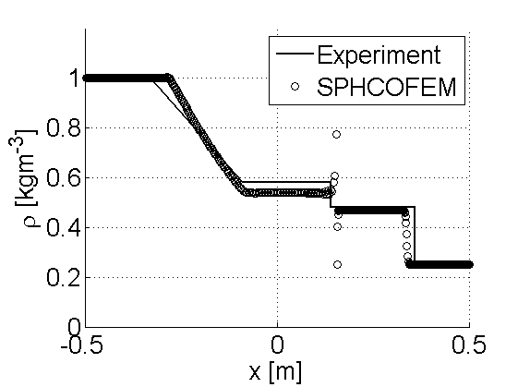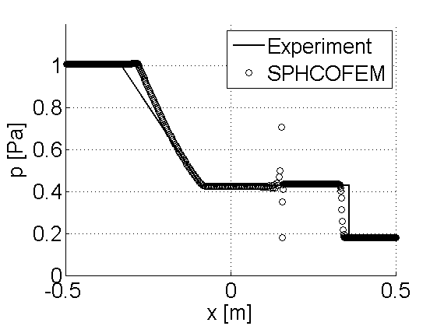
Fig. 1 Density (left) and pressure (right) distribution

Broken dam
Due to the complexity of any SPH calculation, the majority of the problems are investigated in 2D as planar flows. The broken dam is a typical problem for the 2D approach.
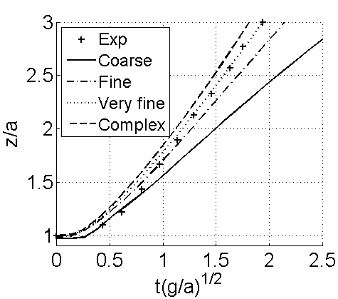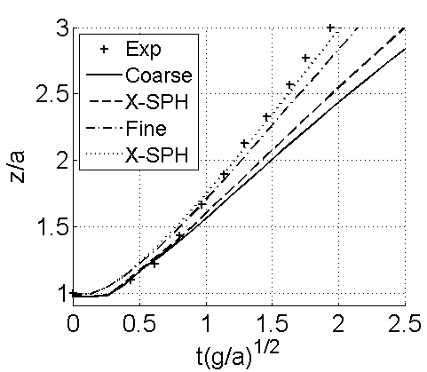
Fig. 2 Broken dam front surge propagation
The task is also used to evaluate the influence of the number of particles, the influence of the chosen method for NNS and the influence of the X-SPH variant.
Fig. 2 (left) shows the propagation of the surge front of the water domain after releasing the dam, taking into account the complexity of the model. Dimensionless time and water front position are defined with the gravitational acceleration g and the water front position z.
Fig. 2 (right) shows the influence of the X-SPH variant. Table 1 summarizes the time demand for particular calculations run on the table PC with Intel® Core™ i5-4570 CPU @ 3.20 GHz 3.20 GHz, 16 GB, 64 bit.

Crashing ball
The crashing ball is the only spatial problem, where the results are compared to the FEM computational environment in a different code using full 3D finite elements.
Table 1 Time demand for particular calculations
Model | Particles | Variant | NNS | Calculation [s]
Coarse | 19 x 19 | SPH | N² | 1.34
 |  | SPH | Sub-sets | 1.32
 |  | X-SPH | N² | 5.40
 |  | X-SPH | Sub-sets | 5.33
Fine | 57 x 57 | SPH | N² | 80.65
 |  | SPH | Sub-sets | 56.00
 |  | X-SPH | N² | 779.04
 |  | X-SPH | Sub-sets | 754.14
Very fine | 114 x 114 | SPH | N² | 1 850.75
 |  | SPH | Sub-sets | 974.21
Complex | 228 x 228 | SPH | N² | 79 243.73
 |  | SPH | Sub-sets | 14 290.08
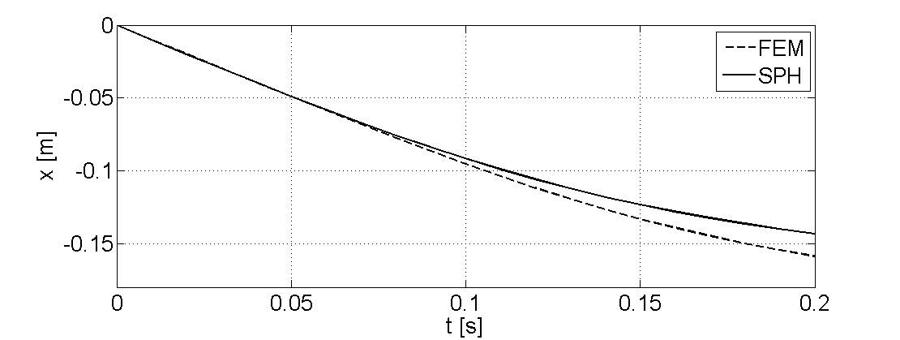
Fig. 3 Water front propagation
Fig. 3 shows the top ball particle displacement during the water ball collapse when crashing the rigid ball.

Discussion
The validation tasks presented in the paper prove the SPHCOFEM solver as a tool for modeling fluid flow coupled to the boundary.
The shock tube results show the use of the algorithm in the simplest problems’ investigation in 1D. One can see the discontinuity in both pressure and density (see Fig. 1) during the simulation, which are caused by the shock wave not being smoothed ideally.
The broken dam contributes to the own algorithm analysis itself. The results are successfully compared to the experimental data (Fig. 2) and it can be seen that there is not always a necessity to use a too complex model having a high number of particles. The optimization approach is proved to be useful, when a higher number of particles is taken into account. The X-SPH variant improves the results (Fig. 2) even for a lower number of particles, but the time consumption is considerably higher.
The spatial problem of the crashing ball also proved the performance of the algorithm, but in the 3D problems, NNS is usually to be taken into account due to the high calculation time consumption.

CONCLUSIONS
The computational system SPHCOFEM investigating the problems of fluid flow and its interaction with deformable boundaries was developed. The core of the package in C++ is the Lagrangean method for fluid flow simulation called smoothed particle hydrodynamics (SPH) that is coupled via the continuous contact model to the boundary modeled by the finite element method (FEM).
The algorithm presented is implemented as in-house software for investigation of fluid coupling to a deformable boundary in 1D, 2D or 3D. There is a graphical user interface (GUI) for reading the structured input text file describing the particle coordinates and initial conditions as well as the boundary definitions in the MATLAB environment.
The study shows both the advantages and disadvantages of using SPH coupled to FE and its exploitation for investigating real problems.

ACKNOWLEDGMENT
The work was co-financed by the internal research project SGS-2013-026 “Development of biomechanical models for medicine”.

Conflict of Interest
The author declares that he has no conflict of interest.

REFERENCES
- Violeau D (2012) Fluid Mechanics and the SPH Method: Theory and Application. Oxford University Press
- Gockenbach M S (2006) Understanding and Implementing the Finite Element Method. Society for Industrial and Applied Mathematics, Philadelphia
- Hynčík L (2002) Smoothed particle hydrodynamics theory and practice. Engineering Mechanics 9:1–15
- Gingold R A, Monaghan J J (1977) Smoothed particle hydrodynamics: theory and application to non-spherical stars. Monthly Notices of the Royal Astronomical Society 181:375–389
- Lobovský L, Křen, J (2002) Smoothed particle hydrodynamics modelling of fluids and solids. Applied and Computational Mechanics 1:521–530
- Ellero M, Serrano M, Español P (2007) Incompressible smoothed particle hydrodynamics. Journal of Computational Physics 226:1731–1752
- Shahriari S, Hassan I G, Kadem L (2013) Modeling unsteady flow characteristics using smoothed particle hydrodynamics. Applied Mathematical Modelling 37:1431–1450
- Hynčík L (2014) SPHCOFEM User’s Manual. University of West Bohemia
- Henneken E A C (1995) Smoothed Particle Hydrodynamics. Sterrewacht, Leiden
- Bonet J, Lok T S L (1999) Variational and momentum preservation aspects of Smoothed Particle Hydrodynamic formulations. Computed Methods Apl. Mech. Engrg 180:97–115
- Hynčík L (2002) Biomechanical model of abdominal organs and tissues for crash tests purposes. University of West Bohemia, Plzeň

Author: Luděk Hynčík
Institute: University of West Bohemia
Street: Univerzitní 8
City: Plzeň
Country: Czech Republic
Email: hyncik@ntc.zcu.cz

