饼图
import matplotlib.pyplot as plt
# Pie chart, where the slices will be ordered and plotted counter-clockwise:
labels = 'Frogs', 'Hogs', 'Dogs', 'Logs'
sizes = [15, 30, 45, 10]
explode = (0, 0.1, 0, 0) # only "explode" the 2nd slice (i.e. 'Hogs')
fig1, ax1 = plt.subplots()
ax1.pie(sizes, explode=explode, labels=labels, autopct='%1.1f%%',
shadow=True, startangle=90)
ax1.axis('equal') # Equal aspect ratio ensures that pie is drawn as a circle.
plt.show()

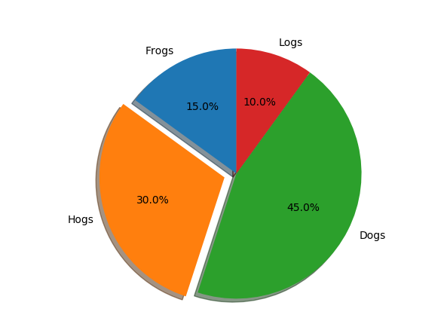

条形图1
import numpy as np
import matplotlib.pyplot as plt
from matplotlib.ticker import MaxNLocator
from collections import namedtuple
n_groups = 5
means_men = (20, 35, 30, 35, 27)
std_men = (2, 3, 4, 1, 2)
means_women = (25, 32, 34, 20, 25)
std_women = (3, 5, 2, 3, 3)
fig, ax = plt.subplots()
index = np.arange(n_groups)
bar_width = 0.35
opacity = 0.4
error_config = {'ecolor': '0.3'}
rects1 = ax.bar(index, means_men, bar_width,
alpha=opacity, color='b',
yerr=std_men, error_kw=error_config,
label='Men')
rects2 = ax.bar(index + bar_width, means_women, bar_width,
alpha=opacity, color='r',
yerr=std_women, error_kw=error_config,
label='Women')
ax.set_xlabel('Group')
ax.set_ylabel('Scores')
ax.set_title('Scores by group and gender')
ax.set_xticks(index + bar_width / 2)
ax.set_xticklabels(('A', 'B', 'C', 'D', 'E'))
ax.legend()
fig.tight_layout()
plt.show()
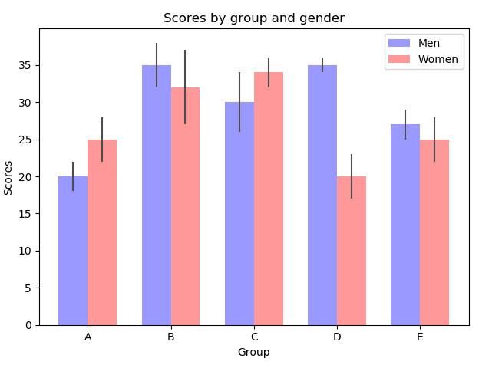

表格图
import numpy as np
import matplotlib.pyplot as plt
data = [[ 66386, 174296, 75131, 577908, 32015],
[ 58230, 381139, 78045, 99308, 160454],
[ 89135, 80552, 152558, 497981, 603535],
[ 78415, 81858, 150656, 193263, 69638],
[139361, 331509, 343164, 781380, 52269]]
columns = ('Freeze', 'Wind', 'Flood', 'Quake', 'Hail')
rows = ['%d year' % x for x in (100, 50, 20, 10, 5)]
values = np.arange(0, 2500, 500)
value_increment = 1000
# Get some pastel shades for the colors
colors = plt.cm.BuPu(np.linspace(0, 0.5, len(rows)))
n_rows = len(data)
index = np.arange(len(columns)) + 0.3
bar_width = 0.4
# Initialize the vertical-offset for the stacked bar chart.
y_offset = np.zeros(len(columns))
# Plot bars and create text labels for the table
cell_text = []
for row in range(n_rows):
plt.bar(index, data[row], bar_width, bottom=y_offset, color=colors[row])
y_offset = y_offset + data[row]
cell_text.append(['%1.1f' % (x / 1000.0) for x in y_offset])
# Reverse colors and text labels to display the last value at the top.
colors = colors[::-1]
cell_text.reverse()
# Add a table at the bottom of the axes
the_table = plt.table(cellText=cell_text,
rowLabels=rows,
rowColours=colors,
colLabels=columns,
loc='bottom')
# Adjust layout to make room for the table:
plt.subplots_adjust(left=0.2, bottom=0.2)
plt.ylabel("Loss in ${0}'s".format(value_increment))
plt.yticks(values * value_increment, ['%d' % val for val in values])
plt.xticks([])
plt.title('Loss by Disaster')
plt.show()

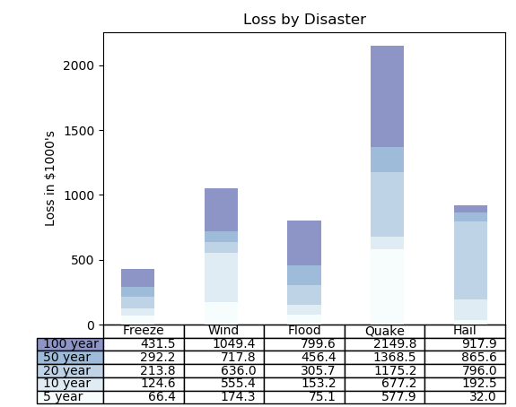

散点图
import numpy as np
import matplotlib.pyplot as plt
import matplotlib.cbook as cbook
# Load a numpy record array from yahoo csv data with fields date, open, close,
# volume, adj_close from the mpl-data/example directory. The record array
# stores the date as an np.datetime64 with a day unit ('D') in the date column.
with cbook.get_sample_data('goog.npz') as datafile:
price_data = np.load(datafile)['price_data'].view(np.recarray)
price_data = price_data[-250:] # get the most recent 250 trading days
delta1 = np.diff(price_data.adj_close) / price_data.adj_close[:-1]
# Marker size in units of points^2
volume = (15 * price_data.volume[:-2] / price_data.volume[0])**2
close = 0.003 * price_data.close[:-2] / 0.003 * price_data.open[:-2]
fig, ax = plt.subplots()
ax.scatter(delta1[:-1], delta1[1:], c=close, s=volume, alpha=0.5)
ax.set_xlabel(r'$\Delta_i$', fontsize=15)
ax.set_ylabel(r'$\Delta_{i+1}$', fontsize=15)
ax.set_title('Volume and percent change')
ax.grid(True)
fig.tight_layout()
plt.show()
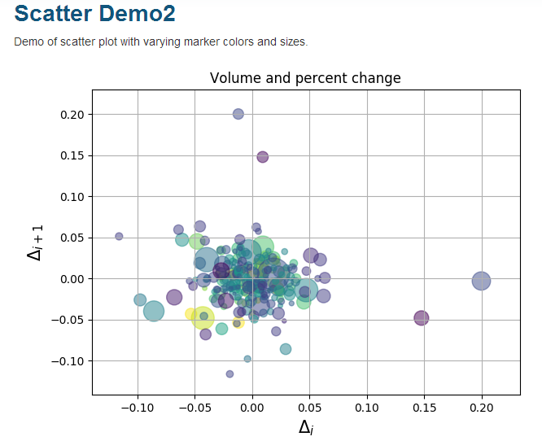

平滑图
import numpy as np
import matplotlib.pyplot as plt
from matplotlib.widgets import Slider, Button, RadioButtons

fig, ax = plt.subplots()
plt.subplots_adjust(left=0.25, bottom=0.25)
t = np.arange(0.0, 1.0, 0.001)
a0 = 5
f0 = 3
delta_f = 5.0
s = a0*np.sin(2*np.pi*f0*t)
l, = plt.plot(t, s, lw=2, color='red')
plt.axis([0, 1, -10, 10])

axcolor = 'lightgoldenrodyellow'
axfreq = plt.axes([0.25, 0.1, 0.65, 0.03], facecolor=axcolor)
axamp = plt.axes([0.25, 0.15, 0.65, 0.03], facecolor=axcolor)

sfreq = Slider(axfreq, 'Freq', 0.1, 30.0, valinit=f0, valstep=delta_f)
samp = Slider(axamp, 'Amp', 0.1, 10.0, valinit=a0)

def update(val):
amp = samp.val
freq = sfreq.val
l.set_ydata(amp*np.sin(2*np.pi*freq*t))
fig.canvas.draw_idle()
sfreq.on_changed(update)
samp.on_changed(update)

resetax = plt.axes([0.8, 0.025, 0.1, 0.04])
button = Button(resetax, 'Reset', color=axcolor, hovercolor='0.975')

def reset(event):
sfreq.reset()
samp.reset()
button.on_clicked(reset)

rax = plt.axes([0.025, 0.5, 0.15, 0.15], facecolor=axcolor)
radio = RadioButtons(rax, ('red', 'blue', 'green'), active=0)

def colorfunc(label):
l.set_color(label)
fig.canvas.draw_idle()
radio.on_clicked(colorfunc)

plt.show()

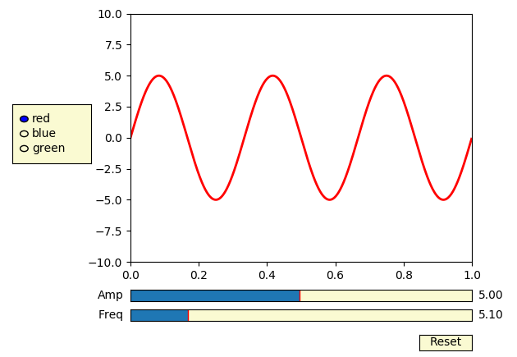

数据打钩标签图

import datetime
import numpy as np
import matplotlib.pyplot as plt
import matplotlib.dates as mdates
import matplotlib.cbook as cbook
years = mdates.YearLocator() # every year
months = mdates.MonthLocator() # every month
yearsFmt = mdates.DateFormatter('%Y')
# Load a numpy record array from yahoo csv data with fields date, open, close,
# volume, adj_close from the mpl-data/example directory. The record array
# stores the date as an np.datetime64 with a day unit ('D') in the date column.
with cbook.get_sample_data('goog.npz') as datafile:
r = np.load(datafile)['price_data'].view(np.recarray)
fig, ax = plt.subplots()
ax.plot(r.date, r.adj_close)
# format the ticks
ax.xaxis.set_major_locator(years)
ax.xaxis.set_major_formatter(yearsFmt)
ax.xaxis.set_minor_locator(months)
# round to nearest years...
datemin = np.datetime64(r.date[0], 'Y')
datemax = np.datetime64(r.date[-1], 'Y') + np.timedelta64(1, 'Y')
ax.set_xlim(datemin, datemax)
# format the coords message box
def price(x):
return '$%1.2f' % x
ax.format_xdata = mdates.DateFormatter('%Y-%m-%d')
ax.format_ydata = price
ax.grid(True)
# rotates and right aligns the x labels, and moves the bottom of the
# axes up to make room for them
fig.autofmt_xdate()
plt.show()
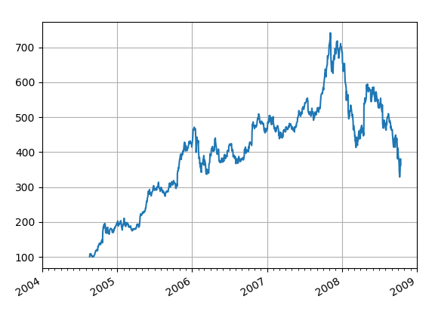

使用预定义标签的图例
import numpy as np
import matplotlib.pyplot as plt

# Make some fake data.
a = b = np.arange(0, 3, .02)
c = np.exp(a)
d = c[::-1]

# Create plots with pre-defined labels.
fig, ax = plt.subplots()
ax.plot(a, c, 'k--', label='Model length')
ax.plot(a, d, 'k:', label='Data length')
ax.plot(a, c + d, 'k', label='Total message length')

legend = ax.legend(loc='upper center', shadow=True, fontsize='x-large')

# Put a nicer background color on the legend.
legend.get_frame().set_facecolor('#00FFCC')

plt.show()

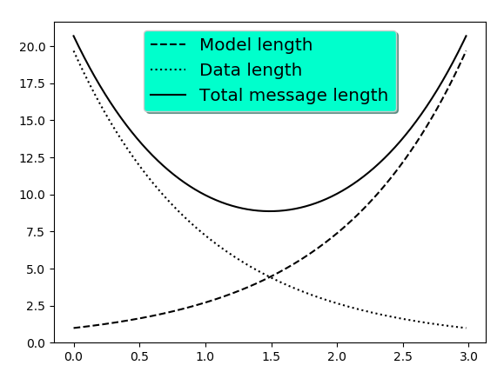

数学公式编辑图
from __future__ import print_function
import matplotlib.pyplot as plt
import subprocess
import sys
import re
import gc

# Selection of features following "Writing mathematical expressions" tutorial
mathtext_titles = {
0: "Header demo",
1: "Subscripts and superscripts",
2: "Fractions, binomials and stacked numbers",
3: "Radicals",
4: "Fonts",
5: "Accents",
6: "Greek, Hebrew",
7: "Delimiters, functions and Symbols"}
n_lines = len(mathtext_titles)

# Randomly picked examples
mathext_demos = {
0: r"$W^{3\beta}_{\delta_1 \rho_1 \sigma_2} = "
r"U^{3\beta}_{\delta_1 \rho_1} + \frac{1}{8 \pi 2} "
r"\int^{\alpha_2}_{\alpha_2} d \alpha^\prime_2 \left[\frac{ "
r"U^{2\beta}_{\delta_1 \rho_1} - \alpha^\prime_2U^{1\beta}_"
r"{\rho_1 \sigma_2} }{U^{0\beta}_{\rho_1 \sigma_2}}\right]$",

1: r"$\alpha_i > \beta_i,\ "
r"\alpha_{i+1}^j = {\rm sin}(2\pi f_j t_i) e^{-5 t_i/\tau},\ "
r"\ldots$",

2: r"$\frac{3}{4},\ \binom{3}{4},\ \stackrel{3}{4},\ "
r"\left(\frac{5 - \frac{1}{x}}{4}\right),\ \ldots$",

3: r"$\sqrt{2},\ \sqrt[3]{x},\ \ldots$",

4: r"$\mathrm{Roman}\ , \ \mathit{Italic}\ , \ \mathtt{Typewriter} \ "
r"\mathrm{or}\ \mathcal{CALLIGRAPHY}$",

5: r"$\acute a,\ \bar a,\ \breve a,\ \dot a,\ \ddot a, \ \grave a, \ "
r"\hat a,\ \tilde a,\ \vec a,\ \widehat{xyz},\ \widetilde{xyz},\ "
r"\ldots$",

6: r"$\alpha,\ \beta,\ \chi,\ \delta,\ \lambda,\ \mu,\ "
r"\Delta,\ \Gamma,\ \Omega,\ \Phi,\ \Pi,\ \Upsilon,\ \nabla,\ "
r"\aleph,\ \beth,\ \daleth,\ \gimel,\ \ldots$",

7: r"$\coprod,\ \int,\ \oint,\ \prod,\ \sum,\ "
r"\log,\ \sin,\ \approx,\ \oplus,\ \star,\ \varpropto,\ "
r"\infty,\ \partial,\ \Re,\ \leftrightsquigarrow, \ \ldots$"}

def doall():
# Colors used in mpl online documentation.
mpl_blue_rvb = (191. / 255., 209. / 256., 212. / 255.)
mpl_orange_rvb = (202. / 255., 121. / 256., 0. / 255.)
mpl_grey_rvb = (51. / 255., 51. / 255., 51. / 255.)

# Creating figure and axis.
plt.figure(figsize=(6, 7))
plt.axes([0.01, 0.01, 0.98, 0.90], facecolor="white", frameon=True)
plt.gca().set_xlim(0., 1.)
plt.gca().set_ylim(0., 1.)
plt.gca().set_title("Matplotlib's math rendering engine",
color=mpl_grey_rvb, fontsize=14, weight='bold')
plt.gca().set_xticklabels("", visible=False)
plt.gca().set_yticklabels("", visible=False)

# Gap between lines in axes coords
line_axesfrac = (1. / (n_lines))

# Plotting header demonstration formula
full_demo = mathext_demos[0]
plt.annotate(full_demo,
xy=(0.5, 1. - 0.59 * line_axesfrac),
xycoords='data', color=mpl_orange_rvb, ha='center',
fontsize=20)

# Plotting features demonstration formulae
for i_line in range(1, n_lines):
baseline = 1 - (i_line) * line_axesfrac
baseline_next = baseline - line_axesfrac
title = mathtext_titles[i_line] + ":"
fill_color = ['white', mpl_blue_rvb][i_line % 2]
plt.fill_between([0., 1.], [baseline, baseline],
[baseline_next, baseline_next],
color=fill_color, alpha=0.5)
plt.annotate(title,
xy=(0.07, baseline - 0.3 * line_axesfrac),
xycoords='data', color=mpl_grey_rvb, weight='bold')
demo = mathext_demos[i_line]
plt.annotate(demo,
xy=(0.05, baseline - 0.75 * line_axesfrac),
xycoords='data', color=mpl_grey_rvb,
fontsize=16)

for i in range(n_lines):
s = mathext_demos[i]
print(i, s)
plt.show()

if '--latex' in sys.argv:
# Run: python mathtext_examples.py --latex
# Need amsmath and amssymb packages.
fd = open("mathtext_examples.ltx", "w")
fd.write("\\documentclass{article}\n")
fd.write("\\usepackage{amsmath, amssymb}\n")
fd.write("\\begin{document}\n")
fd.write("\\begin{enumerate}\n")

for i in range(n_lines):
s = mathext_demos[i]
s = re.sub(r"(?<!\\)\$", "$$", s)
fd.write("\\item %s\n" % s)

fd.write("\\end{enumerate}\n")
fd.write("\\end{document}\n")
fd.close()

subprocess.call(["pdflatex", "mathtext_examples.ltx"])
else:
doall()

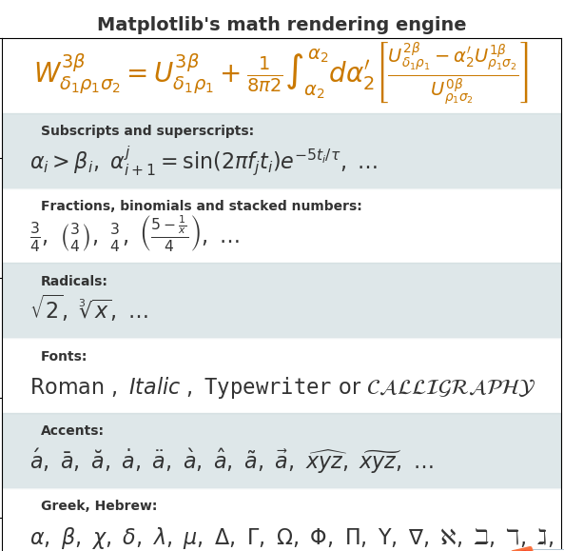

读取数学问题使用TEX
from __future__ import unicode_literals
import numpy as np
import matplotlib
matplotlib.rcParams['text.usetex'] = True
matplotlib.rcParams['text.latex.unicode'] = True
import matplotlib.pyplot as plt

t = np.linspace(0.0, 1.0, 100)
s = np.cos(4 * np.pi * t) + 2

fig, ax = plt.subplots(figsize=(6, 4), tight_layout=True)
ax.plot(t, s)

ax.set_xlabel(r'\textbf{time (s)}')
ax.set_ylabel('\\textit{Velocity (\N{DEGREE SIGN}/sec)}', fontsize=16)
ax.set_title(r'\TeX\ is Number $\displaystyle\sum_{n=1}^\infty'
r'\frac{-e^{i\pi}}{2^n}$!', fontsize=16, color='r')
plt.show()

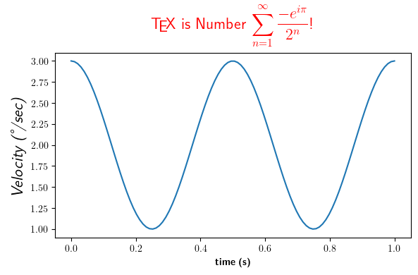

XKCD图
import matplotlib.pyplot as plt
import numpy as np
with plt.xkcd():
# Based on "Stove Ownership" from XKCD by Randall Monroe
# http://xkcd.com/418/

fig = plt.figure()
ax = fig.add_axes((0.1, 0.2, 0.8, 0.7))
ax.spines['right'].set_color('none')
ax.spines['top'].set_color('none')
plt.xticks([])
plt.yticks([])
ax.set_ylim([-30, 10])

data = np.ones(100)
data[70:] -= np.arange(30)

plt.annotate(
'THE DAY I REALIZED\nI COULD COOK BACON\nWHENEVER I WANTED',
xy=(70, 1), arrowprops=dict(arrowstyle='->'), xytext=(15, -10))

plt.plot(data)

plt.xlabel('time')
plt.ylabel('my overall health')
fig.text(
0.5, 0.05,
'"Stove Ownership" from xkcd by Randall Monroe',
ha='center')
with plt.xkcd():
# Based on "The Data So Far" from XKCD by Randall Monroe
# http://xkcd.com/373/

fig = plt.figure()
ax = fig.add_axes((0.1, 0.2, 0.8, 0.7))
ax.bar([0, 1], [0, 100], 0.25)
ax.spines['right'].set_color('none')
ax.spines['top'].set_color('none')
ax.xaxis.set_ticks_position('bottom')
ax.set_xticks([0, 1])
ax.set_xlim([-0.5, 1.5])
ax.set_ylim([0, 110])
ax.set_xticklabels(['CONFIRMED BY\nEXPERIMENT', 'REFUTED BY\nEXPERIMENT'])
plt.yticks([])

plt.title("CLAIMS OF SUPERNATURAL POWERS")

fig.text(
0.5, 0.05,
'"The Data So Far" from xkcd by Randall Monroe',
ha='center')

plt.show()
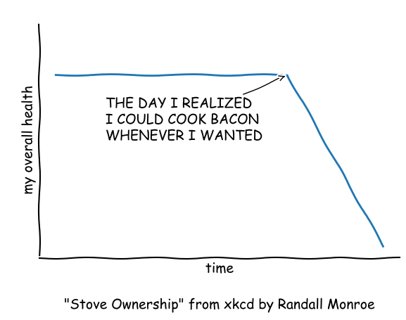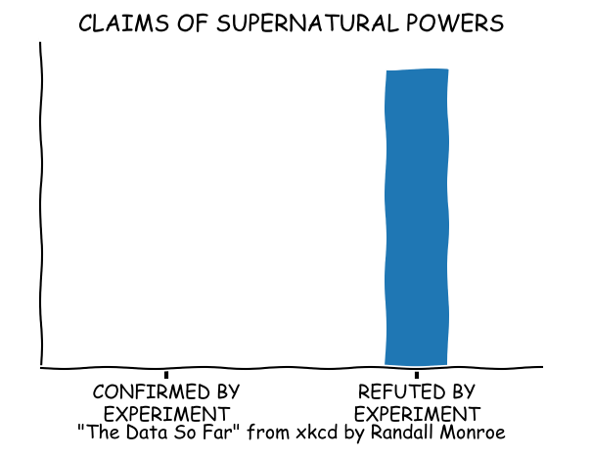

样本子图
import matplotlib.pyplot as plt
import numpy as np

np.random.seed(19680801)
data = np.random.randn(2, 100)

fig, axs = plt.subplots(2, 2, figsize=(5, 5))
axs[0, 0].hist(data[0])
axs[1, 0].scatter(data[0], data[1])
axs[0, 1].plot(data[0], data[1])
axs[1, 1].hist2d(data[0], data[1])

plt.show()
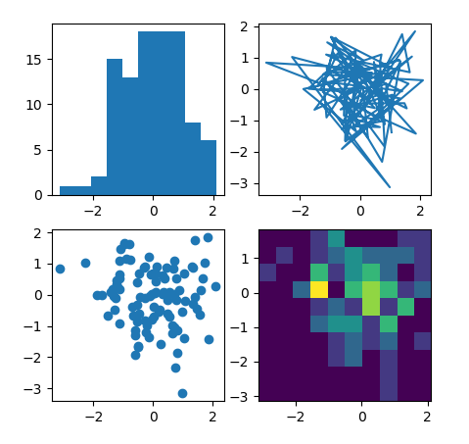

极图
import numpy as np
import matplotlib.pyplot as plt

r = np.arange(0, 2, 0.01)
theta = 2 * np.pi * r

ax = plt.subplot(111, projection='polar')
ax.plot(theta, r)
ax.set_rmax(2)
ax.set_rticks([0.5, 1, 1.5, 2]) # Less radial ticks
ax.set_rlabel_position(-22.5) # Move radial labels away from plotted line
ax.grid(True)

ax.set_title("A line plot on a polar axis", va='bottom')
plt.show()
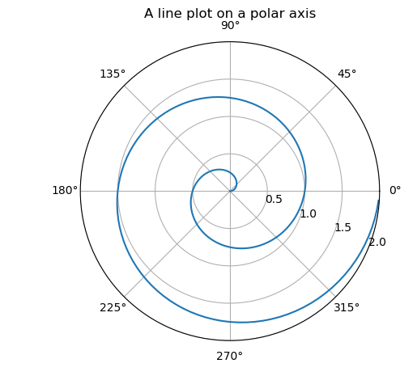

Log图
import numpy as np
import matplotlib.pyplot as plt

# Data for plotting
t = np.arange(0.01, 20.0, 0.01)

# Create figure
fig, ((ax1, ax2), (ax3, ax4)) = plt.subplots(2, 2)

# log y axis
ax1.semilogy(t, np.exp(-t / 5.0))
ax1.set(title='semilogy')
ax1.grid()

# log x axis
ax2.semilogx(t, np.sin(2 * np.pi * t))
ax2.set(title='semilogx')
ax2.grid()

# log x and y axis
ax3.loglog(t, 20 * np.exp(-t / 10.0), basex=2)
ax3.set(title='loglog base 2 on x')
ax3.grid()

# With errorbars: clip non-positive values
# Use new data for plotting
x = 10.0**np.linspace(0.0, 2.0, 20)
y = x**2.0

ax4.set_xscale("log", nonposx='clip')
ax4.set_yscale("log", nonposy='clip')
ax4.set(title='Errorbars go negative')
ax4.errorbar(x, y, xerr=0.1 * x, yerr=5.0 + 0.75 * y)
# ylim must be set after errorbar to allow errorbar to autoscale limits
ax4.set_ylim(ymin=0.1)

fig.tight_layout()
plt.show()

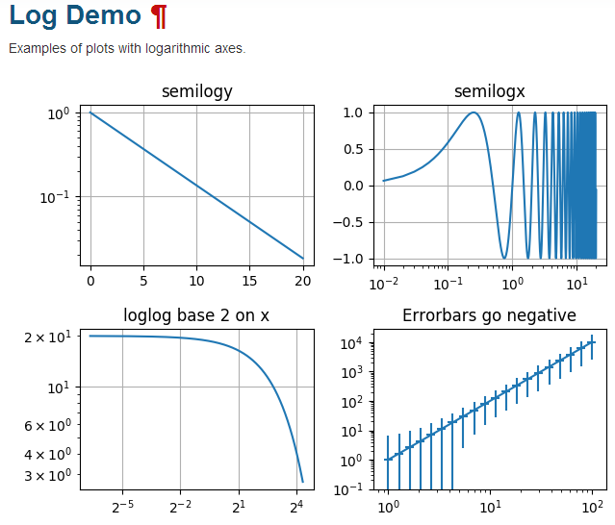

椭圆图
import matplotlib.pyplot as plt
import numpy as np
from matplotlib.patches import Ellipse

NUM = 250

ells = [Ellipse(xy=np.random.rand(2) * 10,
width=np.random.rand(), height=np.random.rand(),
angle=np.random.rand() * 360)
for i in range(NUM)]

fig, ax = plt.subplots(subplot_kw={'aspect': 'equal'})
for e in ells:
ax.add_artist(e)
e.set_clip_box(ax.bbox)
e.set_alpha(np.random.rand())
e.set_facecolor(np.random.rand(3))

ax.set_xlim(0, 10)
ax.set_ylim(0, 10)

plt.show()

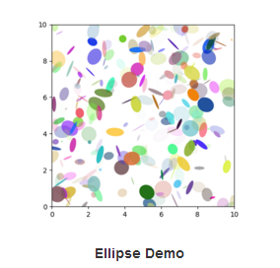

流向图
import numpy as np
import matplotlib.pyplot as plt
import matplotlib.gridspec as gridspec

w = 3
Y, X = np.mgrid[-w:w:100j, -w:w:100j]
U = -1 - X**2 + Y
V = 1 + X - Y**2
speed = np.sqrt(U*U + V*V)

fig = plt.figure(figsize=(7, 9))
gs = gridspec.GridSpec(nrows=3, ncols=2, height_ratios=[1, 1, 2])

# Varying density along a streamline
ax0 = fig.add_subplot(gs[0, 0])
ax0.streamplot(X, Y, U, V, density=[0.5, 1])
ax0.set_title('Varying Density')

# Varying color along a streamline
ax1 = fig.add_subplot(gs[0, 1])
strm = ax1.streamplot(X, Y, U, V, color=U, linewidth=2, cmap='autumn')
fig.colorbar(strm.lines)
ax1.set_title('Varying Color')

# Varying line width along a streamline
ax2 = fig.add_subplot(gs[1, 0])
lw = 5*speed / speed.max()
ax2.streamplot(X, Y, U, V, density=0.6, color='k', linewidth=lw)
ax2.set_title('Varying Line Width')

# Controlling the starting points of the streamlines
seed_points = np.array([[-2, -1, 0, 1, 2, -1], [-2, -1, 0, 1, 2, 2]])

ax3 = fig.add_subplot(gs[1, 1])
strm = ax3.streamplot(X, Y, U, V, color=U, linewidth=2,
cmap='autumn', start_points=seed_points.T)
fig.colorbar(strm.lines)
ax3.set_title('Controlling Starting Points')

# Displaying the starting points with blue symbols.
ax3.plot(seed_points[0], seed_points[1], 'bo')
ax3.axis((-w, w, -w, w))

# Create a mask
mask = np.zeros(U.shape, dtype=bool)
mask[40:60, 40:60] = True
U[:20, :20] = np.nan
U = np.ma.array(U, mask=mask)

ax4 = fig.add_subplot(gs[2:, :])
ax4.streamplot(X, Y, U, V, color='r')
ax4.set_title('Streamplot with Masking')

ax4.imshow(~mask, extent=(-w, w, -w, w), alpha=0.5,
interpolation='nearest', cmap='gray', aspect='auto')
ax4.set_aspect('equal')

plt.tight_layout()
plt.show()

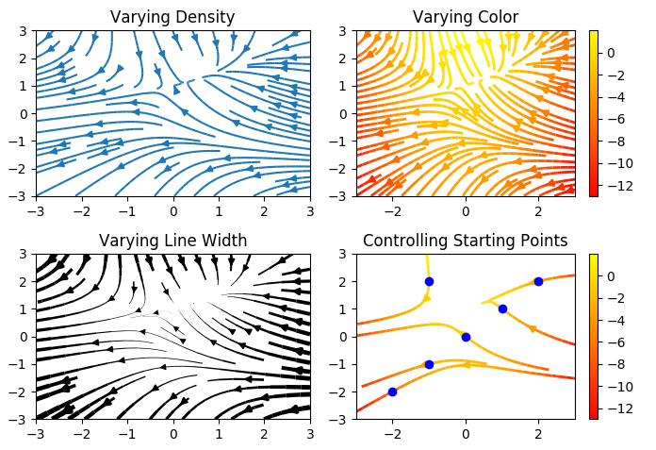
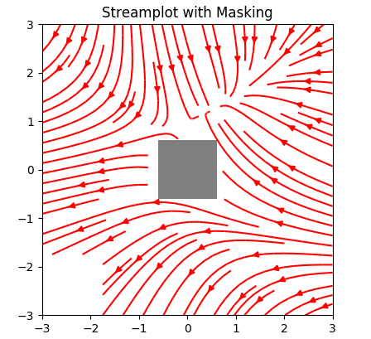

线形图
import matplotlib
import matplotlib.pyplot as plt
import numpy as np

# Data for plotting
t = np.arange(0.0, 2.0, 0.01)
s = 1 + np.sin(2 * np.pi * t)

# Note that using plt.subplots below is equivalent to using
# fig = plt.figure() and then ax = fig.add_subplot(111)
fig, ax = plt.subplots()
ax.plot(t, s)

ax.set(xlabel='time (s)', ylabel='voltage (mV)',
title='About as simple as it gets, folks')
ax.grid()

fig.savefig("test.png")
plt.show()

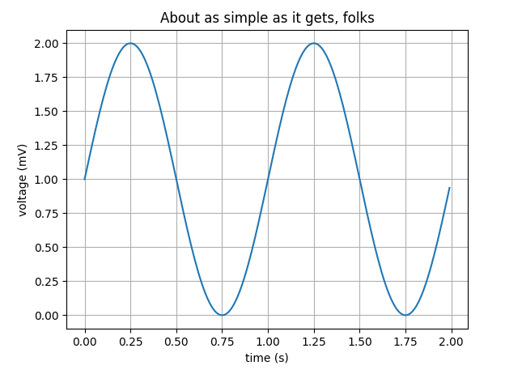

多重图
import numpy as np
import matplotlib.pyplot as plt

x1 = np.linspace(0.0, 5.0)
x2 = np.linspace(0.0, 2.0)

y1 = np.cos(2 * np.pi * x1) * np.exp(-x1)
y2 = np.cos(2 * np.pi * x2)

plt.subplot(2, 1, 1)
plt.plot(x1, y1, 'o-')
plt.title('A tale of 2 subplots')
plt.ylabel('Damped oscillation')

plt.subplot(2, 1, 2)
plt.plot(x2, y2, '.-')
plt.xlabel('time (s)')
plt.ylabel('Undamped')

plt.show()

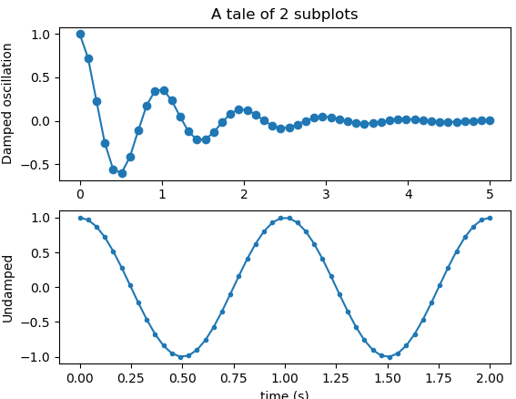

图片处理图
from __future__ import print_function

import numpy as np
import matplotlib.cm as cm
import matplotlib.pyplot as plt
import matplotlib.cbook as cbook
from matplotlib.path import Path
from matplotlib.patches import PathPatch
delta = 0.025
x = y = np.arange(-3.0, 3.0, delta)
X, Y = np.meshgrid(x, y)
Z1 = np.exp(-X**2 - Y**2)
Z2 = np.exp(-(X - 1)**2 - (Y - 1)**2)
Z = (Z1 - Z2) * 2

im = plt.imshow(Z, interpolation='bilinear', cmap=cm.RdYlGn,
origin='lower', extent=[-3, 3, -3, 3],
vmax=abs(Z).max(), vmin=-abs(Z).max())

plt.show()
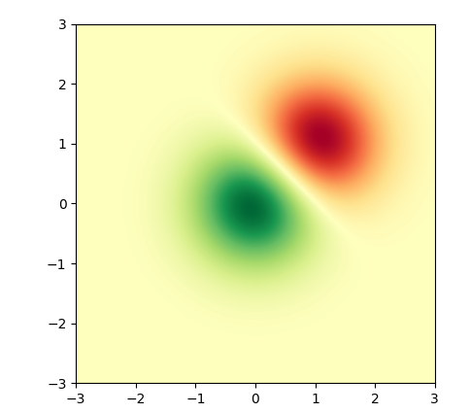

直方图
import matplotlib
import numpy as np
import matplotlib.pyplot as plt

np.random.seed(19680801)

# example data
mu = 100 # mean of distribution
sigma = 15 # standard deviation of distribution
x = mu + sigma * np.random.randn(437)

num_bins = 50

fig, ax = plt.subplots()

# the histogram of the data
n, bins, patches = ax.hist(x, num_bins, density=1)

# add a 'best fit' line
y = ((1 / (np.sqrt(2 * np.pi) * sigma)) *
np.exp(-0.5 * (1 / sigma * (bins - mu))**2))
ax.plot(bins, y, '--')
ax.set_xlabel('Smarts')
ax.set_ylabel('Probability density')
ax.set_title(r'Histogram of IQ: $\mu=100$, $\sigma=15$')

# Tweak spacing to prevent clipping of ylabel
fig.tight_layout()
plt.show()

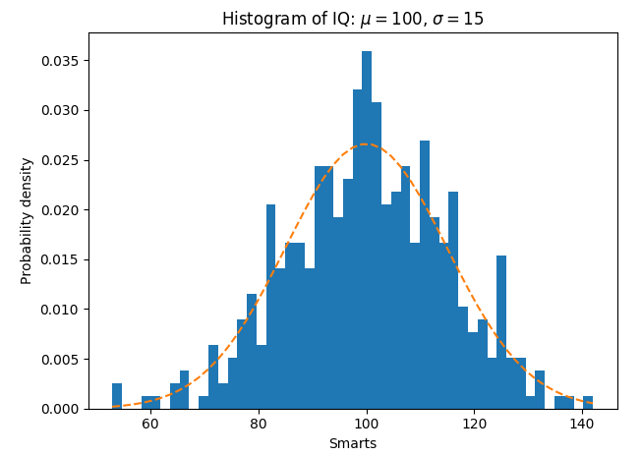

路径图
import matplotlib.path as mpath
import matplotlib.patches as mpatches
import matplotlib.pyplot as plt

fig, ax = plt.subplots()

Path = mpath.Path
path_data = [
(Path.MOVETO, (1.58, -2.57)),
(Path.CURVE4, (0.35, -1.1)),
(Path.CURVE4, (-1.75, 2.0)),
(Path.CURVE4, (0.375, 2.0)),
(Path.LINETO, (0.85, 1.15)),
(Path.CURVE4, (2.2, 3.2)),
(Path.CURVE4, (3, 0.05)),
(Path.CURVE4, (2.0, -0.5)),
(Path.CLOSEPOLY, (1.58, -2.57)),
]
codes, verts = zip(*path_data)
path = mpath.Path(verts, codes)
patch = mpatches.PathPatch(path, facecolor='r', alpha=0.5)
ax.add_patch(patch)

# plot control points and connecting lines
x, y = zip(*path.vertices)
line, = ax.plot(x, y, 'go-')

ax.grid()
ax.axis('equal')
plt.show()

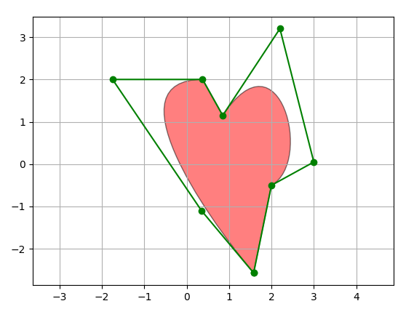

三维图
from mpl_toolkits.mplot3d import Axes3D
import matplotlib.pyplot as plt
from matplotlib import cm
from matplotlib.ticker import LinearLocator, FormatStrFormatter
import numpy as np

fig = plt.figure()
ax = fig.gca(projection='3d')

# Make data.
X = np.arange(-5, 5, 0.25)
Y = np.arange(-5, 5, 0.25)
X, Y = np.meshgrid(X, Y)
R = np.sqrt(X**2 + Y**2)
Z = np.sin(R)

# Plot the surface.
surf = ax.plot_surface(X, Y, Z, cmap=cm.coolwarm,
linewidth=0, antialiased=False)

# Customize the z axis.
ax.set_zlim(-1.01, 1.01)
ax.zaxis.set_major_locator(LinearLocator(10))
ax.zaxis.set_major_formatter(FormatStrFormatter('%.02f'))

# Add a color bar which maps values to colors.
fig.colorbar(surf, shrink=0.5, aspect=5)

plt.show()

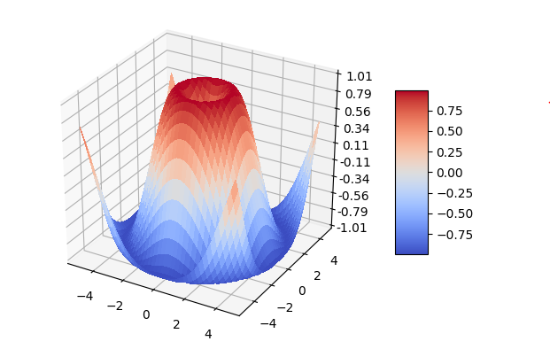

轮廓和伪彩色
import matplotlib
import matplotlib.pyplot as plt
from matplotlib.colors import BoundaryNorm
from matplotlib.ticker import MaxNLocator
import numpy as np

# make these smaller to increase the resolution
dx, dy = 0.05, 0.05

# generate 2 2d grids for the x & y bounds
y, x = np.mgrid[slice(1, 5 + dy, dy),
slice(1, 5 + dx, dx)]

z = np.sin(x)**10 + np.cos(10 + y*x) * np.cos(x)

# x and y are bounds, so z should be the value *inside* those bounds.
# Therefore, remove the last value from the z array.
z = z[:-1, :-1]
levels = MaxNLocator(nbins=15).tick_values(z.min(), z.max())

# pick the desired colormap, sensible levels, and define a normalization
# instance which takes data values and translates those into levels.
cmap = plt.get_cmap('PiYG')
norm = BoundaryNorm(levels, ncolors=cmap.N, clip=True)

fig, (ax0, ax1) = plt.subplots(nrows=2)

im = ax0.pcolormesh(x, y, z, cmap=cmap, norm=norm)
fig.colorbar(im, ax=ax0)
ax0.set_title('pcolormesh with levels')

# contours are *point* based plots, so convert our bound into point
# centers
cf = ax1.contourf(x[:-1, :-1] + dx/2.,
y[:-1, :-1] + dy/2., z, levels=levels,
cmap=cmap)
fig.colorbar(cf, ax=ax1)
ax1.set_title('contourf with levels')

# adjust spacing between subplots so `ax1` title and `ax0` tick labels
# don't overlap
fig.tight_layout()

plt.show()

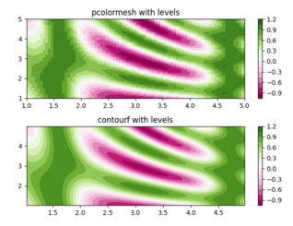

填满图
import numpy as np
import matplotlib.pyplot as plt

x = [0, 1, 2, 1]
y = [1, 2, 1, 0]

fig, ax = plt.subplots()
ax.fill(x, y)
plt.show()

