2026 MCM
Problem B: Creating a Moon Colony Using a Space Elevator System
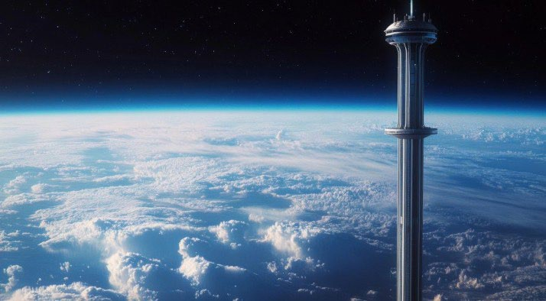
Imagine a future where it’s possible for anyone to visit space by taking a leisurely and scenic ride from the Equator to Earth’s orbit and then catching a routine, safe, and inexpensive rocket flight to the Moon, Mars, or beyond. In this future, we could build lush, green, and beautiful space habitats with artificial gravity, where people would vacation, work, or even live. These habitats would alleviate pressure on Earth’s delicate, overworked, and fragile ecosystems. The technology to enable these events would provide humankind with limitless, safe, routine, environmentally friendly, efficient, and global access to space. To achieve these goals, some people envision a Space Elevator System, powered by electricity, offering a scalable infrastructure for interplanetary logistics, commerce, and exploration.
At its final operating configuration, the Space Elevator System would comprise three Galactic Harbours, ideally separated by 120 degrees around the equator. Each Galactic Harbour would include a single Earth port with two100,000 km-long tethers connected to two apex anchors, with multiple space elevators operating together, each capable of lifting massive payloads daily from Earth to geosynchronous orbit (GEO) and beyond to the apex anchor where they can be loaded on a rocket and delivered anywhere using much less fuel.
The Moon Colony Management (MCM) Agency is preparing to build a Moon Colony with an estimated 100,000 people beginning in the year 2050, after completion of the Space Elevator System. It is estimated that the Moon Colony will need about 100 million metric tons of materials. Additionally, water and supplies will routinely need to be sent to sustain the Moon’s population once the colony is complete. To get to the Moon, the Galactic Harbour must send material in two steps: first, from the Earth port to the apex anchor via a space elevator, and second, from the apex anchor to the Moon Colony via a rocket. The MCM Agency anticipates that the Galactic Harbor will provide an advanced lift system capable of moving 179,000 metric tons every year, while generating no atmospheric pollution.

The agency is also considering using traditional rockets to supply material for construction and supplies to the Moon Colony. The Earth current has ten rocket launch sites: Alaska, California, Texas, Florida, and Virginia (United States), Kazakhstan, French Guiana, Satish Dhawan Space Centre (India), Taiyuan Satellite Launch Center (China), and Mahia Peninsula (New Zealand).

A rocket would require a single step from the rocket launch site on Earth to the Moon Colony. By 2050 it is estimated that rockets will be able to carry 100-150 metric tons of payload to the Moon using advanced Falcon Heavy launches. You may assume perfect conditions for both the Galactic Harbour system (e.g., no swaying of the tether) and rocket launches (e.g., no failed launches). You should consider the cost and timeline to deliver the materials from the surface of the Earth to the Moon Colony site for the different scenarios.

Your Task:
Your task is to utilize a mathematical model to determine the cost and associated timeline in order to transport material to build a 100,000 person Moon Colony starting in 2050. You will need to compare the Modern-Day Space Elevator System’s three Galactic Harbours to traditional rockets launched from selected rocket bases.

Your model should include:
- Consideration of three different scenarios for how the 100 million metric tons of materials will be delivered to build the 100,000-person Moon Colony;
  - using the Space Elevator System’s three Galactic Harbor’s alone,
  - traditional rocket launches from existing bases alone (you may choose which facilities to use), or,
  - some combination of the two methods.
- To what extent does your solution(s) change if the transportation systems are not in perfect working order (e.g, swaying of the tether, rockets fail, elevators break, etc.)?
- Investigate the water needs for a one-year period once the 100,000-person Moon Colony is fully operational. Use your delivery model to understand the additional cost and timeline needed to ensure the colony has sufficient water for one full year after the Moon Colony is inhabited.
- Discuss the impact on the Earth’s environment for achieving the 100,000-person Moon Colony under the different scenarios. How would you adjust your model to minimize the environmental impact?
- Write a one-page letter recommending a course of action to the fictional MCM Agency to build and sustain a 100,000-person Moon Colony.
Your PDF solution of no more than 25 total pages should include:
- One-page Summary Sheet.
- Table of Contents.
- Your complete solution.
- One-page letter to MCM Agency
- References list.
- AI Use Report (If used does not count toward the 25-page limit.)

Note: There is no specific required minimum page length for a complete MCM submission. You may use up to 25 total pages for all your solution work and any additional information you want to include (for example: drawings, diagrams, calculations, tables). Partial solutions are accepted. We permit the careful use of AI such as ChatGPT, although it is not necessary to create a solution to this problem. If you choose to utilize a generative AI, you must follow the COMAP AI use policy. This will result in an additional AI use report that you must add to the end of your PDF solution file and does not count toward the 25 total page limit for your solution.

Glossary

Space Elevator System is comprised of three Galactic Harbours plus additional support facilities.

Galactic Harbour is comprised of two apex anchors each connected by two tethers to a single Earth Port.

Earth Port is the location on the Earth that provides surface support for the Galactic Harbour.

Tethers are 100,000 km long graphene material that links the Earth port and apex anchors in the Space Elevator System.

Apex Anchor is the counterweight in space at the end of the 100,000 km tether.
Geosynchronous orbit (GEO) is approximately 35,786 km above the surface of the Earth where the orbital period to circle Earth is 24 hours, matching Earth’s rotation so it stays over the same longitude each day.
Moon Colony is a habitat on the moon with the capacity to support 100,000-persons.

