A Report on GAME HACKATHON 2024

Titled

*“GameGen: Conquer Algorithmic Challenges in Gaming using Java”*

Report Made by

DeeW Gang

Abhijit Sirke: 2023510054

Tanmay Umtol: 2023510061

Nitin Kumar Yadav: 2023510068

Yash Rautela: 2023510047

FYMCA Sem-II

Academic Year: 2023-24

ISE-2 (DAA and JAVA)

Under the Guidance of

Dr. Aarti Karande

Prof. Sakina Salmani



Master of Computer Applications Program

Computer Science and Engineering Department

**Bharatiya Vidya Bhavan’s**

**SARDAR PATEL INSTITUTE OF TECHNOLOGY**

Munshi Nagar, Andheri (W), Mumbai – 400 058.

(Autonomous Institute Affiliated to University of Mumbai)

Date: 16th April 2024

**Group Member Description along with Latest Photo**

| **Group member Name** | **Description of the person (Tell about yourself which best describes you as a person and as professional)** |
| --- | --- |
| Abhijit Shirke | I have a problem solving mindset which is why I can solve errors very efficiently. |
| Tanmay Umtol | I have a very creative and a calm mindset which helps me alot to create GUI that helps users interact with ease. |
| Nitin Kumar Yadav | I am a very happy person and always make sure I smile which indirectly helps with me making a tense situation easy. |
| Yash Rautela | I Love challenges which make me go onto the next level and learn new things. I make sure to get the task done before the given time no matter what. |

Group Photo with Name of the group.

( kindly take group photo and upload with name of the group)

**DeeW GANG**

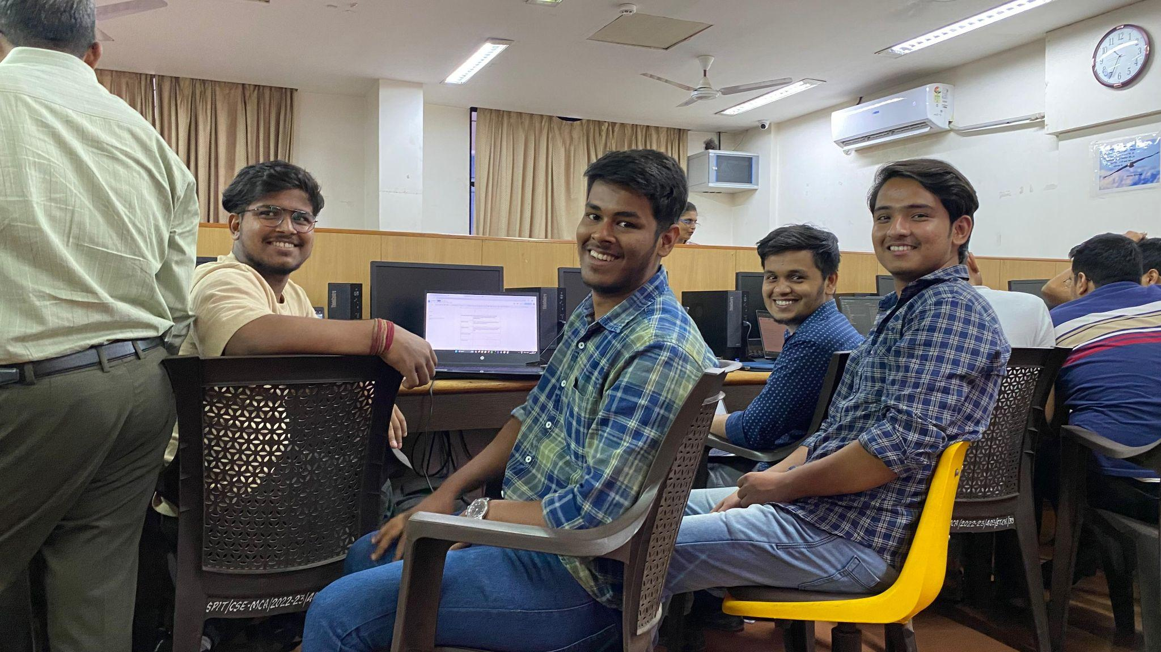

Table of Contents

| **Sr. No.** | **Title** | **Page No.** |
| --- | --- | --- |
| 1 | Description of Game and Motivation | 4 |
| 2 | Tools used (Both frontend and Backend) | 4 |
| 3 | Detailed Innovation description | 4-5 |
| 4 | Screenshots | 5-6 |
| 5 | References | 7 |

1. **Description of Game and Motivation:**

Our chess game aims to provide a digital platform for players to enjoy the classic strategy game of chess in a convenient and engaging way. Chess has been a timeless game known for its complexity, strategy, and intellectual challenge. Our motivation behind creating this game is to offer both beginners and seasoned players an accessible and immersive experience to enjoy the game anytime, anywhere. With intuitive controls, customizable settings, and multiplayer options, our chess game seeks to cater to a diverse audience of players, fostering a sense of competition, camaraderie, and intellectual stimulation.

1. **Tools Used (Both Frontend and Backend):**

***Frontend***: We utilized Java to develop the user interface (UI) and interactive elements of the game. These technologies allowed us to create a visually appealing and responsive design that enhances the user experience.

***Backend***: For the backend, we employed Java for secure code.

**3.Detailed Innovation Description:**

Our chess game incorporates several innovative features to enhance gameplay and user experience:

**AI Difficulty Levels:** Players can choose from various AI difficulty levels, ranging from beginner to advanced, to tailor the game's challenge level to their skill level.

**Online Multiplayer:** We implemented online multiplayer functionality, allowing players to challenge their friends or compete against other chess enthusiasts worldwide in real-time matches.

**Interactive Tutorials:** To assist new players in learning the rules and strategies of chess, we included interactive tutorials and hints that guide players through gameplay and provide helpful tips.

**Customization Options:** Players have the ability to customize their gaming experience by adjusting settings such as board themes, piece designs, and sound effects, allowing for personalization and immersion.

**Analytical Tools:** Our game provides players with analytical tools and in-game statistics to track their performance, analyze their moves, and improve their strategic skills over time.

**4.Screenshots**

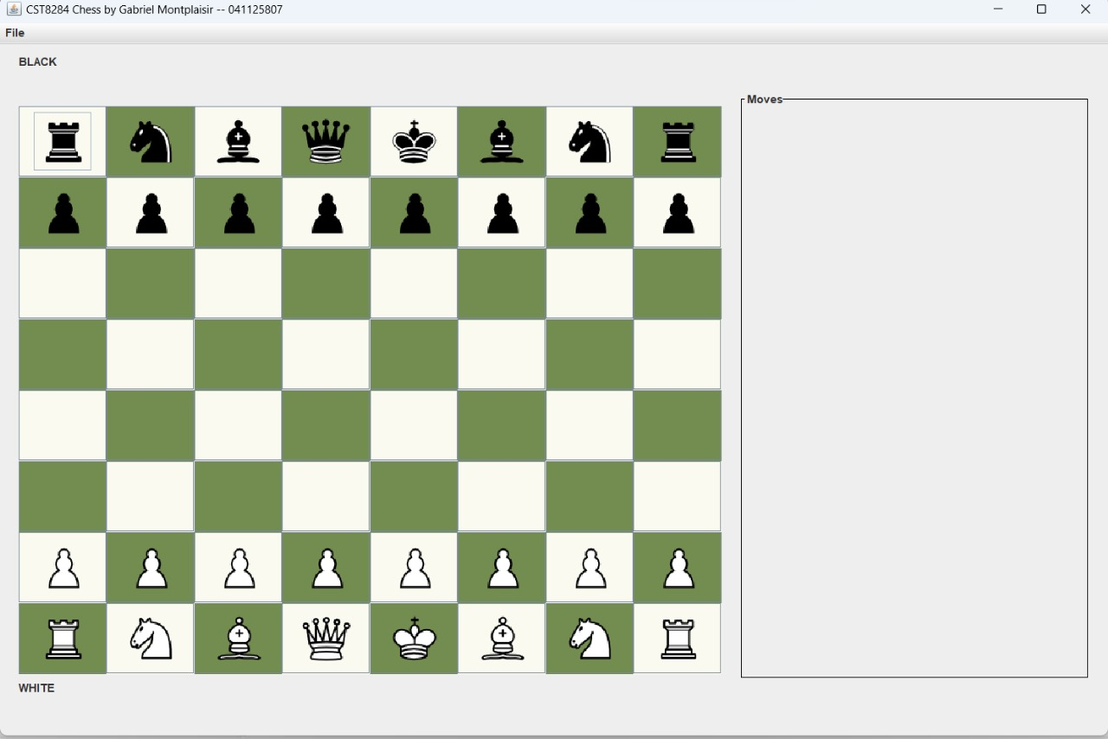

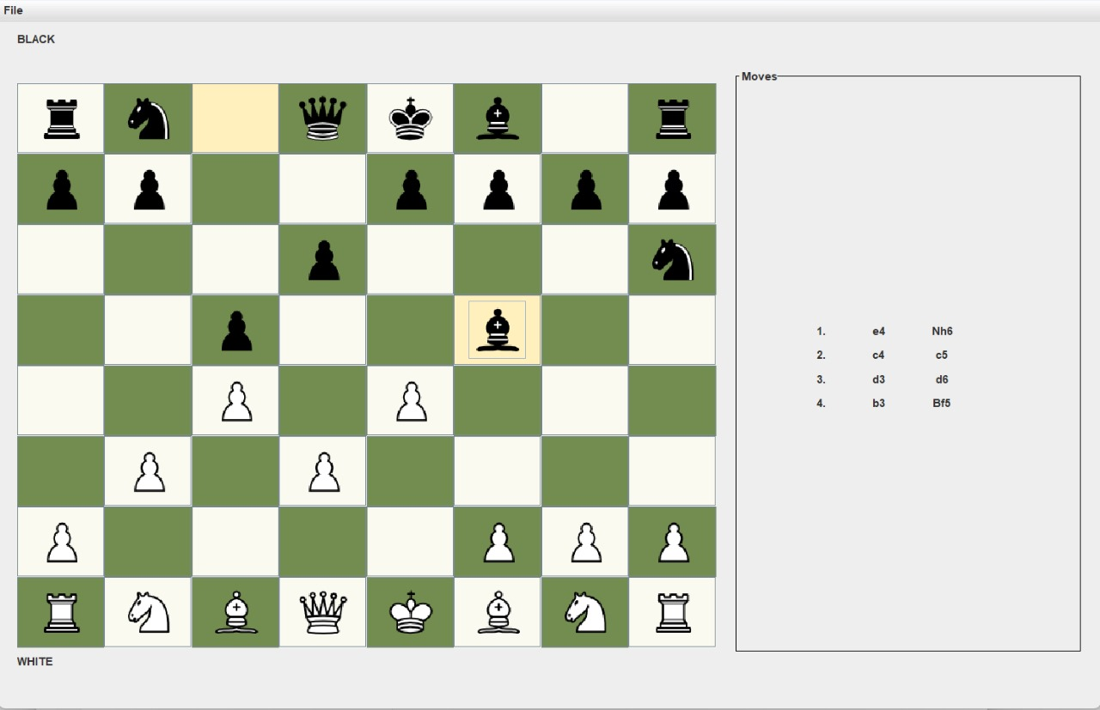

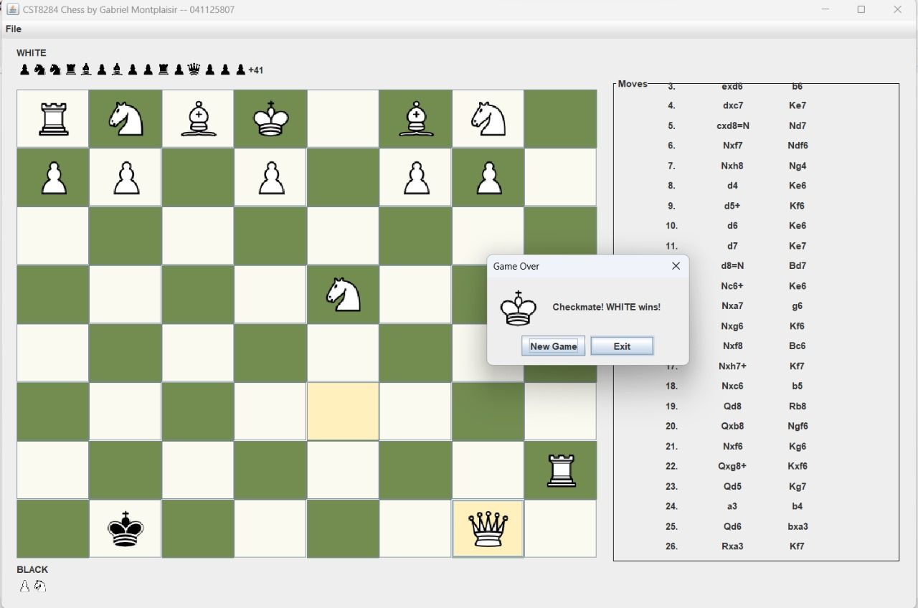

**5.References:**

Google for error Solving and reference.