**Entity Relationship (ER) Modeling**

**Question 1 :** Suppose you are given the following requirements for a simple database for the National Hockey League (NHL):

* the NHL has many teams,
* each team has a name, a city, a coach, a captain, and a set of players,
* each player belongs to only one team,
* each player has a name, a position (such as left wing or goalie), a skill level, and a set of injury records,
* a team captain is also a player,
* a game is played between two teams (referred to as host_team and guest_team) and has a date (such as May 11th, 1999) and a score (such as 4 to 2).

Construct a clean and concise ER diagram for the NHL database.

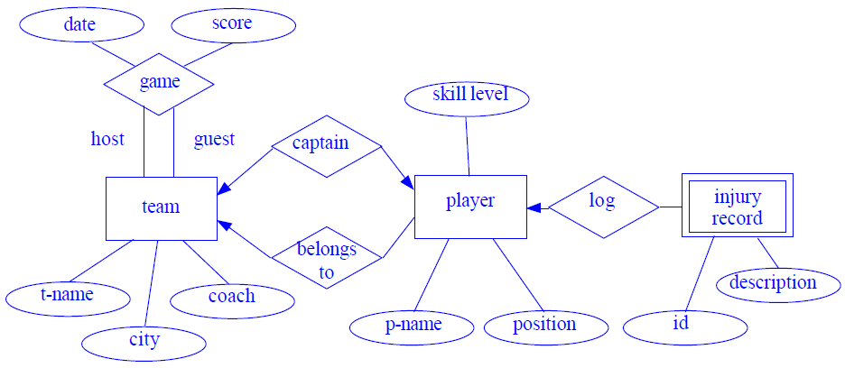**Answer :**

**Question 2:** A university registrar’s office maintains data about the following entities:

1. courses, including number, title, credits, syllabus, and prerequisites;
2. course offerings, including course number, year, semester, section number, instructor(s), timings, and classroom;
3. students, including student-id, name, and program;
4. instructors, including identi cation number, name, department, and title.

Further, the enrollment of students in courses and grades awarded to students in each course they are enrolled for must be appropriately modeled. Construct an E-R diagram for the registrar’s of ce.Document all assumptions that you make about the mapping constraints.

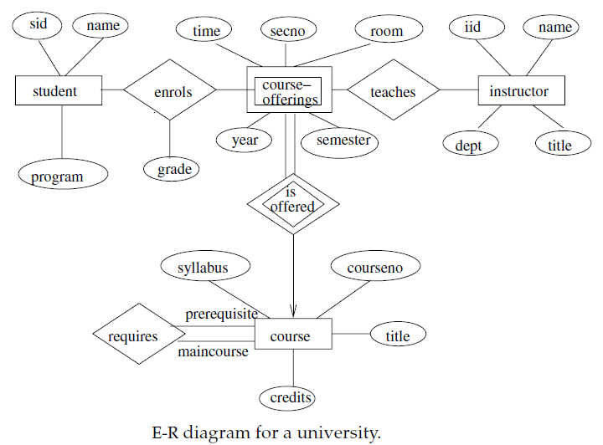**Answer :**

**Question 3:** Construct appropriate tables for the above ER Diagram ?

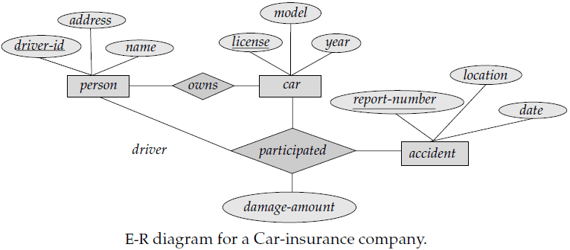

**Car insurance tables:**

* **person** (driver-id, name, address)
* **car** (license, year,model)
* **accident** (report-number, date, location)
* **participated**(driver-id, license, report-number, damage-amount)

**Question 4:** Construct appropriate tables for the above ER Diagram ?

* **patients** (patient-id, name, insurance, date-admitted, date-checked-out)
* **doctors** (doctor-id, name, specialization)
* **test** (testid, testname, date, time, result)
* **doctor-patient** (patient-id, doctor-id)
* **test-log** (testid, patient-id) performed-by (testid, doctor-id)

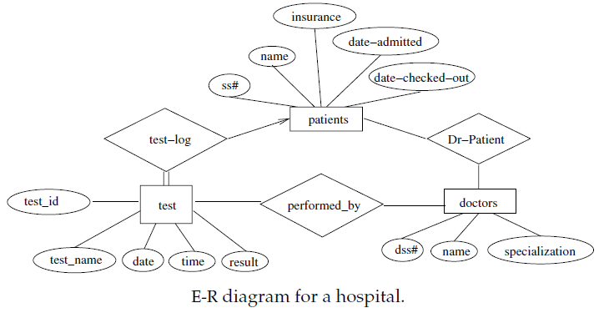

**Question 5:** Here we are going to design an Entity Relationship (ER) model for a college database . Say we have the following statements.

1. A college contains many departments
2. Each department can offer any number of courses
3. Many instructors can work in a department
4. An instructor can work only in one department
5. For each department there is a Head
6. An instructor can be head of only one department
7. Each instructor can take any number of courses
8. A course can be taken by only one instructor
9. A student can enroll for any number of courses
10. Each course can have any number of students

Answer : Step 1 : Identify the Entities

1. Department
2. Course
3. Instructor
4. Student

Stem 2 : Identify the relationships

1. One department offers many courses. But one particular course can be offered by only one department. hence the cardinality between department and course is One to Many (1:N)
2. One department has multiple instructors . But instructor belongs to only one department. Hence the cardinality between department and instructor is One to Many (1:N)
3. One department has only one head and one head can be the head of only one department. Hence the cardinality is one to one. (1:1)
4. One course can be enrolled by many students and one student can enroll for many courses. Hence the cardinality between course and student is Many to Many (M:N)
5. One course is taught by only one instructor. But one instructor teaches many courses. Hence the cardinality between course and instructor is Many to One (N :1)

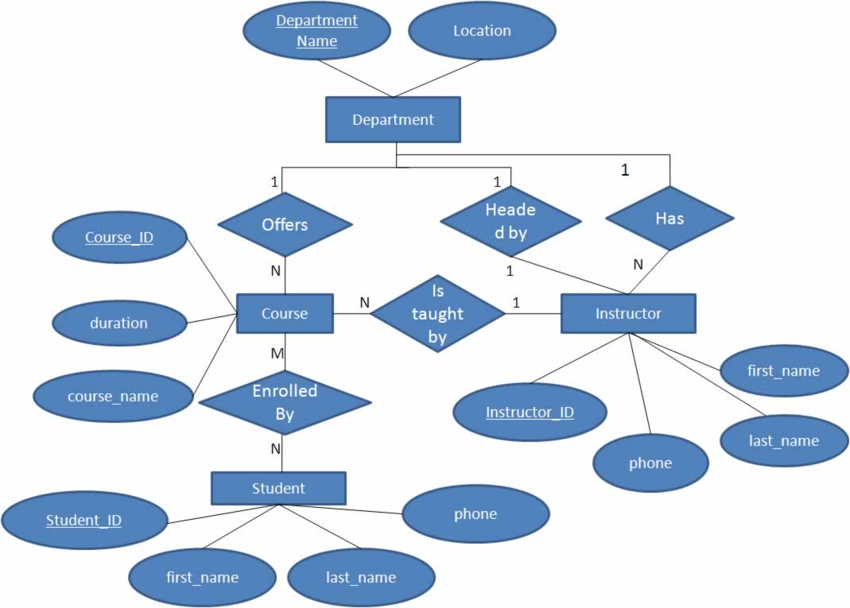

**Question 6 :**

We want to create database for a bank in which we store:

•Customers (id, name, city).

•Accounts (number, balance)

•Loans (number, amount)

•Branches (name, city, assets)

•Each customer can have any number of accounts and loans

•Each account and loan is associated with one branch.

•A customer must have either one account or loan in order to be in the database

•The balance in each account should be >$100. The last two constraints cannot be expressed by the ER diagram.

**Answer:**



**Question :7**

We want to create a very simple database for HKUST in which to record information about professors, students and classes.

•For each professor we need to store the HK-id, name and office number.

•For each student we need to store the student-id and name

•For each class the id (e.g., CSE 3311) and the name.

•Each class is taught by exactly one professor.

•Each student must take at least one class.

•For each class that a student took we need to store the grade Simplifying assumptions: there is only one lecture for each class and only one semester in the database.

**Answer :**

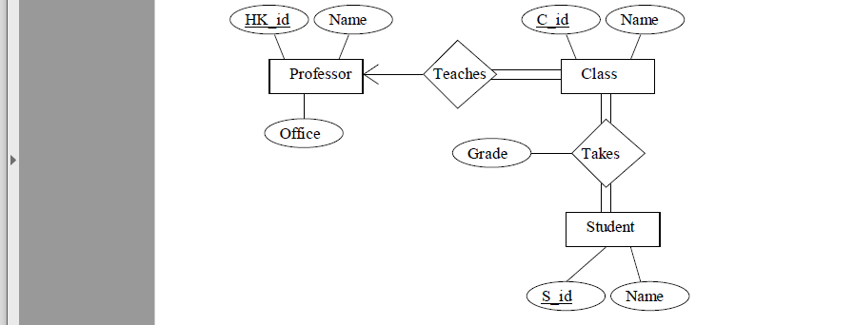

**Question : 8**

A bus company wants to keep track of its bus routes and schedules. Design an ER diagram for the database according to the following description. Identify all constraints and keys:

Each bus route has a route number, a departure station and a destination station.

For each bus route, there is a schedule, which records the departure times of buses.

For each departure time of each route, a driver and a bus can be assigned (however this is not necessary - information about the driver or the bus may sometimes be missing)

A driver has an employee Id, a name and a phone number.

A bus is identified by its license number. The database also records the seating capacity of each bus.

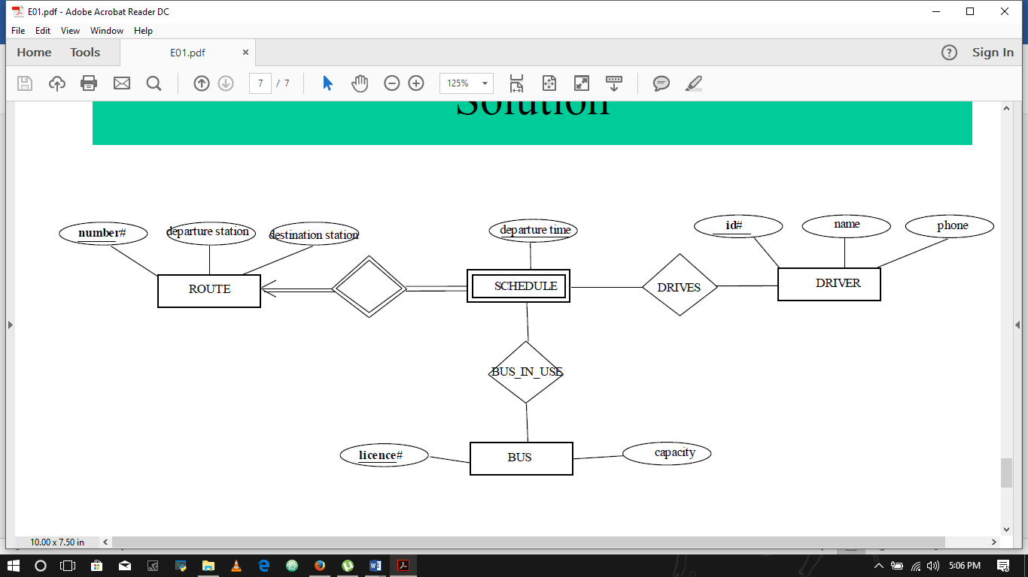**Answer:**

**Convert the ER diagram into tables.**

•Entities

–Route (number, departure, destination)

–Driver (id, name, phone)

–Bus (license, capacity)

•Weak Entity

–Schedule (number, departure-time)

•Relationships

–Drives (number, departure-time, id)

–Bus-in-use (license, number, departure-time)

**Question 9 : **

**Tables for ER diagram :**

**Entities**

–**Branch** (branch-name, branch-city, assets)

–**Customer** (customer-id, customer-name, customer-street, customer-city)

–**Loan** (loan-number, amount)

–**Employee** (employee-id, employee-name, telephone-number, start-date)

–**Account** (account-number, balance)

–**Savings-account** (account-number, interest-rate)

–**Checking-account** (account-number, overdraft-amount)

•**Weak Entity**

–Payment (loan-number, payment-number, payment-date, paymentamount)

•**Multi-valued attribute**

–Dependent (employee-id, dependent-name)

•**Many-to-many relationships**

–Borrower (customer-id, loan-number)

–Depositor (customer-id, account-number, access-date)

**•One-to-many relationships**

–Loan-branch is represented in Loan (loan-number, amount, branch-name)

–Cust-banker is represented in Customer (customer-id, customer-name, customer-street, customer-city, employee-id, type)

–Works-for is represented in Employee (employee-id, employee-name, telephone-number, start-date, manager-id)