# Hands-on Experiment # 6 : Worksheet

Section________1______ Date___17 Feb 2020_______________________________

No more than 3 students per one submission of this worksheet.

Student ID ________6238218321__________ Name_________Sippakorn Ornwichian____________________

Student ID _____________6238160521________ Name_________ Panupong Vijakwitchakorn________________

Student ID _________6238193221________ Name________ Wasu Sonthichai _______

## Part A: Loop Writing Practice

In *MathPowLoop.java*, write Java statements using “loops” to calculate result2 so that its value is similar to result1 (which is calculated from *Math.pow()* ) for every double a and int b.

No methods in the *Math* class is allowed.

List your code here.

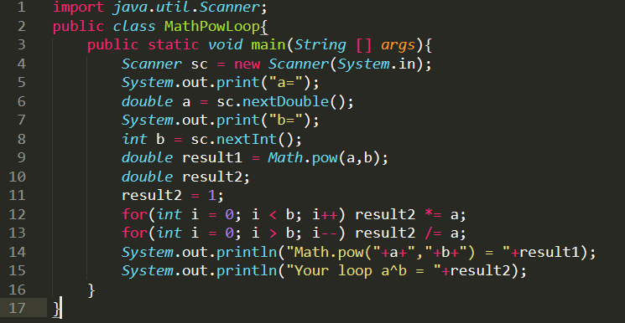

Test your code with the following test data set.

|  |  |  |  |
| --- | --- | --- | --- |
| a | b | Math.pow(a,b) | Your code |
| 2.0 | 8 | 256.0 | 256.0 |
| 2.5 | 3 | 15.625 | 15.625 |
| -2.0 | 8 | 256.0 | 256.0 |
| 1.0 | 1 | 1.0 | 1.0 |
| 1.0 | 0 | 1.0 | 1.0 |
| 2.0 | 30 | 1.073741824E9 | 1.073741824E9 |
| -2.0 | 30 | 1.073741824E9 | 1.073741824E9 |
| 2.0 | -1 | 0.5 | 0.5 |
| 2.0 | -4 | 0.0625 | 0.0625 |

## Part B: Text File Processing

The file *score.csv* contains scores from the midterm examination of a programming course, which has 5 questions (Q1-Q5). The file is in the “Comma-separated Value” format (<http://en.wikipedia.org/wiki/Comma-separated_values>) with the first line being the header labels describing the order of data on the other lines.

* Read <http://docs.oracle.com/javase/7/docs/api/java/util/Scanner.html> to learn how to read a text file using an instance of the Scanner class.
* Open the file in a spreadsheet application (such as MS Excel). If you do not have any spreadsheet application on your machine, try using Google Spreadsheet.
  + Use the application to find the average score, the maximum score, and the minimum score of each question (Q1-Q5).
  + Find the average of the total score and its corresponding standard deviation.
* Fill the results in the following table.

|  |  |  |  |  |
| --- | --- | --- | --- | --- |
| From Spreadsheet | Average | Standard Deviation | Max | Min |
| Q1 | 5.081 | 3.161715 | 10 | 0 |
| Q2 | 5.014 | 3.2425 | 10 | 0 |
| Q3 | 5.586 | 2.25978 | 9 | 2 |
| Q4 | 7.499 | 1.736663 | 10 | 5 |
| Q5 | 5.478 | 1.733065 | 8 | 3 |
| Total | 28.658 | 5.561208 | 46 | 12 |

* Write a Java program to:
  + Compute the average score, the maximum score, and the minimum score of each question (Q1-Q5).
  + Compute the average of the total score and its corresponding standard deviation.
* Fill the results in the following table.

|  |  |  |  |  |
| --- | --- | --- | --- | --- |
| From Your Java App | Average | Standard Deviation | Max | Min |
| Q1 | 5.081 | 3.1617145664971087 | 10 | 0 |
| Q2 | 5.014 | 3.242499653045471 | 10 | 0 |
| Q3 | 5.586 | 2.2597796352742003 | 9 | 2 |
| Q4 | 7.499 | 1.7366631797789693 | 10 | 5 |
| Q5 | 5.478 | 1.7330654921265973 | 8 | 3 |
| Total | 28.658 | 5.5612081421216315 | 46 | 12 |

List your code here.

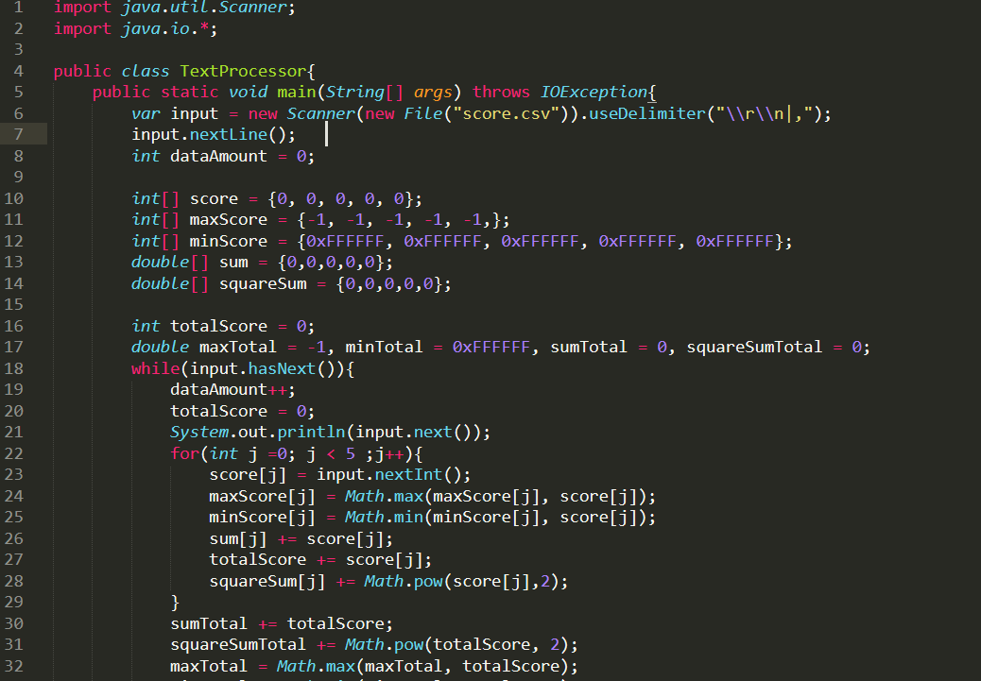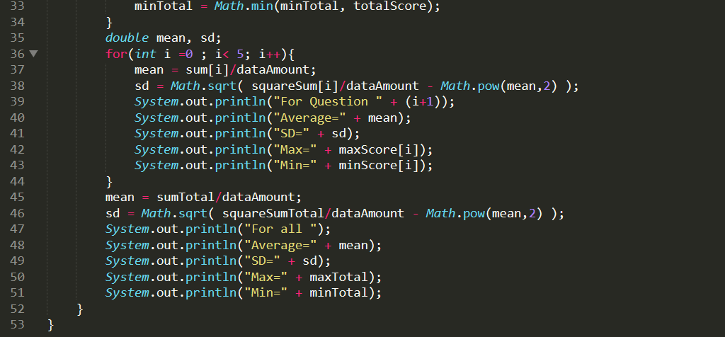

Submit this worksheet (by only one member of the group) via <http://www.myCourseVille.com> (Assignments > Hands-on Experiment # 6) **within the day after your lecture**.