# Hands-on Experiment # 7 : Worksheet

Section_____1_________ Date_____________________16/3/2020_____________

No more than 3 students per one submission of this worksheet.

Student ID ____________6238218321 __________ Name__________ Sippakorn Ornwichian ________

Student ID _________________________________ Name______________________________________

Student ID _________________________________ Name______________________________________

## Part A: Score Look Up Program

This time, you will write a score look up Java application that reads *score.csv* (from the previous experiment) which list exam scores of 1,000 students. The user of the program can enter a student ID and the program shows the scores from the 5 questions as well as the total score associated with that student ID.

Objectives:

* Practice creating Java methods using correct syntax.
* Practice factorizing (dividing) the program into methods with distinct functionalities.
* Try making the program as “readable” as possible.

Instructions:

* Obtain understanding of the program by studying *L07Design.pdf*.
  + The file contains flow charts detailing some parts of the program.
  + Pay attention to the “subroutine (or subprogram)” (as shown below) blocks. These should be method calls.

subroutine

* Complete the program by adding codes to *ScoreLookup.java*.

Key challenge 🡪 Try to divide tasks into methods so that the resulting code is as “readable” as you can.

Have you been able to complete the program? If not, what were the problems?

Yes

Does it work correctly in all cases? If not, what are the cases those your program does not work correctly?

Yes

Include the screenshots below.

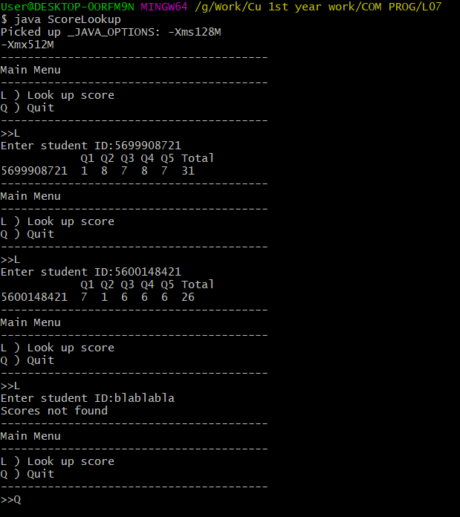

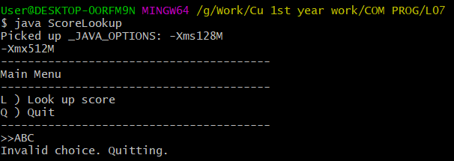

How many methods have you created in the program?

4

List all the methods you created in the table below.

|  |  |  |  |  |
| --- | --- | --- | --- | --- |
| # | Return Type | Method Name | Method Signature | Description |
| 1 | String | constructLookUpStringFromFile | constructLookUpStringFromFile(String) | Read the csv file whose name is specified in the argument list of the method and construct a String containing all lines of the file. The String is then returned. |
| 2 | char | showMainMenu | showMainMenu() | Show main menu and receive user’s input |
| 3 | void | commenceLookUpProcedure | commenceLookUpProcedure(String) | Ask for student IDs and check if the IDs exists |
| 4 | void | printScore | printScore(String, String) | Print out ID and scores of that inquired ID |
|  |  |  |  |  |
|  |  |  |  |  |
|  |  |  |  |  |

Do you think each of your methods is short and explicit enough so that the method can be understood easily? If not, what do you think should be improved?

The names of methods can be shorter and the condition in the for loop in printScore can be more readable

List all your source code here.

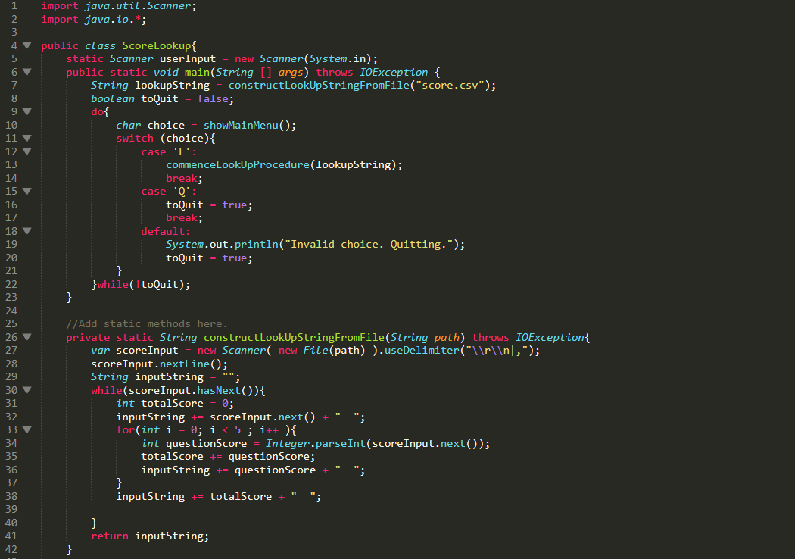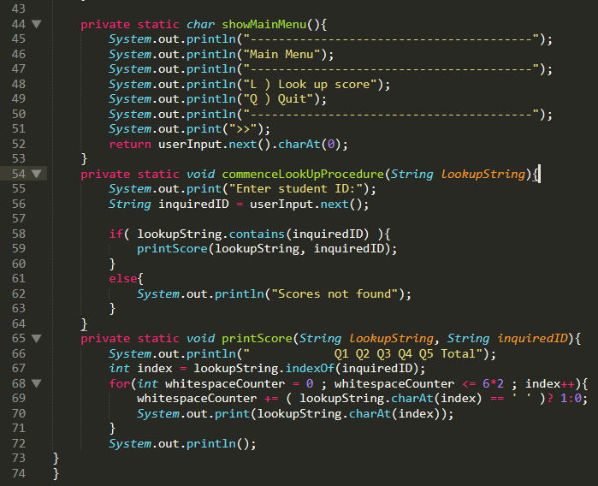

Submit this worksheet (by only one member of the group) via <http://www.myCourseVille.com> (Assignments > Hands-on Experiment # 7) **within the day after your lecture**.