# Hands-on Experiment # 8 : Worksheet

Section_________1_____ Date_______________23/03/2020___________________

No more than 3 students per one submission of this worksheet.

Student ID ____6238218321___________________ Name_____Sippakorn Ornwichian______________

Student ID _________________________________ Name______________________________________

Student ID _________________________________ Name______________________________________

## Sorting.

We are revisiting the processing of *score.csv* again. Now that we know how to use array, things should be much simpler. Also, this time, you are also given with a class called *StudentScore* which is designed so that all scores of a student with a specific ID are stored in a single object of *StudentScore*.

First, study, compile and run *TestStudentScore.java* so that you get some idea of how the *StudentScore* class can be used.

Explain what each statement in TestStudentScore.java does.

public class TestStudentScore{ //Create a class

public static void main(String [] args){ //Create the main method

boolean withHeader = true; //Create boolean withHeader and set its value to true

StudentScore s1 = new StudentScore("5630000021,10,10,9,8,7"); //create an instance of StudentScore

s1.printScore(withHeader); //call printScore method to print header and score

withHeader = false; // set withHeader to false

StudentScore s2 = new StudentScore("5630000121,8,8,10,6,5"); //create an instance of StudentScore

s2.printScore(withHeader); //call printScore method to print only score

}

}

Complete *ScoreSort.java*.

Include the screenshots below.

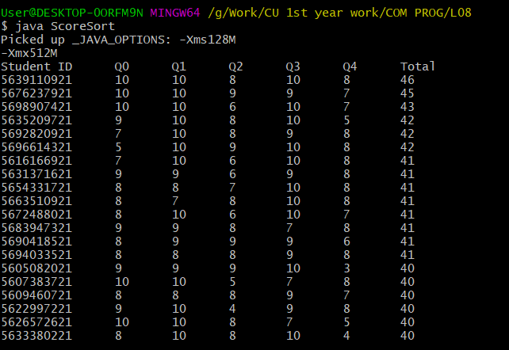

List all your source code here.

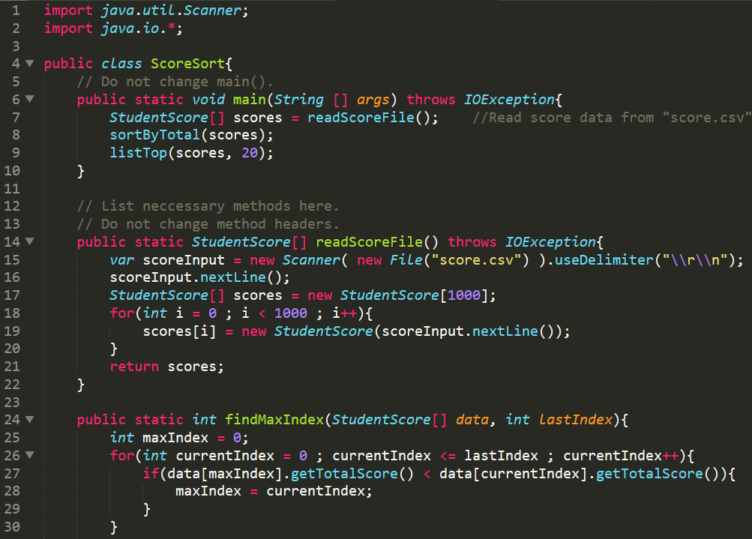 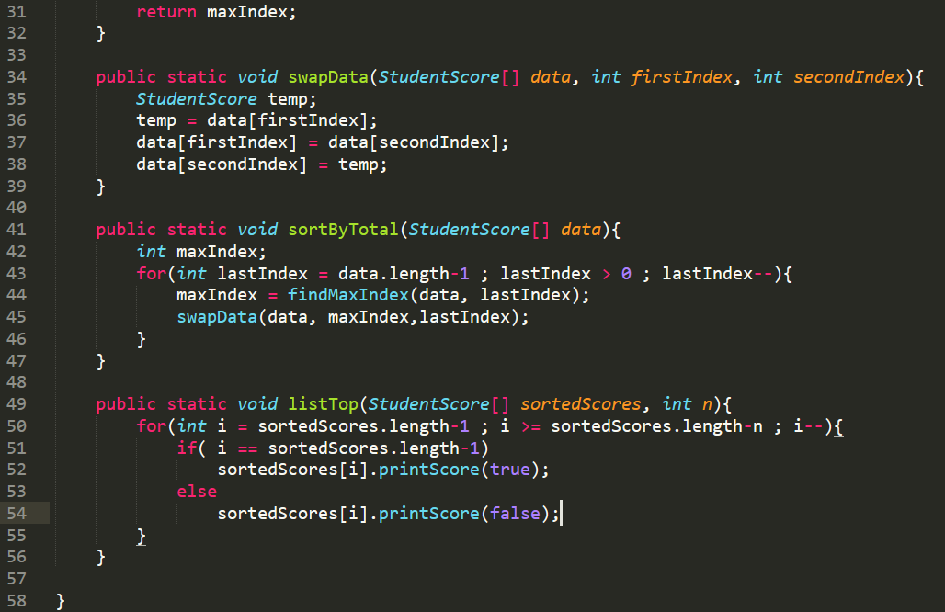

Submit this worksheet (by only one member of the group) via <http://www.myCourseVille.com> (Assignments > Hands-on Experiment # 8) **within the day after your lecture**.