# Hands-on Experiment # 9-2 : Worksheet

Section_______1_______ Date___________30/3/2020_______________________

No more than 3 students per one submission of this worksheet.

Student ID ______6238218321_____________ Name____________Sippakorn Ornwichian_____________

Student ID _____________6238160521________ Name_________ Panupong Vijakwitchakorn________________

Student ID _________________________________ Name______________________________________

## Part A: Understanding Given Resources/Backgrounds

1. Get yourself familiar with the RGB color model. Play around with the color picker on <http://www.colorpicker.com/> and answer the following questions.
   1. What color is it that has the maximal value in R, the maximal value in B, and 0 in G? Capture the picture of the color and post it here.

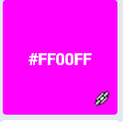

* 1. What are the requirements on the RGB values for all shades of gray?

All three values must be equal

1. Read the API specification of the class *Java101ImageUtil* in *L09-2.pdf*.
   1. How many static methods are there in the class?

6

* 1. How many overloaded methods are there in the class?

3

* 1. Write the “method signatures” of all the overloaded methods. (** Write only the signature)

showViewer (int [][][] rgb,String title)

showViewer (int [][][] rgb1,int [][][] rgb2,String title)

showViewer (int [][][][] rgbs,String title)

1. Read the source code of *Java101ImageUtilExample.java* and try executing the program. Briefly explain what the program does. (** It is recommended NOT TO open big images. The program was not optimized in any ways. Try the program on some images with a few hundreds of pixels in their width/height)

The program will ask users to choose a picture for display. After the user has chosen the picture, it will ask the user to decide if they want the program to simply display the image, to show the image and its flipped version, or to show both along with a 64x128 pixel red patch. If the user did not choose any picture, the program will close.

## Part B: Creating RGB arrays for Desired Images

1. Write a program performing the following steps.
   1. Create a 3-D array of int that when used with showViewer(int [ ][ ][ ],String), the program shows a 64-pixel x 128-pixel all-white image.
   2. Show the image with showViewer(int [ ][ ][ ],String)

List your source code here.

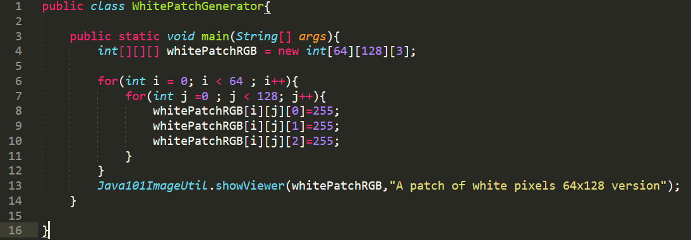

1. Write another program performing the following steps.
   1. Ask the user to input the value of w and h, which are integers in the range of 100 to 200.
   2. Show an image of a triangle as shown in the figure below. Use the colors of your choice.

w/2

w/2

h

List your source code here.

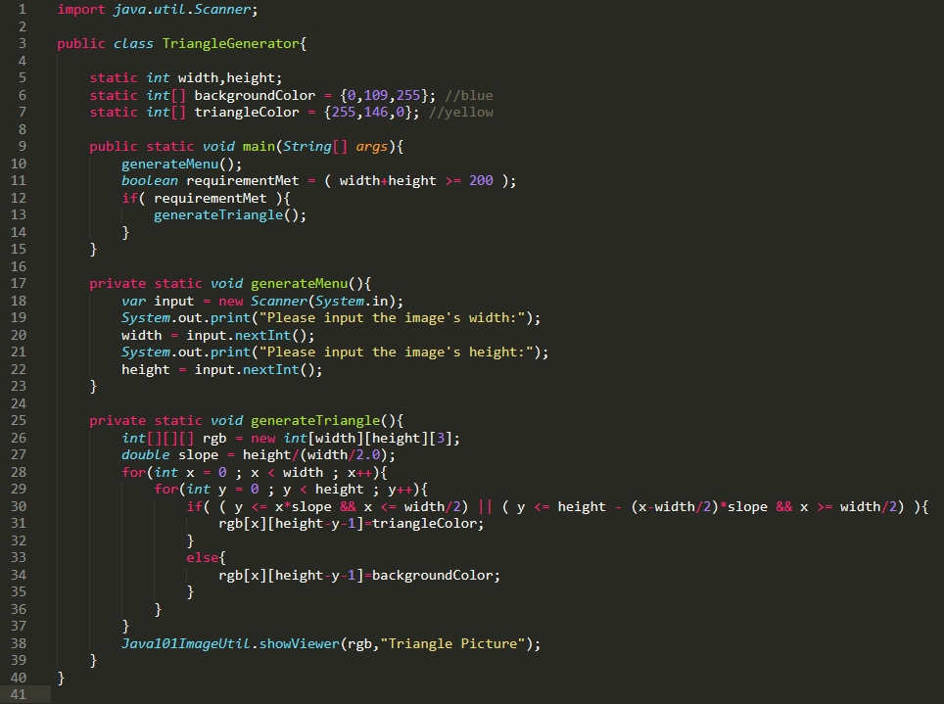

## Part C: Image Manipulation

Modify *DesaturateIt.java* to obtain a Java program performing the following steps.

1. Ask the user to select a gif or a jpg file.
2. Show the original image and its “desaturated” (grayscale) version using showViewer().



Explain how the grayscale values are computed.

Grayscale values can be obtain from calculating the value of R, G, and B after considering its wavelength and its contribution to picture and the Greyscale value can be obtained from following expression:

Greyscale = ( (0.2126 * R) + (0.7152 * G) + (0.0722 * B) )

List your source code here.

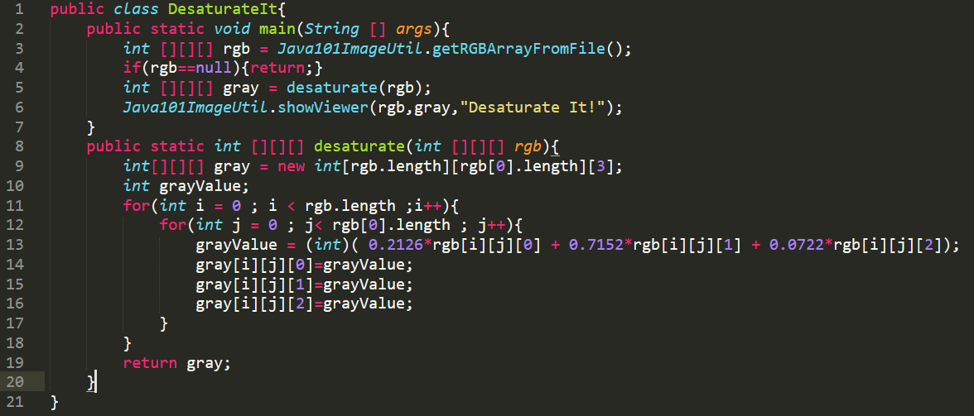

Submit this worksheet (by only one member of the group) via <http://www.myCourseVille.com> (Assignments > Hands-on Experiment # 9-2) **within the day after your lecture.**