Introduction to ASP
What is ASP?

ASP stands for Active Server Pages. Microsoft introduced Active Server Pages in
December 1996, beginning with Version 3.0. Microsoft officially defines ASP as:
“Active Server Pages is an open, compile-free application environment in which you can
combine HTML, scripts, and reusable ActiveX server components to create dynamic and
powerful Web-based business solutions. Active Server pages enables server side scripting
for IIS with native support for both VBScript and Jscript.” (2). In other words, ASP is a
Microsoft technology that enables you to create dynamic web sites with the help of server
side script, such as VBScript and Jscript. ASP technology is supported on all Microsoft
Web servers that are freely available. If you have Window NT 4.0 Server installed, you
can download IIS (Internet Information Server) 3.0 or 4.0. If you are using Window
2000, IIS 5.0 comes with it as a free component. If you have Window 95/98, you can
download Personal Web Server (PWS), which is a smaller version of IIS, from Window
95/98 CD.

What is an ASP file?

An ASP file is quite like an HTML file. It contains text, HTML tags and scripts,
which are executed on the server. The two widely used scripting languages for an ASP
page are VBScript and JScript. VBScript is pretty much like Visual Basic, whereas
Jscript is the Microsoft’s version of JavaScript. However, VBScript is the default
scripting language for ASP (3). Besides these two scripting languages, you can use other
scripting language with ASP as long as you have an ActiveX scripting engine for the
language installed, such as PerlScript.
The difference between an HTML file and an ASP file is that an ASP file has the
“.asp” extension. Furthermore, script delimiters for HTML tags and ASP code are also
different. A script delimiter is a character that marks the starting and ending of a unit.
HTML tags begins with lesser than (<) and greater than (>) brackets, whereas ASP script
typically starts with <% and ends with %>. In between the delimiters are the server-side
scripts.

How does it work?

As you have learned, scripts in an ASP file are server-side scripts, which means that the
scripts are processed on the server and then the result of the scripts will be converted to
HTML before sending to the web browser. To illustrate, let’s take a look at this table to
compare the process of retrieving an HTML page and an ASP page .

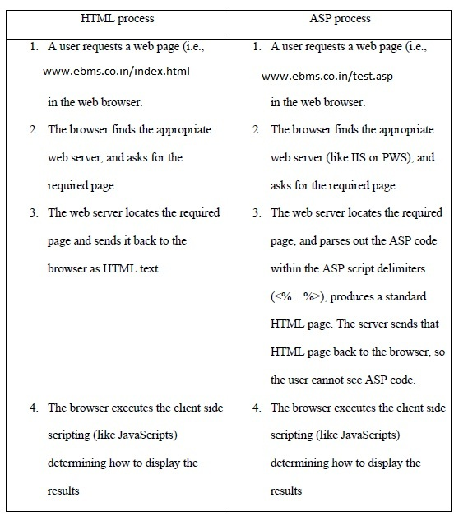

As you can see, the whole process of the two is quite similar. Since ASP is a server-side
technology, the required page is executed on the server before the HTML is created and
served to the client.

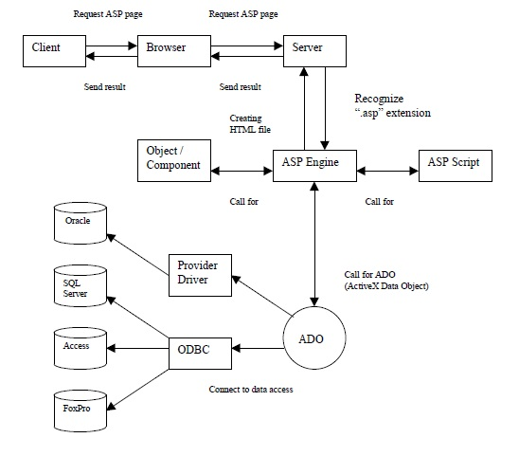

For example, a client types in a URL into your browser. The browser requests the
ASP page from the web server. The server proceeds the file with “.asp” extension to ASP
Engine in which Objects or ActiveX Components can be used to extend the web server
with application-specific functionality. In addition, ASP will use ADO to connect to a database (SQL, Access, Oracle, etc.) to pull out the relevant data, such as the current
weather in a specific area. Thus, a different page is generated according to the area
specified and time that the page is accessed. Then, the server generates HTML tags
before sending it back to the client. Therefore, when you view the source of an ASP file,
you will not see any different from a standard HTML file.

ASP includes five build-in objects:

• Request – to get information from the user that is passed along with an HTTP
request
• Response – to output data to the requesting client
• Server – to control the Internet Information Server
• Session – to store variables associated with a given user session
• Application – to store information that remain active for the lifetime of an
application, such as a page counter.

Advantages of ASP
1. Dynamic web page – Since ASP supports scripting languages, which run on the
web server, your web page can be dynamically created. For example, you can
create your web page so as to greeting each user when they log into your page
differently.
2. Browser independent – ASP is browser independent because all the scripting code
runs on the server. The browser only gets the results from the server in a standard
HTML page.
3. Database Access – One of the greatest assets of ASP is database connectivity.
ASP enables you to easily build rich database functionality into your web site,
such as form processing.
4. Building-in objects – The five built-in objects that come with ASP facilitate Web
application development. For example, you can use Request object to retrieve
browser request information.

Important
You cannot view the ASP source code by selecting "View source" in a browser, you will only see the output from the ASP file, which is plain HTML. This is because the scripts are executed on the server before the result is sent back to the browser.

What is an ASP File?
An ASP file is just the same as an HTML file
An ASP file can contain text, HTML, XML, and scripts
Scripts in an ASP file are executed on the server
An ASP file has the file extension ".asp"

