FEATURE UPDATE 03 / ASSOCIATED TRAINING
Select  Explain  Approve |  | NCC and alternate-supplier requests  Make the supplier choice clear from selection through approval.

  Start with NCC  Confirm the preferred offer |   Explain an exception  Record a meaningful justification |   Review and approve  Check need supplier and authority

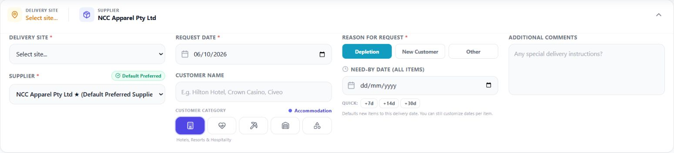

WHAT CHANGED / WHERE TO FIND IT / HOW TO USE IT
Discover the new feature, find it in the app and follow the associated workflow.

NCC and alternate-supplier requests
Make the supplier choice clear from selection through approval.

What is new
NCC is presented as the preferred supplier. Alternate offers and requests carry visible flags, with the business justification recorded in Additional Comments for approval review.

Where you will encounter it
Supplier Stock → Order NCC or Order Alt → Create Request. The supplier field shows the preference or caution; the request detail screen carries the alternate flag and comments into approval.

How it fits your workflow
Choose the offer → confirm request and cart details → explain any supplier exception → Submit Request → approver reviews the need, supplier choice and authority.
Section | Page
NCC preference in Create Request | 3
Check the cart and submit | 4
Explain an alternate supplier | 5
Review the request as an approver | 6
Supplier-choice checklist | 7

Key action
An alternate flag or a generic stored reason is not a complete justification. Record the actual supply constraint and business case in comments.

NCC preference in Create Request
The preferred-supplier controls continue from the directory into request creation. Order NCC passes the selected product and supplier into Create Request.
Where in the app
Supplier Stock → Order NCC → Create Request; the supplier field shows Default Preferred.
The request header shows supplier preference, delivery site, dates, category and comments.
  Confirm the supplier
  Check NCC Apparel and the Default Preferred badge. A fresh request normally defaults to NCC unless a supplier was passed in or restored from a draft.
  Select the delivery site
  Choose the receiving site. Users assigned to multiple sites must make an explicit selection.
  Describe the requirement
  Enter the customer or requirement name, select its category and choose Depletion, New Customer or Other.
   |  | Set the need by date  Enter the actual required date. Apply it to existing cart lines where needed; a header default does not replace every existing line date.
 |  | Add useful comments  State delivery instructions and any information the approver needs.

Required information
Use the actual receiving site, customer or requirement, reason, quantity and required date. Confirm each line before submitting.

From stock selection to a submitted request
The directory handover pre-fills the offer. Confirm the quantity and value before submission; the reservation begins only after approval.
Where in the app
Create Request → expanded Order Summary → Submit Request.
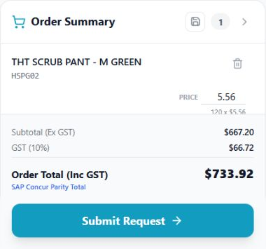  The expanded Order Summary confirms quantity 120 and the recalculated totals. |  | 01 Confirm the cart line  Check HSPG02, the description and the supplier-specific price.  02 Set the quantity to 120  Type 120 in the quantity field, then press Enter or click outside the field so the totals recalculate. Check any carton or pack requirements.  03 Check the line date  Confirm the need-by date on the cart line, including after a bulk date change.  04 Verify the amounts  For NCC HSPG02 at AUD 5.56, 120 units total AUD 667.20 excluding GST. At 10% GST, tax is AUD 66.72 and the total is AUD 733.92.  05 Submit or retain a draft  Choose Submit Request when the details are ready. Save Draft preserves work for later; a draft does not hold stock.  06 Check the submitted record  Open the resulting request and confirm its reference and pending approval status. Do not submit the same requirement again.
Expected result
The request is awaiting approval. The 48-hour reservation window starts when approval is recorded, rather than while you are building the cart.

Alternate suppliers and justification
Alternate offers are now clearly distinguished from NCC. The choice is flagged in Create Request and on the request presented for approval.
Where in the app
Supplier Stock → Order Alt → Create Request → supplier field and Additional Comments.
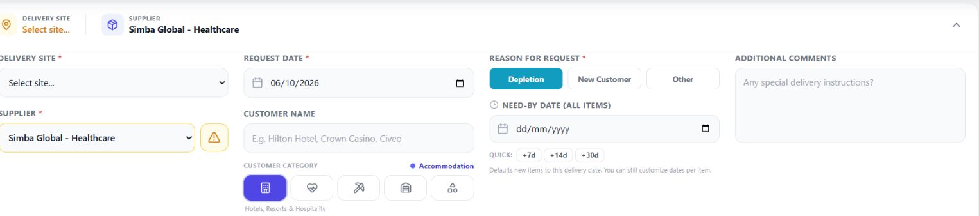
The caution icon flags the alternate supplier; the comments provide the business explanation.
  Choose Order Alt
  Select the alternate offer, then verify the supplier in Create Request. Switching suppliers clears the existing cart; review or re-add the required items.
  Record the exception in comments
  Explain why NCC cannot meet the requirement and why the selected alternate is suitable.
  Confirm price and supply
  Check the supplier code, specification, pack, quantity, lead time and total.
  Submit for review
  The request is marked Alternate Non-NCC for the approver. Follow the configured approval workflow for the designated approver.

What the justification must cover
Record the actual supply constraint, why the alternate product is suitable, its confirmed lead time, quantity, price and value. Provide enough information for the designated approver to assess the exception.
The current screen can store a generic alternate reason automatically. Put the meaningful justification in Additional Comments and follow the configured approval workflow. Use the visible Order Alt action to begin the exception request.

What approvers will now see
The supplier exception remains visible at approval. Review Alternate Non-NCC and the comments alongside the requirement, stock position and value.
Where in the app
Approval queue or request list → open the pending request → supplier flag and comments.
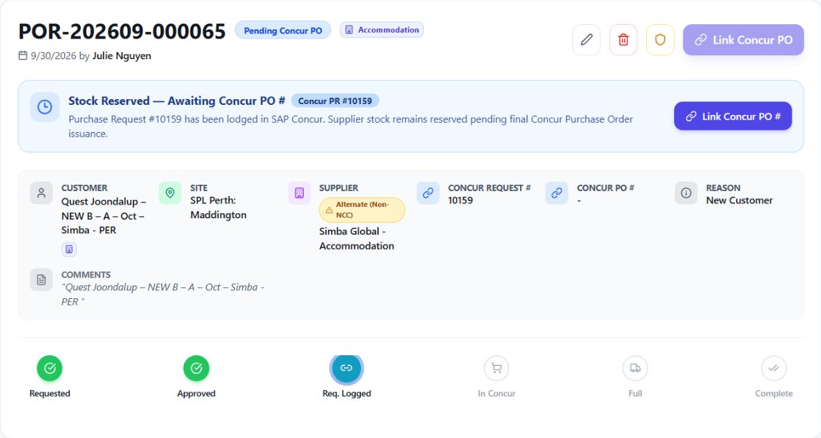
The saved request retains the supplier exception and comments. Decision controls appear when you are the assigned approver for a pending request.
  Open the pending request
  Use the approval queue or request list to open the pending request assigned to you.
  Check the requirement
  Review site, customer, requested quantities, need-by dates, prices and total value.
  Review supplier exceptions
  Look for Alternate Non-NCC and read the comments. Confirm that the reason and the proposed supply meet the requirement; follow the configured approval workflow.
  Check stock and authority
  Review the current directory balance and any supply uncertainty. Confirm the request sits within your approval authority and any separation-of-duties requirements.
  Record a decision
  Select Approve or Reject as appropriate. If information needs correction, resolve it with the requester before approval.
   |  | Verify the handover  After approval, check that the request moves to its Concur entry stage and the reservation banner appears. The requester should now create and link the PR.

Expected result
The approval is recorded in the request history and the 48-hour clock begins. Approving within ProcureFlow does not itself lodge the PR in Concur or place an order with the supplier.

Supplier-choice checklist
Check the supplier decision before it becomes an approved allocation.

Requester checklist
Correct supplier and product; correct receiving site; appropriate requirement and reason; quantities and packs checked; current price and total checked; correct line dates; meaningful comments for the approver.

Supplier exception review
Record the actual supply constraint, why the alternate product is suitable, its confirmed lead time, quantity, price and value. Provide enough information for the designated approver to assess the exception.

Approver checklist
Confirm the requirement, stock and supply timing, supplier exception, price, total and approval authority. Resolve unclear comments before approving. Verify that the saved decision appears on the request.

Handover after approval
Approval begins the 48-hour reservation window. The requester or authorised Concur user creates the real PR and links its number using Enter Request #. A linked PR preserves the hold while the issued PO is awaited; later use Link Concur PO → Sync & Activate.

Quick check
Does a saved draft hold stock? No. The holding window starts when approval is recorded.

