FEATURE UPDATE 07 / ASSOCIATED TRAINING
Check  Order  Receive |  | Supplier bale and carton quantities  Request full supplier packs and record actual units delivered.

  Check the pack  Use the selected supplier size |   Order full packs  Review the adjusted quantity |   Receive actual units  Keep partial deliveries accurate

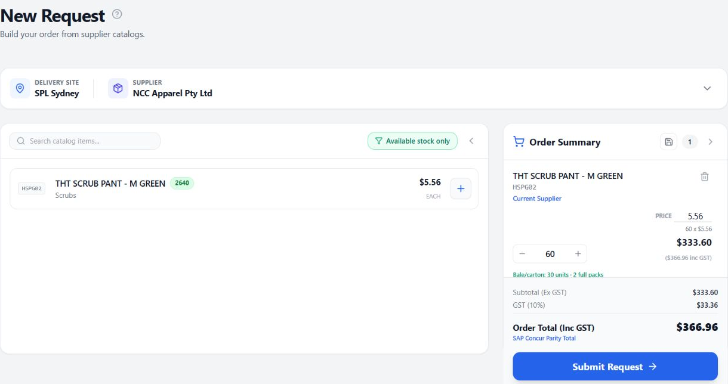

WHAT CHANGED / WHERE TO FIND IT / HOW TO USE IT
Discover the new feature, find it in the app and follow the associated workflow.

Supplier bale and carton quantities
Request quantities now follow the selected supplier's confirmed pack size.

What is new
Quantities round up to whole bales or cartons. The pack size is saved with each order line and remains visible through purchasing, receiving, finance and reports.

Where you will encounter it
Create Request and Request Details show bale/carton information. Supplier Stock and stock reports show orderable full-pack quantities. Record Delivery uses actual units.

How it fits your workflow
Select the supplier and item, check the pack, review the adjusted quantity and total, then submit. After approval, follow the existing Concur handover and record actual receipts.
Section | Page
Check and adjust a request | 3
Review the cart and drafts | 4
Resolve unconfirmed pack sizes | 5
Receive actual delivered quantities | 6
Saved pack details and quick checks | 7

Key action
A 30-unit pack changes an entry of 31 to 60. Check the adjustment before submitting; during receiving, enter only the units actually delivered.

Check and adjust a request
The selected supplier determines the pack. Confirm the product and bale/carton size before adding it to the order.
Where in the app
Create Request > select supplier > open item > Quantity.
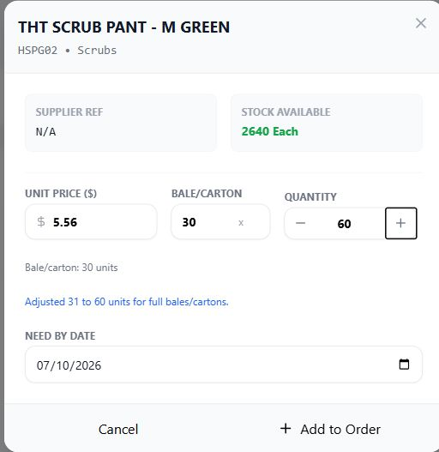
Actual branch preview: 31 adjusts to 60 for a 30-unit pack. Illustrative product and supplier records.
  Check the supplier
  Confirm the supplier and matching product. Another supplier can have a different pack size for the same catalogue item.
  Read the bale or carton size
  The displayed size counts ordering units per full pack. For this illustration, one pack contains 30 Each.
  Enter the required units
  Type 31 and leave the quantity field. The app adjusts it up to 60 and displays an explanation; valid 30 and 60 stay unchanged.
   |  | Use the pack controls  Plus and minus move by one full pack. Quantities and prices remain in the item's ordering UOM, such as Each.
 |  | Review the adjustment  Confirm the rounded quantity meets your need. Check availability, price and the recalculated amount before adding the line.

Confirmed loose ordering
A supplier-confirmed pack of 1 permits loose units. A catalogue default of 1 alone does not confirm that the supplier accepts them.

Review the cart and drafts
Full-pack ordering also applies when you save a draft or change a request. An older odd-quantity draft needs correction before submission.
Where in the app
Create Request > Order Summary > Save Draft or Submit Request.
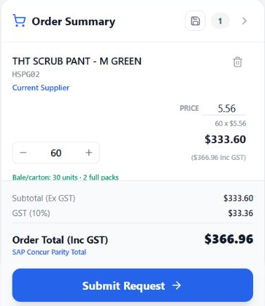  The cart shows 60 units, a 30-unit pack and 2 full packs. Totals remain based on units. |  | 01 Confirm the item and pack  Check the supplier, product and displayed bale/carton size.  02 Review the quantity  Check the rounded quantity and full-pack count. Correct any older draft line flagged for adjustment before saving or submitting.  03 Check the receiving details  Confirm the receiving site and the actual need-by date on every line.  04 Verify the amounts  In this illustration, 60 units at AUD 5.56 total AUD 333.60 excluding GST, AUD 33.36 GST and AUD 366.96 including GST.  05 Save or submit  Choose Save Draft to retain the request, or Submit Request when the details are ready. A saved draft does not reserve stock.  06 Follow the existing handover  Check the saved request and approval status. After approval, create and link the actual Concur PR and then the issued PO.
When an order changes
Changing ordered quantities or the supplier checks the applicable pack again. Later supplier reports and receipt-only edits do not rewrite the saved order's pack.

Resolve unconfirmed pack sizes
New ordering is blocked when the supplier pack is missing or conflicting. Physical stock can still be visible, but a full-pack orderable quantity cannot be confirmed.
Where in the app
Create Request > open item; Supplier Stock > orderable balance and pack details.
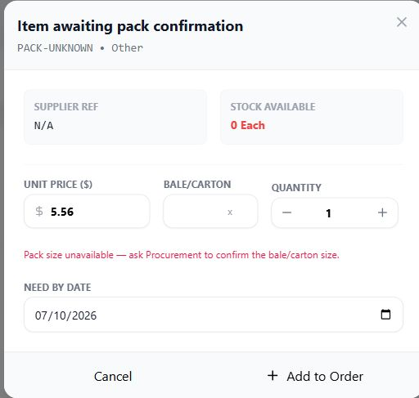
An unconfirmed pack disables Add to Order and asks Procurement to confirm the size.
  Read the message
  Check the item and supplier. Do not treat a zero orderable balance as proof that there is no physical stock.
  Ask Procurement to confirm
  Provide the product and supplier code. Procurement confirms the pack using the existing supplier report carton data or catalogue pack configuration.
  Refresh the information
  Once the source is corrected, refresh the app and reopen the item. Check that the displayed pack matches the selected supplier.
  Review before retrying
  Re-enter the required units, review any adjustment and the total, then continue with the existing request workflow.

How pack information is configured
The feature reuses catalogue UPQ and supplier carton data in the existing ordering UOM. Supplier pack data takes priority; a known catalogue UPQ above 1 can provide a fallback.
Stock conversion factors, pricing conversion factors and minimum order quantities have separate meanings. Users do not need to create a new Bale/Carton UOM or guess a pack size.

Receive actual delivered quantities
The order's saved pack remains visible during receiving. Enter the actual units delivered, including a partial carton or shortage.
Where in the app
Request Details > Record Delivery > Qty received (Each or the saved UOM).
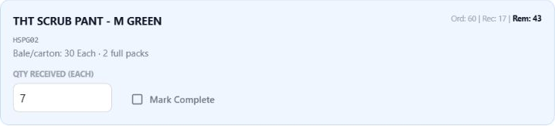
The order is for 60 Each in two packs. Receiving 7 Each stays 7; this is an illustrative receipt.
  Open Record Delivery
  Open the active order and select the receiving action available to your role. Confirm its reference, supplier and product.
  Enter docket and date
  Record the actual docket or packing-slip reference and receiving date. Use the supplier's delivered quantities.
  Enter actual units
  In Qty received, enter 7 when 7 units arrive. Receiving does not round partial cartons up to a full pack.
  Check completion
  Use Mark Complete only when the line should be closed. If further units are still due, leave it open and follow the existing shortage process.
  Add any unplanned item
  Use Add Unplanned Item for goods outside the original order. These have no quantity ordered; they are not a new carton order.
   |  | Confirm and verify  Choose Confirm Receipt, then check the delivery record and remaining balance. Follow the existing variance review for unplanned goods or discrepancies.

Finance and reconciliation
Finance and line-level reports retain saved pack context while receipts and amounts remain in ordering units. Concur quantities, unit prices and export formats keep their existing meaning.

Saved pack details and quick checks
The pack recorded with an order explains what was requested without changing how units and prices are counted.

After saving and reloading
Request Details shows the saved bale/carton size, ordering UOM and full-pack count. For 60 Each at 30 per pack, the order shows 2 full packs. Later supplier changes do not rewrite that history.

Legacy orders and unplanned receipts
Older orders without a captured pack show Pack size not recorded (legacy order). Unplanned receipts show no quantity ordered. Do not infer historical packs from today's supplier report.

Finance and reports
Finance displays the saved pack context. Line-level CSV exports include Ordering UOM, Bale/carton size at order and Ordered pack equivalents. Existing totals remain based on units.

Before submitting
Check the supplier, product, confirmed pack, rounded quantity, price, GST, total and need-by dates. During receiving, enter actual units. A 7-unit receipt is not a full carton even when the order pack is 30.

When this update applies
This guide is prepared for the held feature release. Screens show the actual unreleased branch with illustrative records. Confirm release availability before using these steps in production.

