git config --global user.name "707Alex707"
git config --global user.email "alexandre@dafoe.me”
echo "# Alex Dafoe - 100599423" >> Student.md
git init
git add Student.md
git commit -m "first commit"
git remote add origin https://github.com/SPM-OT/lab-1-707Alex707.git
git push -u origin master
echo “some content” > IgnoreExample.txt
git status
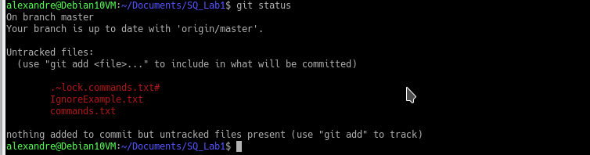
git commit -m "second commit"
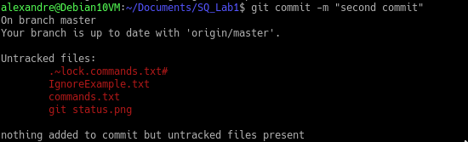

git push -u origin master
echo IgnoreExample.txt > .gitignore
git commit -m “third commit”
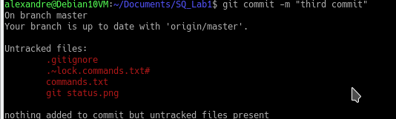

git status
git push -u origin master
git branch TestA
git checkout TestA
echo Hi > BranchExample.txt
git add BranchExample.txt
git commit -m "fourth commit TestA Branch"
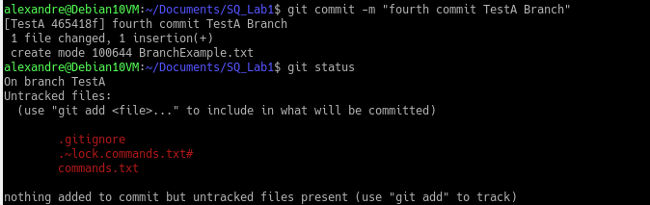
echo Hello >> BranchExample.txt
git add BranchExample.txt
git commit -m "5th commit TestA Branch"
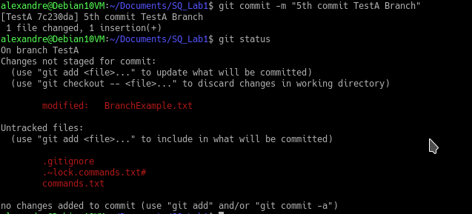
git push -u origin TestA
git checkout master
echo Im on master now >> RemoveExample.txt
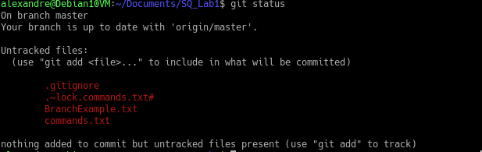
touch RemoveExample.txt
rm RemoveExample.txt
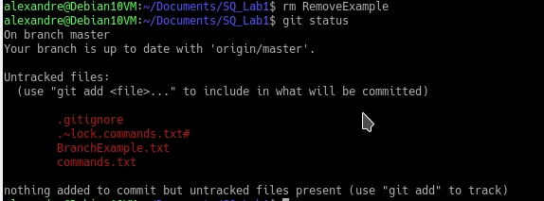

git add .
Git clean -n
git clean -f
git add .
git commit -m "last commit"

