Git status after editing ‘IgnoreExample.txt’  
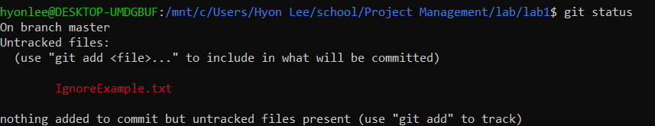

Git status after ‘IgnoreExample.txt’ was added to ‘.gitignore’  
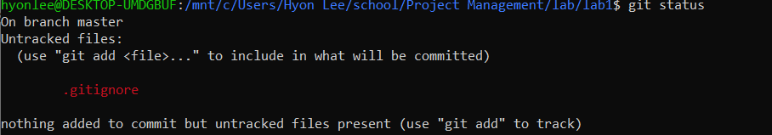

Content of the ‘BranchExample.txt’ file in the ‘newbranch’ branch   
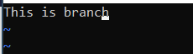

Content of ‘BranchExample.txt’ file in the ‘master’ branch  


Git status after removing ‘RemoveExample.txt’  
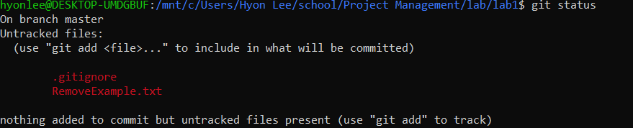Git status after cleaning   
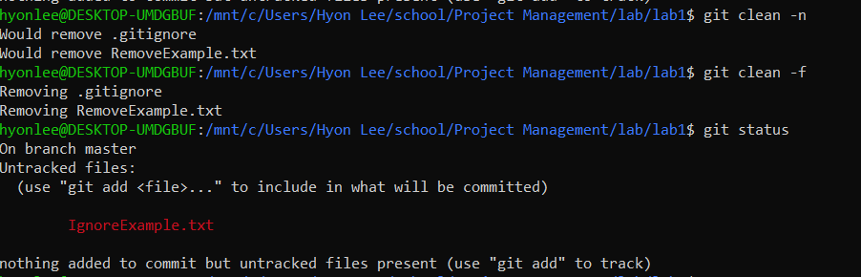

Screenshot of github repository   
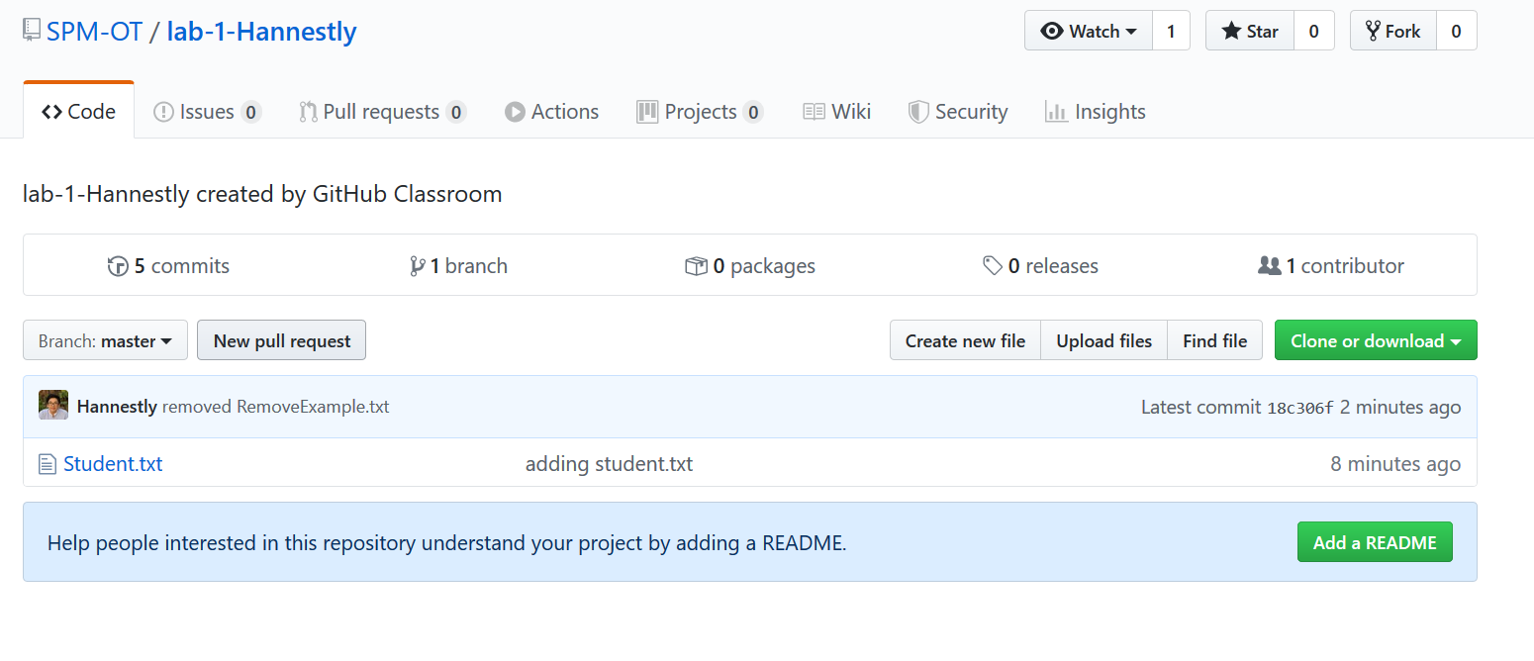

Screenshot of local repository   
