**LAB 1 Screenshots**

1. Screenshot of git status for IgnoreExample.txt

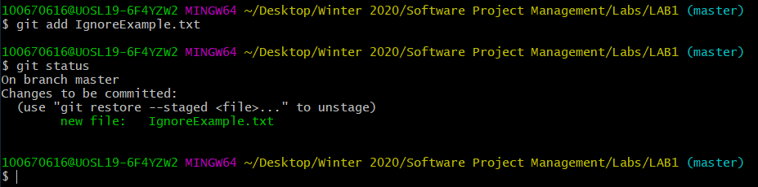

1. Screenshot after .gitignore is created

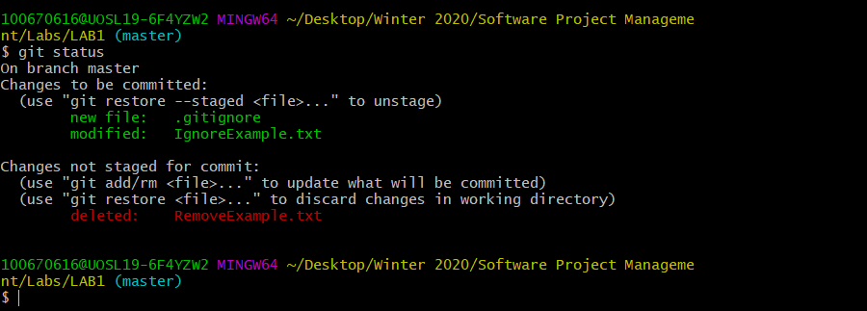

1. Screenshot after branch is created and BranchExample.txt has been created, added and committed.

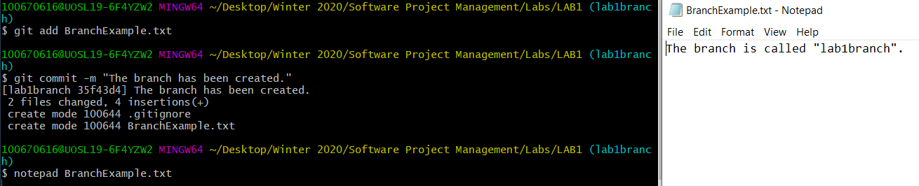

1. Screenshot after BranchExample.txt is created on the master branch

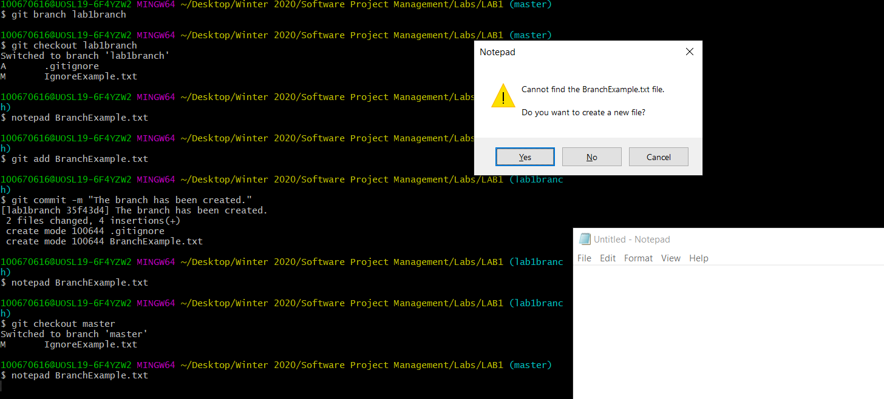

1. Screenshot after the RemoveExample.txt file has been removed.

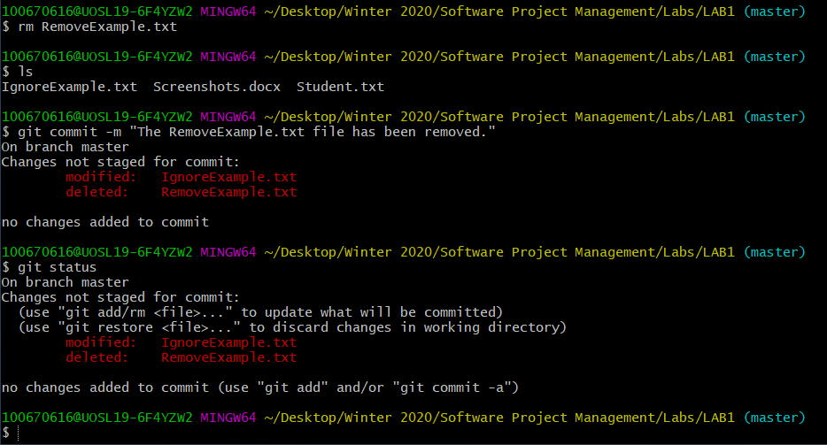

1. Screenshot of git status of clean command is used

