Initializing

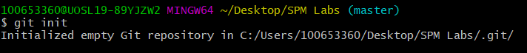

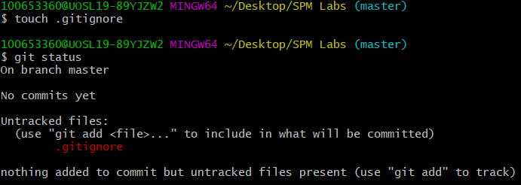

Add Student.txt and edit content

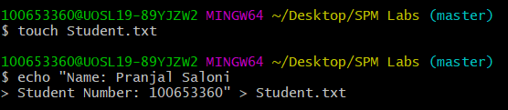

Add IgnoreExample.txt and edit content

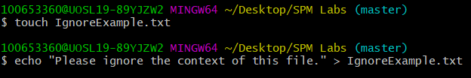

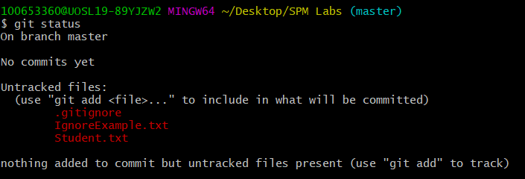

Add IgnoreExample.txt to .gitignore

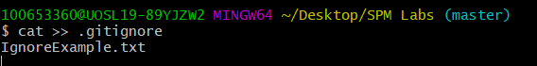

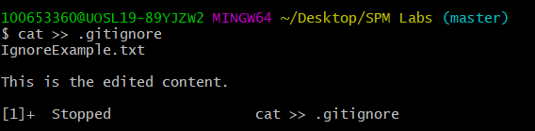

Add BranchExample.txt and edit content

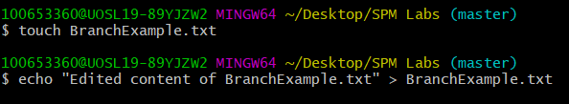

Git status

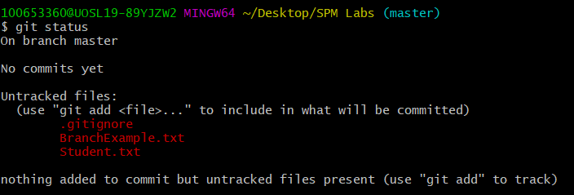

Add RemoveExample.txt



Git status

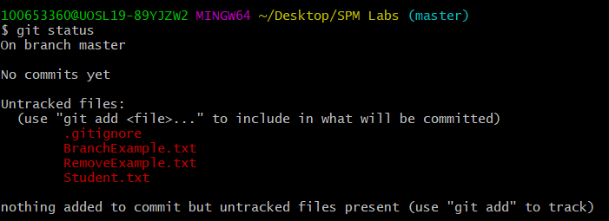

Remove RemoveExample.txt



Git status

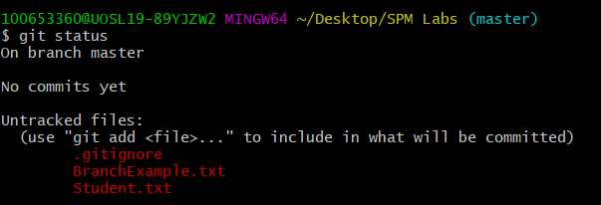

Clean

