Committing readme:

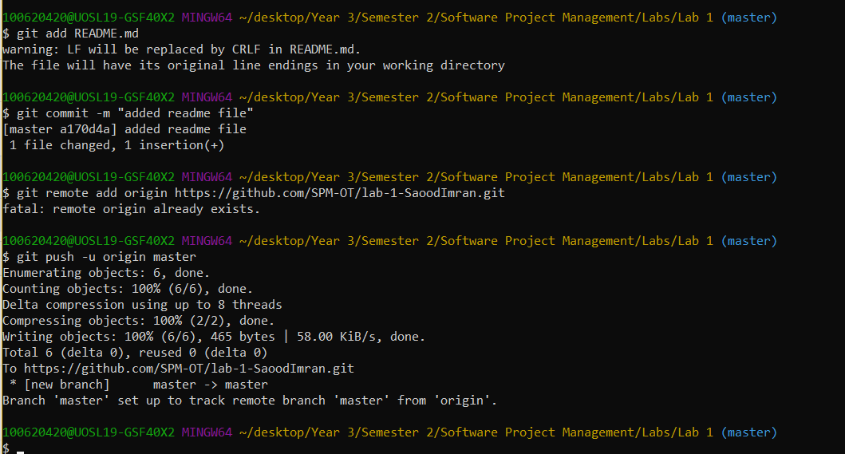

Committing student name and ID:

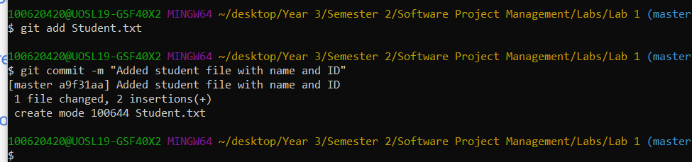

Git status:

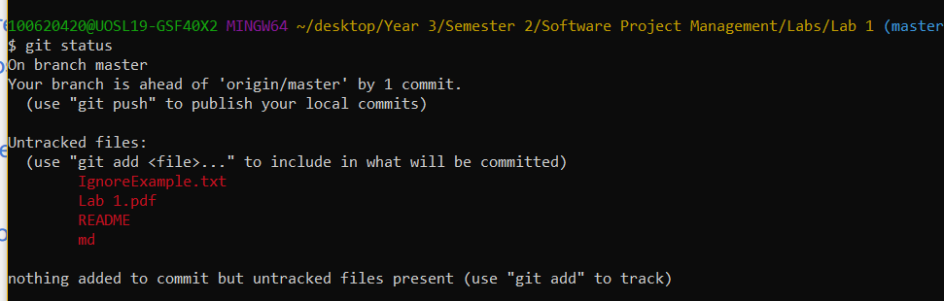

Creating new test branch and committing branch example file to it:

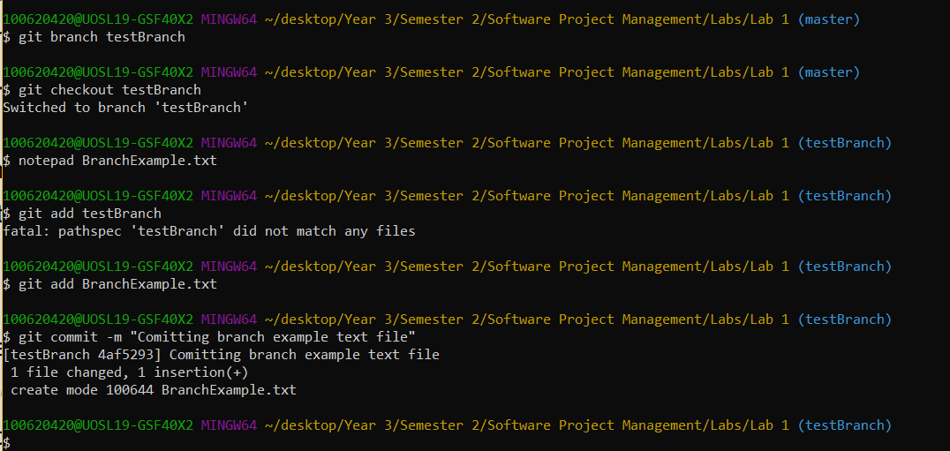

Master branch has an empty BranchExample.txt:

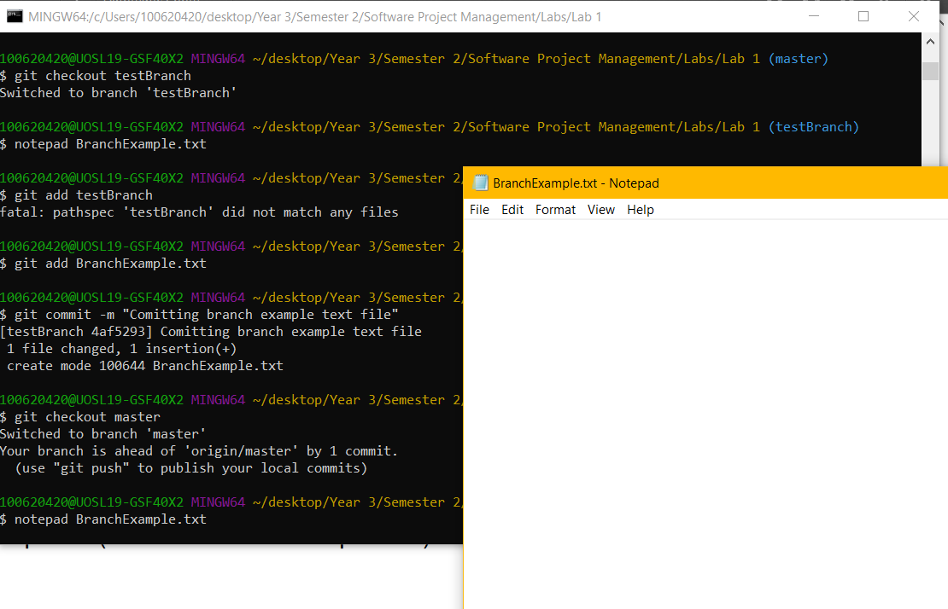

Adding and removing and getting status after creating RemoveExample.txt:

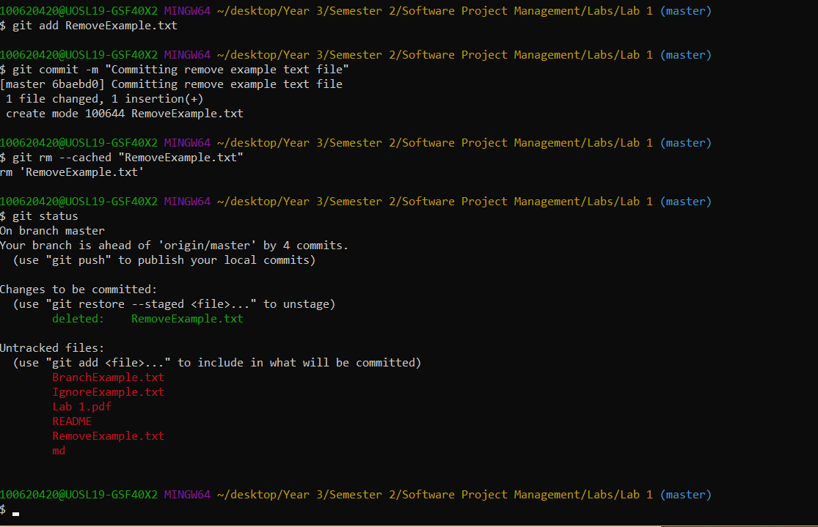

Cleaning all files:

