Lab 1. Intro to Github

Practical:

Initialize Git:

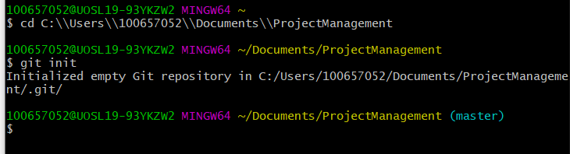

Track and Commit student.txt file

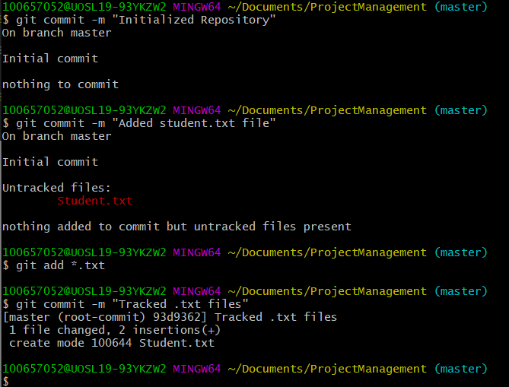

Add remote origin and push files:

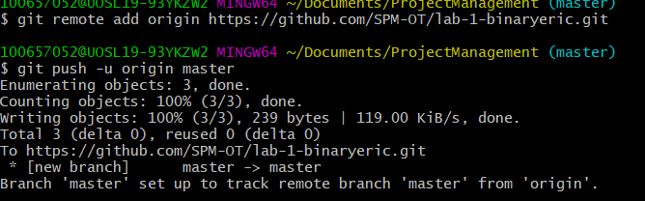

Add the ignore file and ExampleIgnore.txt

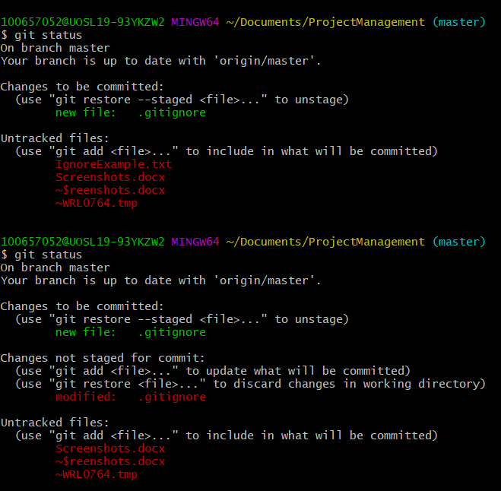

Create Branch Example and Switch

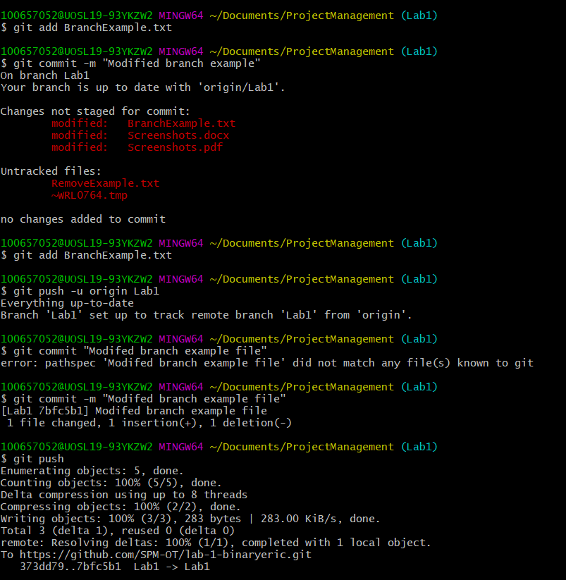

Switch to master branch:

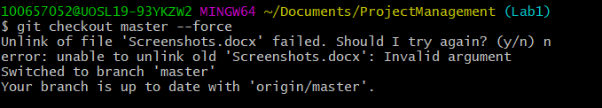

Add RemoveExample and then Delete it:

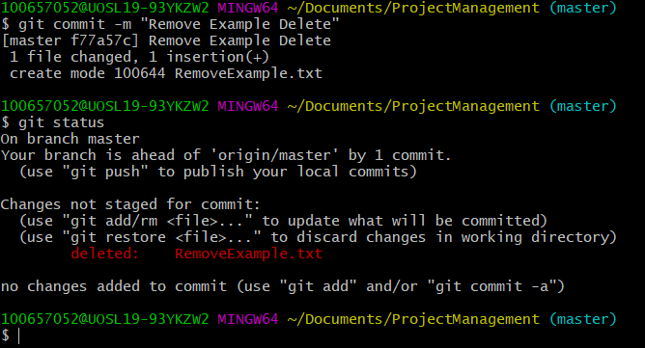

Git Clean and Status for RemoveExample

