**Lab 1**

**Danial Asghar 100671850**

1. Create a Git Repository using the cheat-sheet commands



1. Edit student file to include name and student id



1. Commit changes

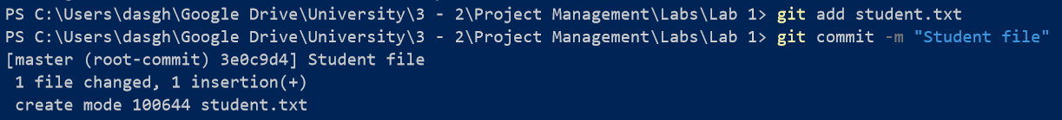

1. Create IgnoreExample.txt

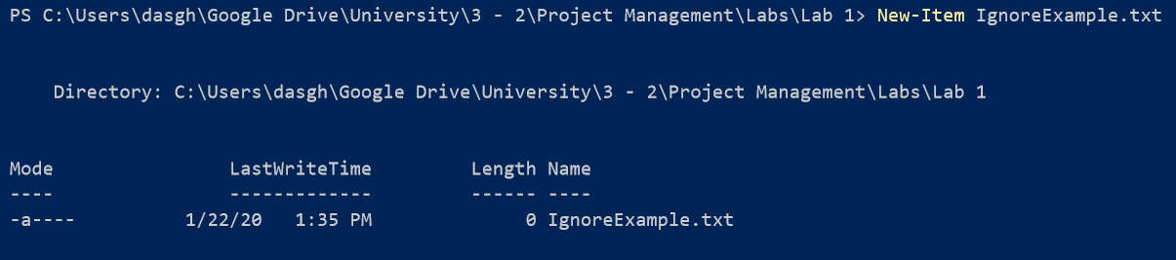

1. Edit content of IgnoreExample.txt



1. Use git status

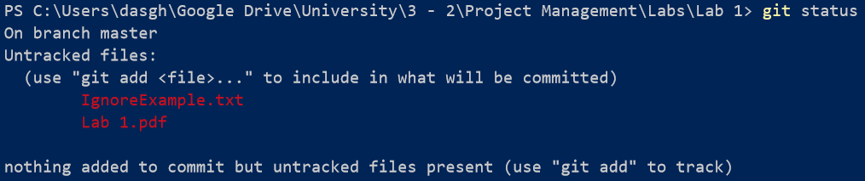

1. Commit changes

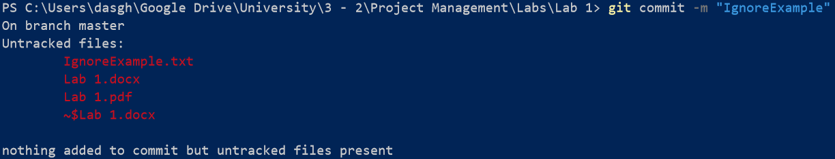

1. Add IgnoreExample.txt to .gitignore file

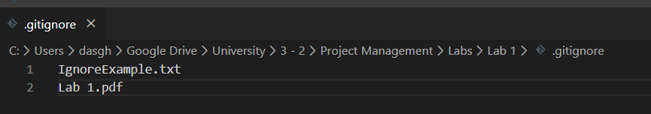

1. Edit content of IgnoreExample

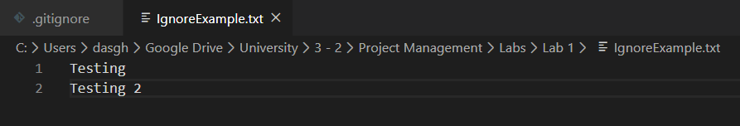

1. Use git status

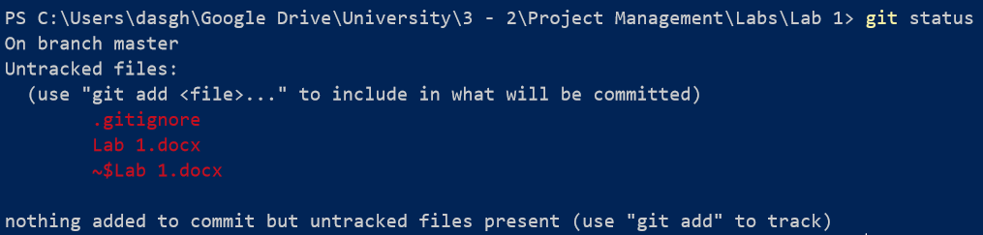

1. Create a new git branch using git branch, create Branch.Example.txt, use git add for branchexample.txt, commit

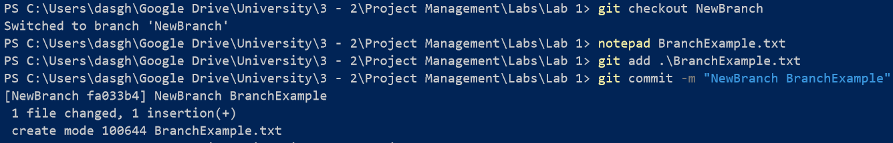

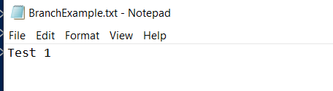

1. Switch to master and run notepad command



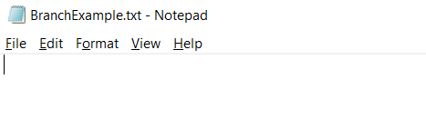

1. RemoveExample.txt create, add, commit. Then remove and status

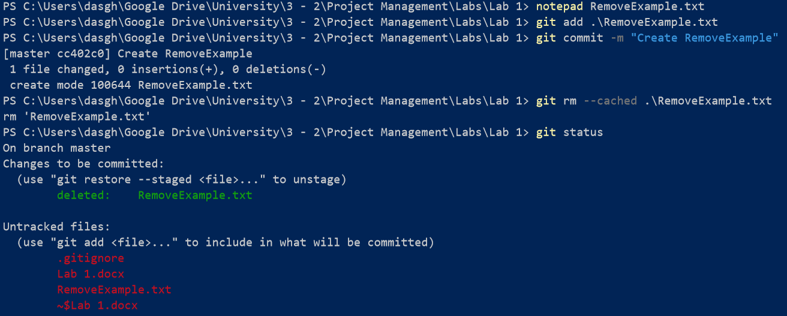

1. Clean command and status

