● Create a Git repository using the cheat-sheet commands

● Keep a word document named “Screenshots” open to put screen shots in

● Edit “Student” file to include your own Student Name & Student ID

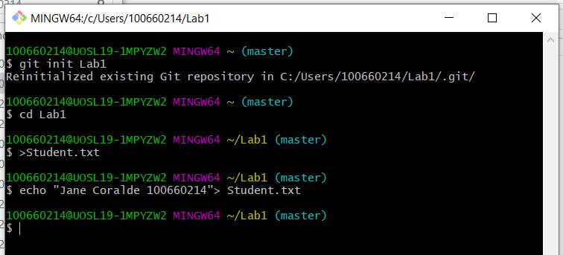

● Commit changes

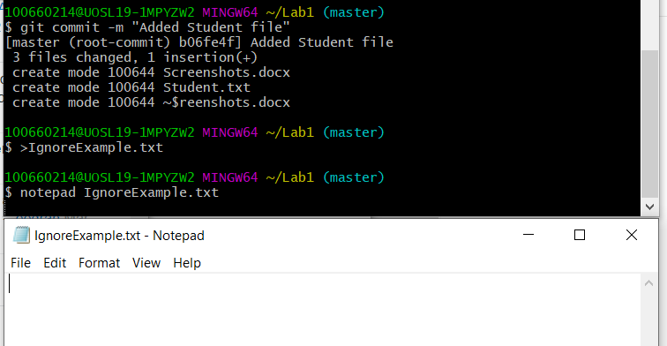

● Create IgnoreExample.txt

● Edit content of IgnoreExample.txt



● Use git status and screenshot the outcome

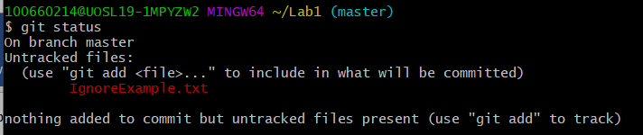  
● Commit changes

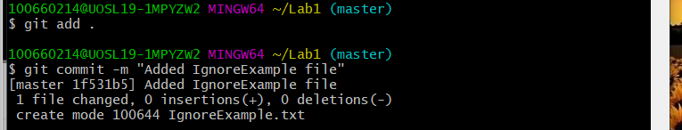

● Add IgnoreExample.txt to .gitignore file

● Edit content of IgnoreExample.txt

● Use git status and screenshot the outcome

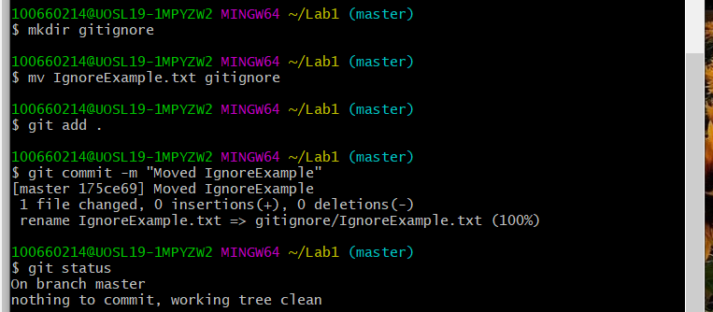

● Create a new branch using git branch

● Switch to new branch

● Edit BranchExample.txt (create this if not present) via notepad command

notepad BranchExample.txt

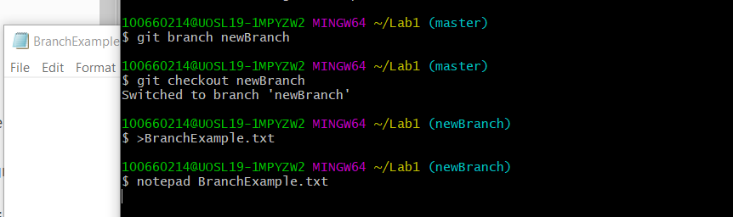

● Use git add for update branch example, commit and use notepad command again

● Screenshot content

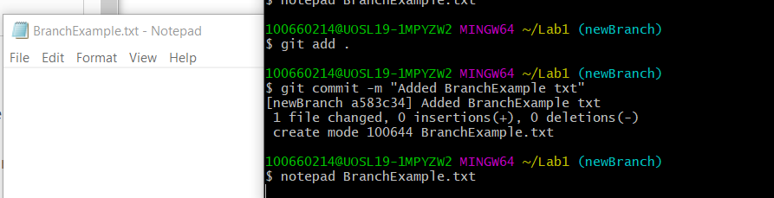

● Switch back to master branch



● Use same notepad command

● Screenshot the outcome

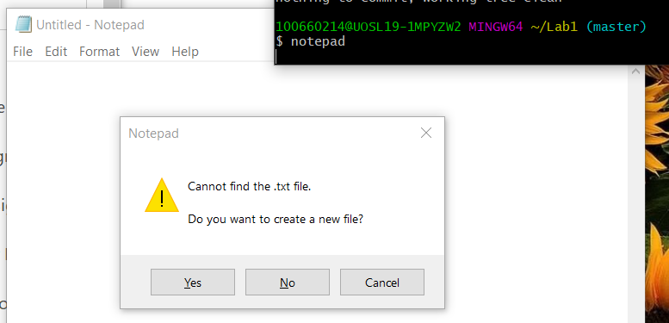

● Remove RemoveExample.txt (create one first if not present)

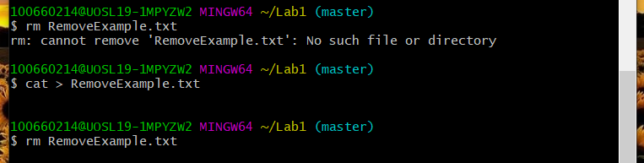

● Commit

● Use git status and screenshot outcome

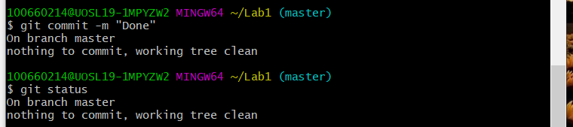

● Use clean command to remove file completely

● Use git status and screenshot outcome

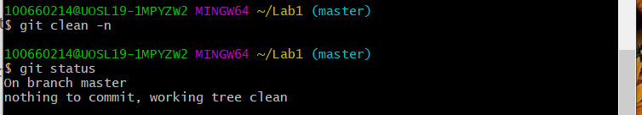

● Use git add to add your word document with the screenshots to the repository, it should look something like this:

git add Screenshots.docx

● Commit

