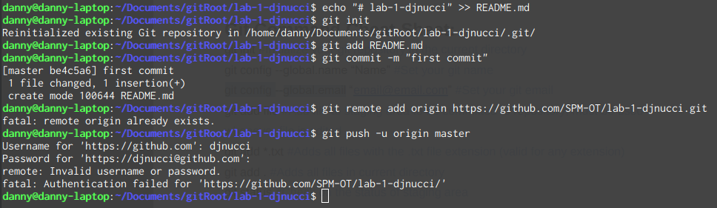
Had to disable 2FA to log in on commandline. Commit init to master
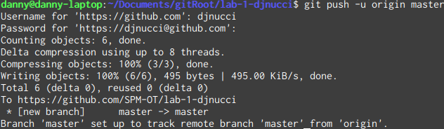
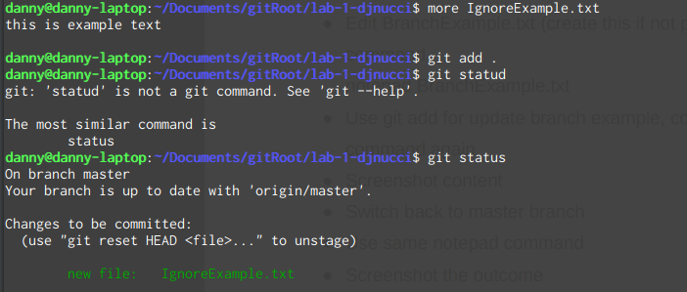
Push to master

Add Ignore example to master
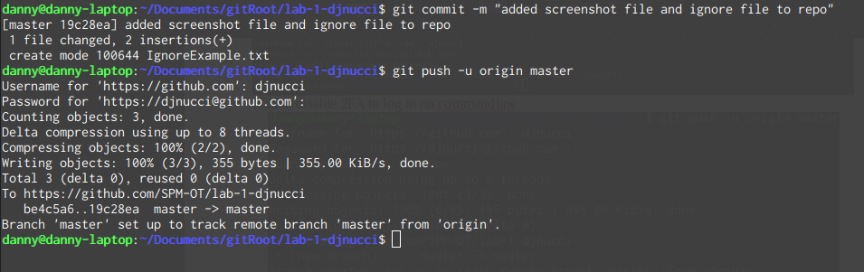
Commit example.txt to master

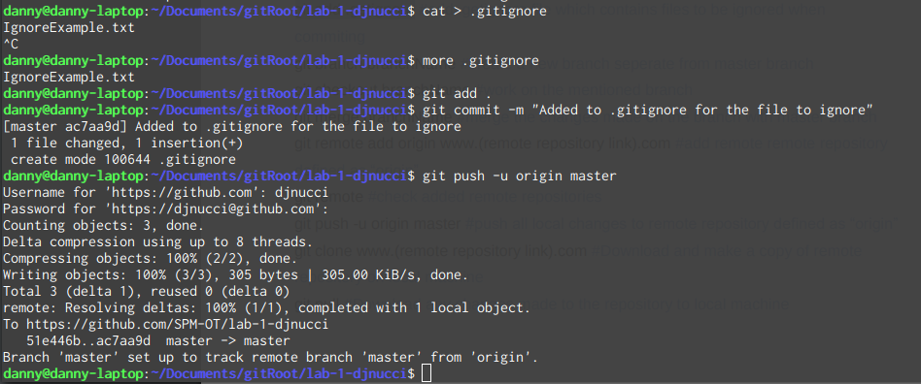
Made a .gitignore
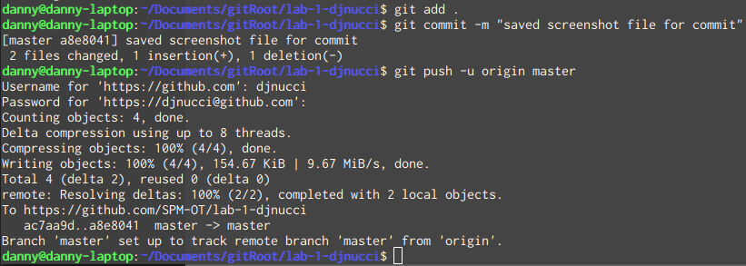
Commit screenshot file
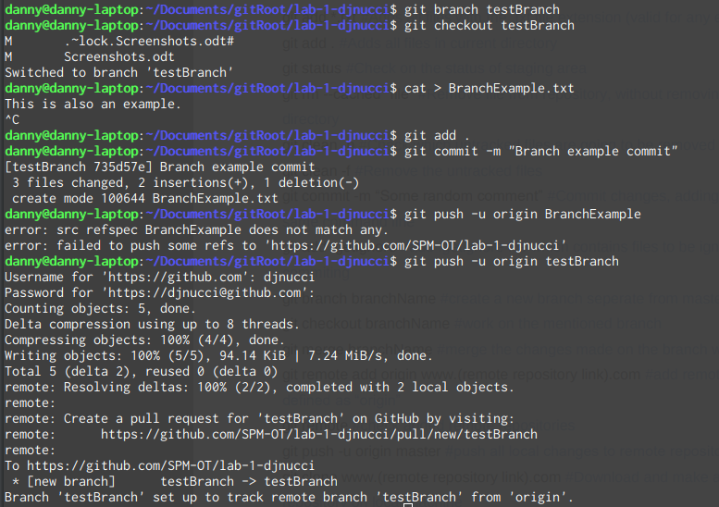

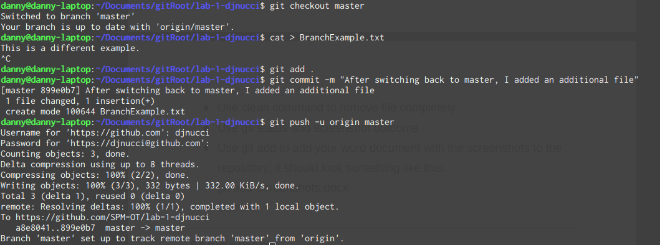
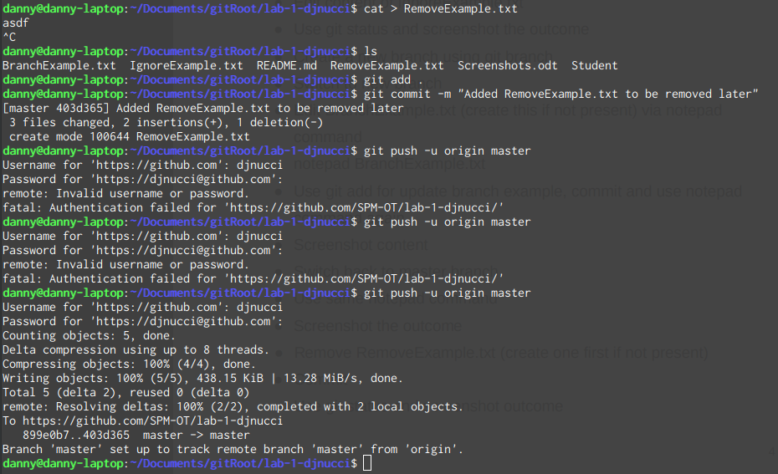
RemoveExample.txt added and then removed

Switch back to master and make a branch example

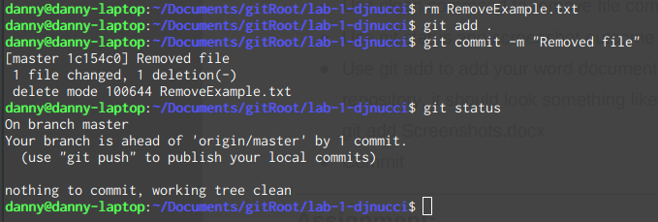
remove RemoveExample.txt

clean out the remove example

