**Making .gitignore**

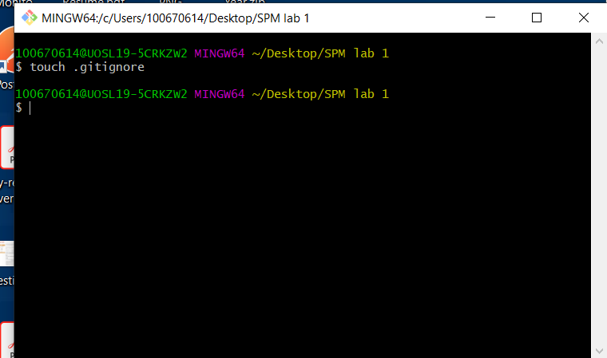

**Clone the file:**

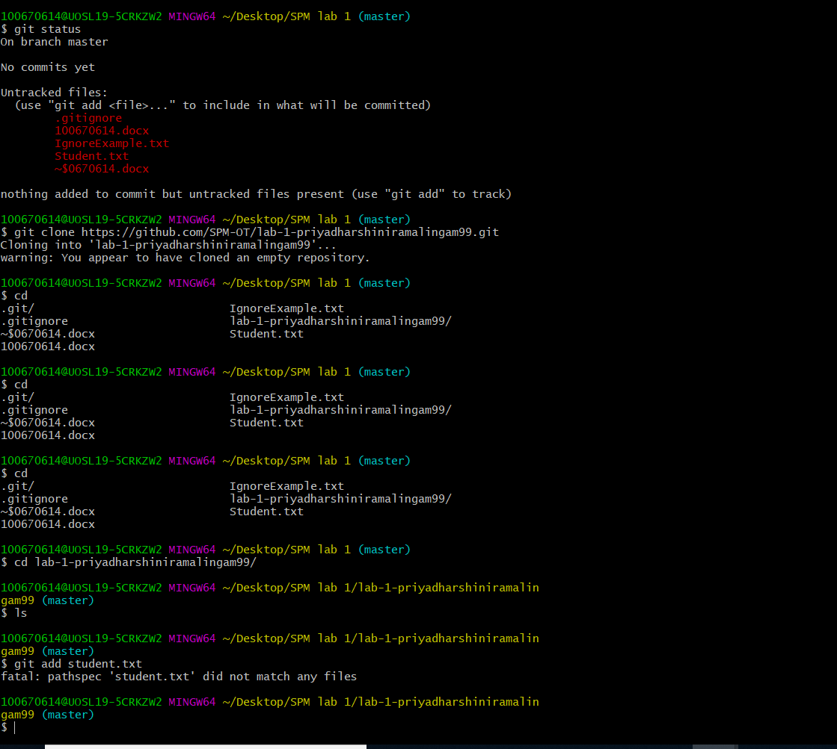

Making a IgnoreExample.txt

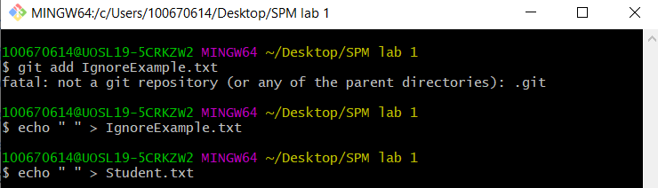

Making student.txt



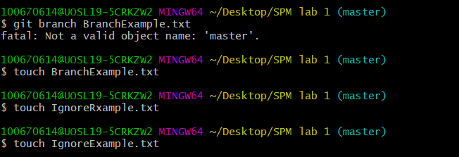

Adding student Name and number to the student.txt

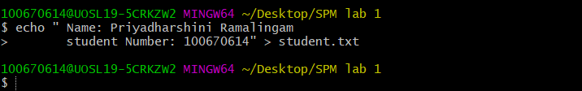

Add IgnoreExample.txt to .gitignore.txt

