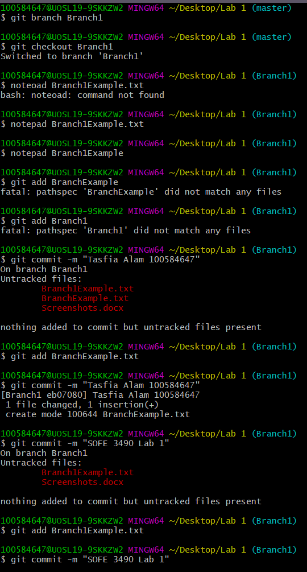Tasfia Alam

100584647

SOFE 3490 LAB 1

This screenshot is for creating a new branch called Branch1 and adding the BranchExample.txt file to the branch. 🡪

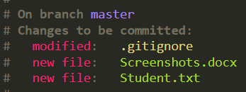This screenshot is for adding the IgnoreExample.txt to .gitignore file

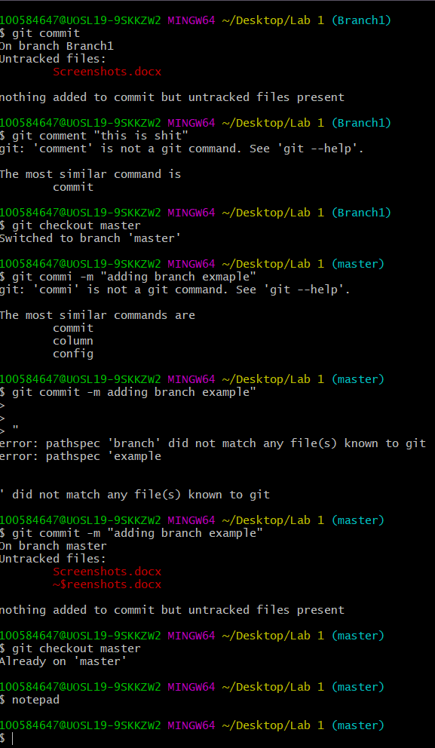

Switching branches

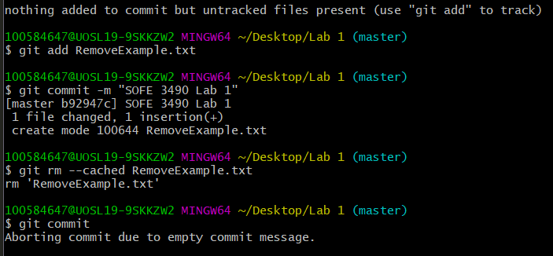Adding the RemoveExample.txt to the master branch. Removing the RemoveExample.txt file and cleaning it out. Then adding the Screenshots.docx file into the repository, and adding the Student.txt file

