**Practical:**

Create a Git repository using the cheat-sheet commands

Keep a word document named “Screenshots” open to put screen shots in

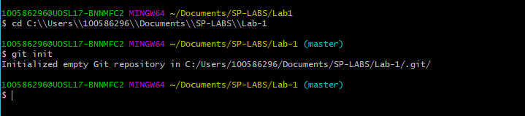

Edit “Student” file to include your own Student Name & Student ID

Commit changes

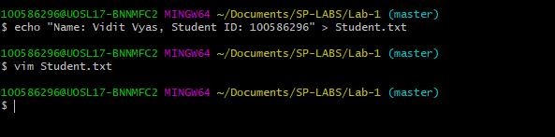

Create IgnoreExample.txt

Edit content of IgnoreExample.txt

Use git status and screenshot the outcome

Commit changes

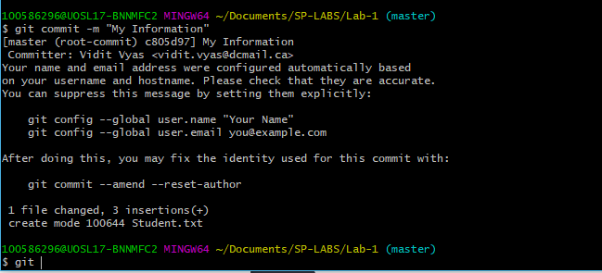

Add IgnoreExample.txt to .gitignore file

Edit content of IgnoreExample.txt

Use git status and screenshot the outcome

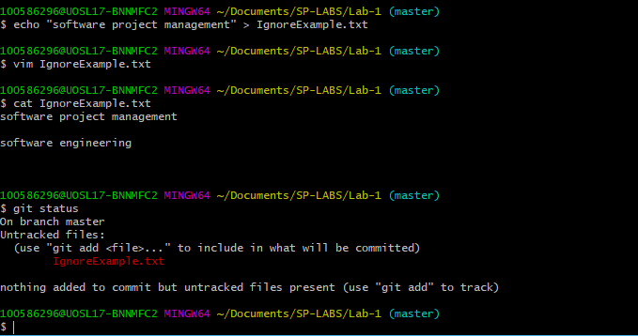

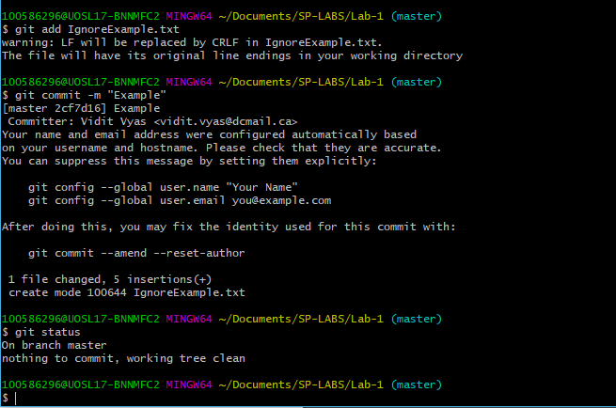

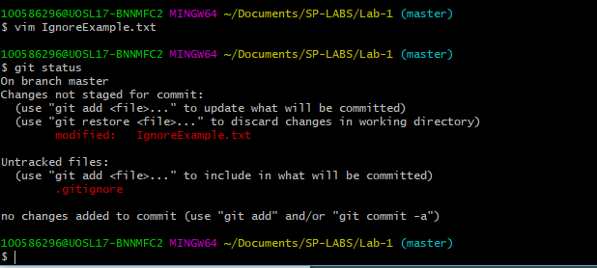

Create a new branch using git branch

Switch to new branch

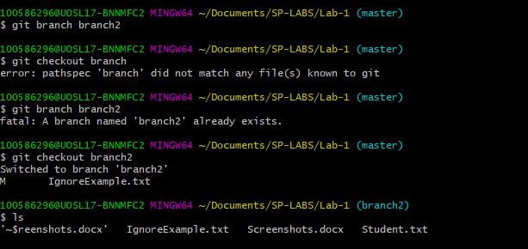

Edit BranchExample.txt (create this if not present) via notepad command notepad BranchExample.txt

Use git add for update branch example, commit and use notepad command again

Remove RemoveExample.txt (create one first if not present)

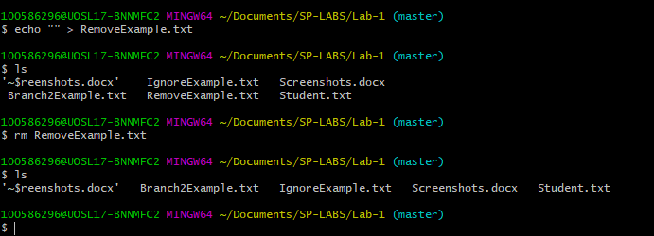

Screenshot content

Switch back to master branch

Use same notepad command

Screenshot the outcome

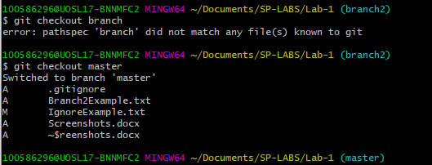

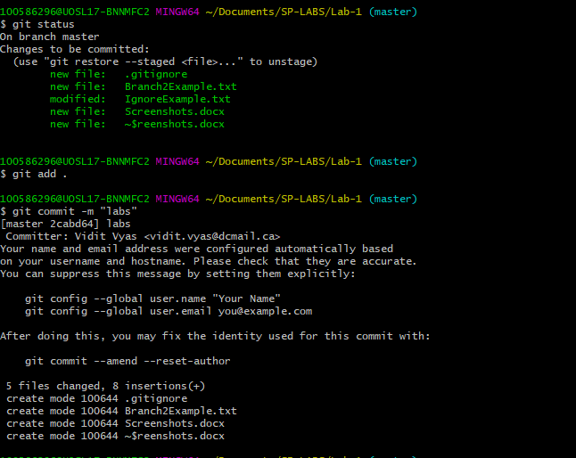

Use clean command to remove file completely

Use git status and screenshot outcome

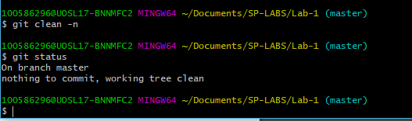

Use git add to add your word document with the screenshots to the repository, it should look something like this: git add Screenshots.docx

Commit