

Faculty of Engineering and Applied Science

Software Project Management

Laboratory 3

Date: 3/3/2020

Hoang Vu 100675262

Ming Lau 100623165

Armando Cuesta Leyva 100652479

*The Project: Ipad Restaurant Menu*

The list of sub-projects to complete:

1. Front End
   1. View of dishes categories and detailed introductions
   2. Order dishes and send it to the kitchen
   3. View the ordered information and the total due
   4. Customer serves: pay the bill
   5. Quick dishes search
2. Back End
   1. POS system
   2. Order management
   3. Table management
   4. Printer management
   5. Staff management
3. Customer Feature
   1. Customize the user interface according to their restaurant-style, such as restaurant logo and colour

*Software Project Estimation*

Calculating Estimated Efforts (the Estimated time it’ll take to complete the project)

Embedded – A software project requiring the highest level of complexity, creativity, and experience requirement fall under this category. Such software requires a larger team size than the other two models and also the developers need to be sufficiently experienced and creative to develop such complex models.

Basic Model: E = a(KLOC)^b

Embedded A: 3.6 B:1.20

10 Sub Task in the project. Those 10 might take between 1k and 3Kloc

The last one might take at max 1kLOC

The net of all the Lines of Code would be on average 2k \* 10 + 1K = 20 + 1 = 21KLOC

The effort might be 3.6 \* (21) ^ 1.20 = 138.9 person per month effort.

Duration = 2.5\*(138.9)^0.32 = 12 months. So about a year on average. If done 1 by 1 of course, if instead it is done maybe 2 at a time we can reduce it to 6 months and furthermore depending on the people we have.

*Activity Planning*

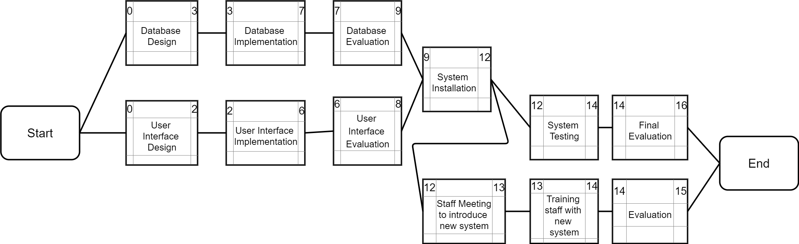

*Risk Management*

1. Design risk

Some of the design or content may fail to meet requirements or may be rejected by stakeholders. In that case, we need to reach a consensus with our customers before implementing the application.

2. Technology risk

Such as the connection outages that disrupt the service. To avoid this problem we have to make a backup plan which is about our contingency measures.

3. Lack of experience

Some employees may lack experience implementing an ios application, and in that case, we need to understand the employee’s strengths to allocate the work.

4. Security Risk

The database design may introduce information security vulnerabilities. We should choose the best method to implement the database.