SPM ASSIGNMENT – 4

PHASE- I

First Name: Ginnavaram

Last Name: Sai Ruchith Reddy

Github-ID: GFA20SCM69

* A new Github account is created with an ID following the instructions as mailed. In my case my github user id is GFA20SCM69 and created an issue following the instructions given.

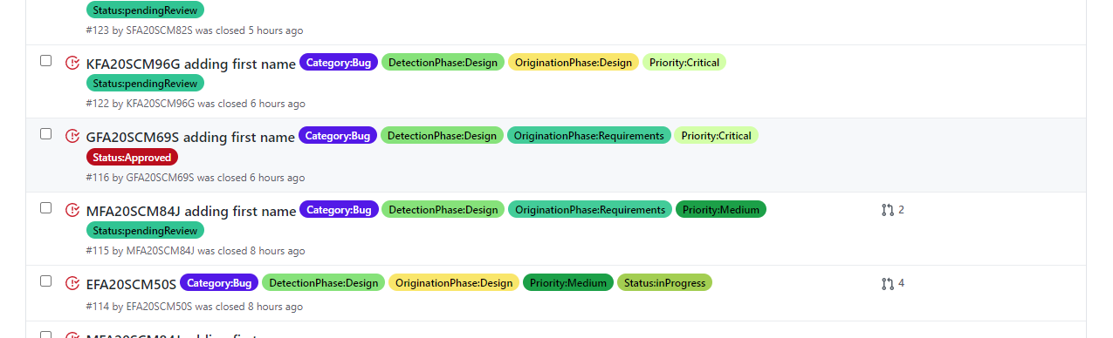

* The project SCM587FA20 is forked to my account and then cloned it locally.
* Since my first name starts with the letter G, my github userid is added to g.java file.
* The java file is edited and commit in my repository as shown in the screenshot below

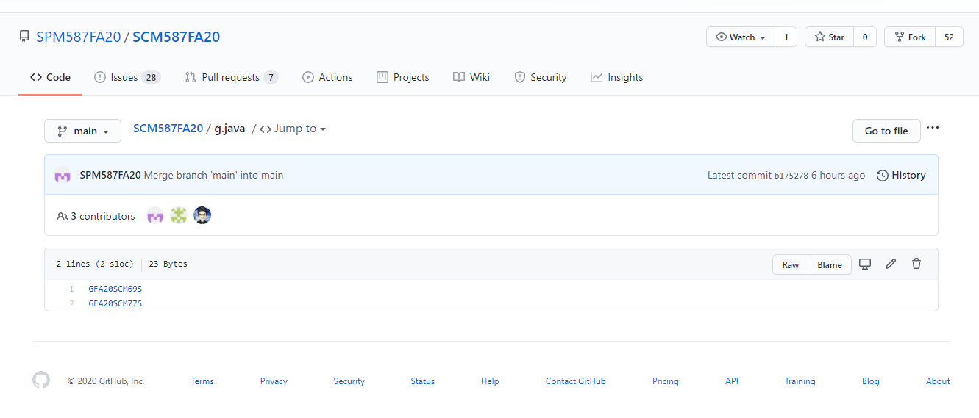

* Now, a new pull request is created which is approved and merged by the reviewer

