Sensory Spohf
Location A
Sensor mounted at greenhouse structure at plant top level.
1 Sensor id:
S2103-01-temp-hum-co2
Measurements: temperature humidity and co2
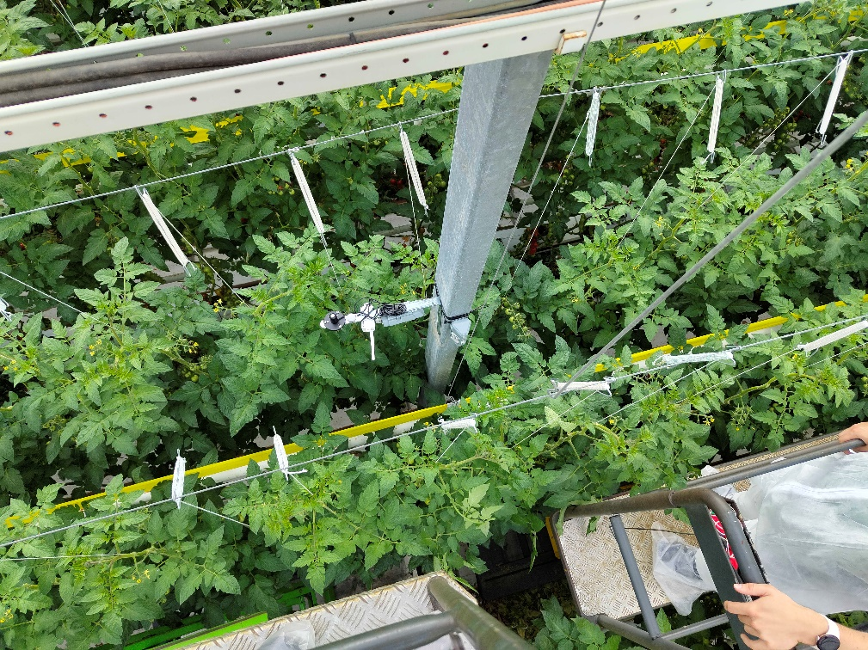

Location B
Sensors are mounted at sensor rig. Located in the middle of the greenhouse on a special structure at plant top level. Its plant row is 3 rows to the right from the gateway.
2 sensor id’s
B1= s2100-02-par Measurement: PAR value (light)
B2= lht65s-e5-02 Measurements: Lux (light), temperature, humidity
Lux sensor is external data. Temperature and humidity are measured in the device node.
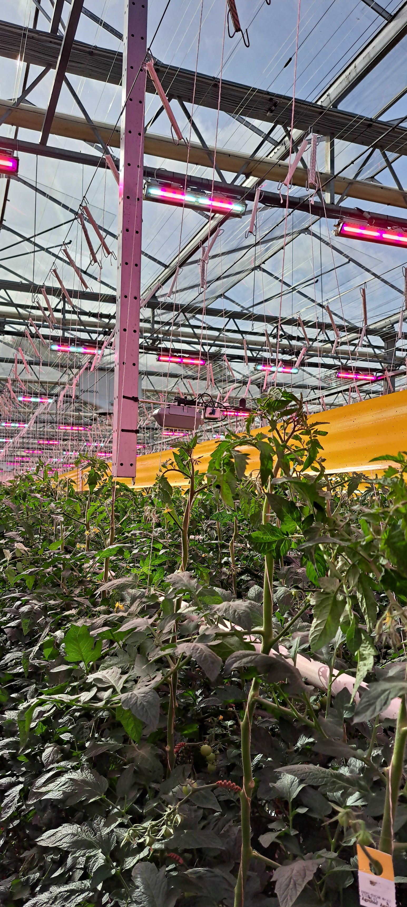
B1 = red
B2 = Bleu

Location C
Location C is not placed yet
1 sensor id
Lht65s-ne117-01 Measurements: external temperature (ext. data), temperature, humidity

Location D
Located in the top of the greenhouse above the screens.
3 sensor ids
D1= s2100-01-par Measurement: PAR value (light)
D2= lht65s-e5-01 Measurements: Lux (light), temperature, humidity
Lux sensor is external data. Temperature and humidity are measured in the device node.
D3= s2101-01-temp-hum: temperature, humidity

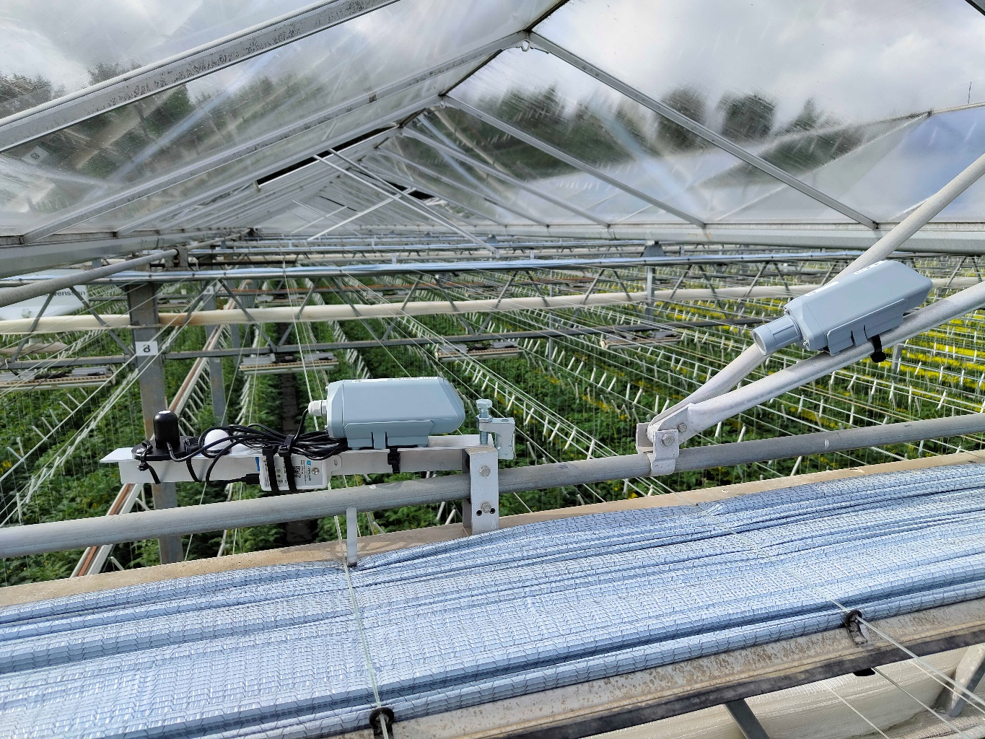
D1= red
D2= bleu
D3= green

Location E
Located at top greenhouse and external sensors positioned at glass.
2 sensor ids
S2107-01-temp external temperature sensor
Lht65s-ne117-02 external temperature sensor, internal temperature sensor, internal humidity sensor
Temperature ext. is external data. Temperature and humidity are measured in the device node.
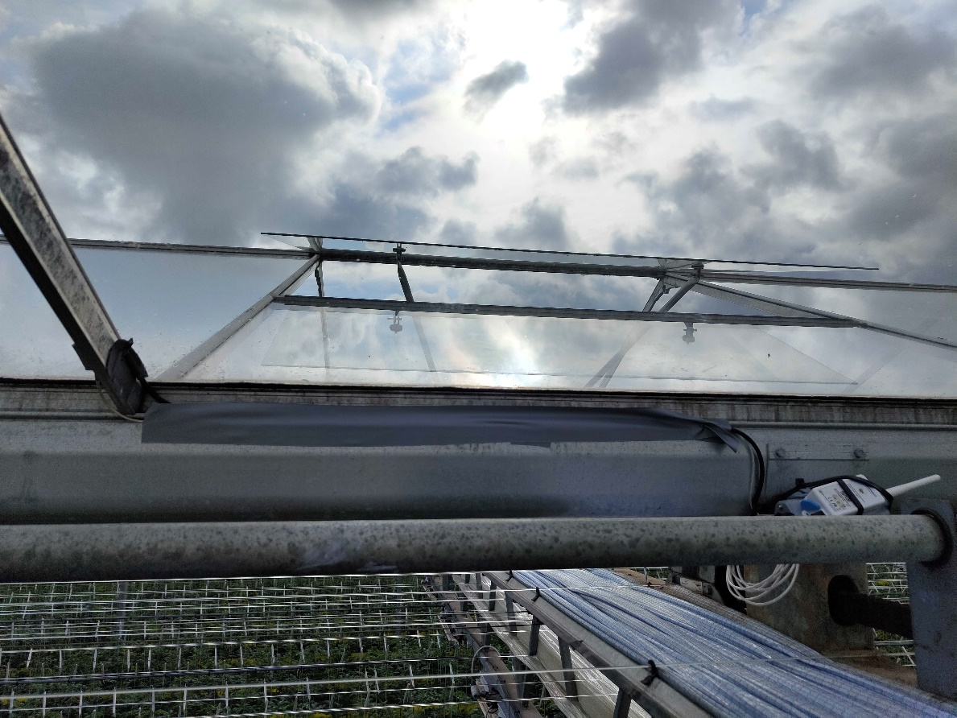

Location F
Location F is located at the centre path. Here is the gateway box antenna and a sensor mounted. The sensor external temperature sensor is mounted at a heating pipe on the side at plant middle level. The function of this measurement is to track if the heating is on.
Sensor id:
Lht65s-ne117-03
Temperature ext. is external data. Temperature and humidity are measured in the device node.
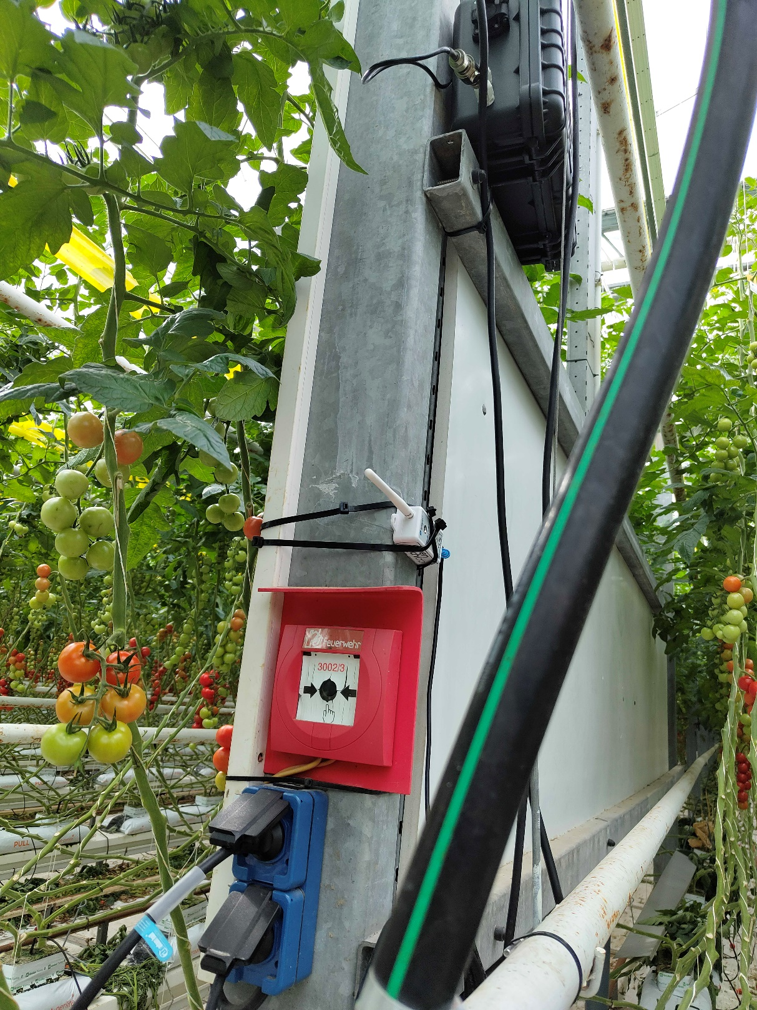

Location G
Location G is a random choice of mounting a temperature humidity sensor. At plant level in the greenhouse.

Ana gives update about sensor location
Sensor id:
S31-lb-01
External humidity sensor= Hum_SHT31
External temperature sensor= TempC_SHT31

Location H
Location h is in row 2055 is on the otherside of the path then the gateway.
Approximately 10 meter in this pad the dendrometers are mounted.
Sensor id:
Dendro-01
ADC_CH0V = stem thickness before first cluster
ADC_CH1V = stem thickness in-between clusters
Sensor id:
Dendro-02
ADC_CH0V = fruit measurement 1 fruit on cluster
ADC_CH1V = fruit measurement 1 for last fruit on cluster.
ADC_CH4V = stem thickness before first cluster
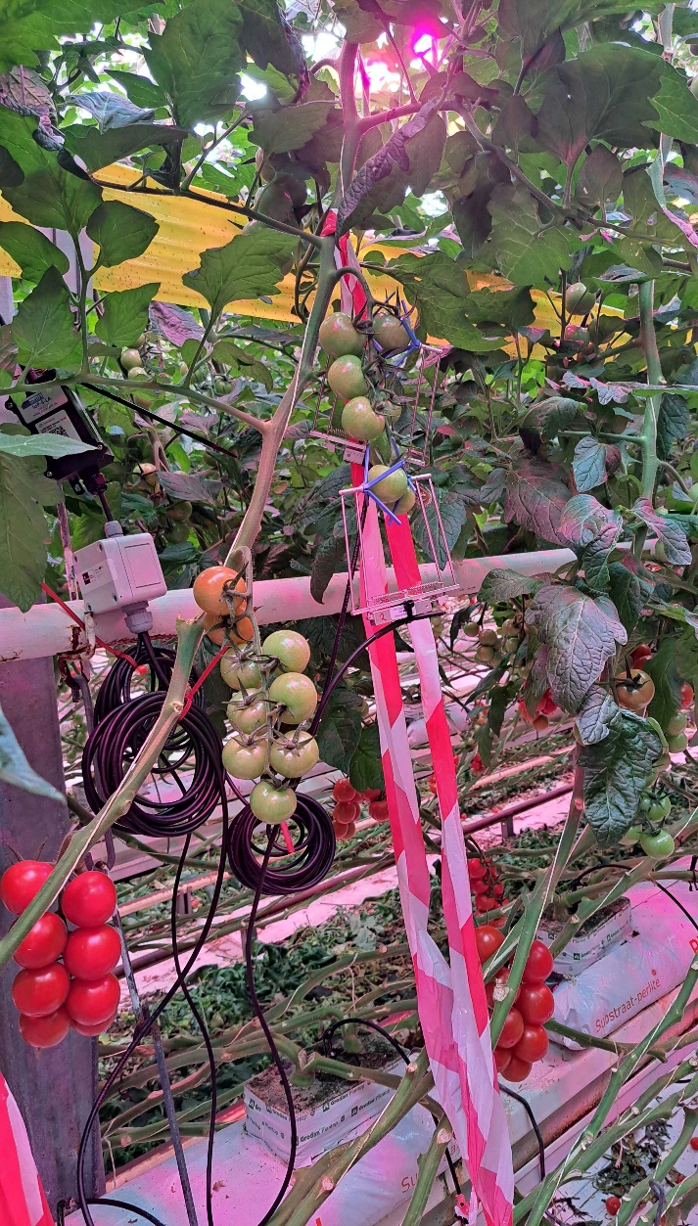

Location Outside
S1000-Weatherstation
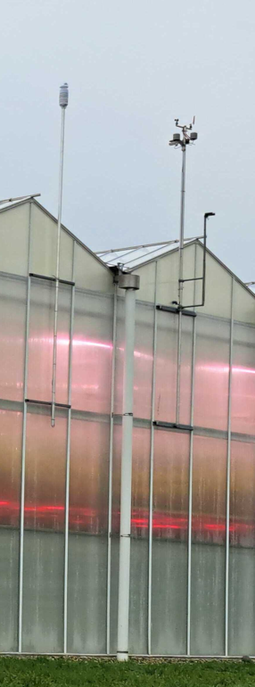
Measurements outside
Tempature [Celcius]
Air humidity [ RH%]
Air pressure [hPa]
Licht intensity [Lux]
Wind speed [m/s]
Wind direction degrees from north
Rainfall [mm/h]
Partical matter pm 2.5 [ug/m3]
Partical matter pm 10 [ug/m3]
Co2 [ppm]

