Jack Mackerel Assessment SCW14
17 March 2026
This document was compiled in RMarkdown, and shows the incremental results of the Chilean Jack Mackerel (Trachurus murphyi) stock assessment benchmark in 2026. The files associated with this document can be found on Github.
Annoted data files can be found in the Excel spreadsheet newAge.xlsx on jjm/assessment/data.
- Compiled the latest jjm/src/jjms.tpl
  - This can be done by navigating to the jjm/src folder in your Terminal, and using the make command
  - You will need to have ADMB installed to do this.
  - This does not need to be done if you’re only re-compiling the R Markdown document.
- Updated the jjmR package
  - This can be done in R using the command remotes::install_github("SPRFMO/jjmR")

Model Naming Convention
File naming conventions have been changed to reflect the stock structure hypotheses associated with each run. The h1 denotes the single-stock hypothesis, while h2 denotes the two-stock one.
Model | Description
0.00 | Exact 2021 (single stock h1 and two-stock h2) model and data set through 2020 (mod1.0 from SC09)
0.01 | As 0.00 but with the model beginning at age-0.
0.02 | As 0.01 but replacing previous age data with updated data; mean stock weight at age calculated as a mean from SC_Chile 4th quarter, 1995-2020; natural mortality set to 0.25; downweighting DEPM.
0.03 | As 0.00 but replacing previous age data with updated data; mean stock weight at age calculated as a mean from SC_Chile 4th quarter, 1995-2020; natural mortality set to 0.25; downweighting DEPM.
0.04 | As 0.03 but with L_infinity updated to reflect TL (80.4) instead of FL (74.4); Lo updated to 15.75 to reflect the mean total length of age-1 fish.
—— | ——
1.00 | As 0.04.
1.01 | As 1.00 but with changes in selectivity. (JNI)
1.02 | As 1.00 but with age-varying M (Chen and Watanabe method; scaled to 0.28 (average over entire vector)). (NH)
1.03 | As 1.00 but with the new offshore CPUE index that incorporates effort creep. (MP)
1.04 | As 1.00 but with pre-weighted sample sizes for composition data. (IP)
1.05 | As 1.04 but with sample sizes for composition data and CVs of index data based on expert judgement.
1.06 | As 1.03 but with the Chilean CPUE index that incorporates a 1% effort creep. (NH)
1.07 | As 1.04 but with the updated CVs on all the indices (Candidate for furture).
1.08 | As 1.07 but with high weights on composition data (compare francis weights w/ 1.07).
1.09 | As 1.07 and 1.06 (combination) and updated CVs because the index series had changed
1.10 | As 1.09 with 5x the sample size (ie, 150, 250, 200) for the multinomials (composition data).
j.11 | As 1.10 but removing recent age compositions from Chile AcousCS.
1.12 | As 1.11 but Francis weights applied only in one iteration.
1.13 | As 1.12 but Francis weights applied second iteration
You’ll need to be in the jjm/assessment directory in order for the code here to run.

Updated Age Data

Single-stock hypothesis
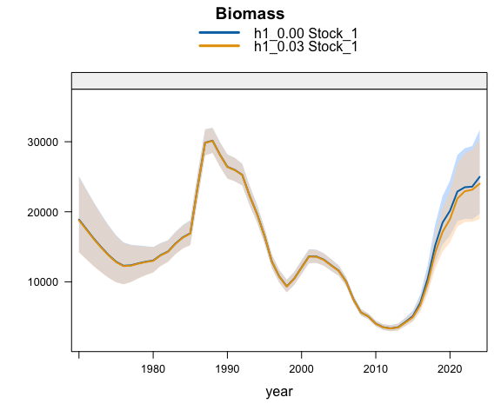
Plot comparing biomass estimated by last year’s model (h1_0.00) with data updated to 2025.
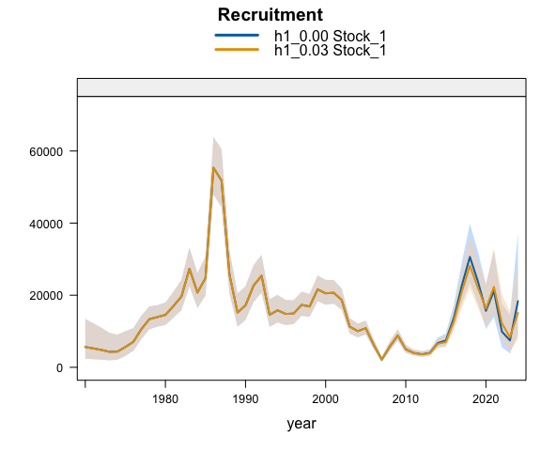
Plot comparing recruitment estimated by last year’s model (h1_0.00) with data updated to 2025.
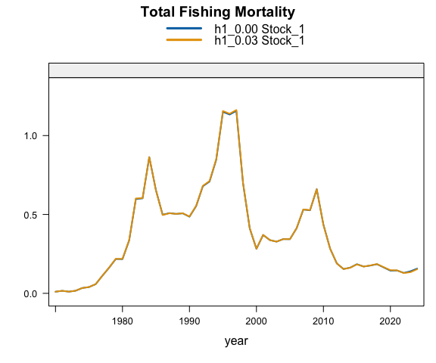
Plot comparing fishing mortality estimated by last year’s model (h1_0.00) with data updated to 2025.

Two-stock hypothesis
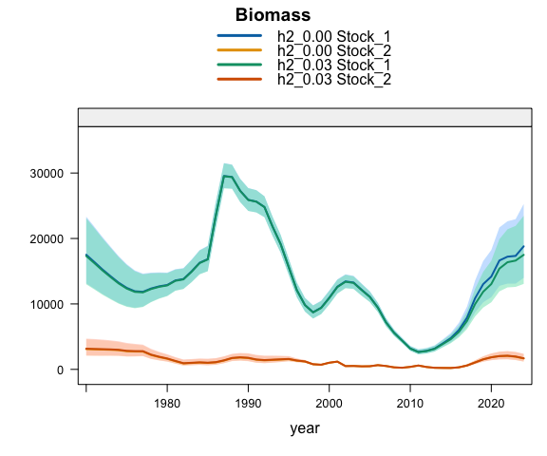
Plot comparing biomass estimated by last year’s model (h2_0.00) with data updated to 2025.
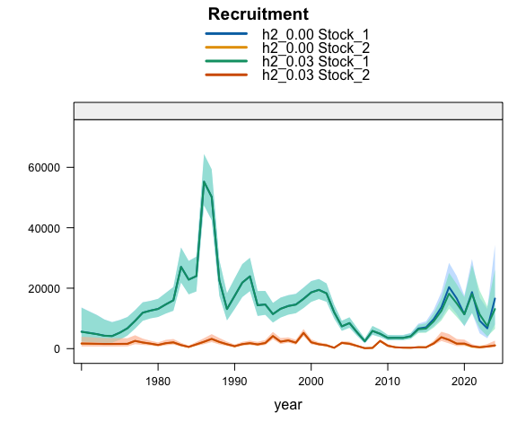
Plot comparing recruitment estimated by last year’s model (h2_0.00) with data updated to 2025.
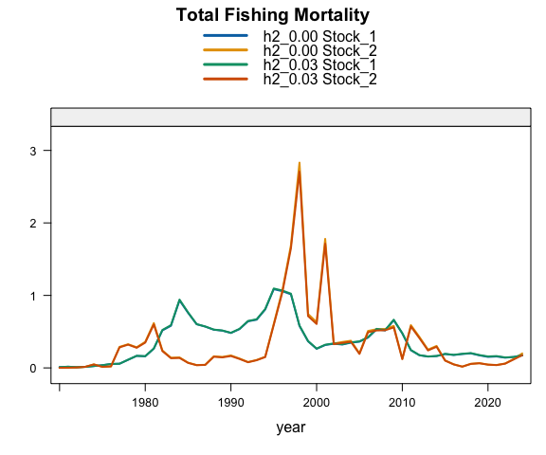
Plot comparing fishing mortality estimated by last year’s model (h2_0.00) with data updated to 2025.

Correcting Growth Parameters

Single-stock hypothesis
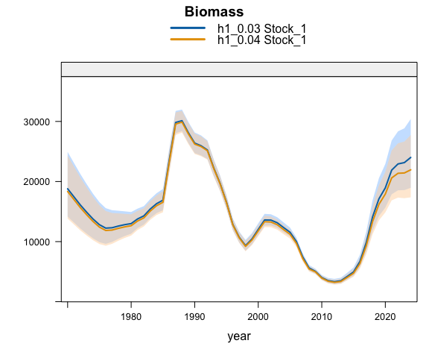
Plot comparing biomass estimated by last year’s model (h1_0.03) with data updated to 2025.
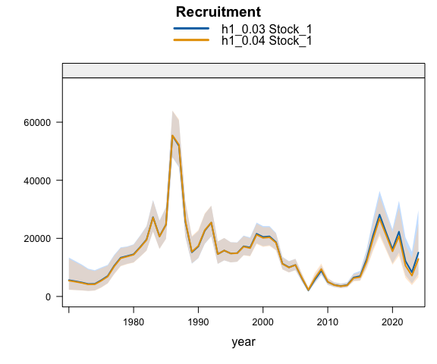
Plot comparing recruitment estimated by last year’s model (h1_0.03) with data updated to 2025.
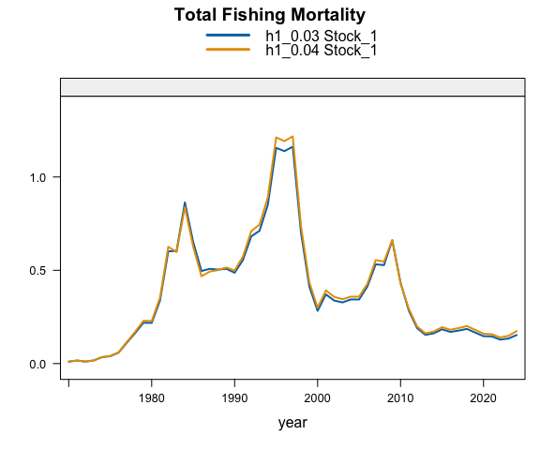
Plot comparing fishing mortality estimated by last year’s model (h1_0.03) with data updated to 2025.

Two-stock hypothesis
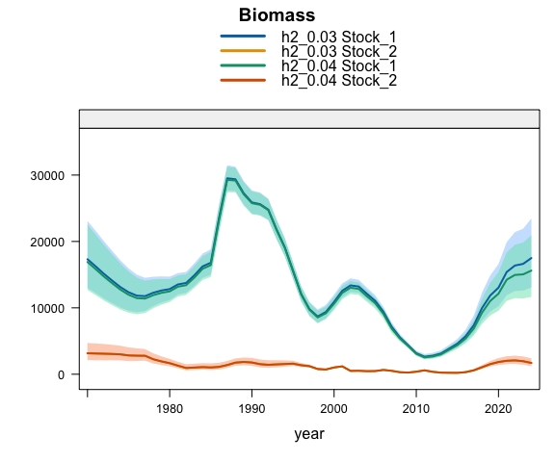
Plot comparing biomass estimated by last year’s model (h2_0.03) with data updated to 2025.
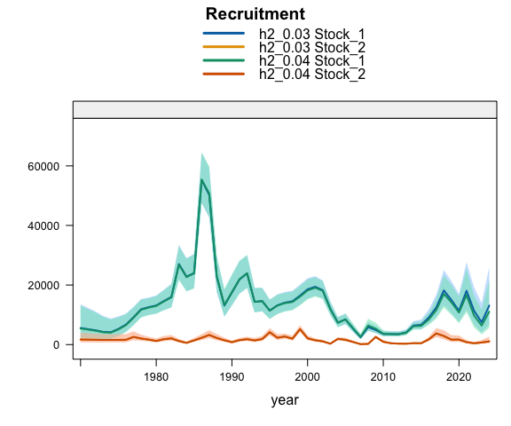
Plot comparing recruitment estimated by last year’s model (h2_0.03) with data updated to 2025.
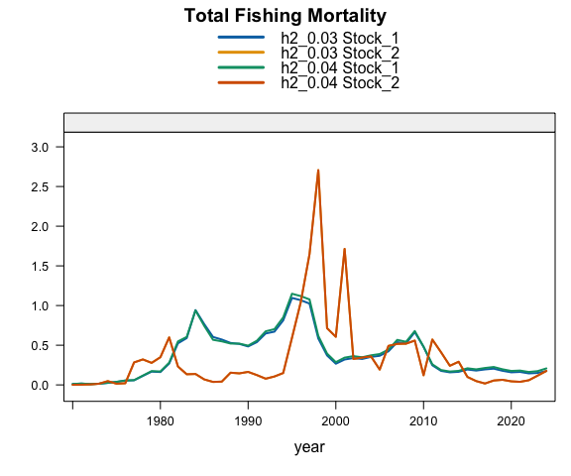
Plot comparing fishing mortality estimated by last year’s model (h2_0.03) with data updated to 2025.

Updated Age Data

Single-stock hypothesis
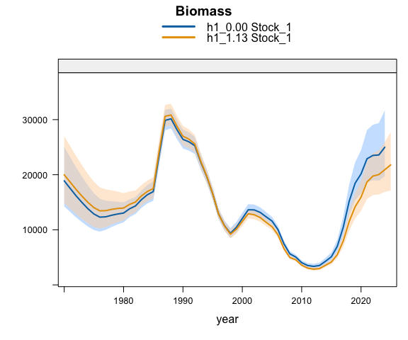
Plot comparing biomass estimated by last year’s model (h1_0.00) with data updated to 2025.
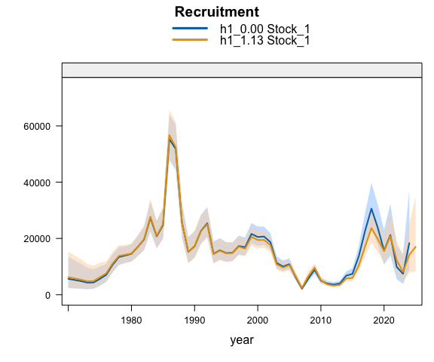
Plot comparing recruitment estimated by last year’s model (h1_0.00) with data updated to 2025.
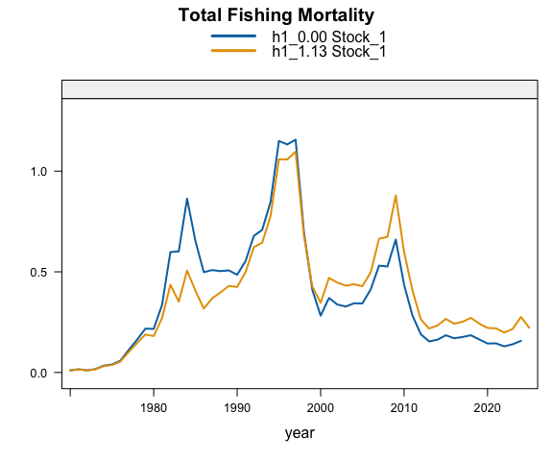
Plot comparing fishing mortality estimated by last year’s model (h1_0.00) with data updated to 2025.

