Developments of the base SC13 model for benchmark and MSE considerations
Table of contents

 | SPRFMOSouth Pacific Regional Fisheries Management OrganisationJack Mackerel Working Group
Working paper JM-WP-BM-01

Abstract
This working paper documents the base SC13 jack mackerel assessment model used for advice under the single-stock and two-stock hypotheses, corresponding to model configurations h1_1.14 and h2_1.14. The paper is intended as a bridge between the full technical annex and a future management strategy evaluation (MSE) framework. Its specific purpose is to describe the Joint Jack Mackerel Model (JJM) as implemented for SC13, identify the principal differences between the two advice models, and define a starting point for evaluating simplified alternatives.
The immediate justification for beginning this work is to avoid carrying into MSE several complicated features that were identified during the July 2025 MSE workshop. These include extensive time-varying selectivity, dynamic reference points that depend on terminal-year model conditions, and projection assumptions that differ from the assumptions used during model fitting. The SC13 base model therefore serves here as the reference assessment formulation from which reduced alternatives can be developed and tested.
This revision incorporates comments from Iago Mosqueira (IPSC/JRC) on selectivity uncertainty, index influence, recruitment regimes, reference point consistency, and northern stock harmonization. Reviewer observations appear in callout boxes throughout Section 6.

1. Introduction
The Joint Jack Mackerel Model has been the core age-structured assessment framework used by SPRFMO for jack mackerel over a series of annual updates and technical workshops. In general terms, the model belongs to the class of forward-projecting statistical catch-at-age models developed for fisheries assessment, with estimated population dynamics linked to catch, abundance indices, and composition data through a likelihood-based framework (D. Fournier & Archibald, 1982; Hilborn & Walters, 1992). The broader modelling approach also depends on standard growth and generalized linear model concepts used throughout fisheries science (Bertalanffy, 1957; McCullagh & Nelder, 1989; Nelder & Wedderburn, 1972).
The formal technical reference for the accepted SC13 assessment remains Annex 11 of the SC13 report, the Jack Mackerel Technical Annex (SPRFMO Scientific Committee, 2025).
Within the present repository, the SC13 assessment update is represented by model series 1.14. The file assessment/README.md documents the sequence of changes leading to this configuration. In summary, the 2025 assessment update began with a base update to data and model structure (1.00) and then proceeded through a sequence of modifications affecting 2025 selectivity, weighting of 2025 age compositions, downweighting of early years of the northern Chile acoustic index, and historical weight-at-age for the Far North fleet. The final advice models were fitted under both stock hypotheses: h1_1.14 for the single-stock hypothesis and h2_1.14 for the two-stock hypothesis.
The motivation for documenting these models in a separate working paper is practical. MSE is most useful when the operating model and the management procedure are both transparent, interpretable, and robust to the major uncertainties that matter for management (Butterworth & Punt, 1999; Punt et al., 2016; Siple et al., 2021). The July 2025 MSE workshop concluded that direct transfer of the full SC13 assessment structure into MSE would likely import avoidable complexity. This paper therefore treats h1_1.14 and h2_1.14 as the base assessment formulations that must first be documented clearly before any simplification is attempted.

2. Materials Used for This Paper
This paper is based on the contents of the assessment directory, with the following files providing the main technical basis for the description:
- assessment/README.md, which documents the model progression to SC13;
- doc/annex/annex_text.qmd, which contains the technical annex narrative;
- assessment/R/SC13.rmd, which records the SC13 update process and the rationale for the final model;
- assessment/R/run_projections.R, which records the projection logic applied to the base model;
- assessment/input/1.14.dat, the common data file used by both stock hypotheses;
- assessment/config/h1_1.14.ctl and assessment/config/h2_1.14.ctl, which define the stock-specific control structures;
- assessment/results/h1_1.14.rep and assessment/results/h2_1.14.rep, which summarize fitted model outputs and likelihood components.
The objective here is not to reproduce every detail already contained in the annex. Rather, the objective is to extract from those materials a concise but technically defensible description of the SC13 base model for later MSE use.

3. General Structure of the JJM Used for SC13

3.1 Overview
The annex describes the JJM as an explicitly age-structured forward projection model estimated by maximum likelihood. That places it firmly within the standard family of integrated fisheries assessment models derived from statistical catch-at-age theory (D. Fournier & Archibald, 1982; Schnute & Richards, 1995). In practical implementation, the JJM is also a highly parameterized nonlinear model fitted through AD Model Builder, which is consistent with the long use of ADMB in stock assessment applications (D. A. Fournier et al., 2012).
For SC13, the model is run over years 1970-2025 and ages 1-12. The common data file assessment/input/1.14.dat specifies four fishery fleets, seven abundance indices, age-composition observations for multiple fisheries and surveys, length compositions for the Far North fleet, annual catches by fleet, and weight-at-age schedules used in both fishery and survey components. The control files then assign those data to either one or two modeled stocks depending on the hypothesis being fitted.

3.2 Data Structure
The SC13 base data set contains four fleets:
- N_Chile;
- SC_Chile_PS;
- FarNorth;
- Offshore_Trawl.
The composition data structure differs by fleet. Age compositions are used for N_Chile, SC_Chile_PS, and Offshore_Trawl, while the FarNorth fleet is fitted to length compositions through the modelled growth relationship. The file assessment/input/1.14.dat indicates that age-composition observations extend from 1980-2025 for the Chilean fleets and 2015-2025 for the offshore fleet, while length-composition observations are available for the Far North fleet from 1980-2025.
The same data file also includes seven abundance indices:
- Chile_AcousCS;
- Chile_AcousN;
- Chile_CPUE;
- DEPM;
- Peru_Acoustic;
- Peru_CPUE;
- Offshore_CPUE.
This is therefore not a sparse index-only assessment. It is a fully integrated model in which trends in biomass and recruitment are informed simultaneously by catch, multiple abundance indices, and composition data, with the latter carrying substantial influence over selectivity and year-class interpretation. The use of composition data at this level also means that weighting, effective sample size, and selectivity specification become major determinants of fit and inference (Francis, 2011).

3.3 Population Dynamics and Observation Model
The annex and control files together indicate a standard age-structured population dynamic framework with stock recruitment, natural mortality, growth, maturity, fleet selectivity, survey selectivity, and catchability. The growth component follows the usual fisheries implementation of the von Bertalanffy growth relationship (Bertalanffy, 1957; Beverton & Holt, 1957). The Far North fleet is modelled through predicted length compositions derived from the age-structured population and the specified growth schedule.
Selectivity is an especially important feature of the SC13 implementation. The annex describes selectivity as non-parametric, fishery-specific, and time-varying. The control files confirm this, showing fleet-specific selectivity structures, annual or block changes by fleet, and selectivity penalties applied to both fisheries and surveys. Time-varying selectivity is a familiar response to changes in fishery behavior and sampling structure, but it is also known to complicate interpretation in catch-at-age assessments (Linton & Bence, 2011).
Catchability is index-specific and includes shared settings across the two hypotheses. The annex further notes that standardized CPUE series include explicit assumptions about efficiency creep, consistent with broader literature on fleet evolution and changing fishing power (Rousseau et al., 2019).
A compact mathematical summary of the core model structure is provided in the appendix so that the main text can stay focused on the SC13 implementation choices rather than on notation.

3.4 Reference Points and Projections
The SC13 annex states that MSY, FMSY, and BMSY are calculated internally within the JJM using equilibrium calculations based on terminal-year catch shares, selectivity-at-age, and weights-at-age. Accordingly, these reference points are dynamic rather than fixed. The annex also notes that recent advice has used a ten-year average of model-estimated BMSY as the reference biomass quantity for comparison.
The projection scripts in assessment/R/run_projections.R add a second layer of structure. Future projections are conducted using fixed terminal selectivity and, for the .ls alternatives, a shorter and more conservative recruitment history. This means the advice process combines a fitted assessment model with a somewhat different projection model. That approach is defensible in annual advice, but it is exactly the kind of multi-stage complexity that MSE seeks to simplify and evaluate explicitly (Punt et al., 2016; Siple et al., 2021).

4. The SC13 Base Advice Models

4.1 Single-Stock Hypothesis: h1_1.14
The control file assessment/config/h1_1.14.ctl defines the single-stock advice model. It specifies one stock, one recruitment regime, one maturity schedule, one population weight-at-age schedule, and a single natural mortality value of 0.28. The stock recruitment component uses steepness 0.65 and recruitment variability 0.6, with recruitment years 2000-2022 entering the stock recruitment specification.
From a structural point of view, h1_1.14 is the simpler of the two advice models. All fishery and survey information is interpreted as informing a common population. However, the model still retains considerable complexity because selectivity is allowed to vary over time and because the Far North fleet is represented with annual selectivity changes extending back to 1981. In effect, the single-stock hypothesis avoids stock splitting but compensates with a flexible fleet-history interpretation.
The fitted report file indicates that the model is strongly informed by composition and selectivity components. The total objective function reported in assessment/results/h1_1.14.rep is 1323.82, with large contributions from fishery age likelihood, fishery length likelihood, fishery selectivity penalties, index likelihood, and survey age likelihood. This confirms that h1_1.14 should not be viewed as a simplified baseline in itself. It is already a sophisticated assessment model.

4.2 Two-Stock Hypothesis: h2_1.14
The control file assessment/config/h2_1.14.ctl defines the two-stock advice model. It specifies two stocks, a more complex recruitment assignment, stock-specific biology for the second stock, and different treatment of the Far North observations. In the terminology used in the annex, the two stocks correspond to a southern stock and a far north stock.
The most consequential structural difference lies in recruitment and biological assignment. The two-stock control file specifies nregbyStock = 1 2, RecMatrix = 1 2 3, and RegShift = 1999. In practical terms, this means that the northern component is not represented simply as a second stock with otherwise identical rules. It is represented with a different recruitment structure that includes a regime shift. The recruitment year blocks in the file are 2000-2022, 1970-1996, and 2001-2016 for the three recruitment assignments. The model also assigns a higher natural mortality value to the second stock (0.33), along with a separate maturity schedule and separate population weight-at-age schedule.
The treatment of the Far North fleet also changes substantially under h2_1.14. Whereas h1_1.14 allows a long annual history of selectivity variation for the Far North fleet, h2_1.14 uses a much simpler regime treatment centered on 2002. This is an important point for later MSE development because the difference between h1 and h2 is not purely a question of stock structure. It is partly a difference in how northern observations are interpreted and regularized.
The fitted report file for h2_1.14 indicates a total objective function of 1194.09. As with the single-stock model, substantial contributions arise from fishery age, fishery length, selectivity penalties, and abundance indices. The lower total objective function relative to h1_1.14 does not by itself establish superiority, but it does confirm that the two-stock hypothesis is a comparably rich fitted model rather than a stripped-down alternative.

4.3 Summary Comparison
Table 1 summarizes the main structural differences between the two SC13 advice models.
Feature | h1_1.14 | h2_1.14
Stock hypothesis | Single shared stock | Southern stock plus far north stock
Number of modeled stocks | 1 | 2
Data file | assessment/input/1.14.dat | assessment/input/1.14.dat
Natural mortality | 0.28 | 0.28 and 0.33
Maturity schedule | One schedule | Stock-specific schedules
Population weight-at-age | One schedule | Stock-specific schedules
Recruitment structure | One curve, 2000-2022 | Three assignments with a 1999 regime shift
Far North selectivity | Annual variation from 1981 | Simplified regime treatment centered on 2002
Projection horizon | 20 years | 20 years
The commonality between the two models is therefore greater than their difference in terms of data inputs and overall assessment machinery. The key differences lie in stock allocation, biology, recruitment structure, and the degree of complexity assigned to the northern part of the system.

5. Why the SC13 Base Model Is Difficult to Transfer Directly into MSE
The July 2025 MSE workshop concluded that the base assessment should first be documented and then simplified before being used as an MSE operating model. The repository materials support that conclusion.
The SC13 base model uses extensive time-varying selectivity. This was increased further in the 2025 assessment to improve fits for the south-central Chile and offshore fleets. Time-varying selectivity may be necessary in annual assessments, but it can make MSE results difficult to interpret because changes in management performance may reflect selectivity specification as much as underlying stock dynamics (Linton & Bence, 2011).
In the base model the reference points are dynamic. BMSY and FMSY typically depend on terminal-year conditions, especially relative catch shares, selectivity-at-age, and weights-at-age. This makes stock status and advice partly conditional on the most recent fitted model state rather than solely on a stable management benchmark. The appropriateness of this as an assessment choice was raised over several meetings and discussions as it complicates the OM design because the benchmark itself changes with the assessment outcome.
Similarly, the projection assumptions differ from the fitting assumptions. The projection scripts show that future calculations rely on fixed selectivity and, in some scenarios, a shortened low-productivity recruitment history. This means that advice is generated from a model in which the fitting phase and the projection phase are intentionally not identical. In MSE, that layering needs to be explicit and deliberate rather than inherited as an assessment convention (Punt et al., 2016; Siple et al., 2021).
Additionally stock-structure uncertainty is mixed in with other differences. The contrast between h1_1.14 and h2_1.14 is more than one stock versus two stocks as an issue. The northern selectivity structure, different mortality, different maturity, different population weight-at-age, and different recruitment regime treatment affect things between the model configurations. For MSE, it will be helpful to separate uncertainty about stock structure from uncertainty about how model complexity has been allocated within each hypothesis.

6. Proposed Simplified Alternatives
The SC13 base model should therefore be regarded as the reference assessment formulation. Simplified alternatives should be judged according to how much of the essential behavior of the base model they retain while reducing structural complexity that is not strictly necessary for MSE.
A practical first set of alternatives is as follows.

6.1 Reduced number of indices
There are three indices in the model that are no longer being conducted and generally fit poorly relative to other data. These included the Central-South acoustic survey, the egg-production index, and the Peruvian acoustic surveys. One sensitivity to omitting these data was considered.
The resulting sensitivity run is represented here by h1_2.00, which removes Chile_AcousCS, DEPM, and Peru_Acoustic from the single-stock configuration and also trims the retained Chile_AcousN series to years 2000 and later. Relative to h1_1.14, this drops 56 index-year observations in total: 13 from Chile_AcousCS, 9 from DEPM, 28 from Peru_Acoustic, and 6 pre-2000 observations from Chile_AcousN. It also reduces the fitted parameter vector by 44 parameters, from 1865 in h1_1.14 to 1821 in h1_2.00. This comparison is useful because it isolates a specific simplification of the observation model while leaving the broader single-stock population structure unchanged.
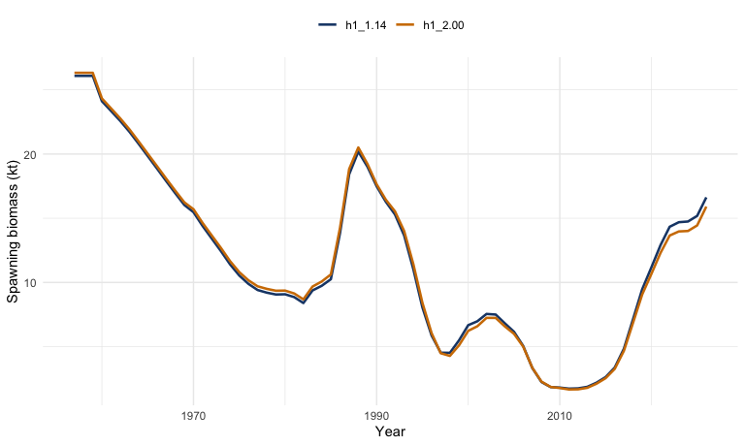
Figure 1: Comparison of spawning biomass trajectories from the base single-stock model (h1_1.14) and the reduced-index sensitivity (h1_2.00).
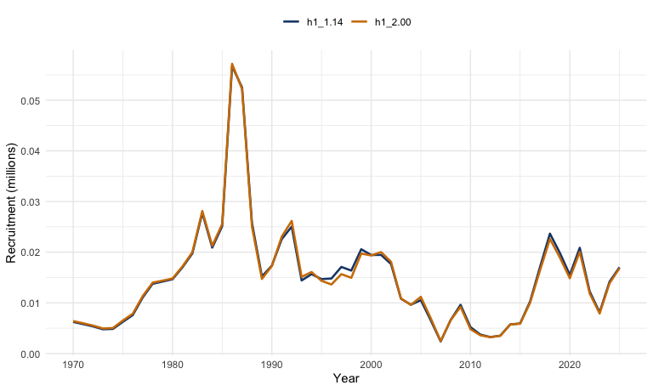
Figure 2: Comparison of recruitment trajectories from the base single-stock model (h1_1.14) and the reduced-index sensitivity (h1_2.00).
Relative to h1_1.14, the reduced-index model leaves the broad historical pattern intact but slightly lowers the terminal objective function, from about 1323.8 in h1_1.14 to about 1234.7 in h1_2.00. Terminal-year spawning biomass uncertainty remains very similar between the two fits, although it is slightly higher in the reduced-index run: the 2025 SSB CV is about 0.125 for h1_1.14 and about 0.129 for h1_2.00. As shown in Figure 1 and Figure 2, the series plots are useful as a first diagnostic of whether the omitted indices were materially changing stock perception or mainly adding noise and additional fitting burden. If the trajectories remain broadly similar, then reducing the index set may be a promising simplification for later MSE work.
 Reviewer comment (I. Mosqueira)
The existing cjm.oem function in the MSE codebase already accommodates the legacy indices and accounts for the one-year lag in reporting the offshore CPUE. This means that the computational infrastructure for alternative index configurations is already in place, which substantially reduces the implementation burden of running multiple index configurations within the MSE framework.

The influence of individual indices on stock perception warrants specific attention alongside the question of which indices to retain. The Chilean acoustic survey (Chile_AcousN) in particular can strongly influence estimates of current stock status and recent recruitment, depending on the time period and the weight given to that series. A leave-one-out analysis — treating the full index set and each successive alternative configuration as separate robustness operating models — would allow MSE to probe sensitivity to individual indices without committing to a single reduced set as the canonical operating model. The leave-one-out approach should therefore be identified as a robustness axis in the MSE operating model grid, complementing the baseline reduced-index run represented by h1_2.00.

6.2 Simplified Selectivity Alternatives
Selectivity specification is the most important source of structural uncertainty in the SC13 base model, i and its treatment in the MSE operating model deserves the most careful consideration of any of the simplification choices discussed in this paper. Two related but distinct dimensions of selectivity need to be addressed.
Within-model selectivity structure. The first dimension is the selectivity structure used during model fitting. One option is to replace long annual selectivity histories with a limited set of blocks for each fleet — for example a historical block, a modern block, and a current block. This preserves the broad evidence that fishery selectivity has changed over time while avoiding dozens of annual deviations that are difficult to interpret and project forward. Block-based selectivity is recommended as the primary simplified alternative for the MSE operating models. It provides an interpretable and tractable representation of selectivity change without the parameter proliferation of annual non-parametric estimation.

Selectivity Time-Block Reduction by Fleet
Using the age-composition tables (Annex Tables 3-5) and the selectivity heatmaps (Annex Figures 37-38), it is possible to define time blocks where the age pattern, as a proxy for selectivity-at-age, is broadly stable for each fleet. The reduction below follows the main regime shifts visible in the data and is broadly consistent with how the current model already treats selectivity in some components.

Fleet 1 — North Chile
The following suggested blocks (based on age comps in Table 3 of the Annex) for this fleet are:
- 1980-1986: Broad dome, peaking around ages 4-6.
- 1987-1999: Strong shift toward young ages, with ages 1-2 dominant.
- 2000-2015: Persistent very young selectivity, again centered on ages 1-2.
- 2016-2025: Transition toward older ages, with ages 4-8 increasing.
The main structural breaks for this fleet are around 1987 and 2016, which is also consistent with the increase in mean age shown in Annex Figure 31.

Fleet 2 — South-Central Chile
The following suggested blocks (based on age comps in Table 4 of the Annex) for this fleet are:
- 1980-1989: Peak ages are around 3-5.
- 1990-2004: Gradual right-shift, with ages 5-8 becoming more important.
- 2005-2013: Broad and relatively flat selectivity across ages 4-8.
- 2014-2025: Clear dominance of older fish, especially ages 5-9.
These blocks are consistent with the gradual aging trend noted elsewhere in the report, including the increase in mean age over the last decade.

Fleet 3 — Far North
The following suggested blocks (based on the length-composition pattern in Table 6 of the Annex, translated to implied age selectivity) for this fleet are:
- 1980-1995: Stable mid-length pattern corresponding roughly to ages 4-7.
- 1996-2004: Modest shift toward smaller fish.
- 2005-2013: Higher variability with mixed modes.
- 2014-2025: Shift toward larger and therefore older fish.
This is notable because the current h2 treatment already uses a simplified two-regime split around 2002, but the data suggest somewhat finer structure could be supported.

Fleet 4 — Offshore trawl
The following suggested blocks (based on age comps in Table 5 of the Annex) for this fleet are:
- 2015-2017: Mixed ages, including some older fish.
- 2018-2020: Shift toward younger fish, especially ages 2-4.
- 2021-2025: Strong young-fish dominance, including a pronounced age-2 spike.
These changes are consistent with the recent selectivity changes noted in the SC13 sensitivity runs.

Cross-Fleet Simplification
If a more parsimonious common structure is preferred, a shared set of broad periods could be:
- Pre-1990
- 1990-2004
- 2005-2015
- 2016-present
This common structure could then be supplemented with:
- fleet-specific deviations, for example through random effects or a low-rank representation; and
- extra flexibility for Fleet 4 after 2018, where the short series suggests sharper recent changes.

Key Insight
Across fleets, the main broad pattern is a recent shift toward older fish after about 2015, with the offshore fleet as the main exception because it shows more recent spikes in younger selectivity.
The clearest global breakpoints appear to be:
- 1987-1990: collapse period associated with younger fish;
- around 2000: a stabilization period; and
- 2015-2016: an aging or structural shift.
These broad breakpoints also align with changes in fishing pressure, the stock rebuilding phase, and the model note that recent selectivity favors older fish.

Illustrative fit with selectivity blocks
To illustrate the effect of imposing the proposed fleet-specific selectivity blocks, I fitted a reduced-index sensitivity with those block years hard-coded in the fishery selectivity specification. The resulting run is represented here by h1_2.01, which keeps the reduced-index data configuration of h1_2.00 but replaces the long annual selectivity histories with the fleet-specific blocks proposed above. The side-by-side selectivity panels in Figure 3 show directly how the fishery selectivity surface changes when the annual histories in h1_2.00 are replaced by the simplified block structure in h1_2.01.
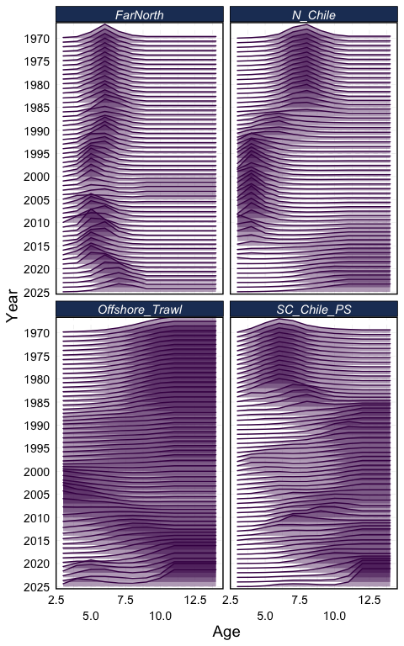  (a) Model h1_2.00 | 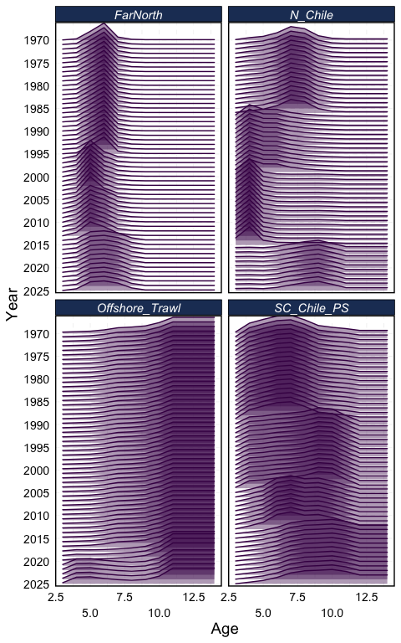  (b) Model h1_2.01
Figure 3: Estimates of selectivity by fishery over time for Models h1_2.00 and h1_2.01, shown in the same style as Figure 37 of the SC13 Jack Mackerel Technical Annex (SPRFMO Scientific Committee, 2025).
Relative to h1_2.00, the block-selectivity run fits the retained data less well and produces a higher recent stock trajectory. The terminal objective function increases from about 1234.7 in h1_2.00 to about 1544.1 in h1_2.01, while the estimated 2025 spawning biomass increases from about 15.9 kt to about 19.9 kt. Terminal recruitment also rises, from about 16.8 million in h1_2.00 to about 21.4 million in h1_2.01. As shown in Figure 4 and Figure 5, simplifying selectivity in this way is therefore not just a bookkeeping reduction in model complexity; it materially changes stock perception and should be treated as a substantive structural alternative in the MSE operating-model set.
Projection-period selectivity uncertainty. The second dimension is the selectivity pattern applied during the projection period of the MSE simulation. In the current assessment, projections use fixed terminal selectivity. In MSE, the future selectivity pattern represents a real source of uncertainty, because the fishing gear and targeting behaviour that produced recent selectivities may not persist over a multi-decade evaluation horizon.
 Reviewer comment (I. Mosqueira)
Rather than projecting with a single terminal selectivity, the projection period can be populated with a range of average-selectivity vectors — for example averages computed over the last 1, 5, 10, 15, or 20 years of the modelled period. These alternatives span from recent directed behaviour (short averages, capturing more targeted fishing patterns) to longer integration of historical fishery change (long averages). This range directly addresses the concern raised at the July 2025 workshop that projection assumptions differ from fitting assumptions. Preliminary runs with such averaging periods have already been explored and provide a practical basis for this robustness dimension.
The block-based formulation should be regarded as the primary simplified alternative. The 1-, 5-, 10-, 15-, and 20-year rolling-average selectivity vectors should then be used as robustness tests to verify that conclusions about management procedure performance are not overly sensitive to the assumption about future selectivity patterns.

This hierarchy — block structure as primary, averaging-period variation as robustness — is consistent with the staged MSE roadmap described by Carruthers (2024) and with the more specific jack mackerel staging discussed in SPRFMO Jack Mackerel Working Group (2025), which separates operating-model specification work from robustness testing and management-procedure refinement. It is also consistent with CCSBT practice in the Bali Procedure review cycle.
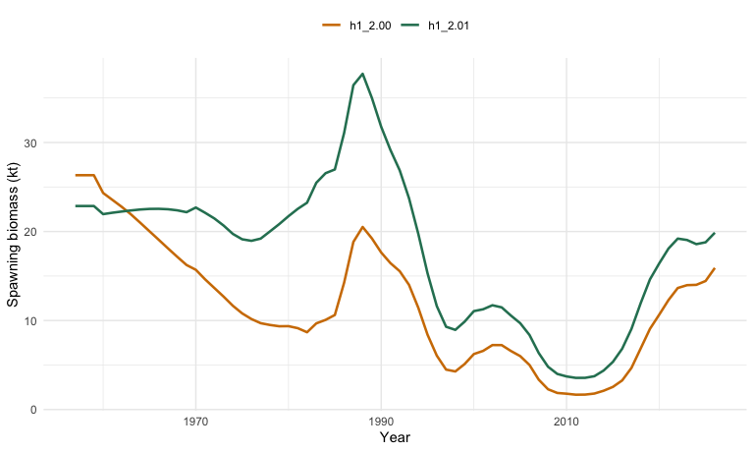
Figure 4: Comparison of spawning biomass trajectories from the reduced-index sensitivity (h1_2.00) and the reduced-index model with fleet-specific selectivity blocks (h1_2.01).
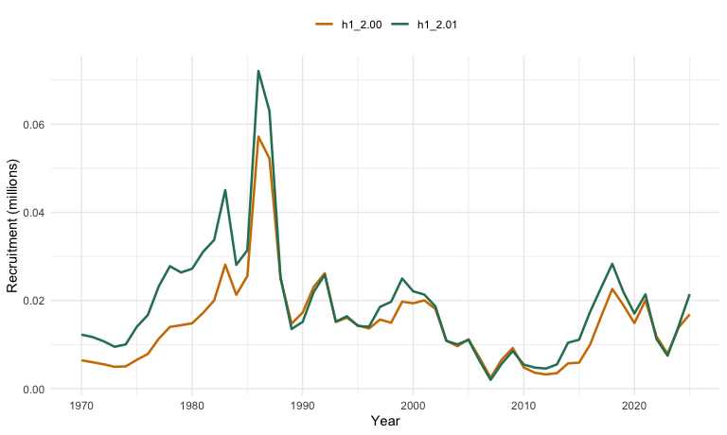
Figure 5: Comparison of recruitment trajectories from the reduced-index sensitivity (h1_2.00) and the reduced-index model with fleet-specific selectivity blocks (h1_2.01).

6.3 Simplified Recruitment Alternatives
A second option is to reduce recruitment complexity by using one recruitment relationship per stock hypothesis, or one per stock under the two-stock model, without additional regime splitting unless that feature is shown to be essential for management performance. The preferred approach is therefore to fit a single Beverton-Holt relationship per stock in the simplified operating model, and then treat regime differences as a robustness test rather than a primary structural alternative.
 Reviewer comment (I. Mosqueira)
Under h2_1.14, the northern component already includes a regime shift at 1999, and this structural feature should be preserved in that operating model to reflect the interpretation embedded in the current assessment. For the single-stock hypothesis, no formal regime splitting is assumed. Evaluating MSE performance with and without regime structure — by comparing h1 and h2 operating models and by running a version of h1 with a productivity regime break — would clarify how sensitive management procedures are to assumptions about long-run productivity.
An important diagnostic concern is that some recent recruitments already exceed the upper envelope of the fitted stock-recruitment curve. This suggests that the fitted Beverton-Holt relationship may be conservative relative to actual recruitment productivity in recent years. Future work should consider whether alternative recruitment distributions, higher ceiling values for recruitment deviations, or a revisited steepness estimate are warranted. Projecting with a recruitment distribution that truncates the upper tail of realized recruitments would be systematically pessimistic about stock productivity, which would in turn bias MSE performance comparisons toward overly cautious management conclusions.

6.4 Fixed-Reference-Point Alternatives
A third option is to evaluate MSE performance relative to fixed biomass and harvest-rate benchmarks rather than dynamic reference points estimated from terminal-year conditions. This would make the interpretation of management performance much clearer while still allowing later comparison back to the SC13 assessment convention.
The dynamic reference point system in the JJM — where BMSY and FMSY shift with terminal-year selectivity and weight-at-age — is appropriate in the annual assessment context but problematic for MSE. If reference points change every year as a function of the operating model state, it becomes difficult to distinguish genuine changes in stock productivity from artefacts of the simulation design.
 Reviewer comment (I. Mosqueira)
If the simplified selectivity alternative adopts block-based selectivity, then reference points should be calculated using the selectivity pattern from the final block period for all future projections. This is internally consistent: the operating model should use the same selectivity for calculating FMSY and BMSY as it uses for projecting future mortality. Using the last block’s selectivity as the reference configuration avoids the problem of reference points shifting mid-simulation as selectivity changes, and it is analogous to the fixed-reference-point convention already applied in several RFMO MSE programmes.

The recommended approach is therefore to calculate reference points once, using the terminal selectivity block and the current biological schedules, and use those fixed values as management benchmarks throughout the MSE simulation. Sensitivity to the choice of reference period can be examined as part of robustness testing.

6.5 Harmonized Northern Treatment
A fourth option is to harmonize how the Far North observations are treated across the single-stock and two-stock hypotheses. The objective would be to ensure that future comparisons of one-stock and two-stock MSE operating models are driven primarily by stock structure rather than by unrelated differences in selectivity regularization.
As documented in Section 4, the current difference between h1 and h2 is not purely about stock allocation. It also reflects a very different degree of flexibility in Far North fleet selectivity: h1_1.14 allows annual variation from 1981, while h2_1.14 uses a much simpler two-regime structure centred on 2002. This confound makes it difficult to attribute differences in MSE outcomes between h1 and h2 to stock structure as opposed to selectivity specification.
 Reviewer comment (I. Mosqueira)
The harmonization objective should be to align the selectivity structure of the Far North fleet across h1 and h2, while retaining the biological differences that distinguish the two-stock hypothesis. In practice, this means that differences in natural mortality, growth, maturity, and weight-at-age should be preserved in h2 as currently specified. What should be harmonized is the structural form and degree of flexibility allowed in Far North fleet selectivity, so that a comparison of h1 and h2 MSE outcomes reflects stock structure rather than selectivity regularization.
One additional area that has been discussed but not yet implemented is explicit uncertainty in northern stock biology, particularly growth. The two-stock hypothesis implies different population dynamics for the northern component, but the current implementation draws on growth parameters estimated from combined data without formal uncertainty in the stock-specific parameters. Uncertainty in northern growth or natural mortality could be incorporated as candidate robustness scenarios in later MSE phases if data become available to support alternative parameterizations.

Implementing the selectivity harmonization will likely require re-fitting h1_1.14 with a simplified Far North selectivity structure that mirrors the h2 treatment, or equivalently re-fitting h2_1.14 with a more flexible Far North selectivity structure analogous to the h1 treatment. The working group should discuss which direction of harmonization is most defensible given the available data and model diagnostics.

7. Conclusions
The materials in this assessment directory show that h1_1.14 and h2_1.14 are not merely two alternative labels for the same model. They are two distinct but closely related assessment formulations built on a common JJM framework, a common SC13 data set, and a common logic for annual advice. Both models are technically rich and both are appropriate starting points for MSE precisely because they represent the current assessment basis used for advice.
At the same time, both models contain features that make them difficult to carry directly into MSE. The most important of these are time-varying selectivity, dynamic reference points, differing fitting and projection assumptions, and confounding between stock-structure uncertainty and other structural differences. The main conclusion of this working paper is therefore that the SC13 base model should be retained as the benchmark for comparison, but not assumed to be the final operating model for MSE.
Following the reviewer comments incorporated in this revision, a clearer set of priorities has emerged for the simplified operating models:
- Selectivity block structure should be the primary simplification, reducing annual deviations to a tractable number of regime periods per fleet.
- Projection-period selectivity uncertainty should be represented by a range of averaging-period options (1, 5, 10, 15, 20 years), evaluated as robustness operating models.
- Index influence — particularly from the Chilean acoustic survey — should be examined through a leave-one-out robustness axis, noting that cjm.oem already supports this infrastructure.
- Recruitment regime differences should be preserved in h2 and examined as a robustness dimension in h1, with explicit attention to recent above-curve recruitments.
- Reference points should be fixed using the terminal selectivity block, calculated once before MSE simulation begins, to ensure internal consistency.
- Far North selectivity should be harmonized across h1 and h2 before operating model comparisons, while retaining the biological differences (M, maturity, weight-at-age) that motivate the two-stock hypothesis.
- Northern stock biology uncertainty (growth, M) should be noted as a candidate robustness scenario for later phases of the MSE programme.
The next step is to construct and compare simplified alternatives that remain faithful to the broad SC13 assessment picture while avoiding the complicated issues identified during the July 2025 MSE workshop. The reviewer comments documented here provide a prioritized roadmap for that work.

Appendix: Compact Equation Summary
This appendix gives a compact schematic description of the equations underlying the SC13 Joint Jack Mackerel Model. It is intended to summarize the structure used in this working paper rather than to reproduce every implementation detail of the ADMB code or every option described in the technical annex and user guide.

7.1 Notation
Let $s$ index stock, $f$ fishery fleet, $i$ abundance index, $a$ age, $l$ length bin, and $y$ year. Let $A$ denote the plus group age. The main state variable is numbers at age, $N_{s,a,y}$, at the start of year $y$.
The biological and fishery quantities used below are:
- $M_{s,a}$: natural mortality;
- $S_{f,s,a,y}^{F}$: fishery selectivity;
- $S_{i,s,a,y}^{I}$: survey or index selectivity;
- $w_{s,a,y}^{pop}$, $w_{f,s,a,y}^{catch}$, and $w_{i,s,a,y}^{I}$: population, catch, and index weights at age;
- $m_{s,a}$: maturity at age;
- $q_{i}$: catchability for abundance index $i$.

7.2 Population Update
For each stock, total mortality at age is
Zs,a,y=Ms,a+f​Ff,s,a,y.
Recruitment enters age 1:
$$N_{s,1,y}=R_{s,y}.$$
For ages $a=1,…,A−2$, cohort survival follows
$$N_{s,a+1,y+1}=N_{s,a,y}exp\left(−Z_{s,a,y}\right).$$
The plus group is updated as
$$\begin{matrix}N_{s,A,y+1} & =N_{s,A−1,y}exp\left(−Z_{s,A−1,y}\right) \\ & +N_{s,A,y}exp\left(−Z_{s,A,y}\right).\end{matrix}$$
Spawning biomass is calculated from mature biomass at the spawning time within the year:
SSBs,y=a​Ns,a,yexp−τZs,a,y ms,a ws,a,ypop.
where $τ$ is the fraction of annual mortality occurring before spawning.

7.3 Stock-Recruitment Relationship
The annex states that the JJM uses a stochastic Beverton-Holt relationship. In compact form,
$$R_{s,y}=\frac{4h_{s}R_{0,s}SSB_{s,y−δ}}{B_{0,s}\left(1−h_{s}\right)+SSB_{s,y−δ}\left(5h_{s}−1\right)}exp\left(ε_{s,y}−\frac{σ_{R,s}^{2}}{2}\right).$$
where $h_{s}$ is steepness, $R_{0,s}$ is unfished recruitment, $B_{0,s}$ is unfished spawning biomass, $δ$ is the lag from spawning to recruitment, and $ε_{s,y}$ is the annual recruitment deviation.
Under h1_1.14, this relationship is applied to a single stock with one recruitment regime. Under h2_1.14, recruitment is assigned across two stocks with a more complex regime structure, including the 1999 shift described in the control file.

7.4 Fishing Mortality and Catch
The annex describes fishing mortality as the product of fleet-specific selectivity and an annual fishing-intensity term. A compact representation is
$$F_{f,s,a,y}=f_{f,y}S_{f,s,a,y}^{F}.$$
where $f_{f,y}$ is the year-specific fleet intensity after incorporating the effort-to-mortality scaling and annual deviations used in the fitted model.
Predicted catch in numbers at age follows the Baranov catch equation:
$$C_{f,s,a,y}^{N}=N_{s,a,y} \frac{F_{f,s,a,y}}{Z_{s,a,y}} \left(1−exp\left(−Z_{s,a,y}\right)\right).$$
Predicted catch in biomass for fleet $f$ is then
Cf,yB=s​a​Cf,s,a,yN wf,s,a,ycatch.

7.5 Abundance Indices
For abundance index $i$, the predicted index is a catchability-scaled vulnerable biomass or abundance quantity:
Ii,ypred=qis​a​Ns,a,yexp−λiZs,a,y ×Si,s,a,yI wi,s,a,yI.
where $λ_{i}$ places the survey or CPUE observation within the year. This expression is schematic because some indices are closer to numbers-at-age and others to biomass, but it captures the model logic used across the SC13 index components.

7.6 Age and Length Compositions
Predicted fishery or survey age composition is obtained by normalizing predicted numbers-at-age in the relevant observation:
pg,a,yage=ng,a,ypreda​ng,a,ypred.
where $g$ denotes the fleet or survey being sampled.
For the Far North fleet, predicted age compositions are converted to predicted length compositions through the growth model:
pf,l,ylen=a​pf,a,yage gf,l∣a.
where $g_{f,l∣a}$ is the probability of a fish of age $a$ being observed in length bin $l$, derived from the von Bertalanffy growth specification used by the model.

7.7 Observation Likelihoods
The annex indicates log-normal likelihoods for catches and abundance indices, and multinomial likelihoods for age and length compositions.
For catches and indices, the negative log-likelihood contribution is written schematically as
ℓLN=y​logOy−logPy22σy2.
where $O_{y}$ and $P_{y}$ are observed and predicted values.
For age or length compositions, with effective sample size $n_{g,y}$,
ℓmult=−y​ng,yk​og,k,ylogpg,k,y.
where $k$ indexes age or length bins, $o_{g,k,y}$ is the observed proportion, and $p_{g,k,y}$ is the predicted proportion.
The SC13 model uses Francis weighting for age-composition effective sample sizes, so the composition likelihood is strongly affected by those externally specified weights.

7.8 Objective Function
The full estimation criterion combines data likelihoods, priors, and smoothing penalties:
$$L=ℓ_{catch}+ℓ_{index}+ℓ_{age}+ℓ_{len}+ℓ_{priors}+ℓ_{sel}.$$
The final term, $ℓ_{sel}$, is especially important in SC13 because the model includes extensive penalties on fishery and survey selectivity trajectories to regularize the time-varying non-parametric selectivity schedules.

7.9 Dynamic Reference Points
The annex states that the JJM calculates equilibrium reference points internally using terminal-year catch shares, selectivity-at-age, and weights-at-age. In compact form,
$$F_{MSY,y}=\underset{F}{arg max}C_{y}^{eq}\left(F\right).$$
$$MSY_{y}=C_{y}^{eq}\left(F_{MSY,y}\right).$$
$$B_{MSY,y}=B_{y}^{eq}\left(F_{MSY,y}\right).$$
where the equilibrium yield and biomass functions are conditional on the terminal-year fishery mix and biological schedules. This is why FMSY, MSY, and BMSY vary through time in the SC13 assessment rather than remaining fixed constants.

References
Bertalanffy, L. von. (1957). Quantitative laws in metabolism and growth. The Quarterly Review of Biology, 32(3), 217–231. https://doi.org/10.1086/401873
Beverton, R. J. H., & Holt, S. J. (1957). On the dynamics of exploited fish populations (Vol. 19, p. 533). H. M. Stationery Office.
Butterworth, D. S., & Punt, A. E. (1999). Experiences in the evaluation and implementation of management procedures. ICES Journal of Marine Science, 56(6), 985–998. https://doi.org/10.1006/jmsc.1999.0532
Carruthers, T. R. (2024). An updated roadmap for MSE development. Collective Volume of Scientific Papers ICCAT, 81(2), 1–14. https://www.iccat.int/Documents/CVSP/CV081_2024/n_2/CV08102149.pdf
Fournier, D. A., Skaug, H. J., Ancheta, J., Ianelli, J., Magnusson, A., Maunder, M. N., Nielsen, A., & Sibert, J. (2012). AD model builder: Using automatic differentiation for statistical inference of highly parameterized complex nonlinear models. Optimization Methods and Software, 27(2), 233–249. https://doi.org/10.1080/10556788.2011.597854
Fournier, D., & Archibald, C. P. (1982). A general theory for analyzing catch at age data. Canadian Journal of Fisheries and Aquatic Sciences, 39(9), 1195–1207. https://doi.org/10.1139/f82-157
Francis, R. I. C. C. (2011). Data weighting in statistical fisheries stock assessment models. Canadian Journal of Fisheries and Aquatic Sciences, 68(7), 1124–1138. https://doi.org/10.1139/f2011-025
Hilborn, R., & Walters, C. J. (1992). Quantitative fisheries stock assessment: Choice, dynamics and uncertainty. Springer. https://doi.org/10.1007/978-1-4615-3598-0
Linton, B. C., & Bence, J. R. (2011). Catch-at-age assessment in the face of time-varying selectivity. ICES Journal of Marine Science, 68(3), 611–625. https://doi.org/10.1093/icesjms/fsq173
McCullagh, P., & Nelder, J. A. (1989). Generalized linear models (2nd ed.). Chapman; Hall.
Nelder, J. A., & Wedderburn, R. W. M. (1972). Generalized linear models. Journal of the Royal Statistical Society. Series A (General), 135(3), 370–384. https://doi.org/10.2307/2344614
Punt, A. E., Butterworth, D. S., Moor, C. L. de, Oliveira, J. A. A. de, & Haddon, M. (2016). Management strategy evaluation: Best practices. Fish and Fisheries, 17(2), 303–334. https://doi.org/10.1111/faf.12104
Rousseau, Y., Watson, R. A., Blanchard, J. L., & Fulton, E. A. (2019). Evolution of global marine fishing fleets and the response of fished resources. Proceedings of the National Academy of Sciences of the United States of America, 116(25), 12238–12243. https://doi.org/10.1073/pnas.1820344116
Schnute, J. T., & Richards, L. J. (1995). The influence of error on population estimates from catch-age models. Canadian Journal of Fisheries and Aquatic Sciences, 52(10), 2063–2077. https://doi.org/10.1139/f95-800
Siple, M. C., Koehn, L. E., Johnson, K. F., Punt, A. E., Canales, T. M., Carpi, P., Moor, C. L. de, Oliveira, J. A. A. de, Gao, J., Jacobsen, N. S., Lam, M. E., Licandeo, R., Lindegren, M., Ma, S., Óskarsson, G. J., Sanchez-Maroño, S., Smoliński, S., Surma, S., Tian, Y., … Zimmermann, F. (2021). Considerations for management strategy evaluation for small pelagic fishes. Fish and Fisheries, 22(6), 1167–1186. https://doi.org/10.1111/faf.12579
SPRFMO Jack Mackerel Working Group. (2025). Report of the JMWG management strategy evaluation technical workshop (SCW15) (SC13-JM09). South Pacific Regional Fisheries Management Organisation (SPRFMO). https://www.sprfmo.int/assets/Meetings/02-SC/13th-SC-2025/Jack-Mackerel/SC13-JM09-Report-of-the-JMWG-Management-Strategy-Evaluation-Technical-Workshop.pdf
SPRFMO Scientific Committee. (2025). Annex 11: Jack mackerel technical annex. South Pacific Regional Fisheries Management Organisation (SPRFMO). https://sprfmo.int/assets/Meetings/02-SC/13th-SC-2025/SC13-Report-Annex-11_final.pdf

