Applying the SAM framework to Chilean Jack Mackerel in the SPRMFO area
Niels Hintzen, Thomas Brunel

Introduction
The Chilean Jack Mackerel (JM) stock in and outside the SPRFMO convention area is currently assessed using a statistical-catch-at-age model (see assessment details for all info). The model has been developed based on a template provided by Ianelli and further refined within the science committee to fit to the data available and stock structure assumptions within the area. Alternative assessment models were considered at a workshop in 2010 (Lima, Peru). With the development of other assessment methods, such as the state-space assessment model (SAM) developed by Nielsen and Berg (Nielsen and Berg, 2014) and prolonged development of Stock Synthesis (Methot and Wetzel, 2013), there is an opportunity to test how data is being treated in each of these assessment models, where data improvements are required and how data should be treated inside the assessment framework. In this study, we apply the SAM framework to the Chilean and Offshore fleet data and compare results and interpretations with the default JJM configuration. We discuss where differences arise and how these can be interpreted and make recommendations to the SPRFMO SC to improve the assessment.

Data
The data used in the exercise is taken from the SC05, 2017 Shanghai two-stock assessment output (mod1.0_2stk), which was used as the basis for advice in 2017 to the commission. The catch data were converted to absolute estimates of numbers-at-age for all fleets, both for the fishing fleets as for the surveys for which age data was available. For this conversion, the absolute catch, catch weight-at-age and numbers proportion-at-age had to be used. Since there is no catch nor survey information prior to 1975, the assessment period runs from 1975-2017. When introducing a catchability break in the Chilean South-Central acoustic survey in 2005, no catch data is available for ages 1-3. As such, these years are dropped from the analyses. A similar approach is taken for the older period of this survey in which no catch data for age 1 is available.

Method
We apply the SAM multi-fleet assessment framework to the JM data. For the period 1975-1979 we assume one generic single fleet to have operated as the offshore fleet was not active in that time yet. The assessment allows for free estimation of F-at-age for the three fleets for all ages (age 1 is assumed to have a zero F for the South-Chile and Offshore fleet given that no catches of these ages are present in the catch-at-age matrices). The plus-group and last true age group are assumed to have identical F. Fishing mortalities within a fishing fleet are correlated by age (assuming an estimated correlation which declines by distance in age following a power function, e.g. age 1 and 2 correlation = 0.5, which implies that age 2-3 correlation is 0.5 as well, but age 1-3 correlation equals to 0.5²). Catchability of the surveys is estimated freely (i.e. does not follow any implied functional form) but is restricted in free parameters as a statistical best fit was obtained when assuming a similar catchability at older ages in all surveys. For all surveys with age data, an auto-regressive correlation correction is applied which reduces the impact of potential year-effects on the model fit. The CPUE surveys are fitted as indicators of exploitable biomass, rather than total biomass. Data weighting is estimated within the assessment model and does not require any prior setting other than the number of data weights to be estimated (an iterative process was undertaken in which as many data weighting parameters as possible were set to be estimated freely, and reduced where statistically a better fit was found). A random-walk recruitment assumption is assumed.

Results

Surveys with age data
We evaluate the internal consistency of these surveys as this is a measure of ability to track cohorts. The survey index value at age x is contrasted with the same year-class one year later at age x+1 (on log-log scale) and a linear trend is fitted among all cohorts combined to illustrate the internal consistency. Higher values indicate better cohort tracking ability. As the DEPM survey prior to 2003 only consists of 2 years of data, this consistency plot cannot be produced.
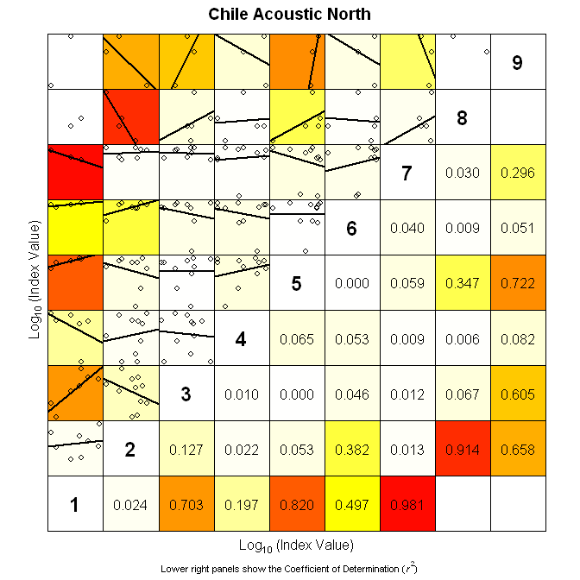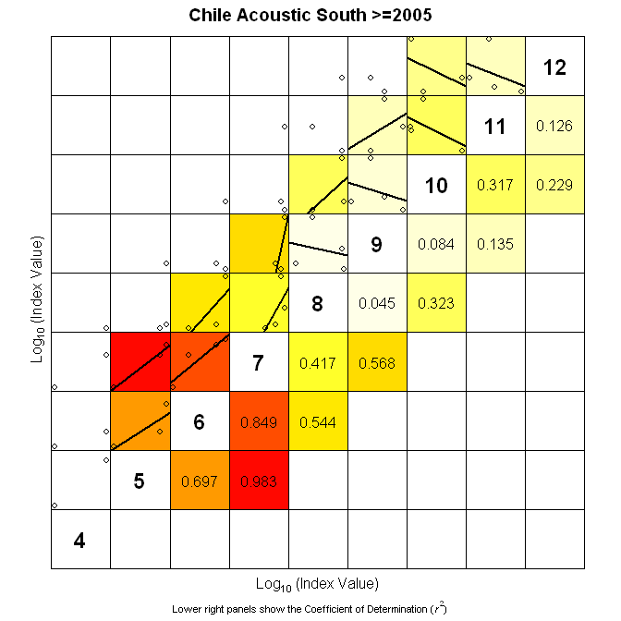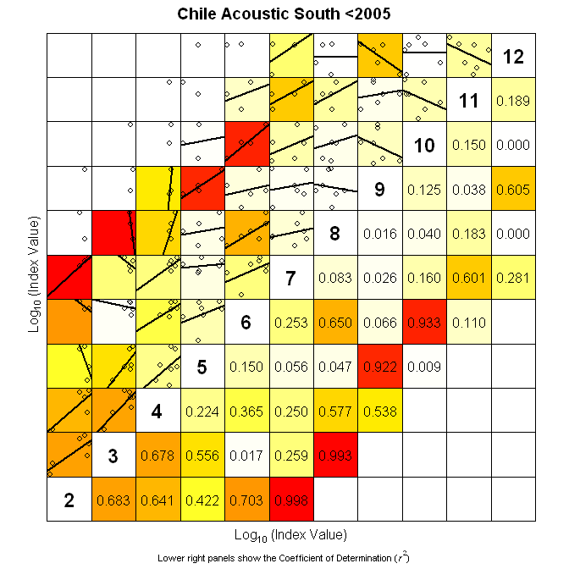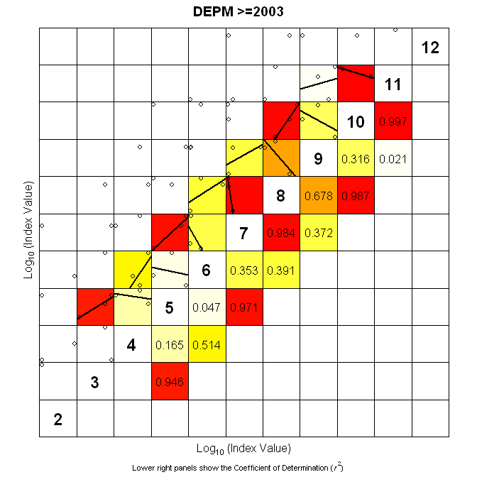
Figure 1. Internal consistency for the four surveys with age-data.
We note very poor internal consistency in all of the surveys with best cohort tracking ability at ages 2-3 in the Chilean South Central survey prior to 2005.

Assessment model fit
The data is fitted appropriately in the assessment model (full set of diagnostics in the annex) and show overall low uncertainty in SSB and F. Recruitment is more uncertain over the entire time-period. Catchability of the surveys shows a dome shape for the Northern Chile Acoustic survey and a more logistic shape for all other surveys (see Figure 3a). For those surveys where a break in catchability has been introduced, we show an overlay of the estimated catchabilities prior and after the break to indicate whether a break was justified (Figure 3b).
The assessment internally weighs each dataset in order to optimize the likelihood of the fit. More noisy datasets are hence associated with higher observation variances and are therefore to a larger extent ‘ignored’ by the assessment model. The results are given in Figure 4 and show that a substantial part of the data is associated with high observation variance / noise.
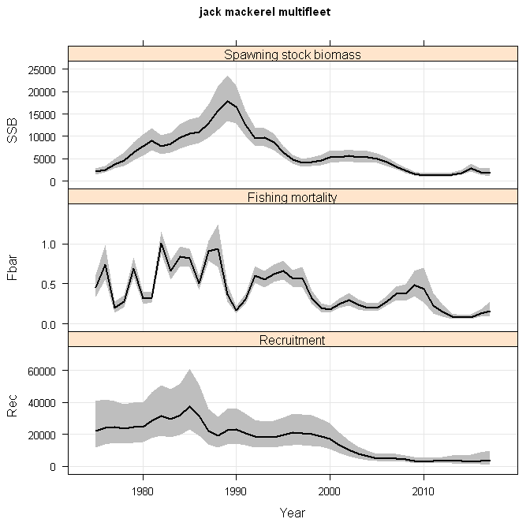
Figure 2. SAM assessment results showing SSB, F and Recruitment over time and associated uncertainty (95% CI).
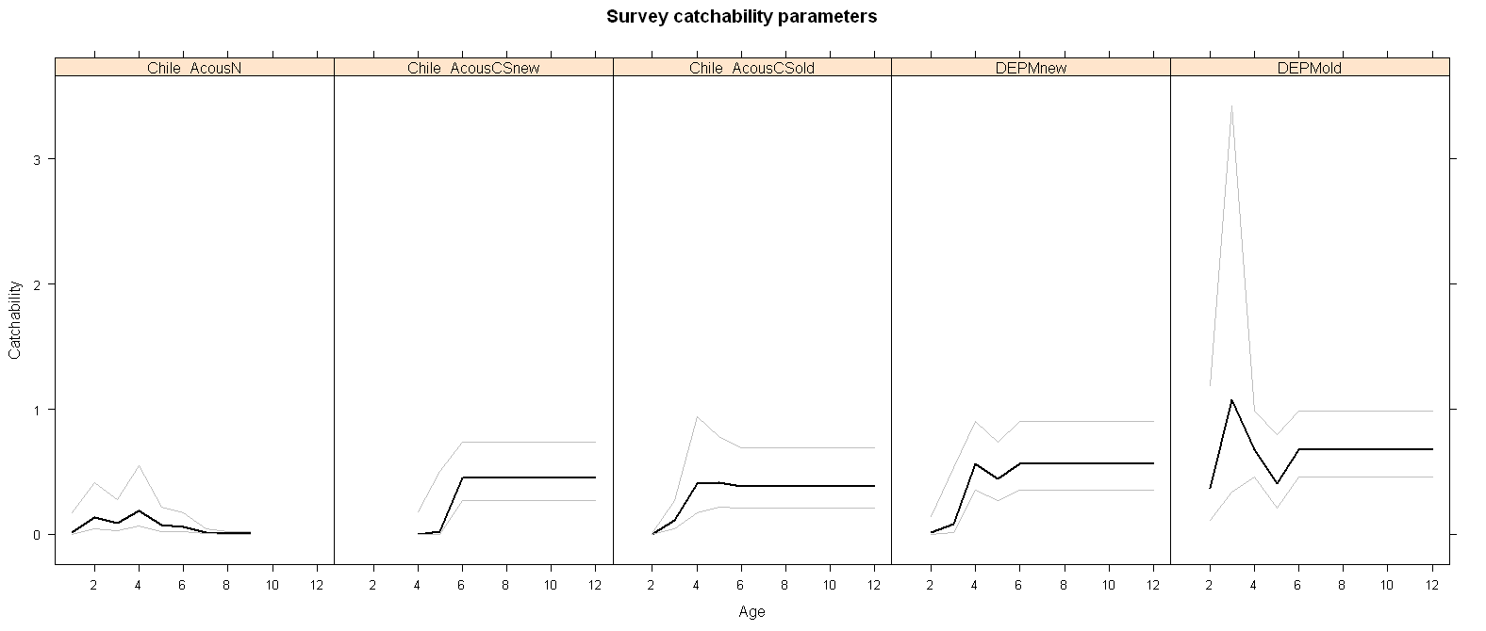
Figure 3a. Catchabilities for each of the surveys with age data.
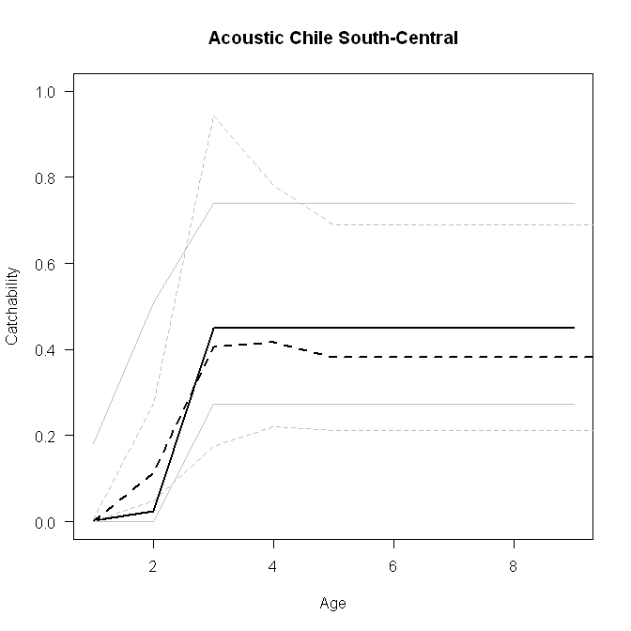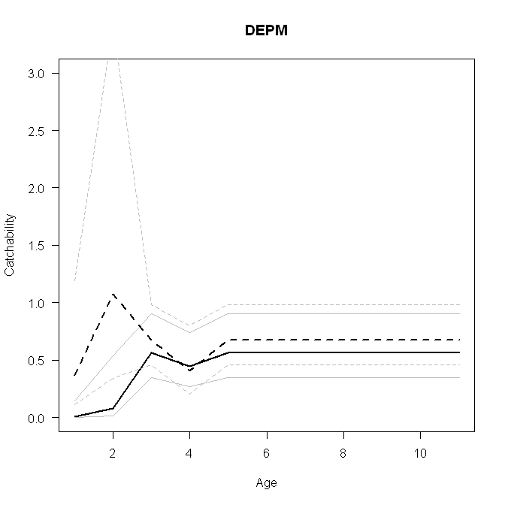
Figure 3b. Overlay of estimated survey catchabilities where break was introduced. Solid lines indicate the most recent period while the dashed lines indicate the earlier period.
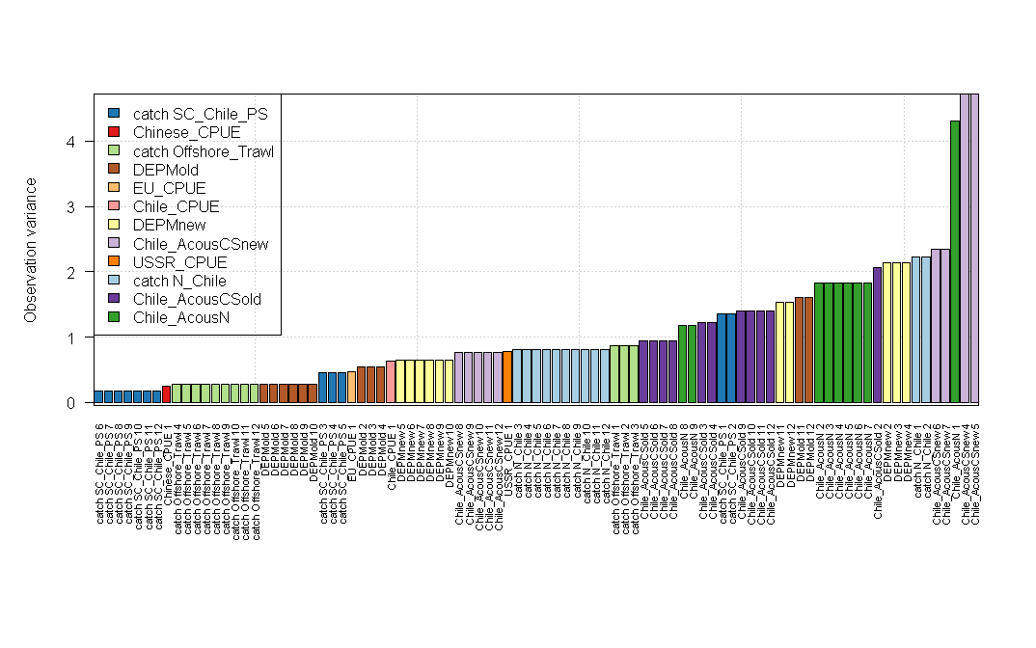
Figure 4. Observation variances per dataset.
In the ideal situation, parameters are estimated completely independently, resulting in a zero-correlation among parameters. Figure 5 shows the correlation among these and indicates some negative trade-offs between catchability parameters (logFpar), observation variances (logSdLogObs) and some positive correlations among catchabilities of surveys and their observation variances. Stronger correlation exists for the auto-regressive correlation correction (transfIRARdist) and observation variances.
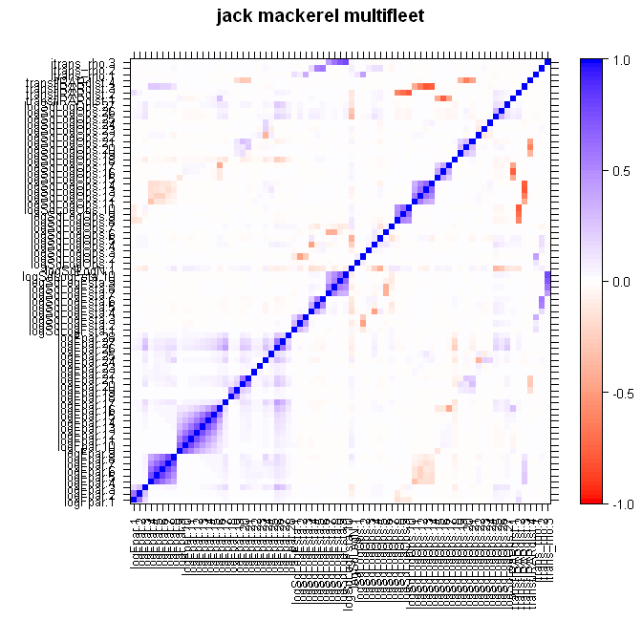
Figure 5. Correlation among parameters as estimated in the assessment
Furthermore we note a substantial change in the selection patterns of the years in especially the South-Central fishery where in the early period larger fish were targeted with in recent years a focus on younger/smaller fish. The offshore fleet in the late 2000’s focussed on smaller fish as well but has shifted in recent years to older/larger fish again.
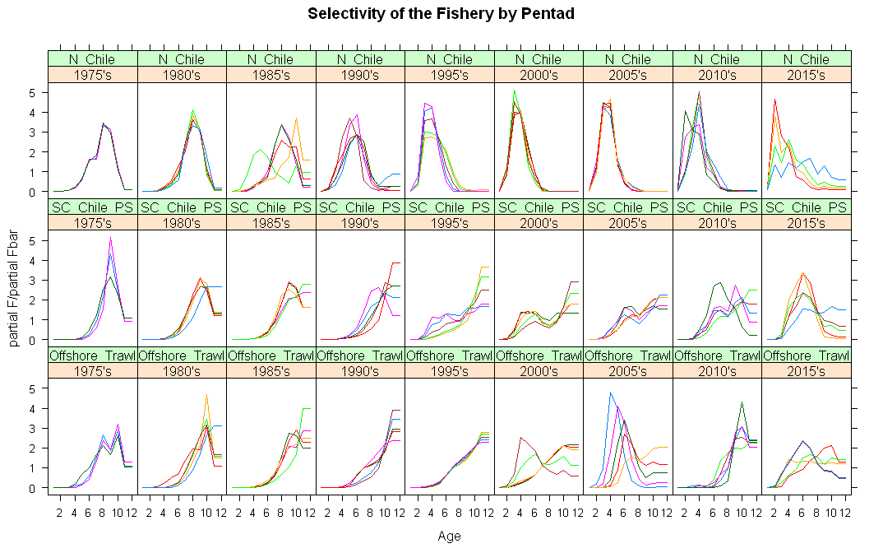
Figure 6. Estimated selection patterns of each of the three fleets over time. Each year is presented by a new line, lines are clustered in sets of 5 years.

Leave-one-out analyses
To test the relevance of each of the datasets to the assessment, we performed a leave-on-out analyses dropping one survey time-series at a time. The results are presented in Figure 7. Note that dropping the Chilean CPUE and Chilean Northern Acoustic survey did not result in a properly converged assessment, which would require further tuning. The Chilean CPUE is the longest index time-series in the model and is hence an important indicator for stock trend. The northern acoustic survey provides the only information on recruitment in recent years and is as such instrumental to estimate the youngest year-classes. Furthermore, dropping the old part of the central Acoustic survey has a marked effect, starting around 2000 but propagating though till the mid-2000s. Given the survey’s poor cohort-tracking ability in ages > 3, this is somewhat worrisome as it indicates that neither catch data provides clear information on cohort trends.
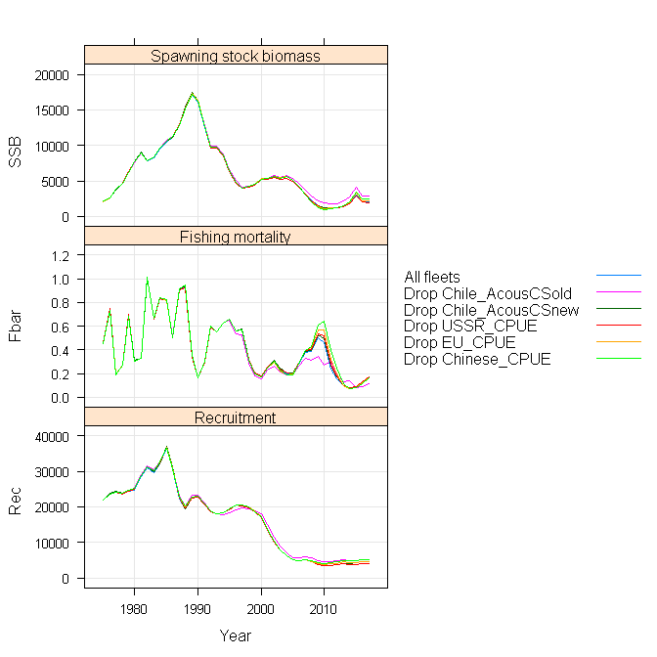
Figure 7. Leave-one-survey-out analyses, showing SSB, F and Recruitment over time.

Retrospective analyses
To test the changing perception on stock status over time, we performed a retrospective analyses dropping one years’ worth of data at a time, for a sequence of 7 years. The results are presented in Figure 8 and 9, where Figure 9 shows the stability in the parameters estimated in retrospective peels. Stable parameter estimates are desired. Most parameters are relatively stable. We have to consider though that many surveys in the assessment are limited in length and almost drop out near the end of the last peels.
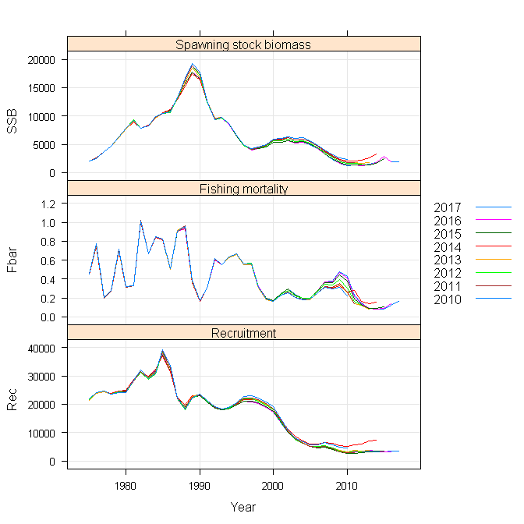
Figure 8: Retrospective peels of the SAM assessment
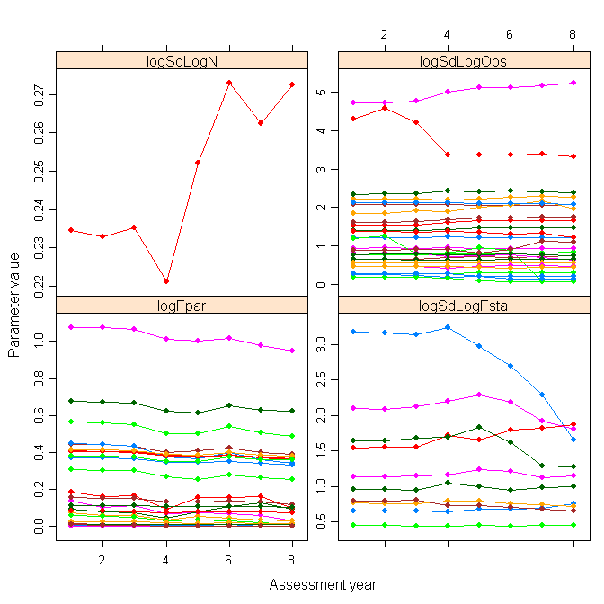
Figure 9: Stability in estimated parameters (logSdLogN = variance in deviation in survivor equation in N, logSdLogObs = observation variances, logFpar = catchabilities, logSdLogFsta = variance in random walk in F).

Assessment model fit comparison
We compare the SC 2017 model fit to the SAM fit here. We note a substantial difference in interpretation of recent recruitment and as such also a change in recent stock trends (see Figure 10). Since the 1990s, fishing mortalities are estimated markedly similar between the models but prior to that period there is a substantial difference, which is reflected in early period SSB as well (lower in the sam model). From this results, we focus on two aspects: i) difference in F in the early period, ii) difference in recruitment perception in recent years.
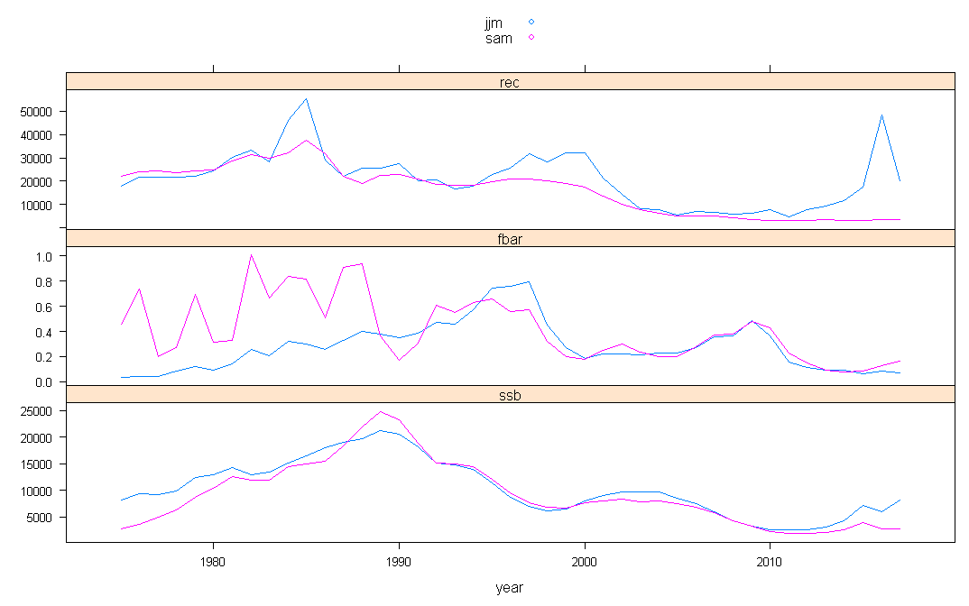
Figure 10. Time-series on recruitment, F and SSB for the JJM model (in blue) and the SAM model (in pink).

Difference in F in the early period
The first available catch data stems from the 1975 from both Chilean fleets. The off-shore fleets enters in 1979. For that reason, the period 1975-1979 was modelled as a combined fleet and results presented in Figure 11 should be interpreted with care. From 1980 onwards however, the differences can more easily be compared. From 1980, the SAM model fits the absolute catch data well. The difference in the fitted selection patterns between the two models is given in Figure 12.
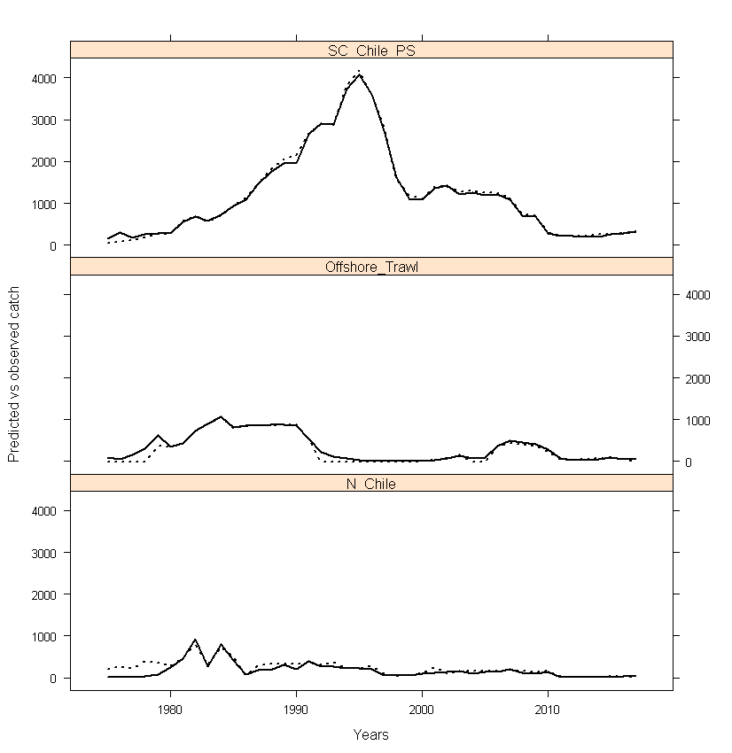
Figure 11: Estimated and predicted total catch from the SAM assessment. Solid line is predicted while dashed line is observed.

Figure 12. Estimated selection pattern of the JJM model (top) vs the SAM model (bottom).

Difference in recruitment perception in recent years
In recent years, the available information on recruitment was obtained from predominantly the Northern Chilean Acoustic information (Figure 11) with almost zero catches for all fishing fleets. The spike in estimated recruitment in the JJM model corresponds closely to this information while the SAM model ignores this dataset as it estimates an observation variance of over 4. The right-hand part of Figure 11 shows the relationship between JJM predicted and North Chile Acoustic observed data.
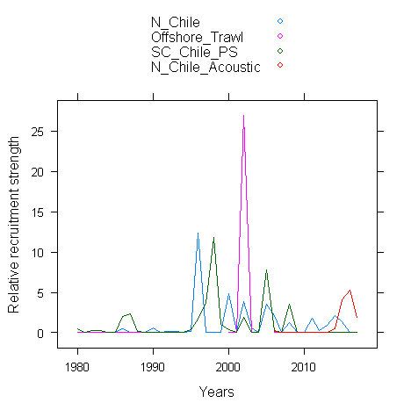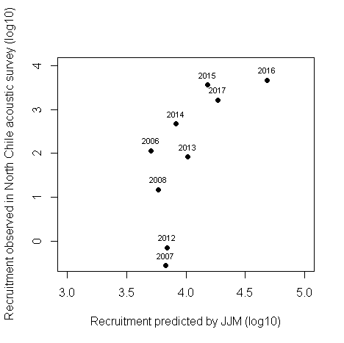
Figure 11left. Recruitment strength information in recent years compared to whole time-series per dataset. Right: Predicted recruitment vs observed recruitment in Northern Chile acoustic survey.

Recommendations
- The surveys with age-data would benefit from standardisation such as applied in (Berg and Kristensen, 2012). These surveys all have high observation variances indicating that they add little information to estimating the perception of the stock. The lack of any internal consistency is a good proxy for the contribution of these surveys. As such, the only age data available comes from the fishing fleets in which we know that sampling of especially the off-shore fleet has been limited.

- The break in the catchability for the Acoustic South-Central survey seems not to be supported by the SAM model. Improved statistical fit would be possible when removing this break. The break in the DEPM may be more appropriate for younger ages, but reduces the impact this survey has overall as the time-series is of limited length.

- The selection pattern estimated by the JJM model in the early period may require further doming at older ages, which could affect the estimation of Fmsy and Bmsy.

- The recruitment information from the Northern Acoustic survey is well fitted within the JJM model, while it is being ignored completely in the SAM model. No direct indication why these two models fit so differently could be detected and requires further investigation.

References
Berg, C. W., and Kristensen, K. 2012. Spatial age-length key modelling using continuation ratio logits. Fisheries Research, 129-130: 119-126.
Methot, R. D., and Wetzel, C. R. 2013. Stock synthesis: A biological and statistical framework for fish stock assessment and fishery management. Fisheries Research, 142: 86-99.
Nielsen, A., and Berg, C. W. 2014. Estimation of time-varying selectivity in stock assessments using state-space models. Fisheries Research, 158: 96-101.

Annex
