Applying the SPICT framework to Chilean Jack Mackerel in the SPRMFO area
Niels Hintzen, Thomas Brunel

Introduction
The Chilean Jack Mackerel (JM) stock in and outside the SPRFMO convention area is currently assessed using a statistical-catch-at-age model (see assessment details for all info). The model has been developed based on a template provided by Ianelli and further refined within the science committee to fit to the data available and stock structure assumptions within the area. The Northern area (Peruvian and Ecuadorian catches) data are not associated with age information nor with yearly information on growth for the catch as well as index data. As such, the data is suitable to be assessed with surplus production methods. A stochastic surplus production model in continuous time (SPICT) has recently been published and allows for estimation of stock biomass within a state-space framework (Pedersen and Berg 2016). Here we assess the Norther part of the CJM using the SPICT framework and compare results with the jjm configuration.

Data
The data used in the exercise is taken from the SC05, 2017 Shanghai two-stock assessment output (mod1.0_2stk), which was used as the basis for advice in 2017 to the commission. The catch data were taken from the Northern fleet only (fleet 3) and the Peruvian acoustic and Peruvian CPUE were used as biomass indicators.

Method
We apply the SPICT framework to the JM northerly data. Although data is available since 1939 we use a similar time-period as with the SAM framework for the Southern data and start in 1975. We fit 3 models, one with both the acoustic and CPUE as indices, and one dropping each of the indices one at a time. All default settings for the runs are used, using wide priors on all estimated parameters. We use initial settings to improve successful convergence. SPICT is downloadable from github following: devtools::install_github("mawp/spict/spict").

Results
Figure 1 and 2 below show the data input to the SPICT runs, identical to the stock assessment input of the two-stock model in SC05. Figure 3-5 show the graphical output of the three SPICT runs and show a biomass above Bmsy in all configurations, although in the last year in which data was available, B was estimated at Bmsy. Exploitation is in all cases well below candidate Fmsy reference points.
Comparing the results with the JJM model (Figure 6) shows a similar biomass estimate when both indices are used. In the early period however, there are larger differences which could potentially be attributed to the change in productivity which is modelled in the JJM. When either of the two indices are dropped, biomass estimates half, while both runs with one index present are consistent on total biomass estimate. A high correlation between the catchability parameters of both surveys (see Figure 7, logq) causes this effect and is not appropriate for an assessment.
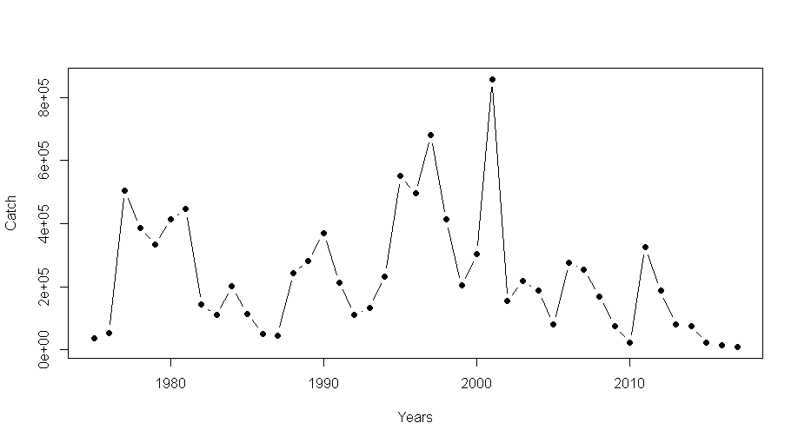
Figure 1. Catch data used as input in the SPICT model run

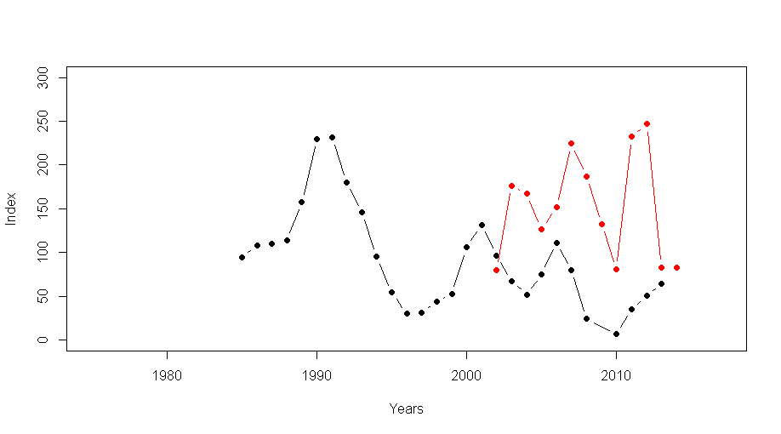
Figure 2. Index data used as input in the SPICT model run. Black represents the acoustic index and the red the CPUE index.
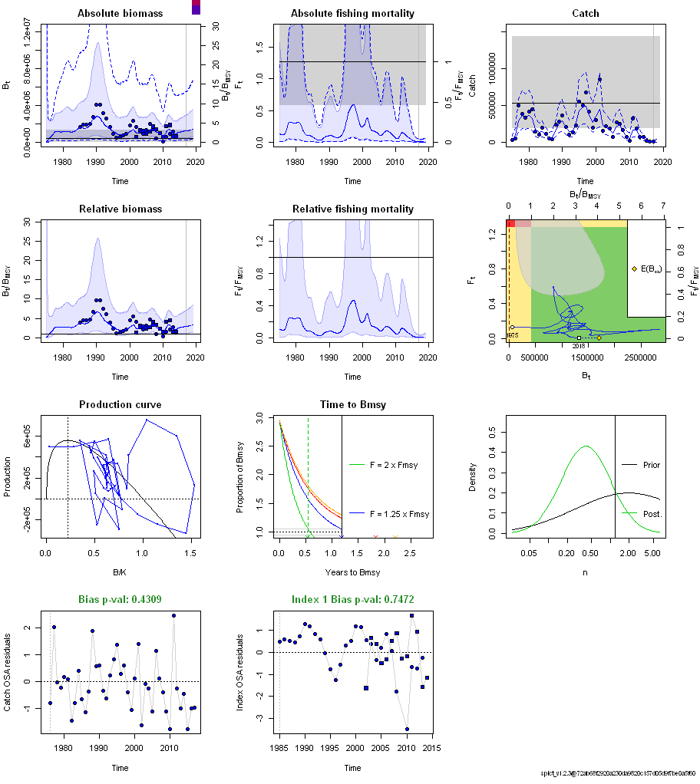
Figure 3a: SPICT fit when using both indices

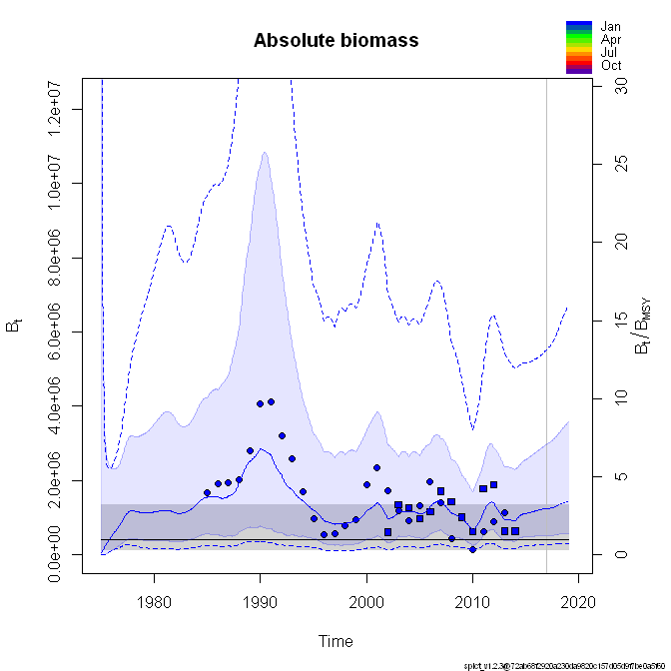
Figure 3b: Enlargement of first panel showing Biomass over time.

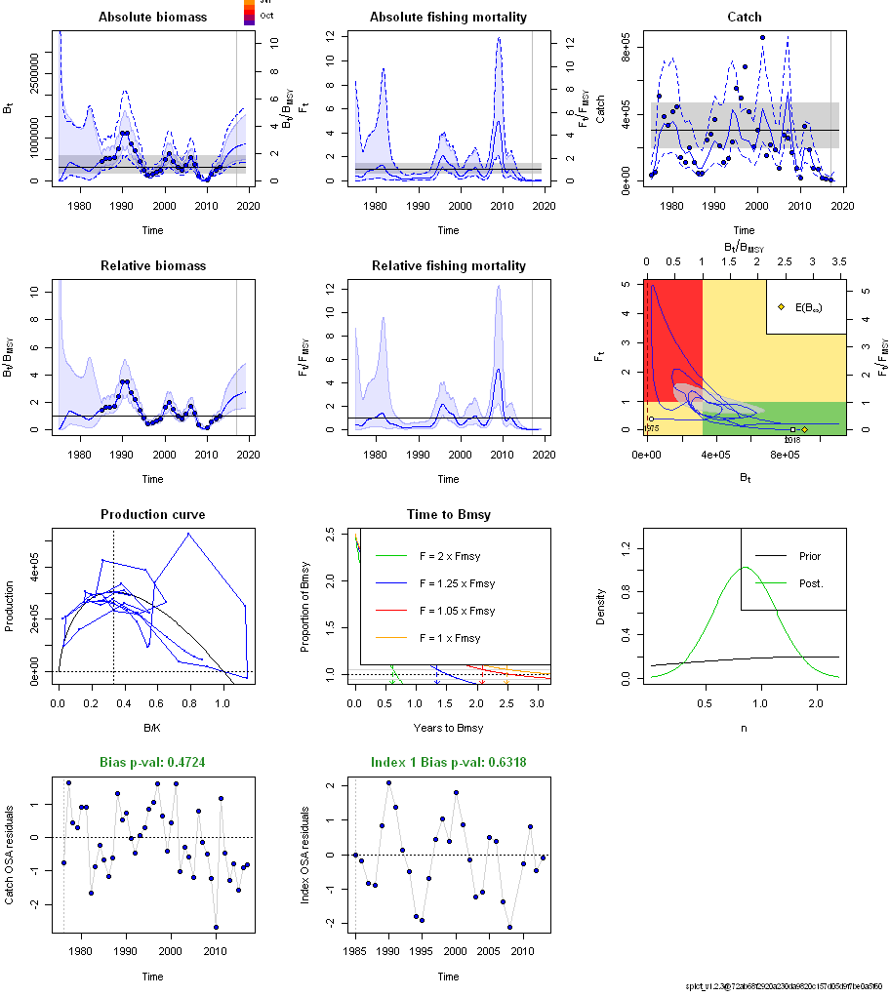
Figure 4a: SPICT fit when using the acoustic survey only

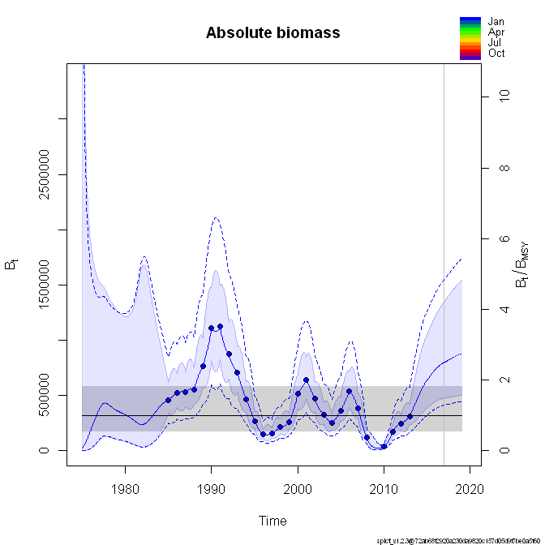
Figure 4b: Enlargement of first panel showing Biomass over time.

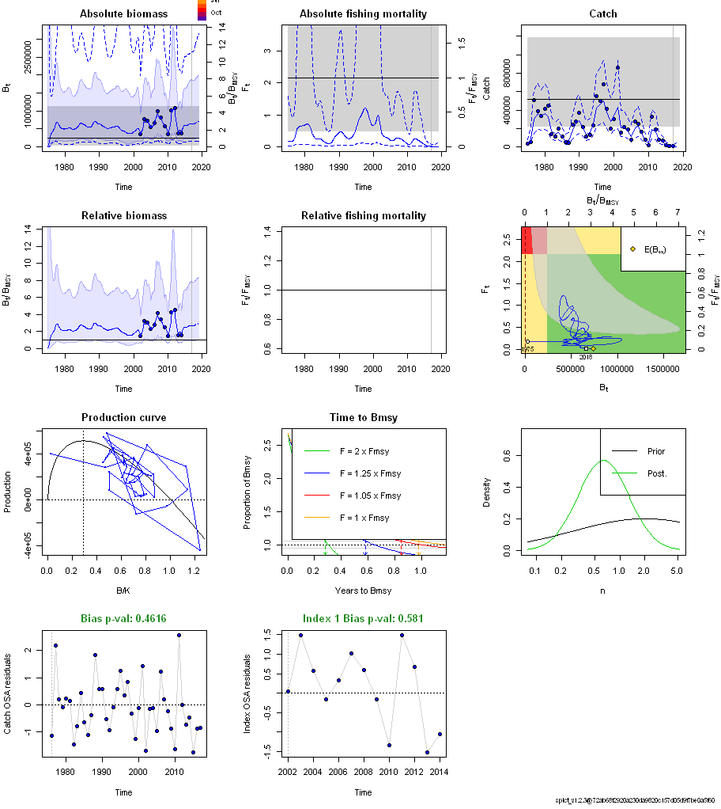
Figure 5a: SPICT fit when using the CPUE index

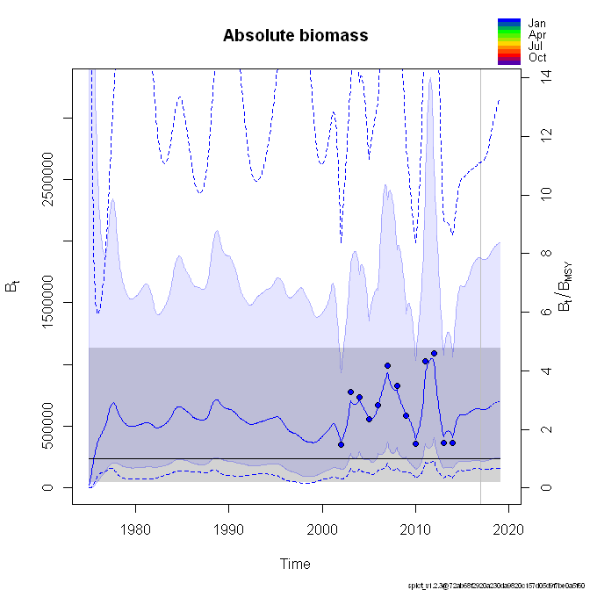
Figure 5b: Enlargement of first panel showing Biomass over time.
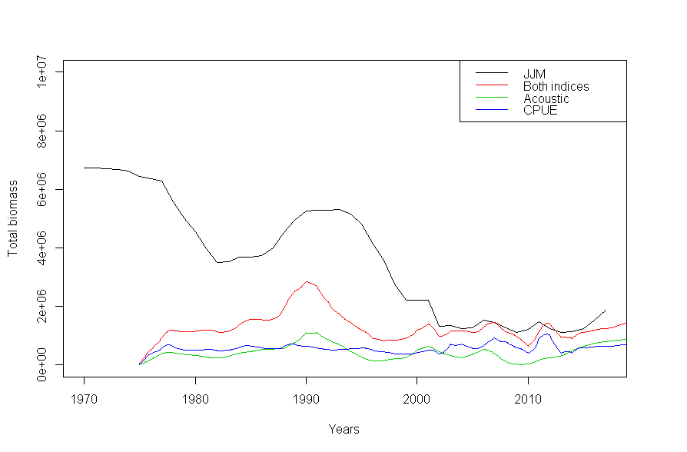
Figure 6: Comparison of total biomass as estimated from the JJM and SPICT runs using both or one single index of biomass.

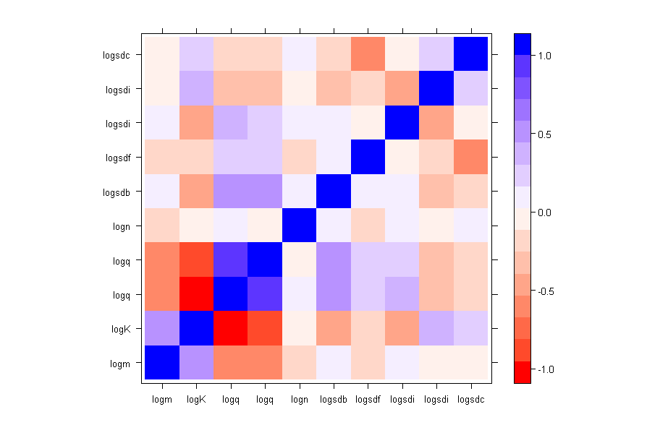
Figure 7: Correlation plot of estimated parameters in the SPICT run using both the indices.

Discussion
The SPICT framework is very simple in design but does estimate similar biomass levels as with the more complex JJM model in the later period. It is however important to note that when either of the indices are dropped, total biomass estimates change substantially while agreeing among each other. This provides valuable information for a potential bias in the current JJM model that may be affected by a correlation effect in the two indices as well, which is inappropriate for an assessment and artificially inflates biomass estimates.
Given that one rather does not use the same data twice (catch and CPUE) the results obtained using the acoustic survey alone may be useful for further investigation on best assessment methodology.

